RahiScan  Automated Rickshaw Fare & Pace Telemetry  A Data Science Lifecycle Case-Study Proposal | Introduction to Data Science  Group Assignment  Submitted 21 October 2026  github.com/ZEKT-VII/RahiScan-DS-Proposal
Group Contributions Form
This form records how our three-member team divided the work behind this proposal. Each member led specific stages of the Data Science Lifecycle and reviewed the stages led by the others, so the whole report reflects a shared design.
Member | Name | Roll Number | Contribution
Member 1 | Muhammad Saad Hussain | SU92-BSCSM-F25-260 | Wrote the case-study story, framed the problem, designed the scanning workflow, data-collection schema, system architecture, and planned the in-app deployment, privacy safeguards, and rollout roadmap. Led the Define, Collect and Deploy stages.
Member 2 | Muhammad Khubaib | SU92-BSCSM-F25-300 | Built the mock Lahore dataset and Python cleaning pipeline, wrote the OCR-face fusion and walking-tail trimming rules, and conducted the exploratory traffic-baseline and fare-ratio analysis. Led the Clean and Explore stages.
Member 3 | Huzaifa | SU92-BSCSM-F25-408 | Built the two-tier identity and gradient-boosting models for fair fares and pace classification, designed the Week-4 holdout evaluation and success thresholds, produced the charts, and maintained the GitHub repository. Led the Model and Evaluate stages.
Lifecycle Ownership Matrix
Member | Define | Collect | Clean | Explore | Model | Evaluate | Deploy
M. Saad Hussain | Lead | Lead | Review | Support | Review | Support | Lead
M. Khubaib | Support | Support | Lead | Lead | Support | Review | Review
Huzaifa | Review | Review | Support | Review | Lead | Lead | Support
Deliverables Submitted
This report (PDF & DOCX, 6 pp.) | Case-study story, 7-stage lifecycle extraction, mock pilot findings and deployment proposal.
Mock dataset | 1,224 ride submissions, 1,200 scans and 364,488 GPS pings from 40 simulated drivers (data/).
Reproducible code | Data generator, cleaning and modelling pipeline, and figure scripts in Python (src/).
GitHub Repository | https://github.com/ZEKT-VII/RahiScan-DS-Proposal
__________________________ __________________________ __________________________
M. Saad Hussain M. Khubaib Huzaifa
1. The Case Study: A Morning on Raiwind Road
It is 7:40 on a Monday in Johar Town and we have an 8:30 lab on campus. The first auto-rickshaw quotes 600 rupees; we bargain down to 520 and board. The driver then crawls along the left lane, stops for tea at a roadside dhaba “for one minute”, and delivers us twelve minutes late. The next morning a different driver covers the same route for 440 rupees in twenty minutes despite heavier traffic.  Lahore's rickshaws lack meters, leaving commuters unable to tell at the curb whether a quote is inflated or whether a driver is habitually slow. We propose RahiScan, a crowd-sourced mobile app where passengers photograph a rickshaw before boarding (Figure 1), fusing number-plate OCR with driver facial recognition (as vehicles are shared across shifts), enter the quoted fare, and log 5-second GPS pings until arrival. | 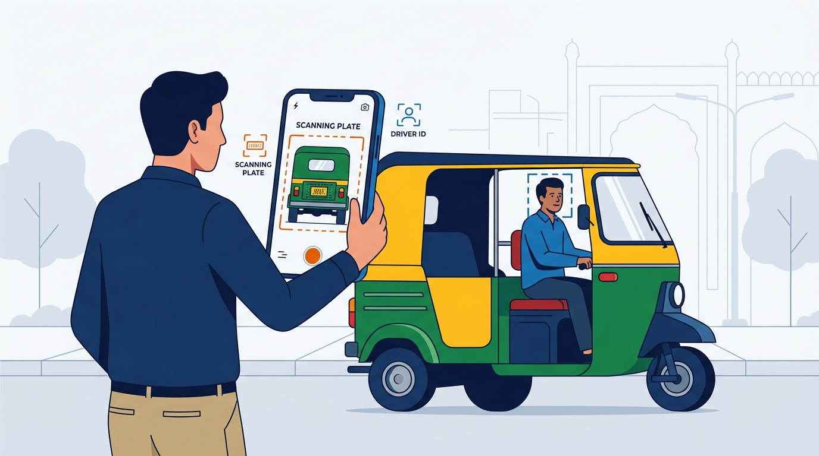  Figure 1: Curbside AR scan reading the plate (orange) and driver face (blue).
2. Extracting the Data Science Lifecycle from the Story
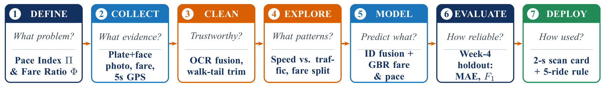
Figure 2: The seven-stage Data Science Lifecycle mapped to RahiScan's guiding questions and planned actions.
Table 1: Data science problems extracted directly from the morning commute story.
Stage | Moment in the story | Data science problem it raises and proposed solution
Define | “We could not tell the two drivers apart.” | Replace subjective complaints with two traffic- and route-normalised ratios: Pace Index Π and Fare Ratio Φ.
Collect | “Every bad ride leaves data nobody records.” | Capture plate+face scans, quoted fares, 5-s GPS/accelerometer traces, and ride-hailing fare benchmarks.
Clean | “We walked into the lab twelve minutes late.” | Trim pedestrian walking tails when users forget End Ride; fuse OCR and face embeddings; drop duplicates/typos.
Explore | “...even though the traffic was worse.” | Separate road congestion from driver habit by comparing trip speed against corridor-hour median speed v_base.
Model | “A different driver took the same route.” | Resolve shared-rickshaw drivers via biometric fusion and predict fair fares and pace classes with gradient boosting.
Evaluate | “Stuck in traffic is not a slow driver.” | Test on an unseen Week-4 holdout to measure false flags on single rides versus multi-ride driver profiles.
Deploy | “We had to decide at the curb, in seconds.” | Return a colour-coded scorecard in under 2 seconds, gated behind a 5-ride minimum and monthly fare retraining.
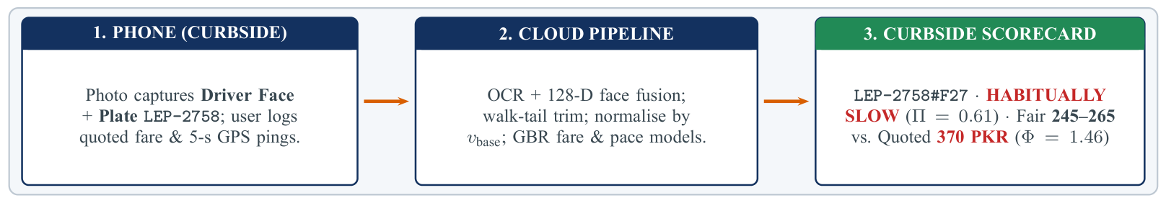
Figure 3: End-to-end RahiScan architecture illustrated with simulated driver D27 from our pilot dataset.
3. Define: Turning Frustration into Measurable Targets
Stage 1 · DEFINE | What problem should be solved?
To replace subjective complaints with testable metrics, we define two dimensionless ratios for every ride i, where 1.0 represents typical behaviour on that corridor and hour, and fix badge thresholds prior to data collection (Table 2):
Driving Pace Index (Π_i)  Π_i = v_obs,i / v_base,i = (d_i / t_i) / median(v_obs on corridor, hour)  Π = 0.60 means moving 40% slower than peer rickshaws on the same road and hour. | Fare Fairness Ratio (Φ_i)  Φ_i = Fare_quoted,i / Fare_fair,i  Fare_fair is predicted from distance, corridor, and congestion using ride-hailing benchmarks.
Table 2: Pre-registered decision rules for driver badges (applied to a driver's median across ≥ 5 verified rides).
Badge | Rule (driver median) | Curbside guidance shown to the passenger
Habitually Slow | Π < 0.75 | Expect trip duration at least 25% longer than ambient traffic requires.
Normal / Fast Pace | 0.75 ≤ Π ≤ 1.15 / Π > 1.15 | Moves with ambient traffic (≤ 1.15) or noticeably brisker (> 1.15).
Overpriced | Φ > 1.25 | Quotes more than 25% above fair benchmark; passenger should negotiate or skip.
4. Collect: The Evidence We Need
Stage 2 · COLLECT | What evidence is needed?
Since no public dataset links Lahore rickshaw drivers to speed and pricing, we designed a four-week pilot with 85 student volunteers across eight campus corridors. To validate our pipeline beforehand, we generated a synthetic pilot dataset (SEED = 2026) spanning 40 drivers across 34 rickshaws (six shift-shared), 1,200 scans, 1,224 trip logs, and 364,488 5-second GPS pings (Table 3, Figure 4). For privacy, only 128-D face embeddings are stored and raw photos are discarded immediately.
Table 3: Planned data streams and volume produced by our four-week simulated Lahore pilot (data/raw/).
Stream | Fields captured | Lifecycle purpose | Mock rows
Curb scan | Plate OCR text & confidence, 128-D face cosine match, low-light flag | Verify driver identity | 1,200
Ride record | User ID, corridor, timestamps, quoted fare (PKR), End Ride flag | Fare & duration log | 1,224
GPS pings | Lat, lon, 5-s timestamp, speed, accelerometer step variance | Trajectory & tail trim | 364,488
Fare benchmark | Contemporaneous inDrive/Careem/Bykea rickshaw quote (PKR) | Ground-truth fair fare | 1,200
Driver gallery | Registered plate-to-driver mapping and shift schedule (34 plates) | Resolve shared vehicles | 40
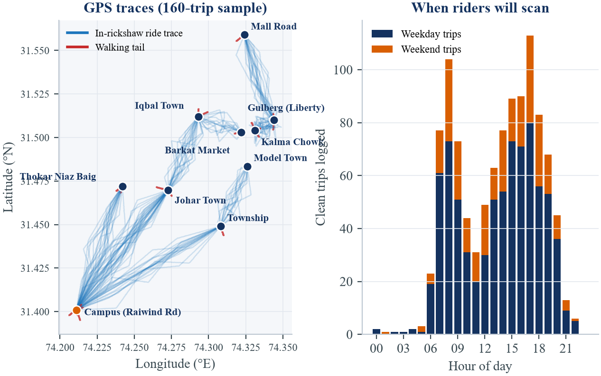
Figure 4: Left: simulated GPS traces across eight Lahore corridors, with red tails showing forgotten End Ride walks. Right: ride volume peaks during the 07:00–09:00 and 16:00–19:00 rush hours.
5. Clean: Can the Data Be Trusted?
Stage 3 · CLEAN | Can the data be trusted?
Street telemetry contains four recurring defects that we injected into our mock pilot and resolved programmatically. First, duplicate uploads from cellular retries within 10 seconds are dropped (1,224 → 1,200). Second, missing or typo fares (e.g. 5,200 instead of 520 PKR) outside [0.4, 4.0]× benchmark are removed (1,200 → 1,147). Third, night glare and dented plates degrade OCR; requiring plate confidence ≥ 0.85 or face similarity ≥ 0.70 (and using the face to disambiguate shared plates) boosts identity precision from 85.7% to 99.8% (1,147 → 1,075), leaving 1,058 verified rides after dropping 17 underpass traces with < 75% GPS coverage (Figure 5, left). Fourth, when a student forgets to tap End Ride, our backward change-point filter trims trailing pings with speed < 6 km/h and step variance > 1.2 m/s² for ≥ 60 s, catching 88.5% of all 130 walking tails with zero false trims and restoring 3.14 km/h to affected drivers (Figure 5, right).
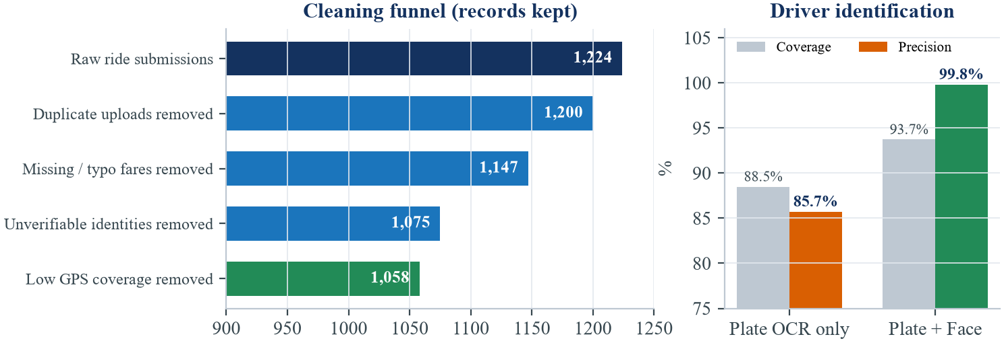 | 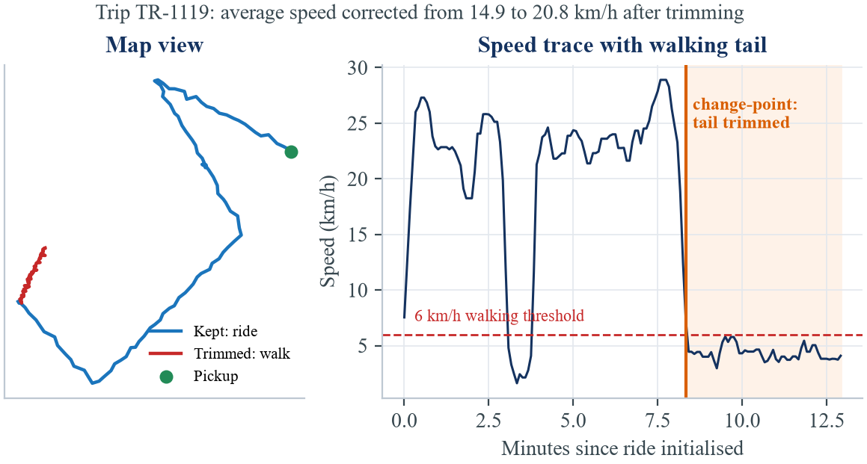
Figure 5: Left: multi-stage cleaning funnel (1,224 raw to 1,058 clean rides) and biometric fusion gain. Right: change-point walking-tail trim on ride TR-1119, preventing a 28% artificial speed penalty.
6. Explore: What Patterns Appear?
Stage 4 · EXPLORE | What patterns appear?
Exploratory analysis confirms why raw speed is unfair: on Mall Road, ambient median speed v_base drops from 22 km/h at night to 5 km/h at 16:00 (Figure 6, left). Normalising by v_base isolates driver pace across all traffic regimes, while the Fare Ratio Φ separates fair quotes (≈ 1.0) from an overpriced tail near 1.7 (Figure 6, right; Table 4).
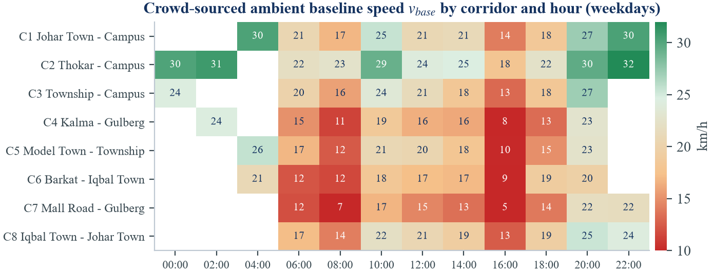 | 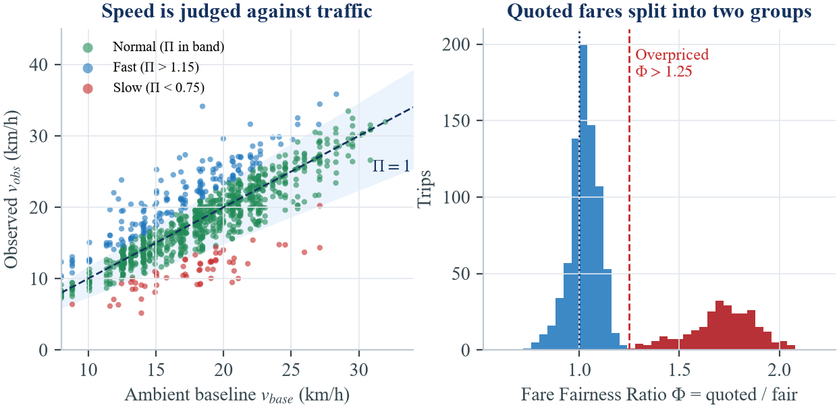
Figure 6: Left: weekday ambient speed v_base by corridor and hour. Right: observed vs. baseline speed showing the Normal Pace band, and the bimodal distribution of Fare Ratio Φ.
Table 4: Sample of cleaned, feature-engineered rides (data/processed/trips_clean.csv) illustrating independent pace and fare scores.
Ride | Plate # Face | Corridor | Hr | km | v_obs | v_base | Π | Quoted/Fair | Φ
TR-0466 | LEP-4334#F04 | Thokar – Campus | 14 | 8.5 | 25.6 | 24.6 | 1.04 | 460 / 458 | 1.00
TR-0827 | LEP-4877#F22 | Kalma – Gulberg | 17 | 2.1 | 7.3 | 8.0 | 0.91 | 180 / 169 | 1.07
TR-0597 | LEP-2758#F27 | Barkat – Iqbal Town | 8 | 3.9 | 6.1 | 11.6 | 0.53 | 370 / 254 | 1.46
TR-0266 | LES-8870#F32 | Township – Campus | 7 | 10.8 | 17.4 | 18.2 | 0.96 | 1070 / 528 | 2.03
7. Model: From Patterns to Predictions
Stage 5 · MODEL | Can patterns support prediction?
Our modelling architecture operates in two tiers (Figure 7, left). Tier 1 (Biometric + OCR Identity Fusion) pairs a CRNN plate reader with a MobileNetV3 128-D face encoder. Because six rickshaws in our pilot are shared across shifts, plate LES-8113 is driven by a fair morning driver (Φ = 1.05) and an overpriced evening driver (Φ = 1.77) who would otherwise be blurred into one misleading profile. Tier 2 (Behavioural Prediction) trains a Gradient-Boosted Regressor (GBR) to predict Fare_fair from distance, corridor, hour, weekend indicator, and ambient speed v_base, plus a multiclass GBR pace classifier. Plotting 4-week driver medians reveals four behavioural clusters and confirms that pace and pricing require separate badges (Figure 7, right).
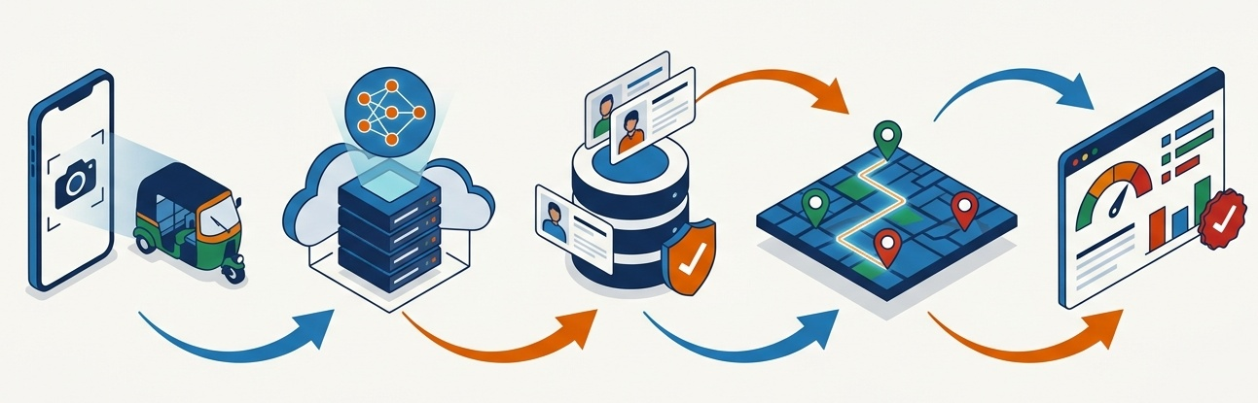 | 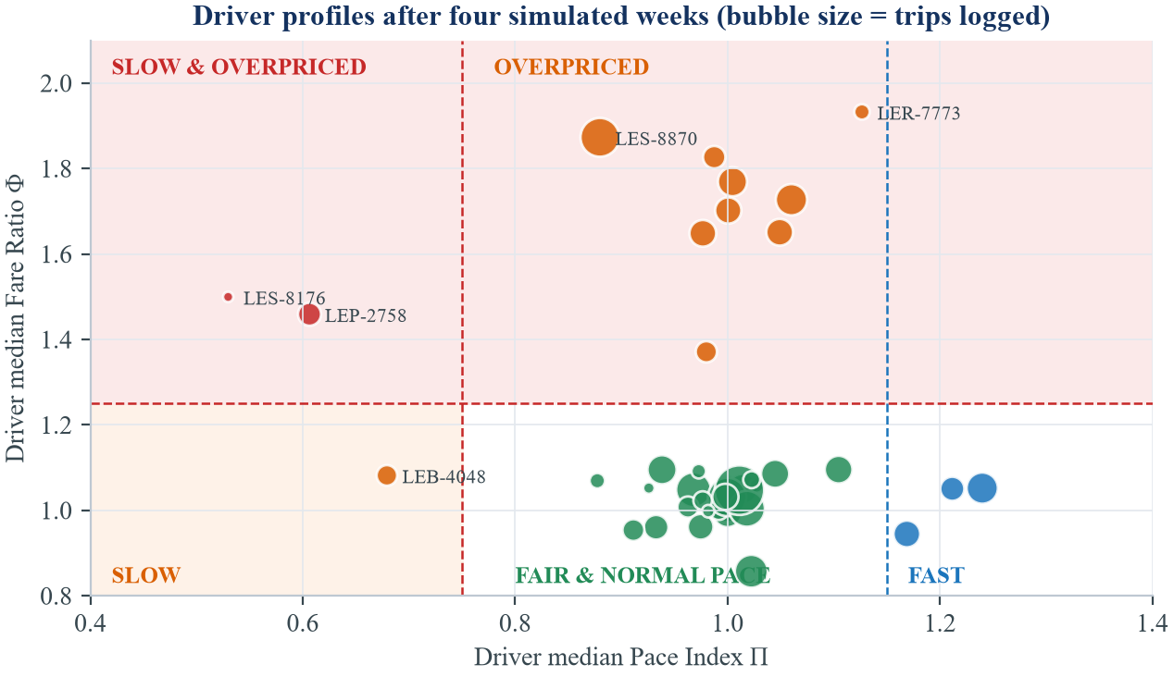
Figure 7: Left: single-scan data journey from phone capture to cloud inference and scorecard. Right: 40 driver profiles across the Pace Index (Π) vs. Fare Ratio (Φ) quadrant.
8. Evaluate: How Reliable Is the Result?
Stage 6 · EVALUATE | How reliable is the result?
To prevent temporal leakage, models are trained strictly on Weeks 1–3 (778 clean rides) and evaluated on the unseen Week-4 holdout (280 rides across all 40 drivers; Table 5). Fair-fare GBR achieves a Mean Absolute Error of 10.9 PKR (beating linear regression at 12.1 PKR and a flat per-km rate at 117.6 PKR). Single-ride pace reaches macro F1 = 0.67 (below the 0.88 target) because individual trips suffer from one-off traffic luck, whereas aggregating over ≥ 5 rides eliminates single-trip noise and lifts driver-level Pace Badge accuracy to 100% (versus 87.5% using raw speed; Figure 8).
Table 5: Holdout evaluation summary on unseen Week-4 trips (n = 280 rides, 40 drivers).
Module | Metric and baseline comparison | Target | Mock result | Status
Driver identity | Precision of verified IDs (plate-only baseline: 85.7%) | ≥ 93% | 99.8% | Met
Walking-tail filter | Recall on 130 forgotten End Ride walking tails (100% precision) | ≥ 0.85 | 0.88 | Met
Fair-fare regressor | Holdout MAE (linear: 12.1 PKR; flat rate: 117.6 PKR) | < 15 PKR | 10.9 PKR | Met
Pace (single ride) | Macro F1 on individual trips (raw speed baseline: 0.45) | ≥ 0.88 | 0.67 | Not met
Pace (driver badge) | Badge accuracy over ≥ 5 rides (raw speed baseline: 87.5%) | ≥ 90% | 100% | Met
Fare badge | Overpriced flag accuracy over ≥ 5 rides | ≥ 90% | 100% | Met
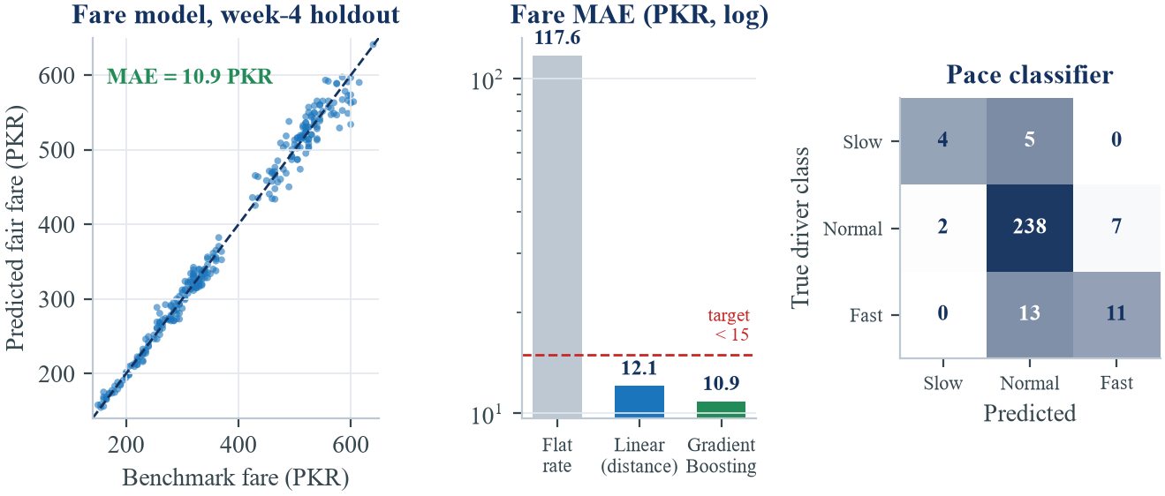 | 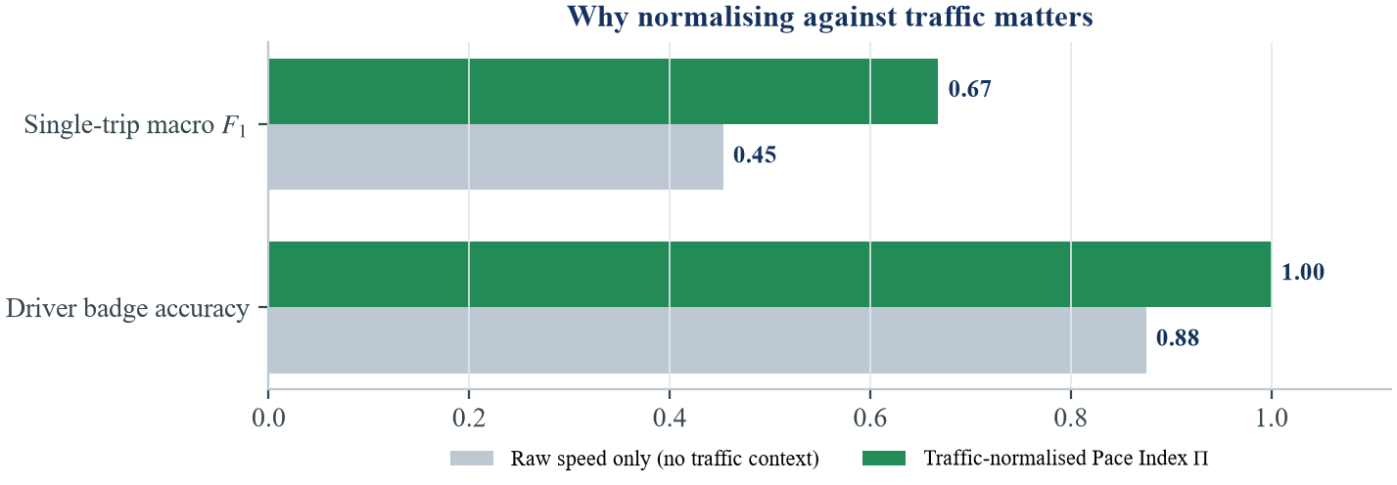
Figure 8: Left: Week-4 holdout fair-fare predictions, log-scale MAE comparison, and single-ride confusion matrix. Right: traffic normalisation (Π) substantially outperforms raw speed.
9. Deploy: How Will the Decision Be Used?
Stage 7 · DEPLOY | How will the decision be used?
The evaluated pipeline will run behind a lightweight FastAPI service powering a three-screen mobile workflow (Figure 9, left): (1) curbside AR camera scan of plate and face, (2) live 5-second GPS trip telemetry with automatic walking-tail detection, and (3) an instant curbside scorecard returned within two seconds so the student can negotiate or wave the rickshaw on before boarding.
Because our Evaluate stage proved that single rides are too noisy to judge a driver fairly (F1 = 0.67), deployment enforces four operational safeguards (Table 6). First, the app displays Insufficient Rides (< 5) until a driver accumulates at least five verified trips, where badge accuracy reaches 100%. Second, driver scores use an exponentially weighted moving median that weights recent rides more heavily, allowing drivers who improve their pricing or pace to recover their badge. Third, drivers can scan their own plate to inspect their log and flag disputed trips for review. Fourth, because fuel prices and inflation shift over time, the fair-fare GBR model is retrained monthly against fresh ride-hailing benchmarks, feeding every completed trip back into the Collect stage. Figure 9 (right) outlines our eight-week execution plan from prototype to campus beta.
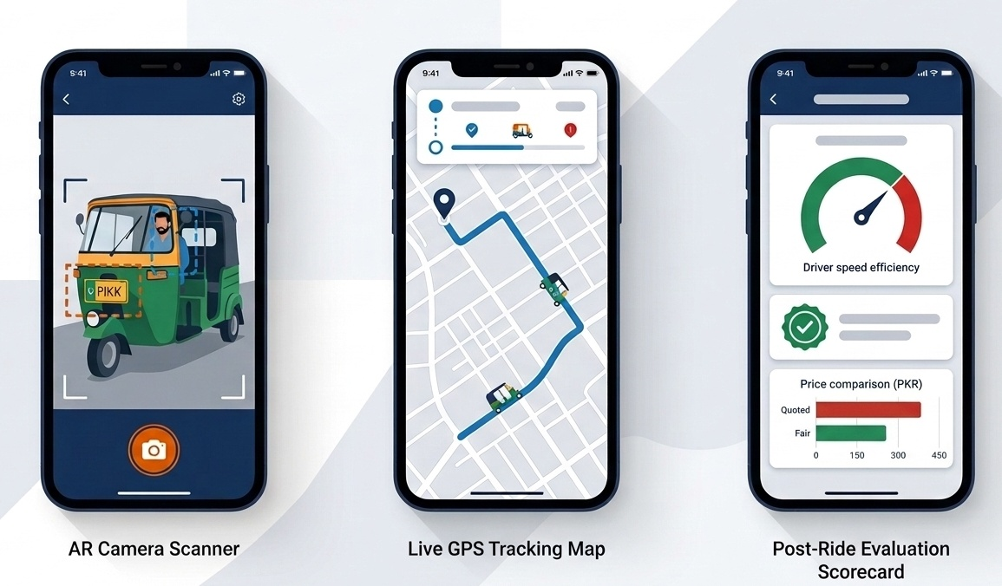 | 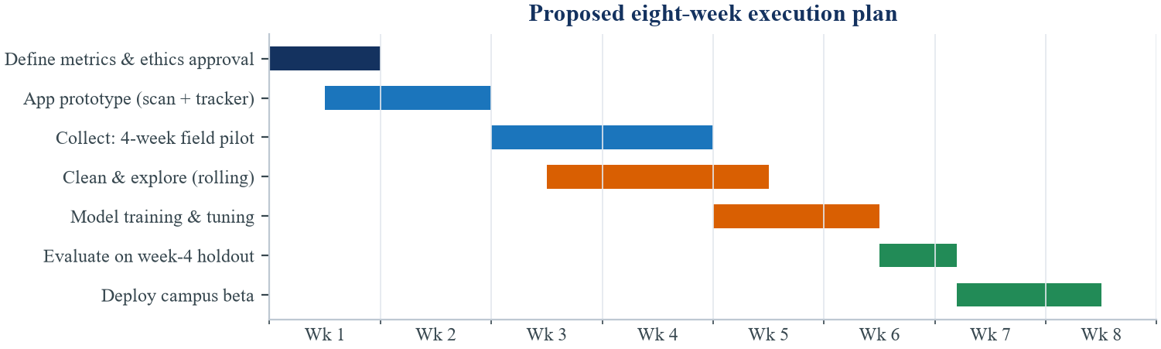
Figure 9: Left: proposed three-screen mobile workflow (AR scan, live GPS tracking, and curbside scorecard in PKR). Right: eight-week project execution roadmap from metrics definition to campus beta.
Table 6: Deployment safeguards translating evaluation lessons into responsible real-world operation.
Operational risk | Lifecycle evidence | Deployment safeguard in RahiScan
Single-ride traffic luck | Single-ride pace macro F1 = 0.67 vs. 100% at ≥ 5 rides (Stage 6) | Suppress pace and fare badges until a driver has ≥ 5 verified trips; show Insufficient Data otherwise.
Shift-shared rickshaws | 6 of 34 plates shared by day/night drivers with different habits (Stage 5) | Key profiles to composite Plate#FaceID rather than license plate alone (99.8% precision).
Forgotten End Ride taps | 10.8% of trips include pedestrian walking tails (Stage 3) | Auto-trim trailing pings with speed < 6 km/h and step variance > 1.2 m/s², plus push-notification prompt.
Fuel & tariff drift | Static fare models degrade when petrol prices shift (Stage 7) | Retrain the GBR fair-fare model monthly on rolling benchmark quotes and weight recent rides exponentially.
Conclusion: Closing the Lifecycle Loop
Our morning rickshaw story exposed a concrete failure mode at every stage of the Data Science Lifecycle. By validating our design on a 1,224-trip simulated Lahore pilot, we demonstrated that combining plate OCR with facial embeddings resolves shared-vehicle ambiguity at 99.8% precision, change-point trimming removes forgotten walking tails, gradient boosting predicts fair fares within 10.9 PKR, and traffic-normalised multi-ride medians classify driver pace and pricing without penalising honest drivers caught in congestion. Replacing our mock CSV streams with live student telemetry will turn RahiScan into a practical transparency tool for Lahore's daily commuters.

