

* **Card Printers**

Did you know?

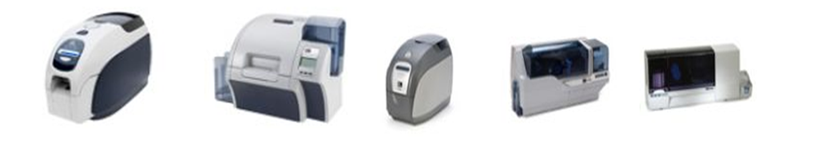

Did you know that the ZXP Series printers don’t support EPCL?

As opposed to the Performance and Value Class printers which support EPCL, the ZXP printers (**ZXP Series 3**, **ZXP Series 8**, and the on-the-horizon **ZXP Series 7**) have no native printer language. This means that sending EPCL commands to any of the ZXP Printers will **not** have a meaningful effect.

One common misconception is that the **ZXP Series 3** supports EPCL since the driver tools contain a command area:

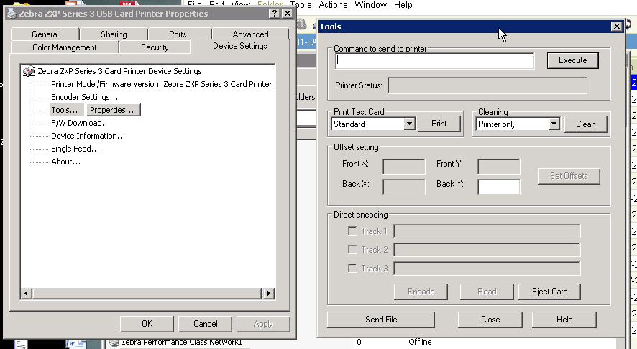

The command area is a relic from the Performance and Value Class printer drivers and serves no real functionality for the **ZXP Series 3**. While the **ZXP Series 3** currently does respond to a very limited amount of EPCL commands, this functionality **will be removed entirely** in future firmware and driver releases.

The ZXP line of printers provides a large array of tools to help troubleshoot and print cards. Tools such as **ZXP ToolBox**, **ZGT**, **PGT**, and the **ZXP Series 8 emulator** provide a large amount of control over the printers. In fact, one common troubleshooting technique is to use a tool such as **ZXP ToolBox** in conjunction with the **ZXP 8 Emulator** to walk a customer through printer modifications. You can find all of these tools at [www.zebra.com/cardpartner](http://www.zebra.com/cardpartner). You must click on the link that says “Click here for EULA”.

