

Comparative Data Mining with
Mushroom and Ionosphere Datasets

CDS535 - Data Mining 2026/ 11/ 04
ZENG Xinying 3162809
HU Ziqi 3163047
WU Yanping 3162225
ZHANG Jiaming 3163475
HU Sirui 3162768

Git link: https://github.com/ZENG-Xinying/CDS535-Data-Mining-Group-Project
Abstract

This project compares classification and pattern-mining workflows on two UCI Machine Learning Repository datasets with contrasting structures: Mushroom and Ionosphere. Mushroom contains 8,124 original records described by nominal attributes and includes missing values in stalk-root; principal classification experiments use a complete-case subset of 5,644 records after removing those records and a constant attribute. Ionosphere contains 351 records, 34 numerical predictors and a binary class, with no missing values and moderate class imbalance. Four classifiers—J48, RandomForest, Logistic and SMO—were evaluated using stratified 10-fold cross-validation and a fixed 66%/34% hold-out split. Apriori was used as an unsupervised association-rule component on Mushroom after excluding the class attribute. All four classifiers achieved 100% accuracy on the processed Mushroom subset. On Ionosphere, RandomForest achieved the strongest 10-fold result (92.88% accuracy; ROC-AUC 0.979) and hold-out accuracy (91.60%). Results illustrate that model complexity provides little measurable benefit on the highly separable Mushroom subset, whereas an ensemble offers an advantage on the smaller, continuous and noisier Ionosphere dataset.

Keywords: Classification, Preprocessing, Cross-Validation

Contents

1 Introduction 1
1.1 Background and Motivation 1
1.2 Project Objectives and Research Questions 1
1.3 Dataset Selection and Expected Contrast 1
1.4 Key Points of Innovation 1
2 Data Sources and Description 2
2.1 Data Sources and Provenance 2
2.2 Descriptive Statistics and Attribute Types 2
2.3 Data Quality Issues 2
2.4 Data Format and Schema 2
3 Data Visualisation and Preprocessing 3
3.1 Data Visualisation 3
3.2 Data Preprocessing Pipeline 4
4 Methods and Workflow in Weka 5
4.1 Modeling Approaches 5
4.2 Pipeline per Dataset 5
4.3 Evaluation Protocols and Metrics 6
4.4 Weka Tools Configuration 6
5 Tasks Performed 6
5.1 Concrete Tasks 6
5.2 Rationale for Method Choices 6
6 Results and Analysis 7
6.1 Quantitative Results 7
6.2 Comparative Analysis of Models and Hyperparameters 8
6.3 Cross-Dataset Comparison 9
6.4 Visualizations and Interpretation 10
7 Discussion 11
7.1 Key Findings and Insights 11
7.2 Limitations and Threats to Validity 11
7.3 Recommendations and Future Work 11
8 Team Contributions 12

1 Introduction

  - Background and Motivation
Data mining uses computational methods to discover predictive patterns and relationships in data. Classification is a supervised task in which a model learns to assign observations to predefined classes. The effectiveness of a classifier depends not only on the algorithm but also on the data representation, missing-value patterns, feature types, class distribution and validation design. A workflow that performs well on one dataset may not transfer directly to another dataset with different characteristics.
This project uses Weka to examine these dependencies through two binary-classification datasets. The Mushroom dataset represents categorical biological descriptions and contains a substantial missing-value issue. The Ionosphere dataset represents numerical radar measurements and has fewer observations, partial class overlap and moderate class imbalance.

1.2 Project Objectives and Research Questions
The project has four objectives: (1) document and inspect two publicly available UCI datasets^{[1]}; (2) compare preprocessing choices appropriate to nominal and numerical attributes; (3) evaluate four classifiers under two validation protocols and compare their results; and (4) use Apriori to explore frequent attribute co-occurrences in Mushroom.
The research questions are: How do data type, sample size, missingness and class distribution relate to observed classifier performance? Do preprocessing choices change performance or data retention? Does RandomForest provide a measurable advantage over a single tree and linear classifiers? What can association rules reveal when the class attribute is excluded?

1.3 Dataset Selection and Expected Contrast
The datasets differ in sample size (8,124 original Mushroom records versus 351 Ionosphere records), predictor type (nominal versus numerical), missingness (Mushroom has 2,480 missing stalk-root values; Ionosphere has none) and class balance. These contrasts allow the project to compare nominal-data handling with numerical scaling, as well as performance on a relatively large, highly separable dataset versus a smaller and more difficult radar dataset.

1.4 Key Points of Innovation
To distinguish this project from standard descriptive analyses, this methodology incorporates several key points of innovation and methodological rigor. First, we implemented rigorous prevention of data leakage: unlike naive workflows that apply global preprocessing, all class-dependent transformations—including missing-value imputation, standardisation, and feature selection—were strictly nested inside each training fold using Weka's FilteredClassifier and AttributeSelectedClassifier. Second, through cross-domain structural contrasting, rather than analyzing isolated datasets, we built a direct comparative bridge between a large-scale categorical domain (Mushroom) and a small-scale continuous radar domain (Ionosphere), providing clear empirical evidence on when algorithmic complexity is truly justified. Finally, we applied comprehensive multi-metric validation, extending evaluation beyond traditional accuracy to incorporate Kappa statistics, precision, recall, F1-scores, ROC-AUC curves, and paired corrected t-tests via Weka Experimenter, ensuring robust statistical validation of model differences.

2 Data Sources and Description

2.1 Data Sources and Provenance
The publicly available Ionosphere^{[2]} dataset is from the UCI Machine Learning Repository (ID 52; DOI: 10.24432/C5W01B; dataset page)^{[3]}. Radar returns were collected in Goose Bay, Labrador, and the dataset was described by V. Sigillito, S. Wing, L. Hutton and K. Baker (1989). Licensed under CC BY 4.0, it permits reuse and adaptation with attribution. Its numerical features and binary classes suit classification experiments.
The Mushroom^{[4]} dataset was obtained from the UCI Machine Learning Repository^{[5]} (Dataset ID: 73; DOI: 10.24432/C5959T; Schlimmer, 1987). The records were originally drawn from The Audubon Society Field Guide to North American Mushrooms (Lincoff, 1981) and donated by Jeff Schlimmer in April 1987. Licensed under CC BY 4.0, it describes hypothetical physical characteristics of 23 gilled mushroom species in the Agaricus and Lepiota families, with the classification task of distinguishing edible from poisonous mushrooms.

2.2 Descriptive Statistics and Attribute Types
Property | Mushroom (original) | Mushroom (main experiment) | Ionosphere
Instances | 8,124 | 5,644 | 351
Attributes | 23 total | 22 total (21 predictors + class) | 35 total (34 predictors + class)
Predictor types | Nominal | Nominal | Numerical
Target classes | edible (e), poisonous (p) | edible (e), poisonous (p) | good (g), bad (b)
Class distribution | 4,208 e (51.8%); 3,916 p (48.2%) | 3,488 e; 2,156 p (counts reported in evaluation confusion matrix) | 225 g (64.1%); 126 b (35.9%)
Missing values | 2,480 in stalk-root (30.53%) | No stalk-root missing values after complete-case deletion | 0

Table 2.2 Descriptive Statistics and Class Distribution

2.3 Data Quality Issues
Mushroom exhibits a high missing-value rate in the stalk-root attribute, where 2,480 instances lack recorded values representing 30.53% of the dataset encoded as ?, and the veil-type attribute is entirely constant containing only a single observed value across all instances thereby providing zero discriminatory power for classification models.
Ionosphere contains zero missing values however it exhibits moderate class imbalance with 64.1% good versus 35.9% bad returns and 34 continuous numerical predictors with potential feature redundancy and noise motivating exploratory feature selection and scaling experiments.

2.4 Data Format and Schema
Both datasets were loaded into the Weka Explorer environment in ARFF format where schemas explicitly document the relation name attribute names categorical value sets for nominal attributes such as cap-shape odor and class labels missing-value codings represented uniformly as ? and target class roles. Mushroom's purely nominal attribute representation bypasses the need for numerical normalization whereas Ionosphere's continuous numerical range requires careful evaluation of normalization and standardization filters to prevent distance-based or gradient-sensitive algorithms from being biased by scale disparities.

3 Data Visualisation and Preprocessing

3.1 Data Visualisation
Figures 3.1.1–3.1.3 present the Ionosphere dataset, while Figure 3.1.4 illustrates the Mushroom dataset for comparison.
Figure 3.1.1 shows 126 class-b instances (35.9%) and 225 class-g instances (64.1%), indicating moderate class imbalance. Therefore, accuracy should be considered alongside precision, recall, F1-score and the confusion matrix.

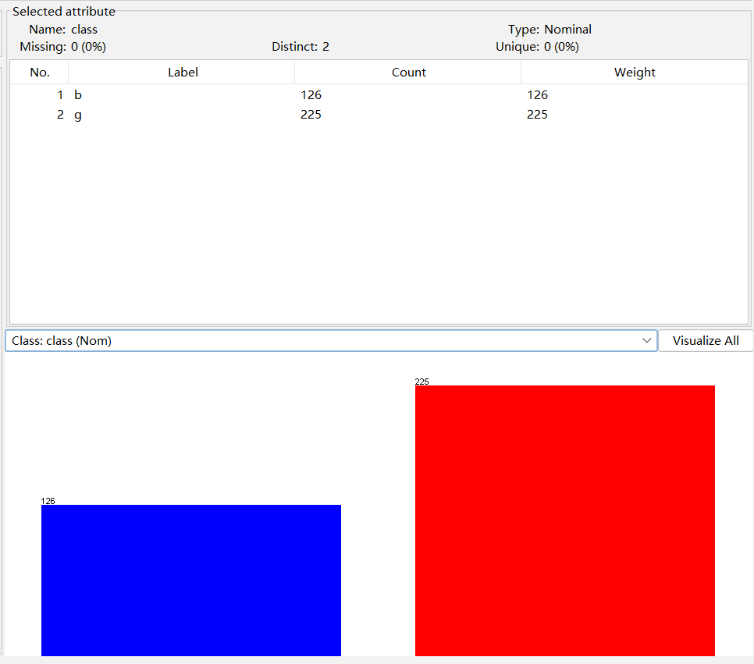

Figure 3.1.1 Class distribution of the Ionosphere dataset

Figure 3.1.2 shows partial overlap between classes in the scatter plot of a04 and a03, suggesting that these two features alone cannot fully separate the classes.

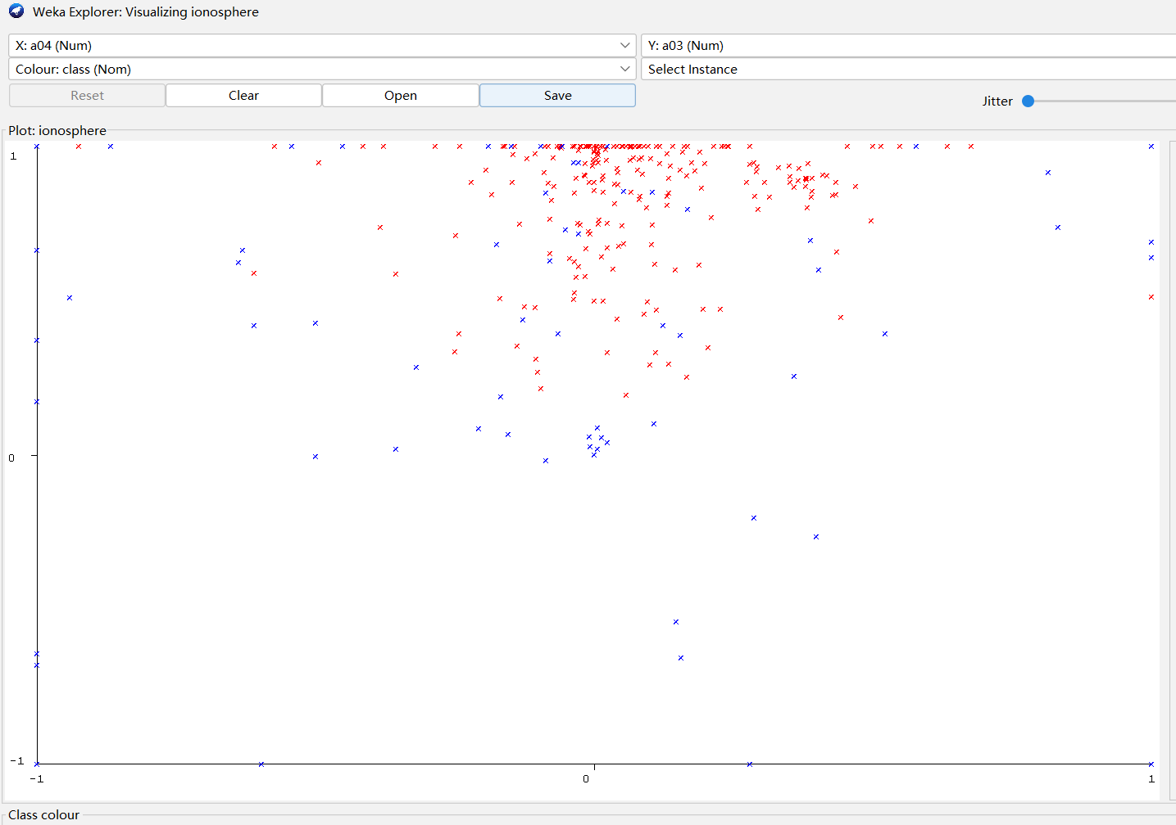

Figure 3.1.2 Scatter plot of attributes a04 (x-axis) and a03 (y-axis)
Figure 3.1.3 shows Weka's inspection of a05, which has no missing values; the dataset summary confirms that no missing values were found overall.

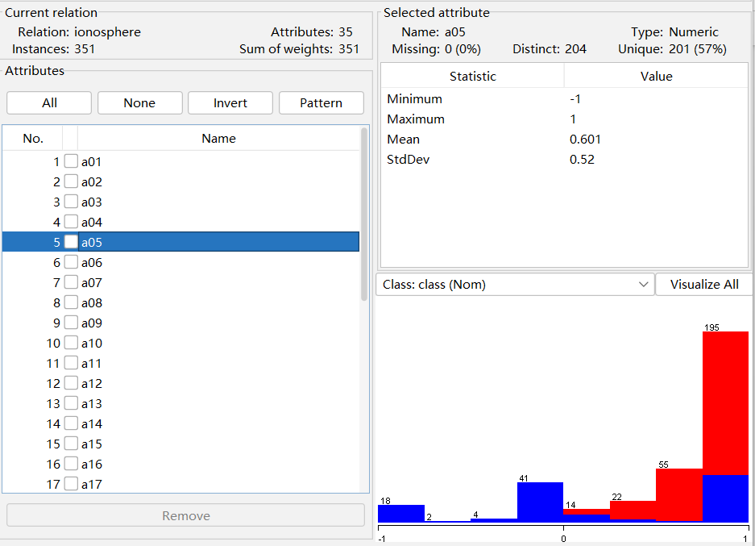

Figure 3.1.3 Attribute-Level Data Quality Check for the Ionosphere Dataset (a05)
Figure 3.1.4 suggests that odor categories are associated with class labels and may help distinguish edible from poisonous mushrooms. Mushroom has a relatively balanced class distribution, with 4,208 edible (51.8%) and 3,916 poisonous (48.2%) instances.

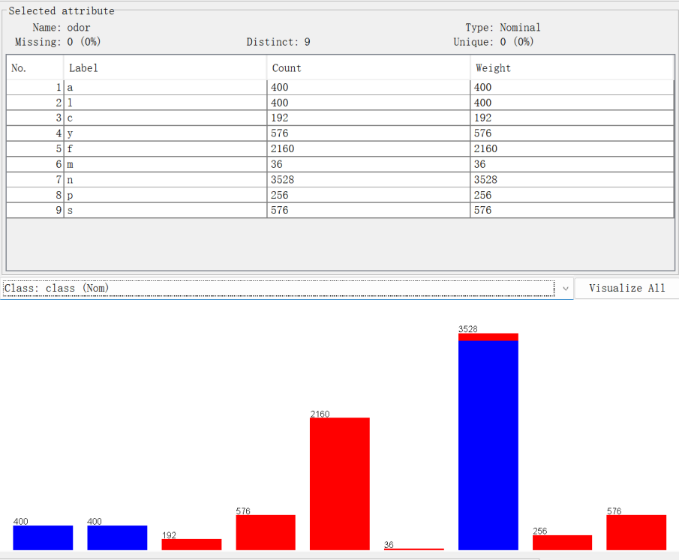

Figure 3.1.4 Distribution of Mushroom Odor Categories by Class
Mushroom has 8,124 instances, nominal predictors and a relatively balanced class distribution (51.8% edible; 48.2% poisonous), whereas Ionosphere has 351 instances, numerical predictors and greater class imbalance (64.1% class g; 35.9% class b). These differences support cross-dataset model comparison.

3.2 Data Preprocessing Pipeline
The Mushroom dataset preprocessing pipeline in Weka involved data cleaning, missing-value handling, and feature evaluation. First, the constant veil-type attribute was removed using the Remove filter because it contained only a single observed value and provided no discriminatory power. Second, to address missing values in the stalk-root attribute (which accounted for 30.53% of the data encoded as ?), records containing missing values were removed using the RemoveWithValues filter, reducing the dataset from 8,124 to 5,644 instances to ensure models were trained exclusively on complete cases. Additionally, attribute selection was conducted using CfsSubsetEval and BestFirst search to assess feature relevance and inter-attribute correlation, yielding an optimal subset merit of approximately 0.58. These preprocessing steps successfully structured the nominal dataset into 22 attributes for subsequent classification experiments.
For the Ionosphere dataset, baseline preprocessing required no imputation due to the absence of missing values. Three comparative scaling and feature-selection strategies were evaluated: Normalize (-S 1.0 -T 0.0) to scale numerical features to [0,1]; Standardize (Weka defaults) to achieve zero mean and unit variance; and supervised attribute selection using CfsSubsetEval paired with BestFirst search (utilizing J48 as the base evaluator) to reduce dimensionality.
Empirical 10-fold cross-validation indicated that applying Normalize slightly reduced RandomForest accuracy from 92.88% to 92.59% and its weighted F-measure from 0.928 to 0.925, showing no performance gain. Consequently, in the four main classification experiments, J48 and RandomForest processed the original numerical features directly, whereas Logistic and SMO incorporated Standardize exclusively inside a FilteredClassifier, with SMO's internal scaling disabled to prevent redundant transformations. Separately, feature selection via AttributeSelectedClassifier identified an average subset of 14 predictors (varying dynamically across folds). To rigorously prevent data leakage, all transformations—including standardization and feature selection—were fitted strictly within each training fold and applied to the corresponding validation fold, as well as strictly restricted to the 232 training instances in the 66%/34% hold-out evaluation protocol before transforming the 119 test instances.

4 Methods and Workflow in Weka

4.1 Modeling Approaches
Classifier | Main settings recorded in the project
J48 | Pruning enabled; confidence factor 0.25; minimum instances per leaf = 2.
RandomForest | 100 trees; seed = 1; unlimited depth; automatic feature-subset size; one execution slot.
Logistic | Ridge parameter = 1.0E−8; maximum iterations = −1 (Weka default/unlimited setting).
SMO | C = 1; PolyKernel exponent = 1 (linear kernel); internal scaling disabled; probability calibration enabled with 3 folds and seed = 1.
The four classifiers were selected to compare an interpretable decision tree (J48), a tree ensemble (RandomForest) and two linear decision mechanisms (Logistic and SMO). Baseline settings were fixed rather than repeatedly tuned after inspecting test results.

4.2 Pipeline per Dataset
Dataset | Input and actual pipeline
Mushroom | Complete-case subset of 5,644 instances and 21 nominal predictors; no external standardization; necessary nominal handling performed internally by the classifiers
Ionosphere | Original 351 instances and 34 numerical predictors; direct J48/RandomForest, and Standardize inside FilteredClassifier for Logistic/SMO
Ionosphere feature selection | Original input; AttributeSelectedClassifier selects attributes within the training portion before fitting J48
feature selection | attributes within the training portion before fitting J48
The primary experiments utilized a complete-case Mushroom subset of 5,644 instances—generated by removing records with missing stalk-root values and a constant veil-type attribute—alongside the full Ionosphere dataset. All classifiers were evaluated using stratified 10-fold cross-validation and a fixed 66%/34% training-test split with a random seed of one. To prevent data leakage, preprocessing steps such as standardization and supervised attribute selection were fitted exclusively on the training folds and applied to the test portions, while SMO's internal scaling was disabled.

4.3 Evaluation Protocols and Metrics
Both datasets were evaluated with stratified 10-fold cross-validation and an independent 66%/34% percentage split using fixed seed 1. The split contained 3,725 training and 1,919 test records for Mushroom, and 232 training and 119 test records for Ionosphere. Positive classes were poisonous (p) for Mushroom and bad return (b) for Ionosphere.
The reported classification measures are accuracy, positive-class precision, recall, F1-score, ROC-AUC and Kappa. Apriori rules were assessed using support, confidence and lift. The Weka Experimenter was configured for the four classifiers on both datasets using 10-fold cross-validation; paired corrected t-tests used significance level 0.05.

4.4 Weka Tools Configuration
Weka^{[6]} Explorer was used to inspect datasets, apply filters, train classifiers and inspect model outputs. FilteredClassifier was used to place standardization inside the classifier pipeline for Ionosphere Logistic and SMO. AttributeSelectedClassifier placed supervised feature selection inside the training process. The Experimenter compared the same four classifiers using the identical configurations as the main results, including Standardize inside a FilteredClassifier for Ionosphere Logistic and SMO; therefore, its significance tests apply directly to the pipelines reported in the main results.
To reduce data leakage, class-dependent preprocessing—including standardization, feature selection and resampling where used—was fitted within each training fold and then applied to that fold’s validation data. For the 66%/34% split, transformations were fitted on the training partition only and applied to the held-out test partition. Globally preprocessed files were not used as the evaluation baseline.

5 Tasks Performed

5.1 Concrete Tasks
The project collected and documented two UCI datasets; inspected class distributions, attribute types and missing values; created exploratory visualisations; compared missing-value strategies and numerical scaling; removed a constant attribute; trained four classifiers; ran feature-selection and tree-count sensitivity checks; conducted 10-fold cross-validation and a fixed hold-out evaluation; compared models with the Weka Experimenter; checked fold-nested preprocessing; and applied Apriori to Mushroom without the class attribute.

5.2 Rationale for Method Choices
J48 allows rules to be interpreted, RandomForest tests ensemble benefits, Logistic and linear SMO allow for contrasting decision mechanisms. Trees do not require common numerical scales. Training-only standardization explicitly appeared for the Ionosphere linear models, while Mushroom’s nominal predictors received no external numerical scaling.
The audited Mushroom deletion version ensured a common input across classifiers. This did not assume deletion was better than imputation. Feature-selection experiments examined whether removing redundant attributes improved performance, while tree-count experiments assessed the effect of increasing the number of trees. Accuracy was reported alongside positive-class F1 and ROC-AUC to evaluate both classification performance and the ability to identify positive cases.

6 Results and Analysis

6.1 Quantitative Results
Table 6.1 summarises the main 10-fold cross-validation results for both datasets, reporting accuracy, Kappa and the positive-class precision, recall, F1-score and ROC-AUC. The positive class is poisonous (p) for Mushroom and bad radar return (b) for Ionosphere.
Dataset | Model | Accuracy % | Kappa | Precision | Recall | F1 | ROC-AUC
Mushroom | J48 | 100.00 | 1.000 | 1.000 | 1.000 | 1.000 | 1.000
Mushroom | RandomForest | 100.00 | 1.000 | 1.000 | 1.000 | 1.000 | 1.000
Mushroom | Logistic | 100.00 | 1.000 | 1.000 | 1.000 | 1.000 | 1.000
Mushroom | SMO | 100.00 | 1.000 | 1.000 | 1.000 | 1.000 | 1.000
Ionosphere | J48 | 91.45 | 0.810 | 0.929 | 0.825 | 0.874 | 0.892
Ionosphere | RandomForest | 92.88 | 0.843 | 0.932 | 0.865 | 0.897 | 0.979
Ionosphere | Logistic | 88.89 | 0.753 | 0.885 | 0.794 | 0.837 | 0.870
Ionosphere | SMO | 88.32 | 0.735 | 0.921 | 0.738 | 0.819 | 0.866
Table 6.1 Main 10-fold cross-validation results
The independent 66%/34% split also identifies RandomForest as the best-performing model on Ionosphere, followed by J48, although the relative order of Logistic and SMO is reversed compared with the 10-fold cross-validation results.
Dataset | Model | Accuracy % | Kappa | ROC-AUC
Mushroom | J48 / RandomForest / Logistic / SMO | 100.00 | 1.000 | 1.000
Ionosphere | J48 | 84.87 | 0.690 | 0.860
Ionosphere | RandomForest | 91.60 | 0.829 | 0.977
Ionosphere | Logistic | 81.51 | 0.623 | 0.801
Ionosphere | SMO | 82.35 | 0.634 | 0.838
Table 6.2Independent 66%/34% hold-out results
On Mushroom, all four classifiers achieved perfect reported performance on the 5,644-instance complete-case subset. The evaluation summary reports 3,488 edible and 2,156 poisonous instances correctly classified, with no off-diagonal confusion-matrix entries. On Ionosphere, RandomForest achieved the highest accuracy (92.88%), Kappa (0.843), recall (0.865), F1 (0.897) and ROC-AUC (0.979). J48 ranked second in accuracy; Logistic and SMO were lower.

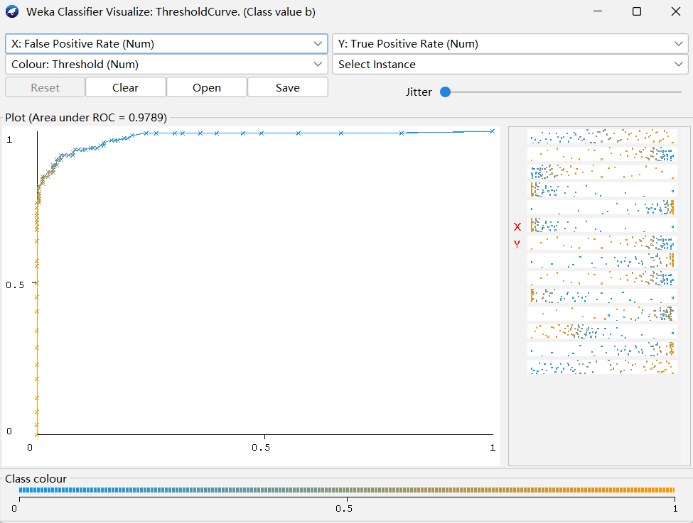
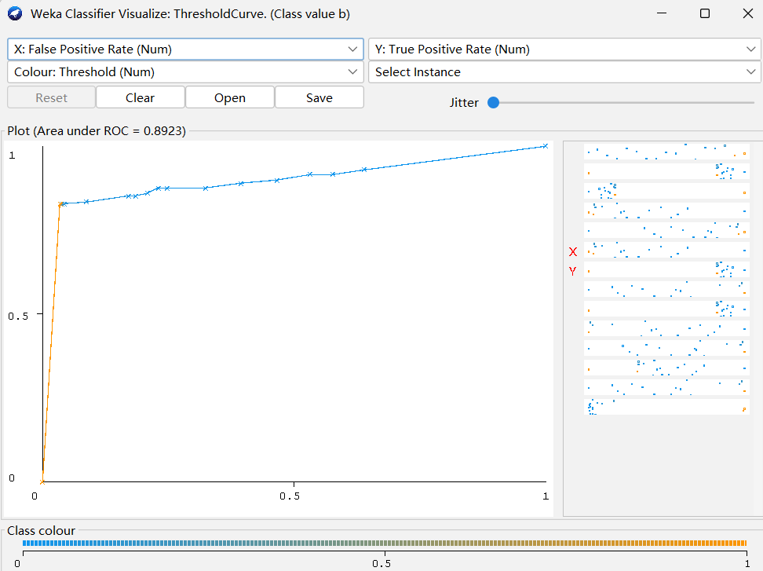
Ionosphere, RandomForest (AUC = 0.979) Ionosphere, J48 (AUC = 0.892)
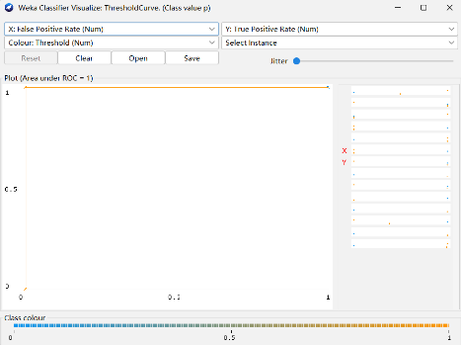
Mushroom, J48 (AUC = 1.00)

6.2 Comparative Analysis of Models and Hyperparameters
The four models were compared statistically in the Experimenter using the paired corrected t-tester at a 0.05 significance level over the ten folds. Across both datasets, none of the three classifiers shows a significant improvement over the baseline J48 in accuracy; the win/draw/loss counts are 0/2/0 for RandomForest, Logistic and SMO, meaning the comparison is a draw on both datasets.
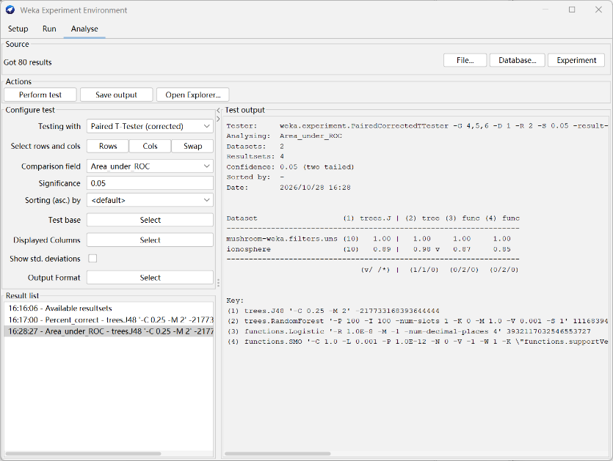
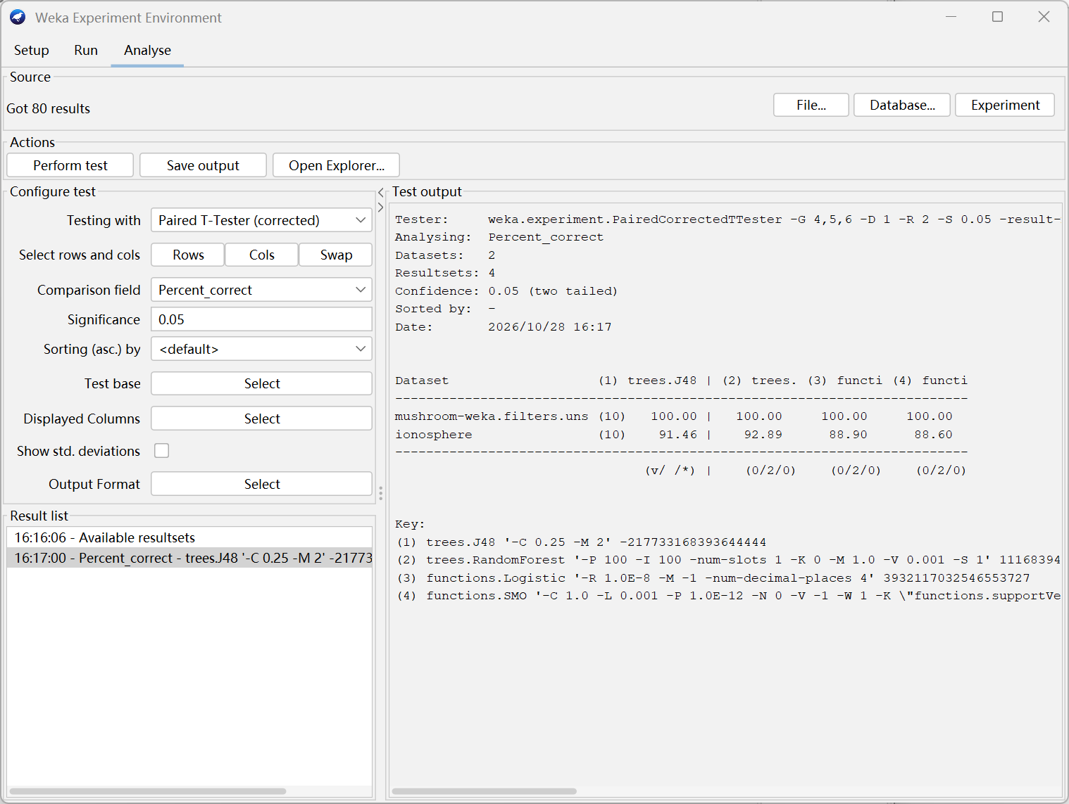
Accuracy comparison ROC-AUC comparison
For ROC-AUC, however, RandomForest records a win/draw/loss count of 1/1/0: it is significantly better than J48 on Ionosphere, while the results on Mushroom are equivalent. Logistic and SMO show no significant improvement over J48 on either dataset. Thus the main advantage of RandomForest is not a large gain in the number of correct predictions, but a much more reliable ranking of the positive class, which is valuable when the decision threshold may vary.
The preprocessing choice had little effect on Mushroom: three ways of handling the missing stalk-root values (retaining, removing, and ReplaceMissingValues) all gave 100% accuracy with J48. Two further checks also showed no stable gain: in-fold feature selection (CfsSubsetEval + BestFirst) did not improve J48, and varying the number of RandomForest trees (50, 100, 200) left the scores essentially unchanged (Ionosphere about 93%).
Apriori^{[7]} was also run on Mushroom without the class, producing 20 rules at minimum support 0.80 and confidence 0.90. The rules have lift close to 1 (e.g. ring-number=o → gill-attachment=f, 97.24% support, 100% confidence), so they reflect frequent co-occurrence rather than strong or class-predicting associations.

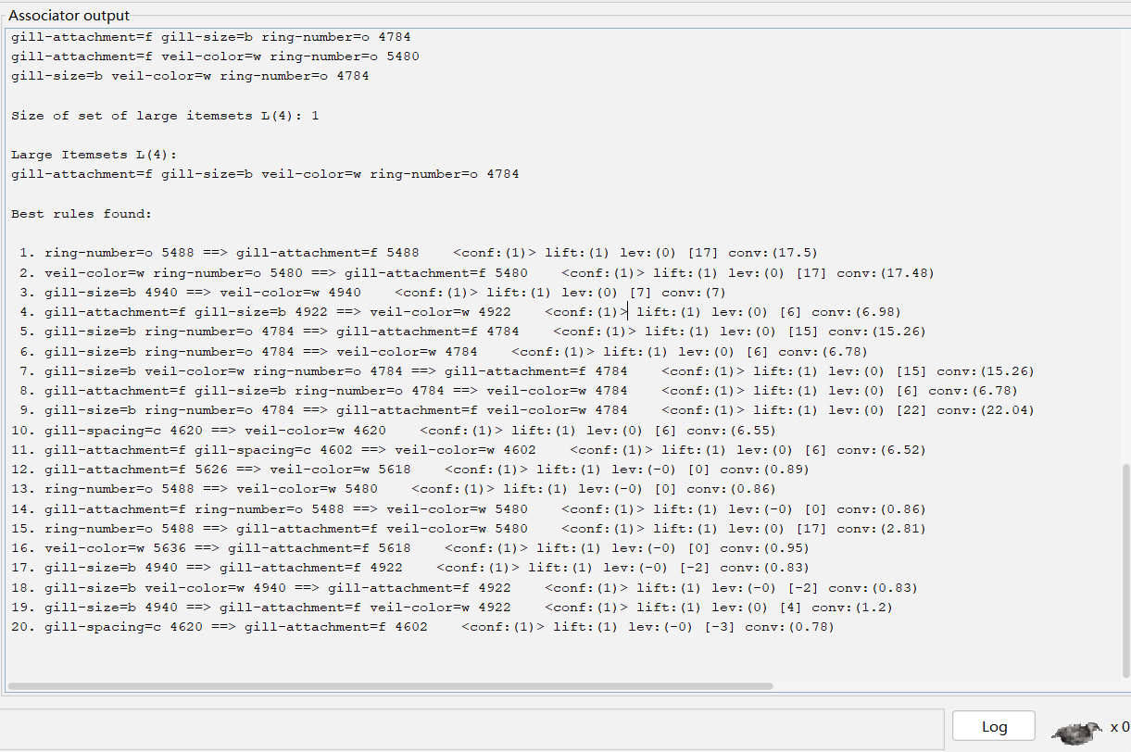
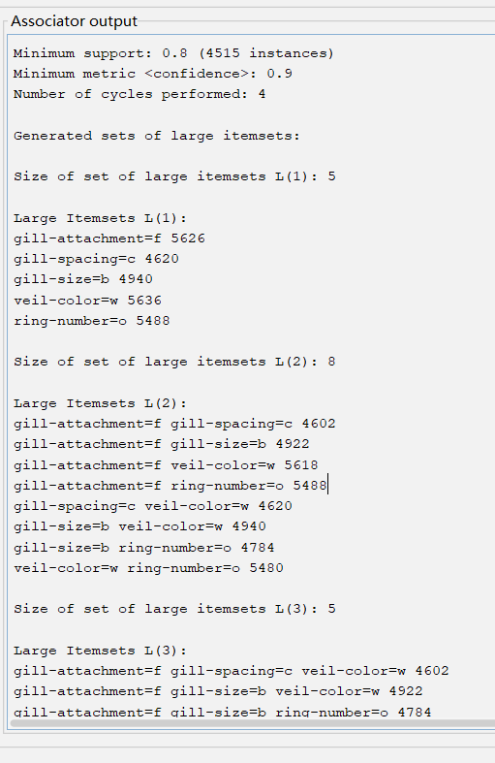
Apriori rules

Apriori settings

6.3 Cross-Dataset Comparison
Across both datasets, none of RandomForest, Logistic or SMO differed significantly from baseline J48 (win/draw/loss = 0/2/0), a draw on both datasets. For ROC-AUC, RandomForest had a win/draw/loss count of 1/1/0: it was significantly better than J48 on Ionosphere, while the results on Mushroom were equivalent; Logistic and SMO showed no significant improvement.
On Mushroom, the three missing-value strategies all produced the same J48 scores. In-fold feature selection using CfsSubsetEval and BestFirst did not improve J48. Changing RandomForest tree count among 50, 100 and 200 left scores essentially unchanged; Ionosphere accuracy remained around 93%. Normalize slightly reduced RandomForest performance on Ionosphere.
The relative behaviour of the models also differs across datasets. On Mushroom the model family is irrelevant, because the problem is easy enough for all four learners; on Ionosphere the ensemble RandomForest benefits from averaging many randomised trees, achieving the highest accuracy and a significantly higher ROC-AUC, while the linear Logistic and SMO models are more constrained by the overlapping distribution. Overall, the cross-dataset comparison shows that the added complexity of an ensemble learner pays off only on the noisier, continuous dataset, while it offers no measurable benefit on the already-separable nominal dataset.
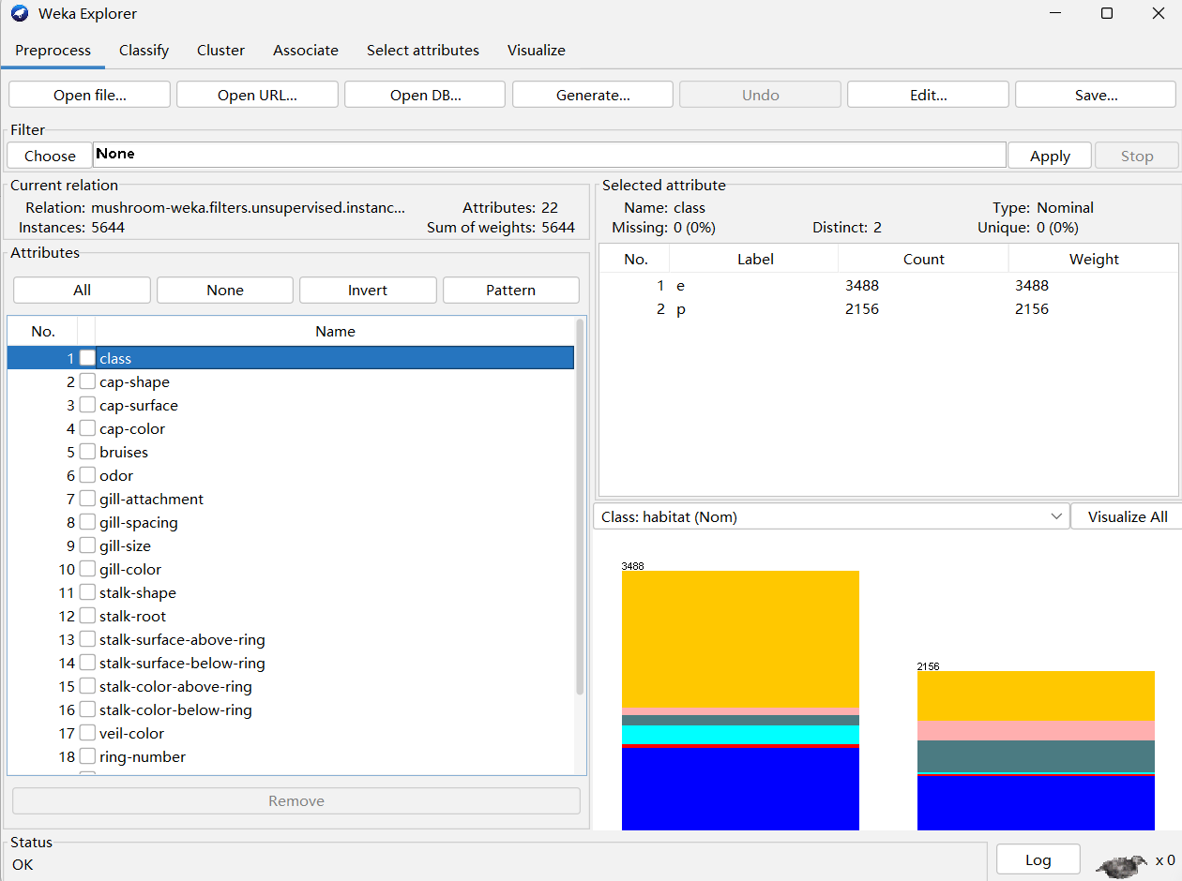
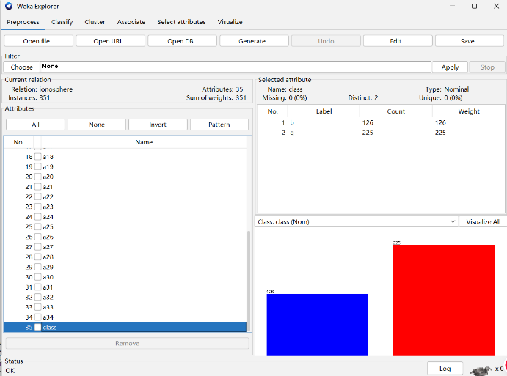
Mushroom (5,644 instances) Ionosphere (351 instances)

6.4 Visualizations and Interpretation

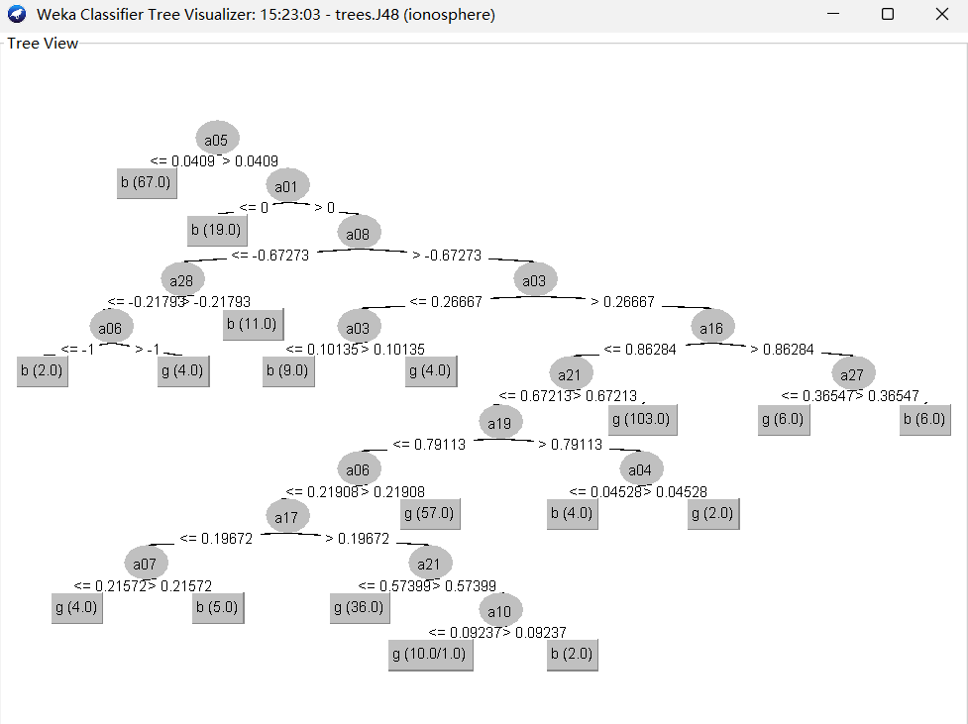

Figure 6.4.1. J48 Decision Tree for the Ionosphere Dataset

Figure 6.4.2. RandomForest ROC Curve (Class b, AUC = 0.9789)

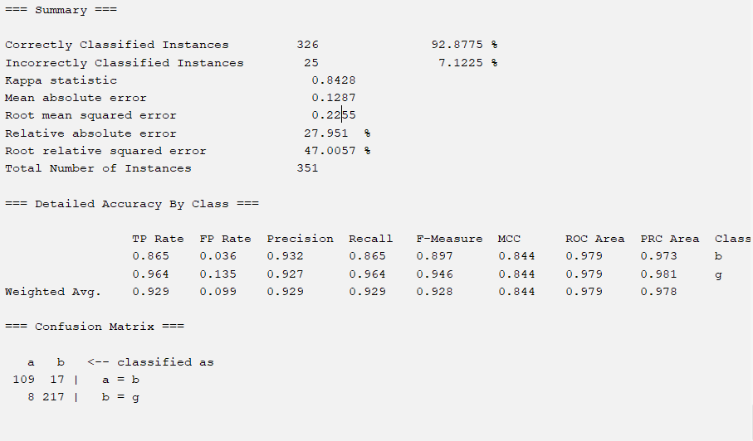
Figure 6.4.3. RandomForest Confusion Matrix and Summary
The J48 decision tree uses a05 as its root attribute. RandomForest achieved 92.88% accuracy and a ROC-AUC of 0.9789 for class b. Its confusion matrix shows that 326 out of 351 instances were correctly classified, while 25 were misclassified.

7 Discussion

7.1 Key Findings and Insights
RandomForest performed best on the harder Ionosphere dataset, with a significantly higher ROC-AUC (0.98) than J48, while all four models reached perfect accuracy on Mushroom. Neither feature selection nor more trees gave a stable improvement, showing that added complexity helps only on the noisier, continuous dataset.

7.2 Limitations and Threats to Validity
The Ionosphere dataset contains only 351 instances with 34 numerical features. Its relatively small sample size may increase the risk of overfitting and limit the generalisability of the models to other radar environments.
The dataset has a moderate class imbalance, with class g accounting for 64.1% and class b for 35.9%. Therefore, accuracy alone may not fully reflect minority-class performance, making precision, recall, F1-score and the confusion matrix important evaluation measures.
For Mushroom, removing 2,480 records with missing stalk-root values reduced the dataset from 8,124 to 5,644 instances. This complete-case deletion may introduce selection bias because the remaining records may not fully represent the original dataset. Therefore, the perfect classification results should be interpreted with caution and should not be generalised to all original records.

7.3 Recommendations and Future Work
Future work could use repeated stratified cross-validation with multiple random seeds to assess model stability and test whether RandomForest’s advantage on Ionosphere persists. Evaluation on additional UCI datasets could examine how well the workflows generalise. For Mushroom, future work could extend the missing-value comparison to other classifiers and random seeds to assess whether the findings remain consistent. Exploring lower Apriori support thresholds could also reveal less frequent but potentially stronger associations.

8 Team Contributions
Member ID | Member | Main Contributions | Contributions
3162225 | WU Yanping | Dataset A collection, cleaning, quality analysis and preprocessing. | 20%
3162809 | ZENG Xinying | Ionosphere data analysis, visualisation and preprocessing. | 20%
3163047 | HU Ziqi | Classification, association rule mining, feature selection and model workflows. | 20%
3163475 | ZHANG Jiaming | Model evaluation, cross-validation, significance testing and leakage checks. | 20%
3162768 | HU Sirui | Report integration, formatting, references, Git management and cross-dataset comparison. | 20%

References
[1] Dua, D., & Graff, C. (2019). UCI Machine Learning Repository. University of California, Irvine, School of Information and Computer Sciences. https://archive.ics.uci.edu/
[2] Sigillito, V. G., Wing, S. P., Hutton, L. V., & Baker, K. B. (1989a). Classification of radar returns from the ionosphere using neural networks. Johns Hopkins APL Technical Digest, 10(3), 262–266. https://secwww.jhuapl.edu/techdigest/Content/techdigest/pdf/V10-N03/10-03-Sigillito_Class.pdf
[3] Sigillito, V., Wing, S., Hutton, L., & Baker, K. (1989b). Ionosphere [Dataset]. UCI Machine Learning Repository (Dataset ID: 52). https://archive.ics.uci.edu/dataset/52/ionosphere. https://doi.org/10.24432/C5W01B. Licensed under CC BY 4.0.
[4] Lincoff, G. H. (Ed.). (1981). The Audubon Society Field Guide to North American Mushrooms. Alfred A. Knopf.
[5] Schlimmer, J. (1987). Mushroom [Dataset]. UCI Machine Learning Repository (Dataset ID: 73). https://archive.ics.uci.edu/dataset/73/mushroom. https://doi.org/10.24432/C5959T. Licensed under CC BY 4.0.
[6] Frank, E., Hall, M. A., & Witten, I. H. (2016). The WEKA Workbench [Online appendix for Data Mining: Practical Machine Learning Tools and Techniques (4th ed.)]. Morgan Kaufmann. https://www.cs.waikato.ac.nz/ml/weka/
[7] Agrawal, R., & Srikant, R. (1994). Fast algorithms for mining association rules in large databases. In Proceedings of the 20th International Conference on Very Large Data Bases (VLDB '94) (pp. 487–499). Morgan Kaufmann.
Data Provenance
The Ionosphere dataset was obtained from the UCI Machine Learning Repository (Dataset ID 52; DOI: 10.24432/C5W01B). It is credited to Sigillito et al. (1989), with radar data collected in Goose Bay, Labrador, by the Johns Hopkins University Applied Physics Laboratory. The dataset contains 351 instances and 34 continuous features, with no missing values. It is licensed under CC BY 4.0, permitting sharing and adaptation with attribution.
The Mushroom dataset was obtained from the UCI Machine Learning Repository (Dataset ID 73; DOI: 10.24432/C5959T). The original data was collected from The Audubon Society Field Guide to North American Mushrooms (Lincoff, 1981) and donated by Jeff Schlimmer in April 1987. It contains 8,124 instances and 22 categorical features, describing the physical characteristics of mushrooms. The target class identifies mushrooms as edible or poisonous, with unknown edibility grouped into the poisonous class. The dataset contains missing values and is licensed under CC BY 4.0.

