|  |  |  |
| --- | --- | --- |
| Лабораторная работа №6 | Ф.И.О. | Алхабил Бахаа А.М |
| Группа | Прин 368 |
| Преподаватель | Сибирный |
| Дата сдачи |  |
| Оценка |  |

**Цель работы:** выполнить анализ датасета, содержащий ответы студентов на опросник.

**Ход работы:**

Preparation of data for analysis:

Chose the following columns for analysis: I spend on studying such a number of hours per week, I spend on studying such % of my time per week, I rest such a number of hours per week, Course.

Cleaned the speakers from NaN, replaced the average value and set the upper limit for columns:

For me, I spend so many hours a week - 105.

For me, I spend 80% of my time in a week studying.

For I rest so many hours a week - 100.

Код:

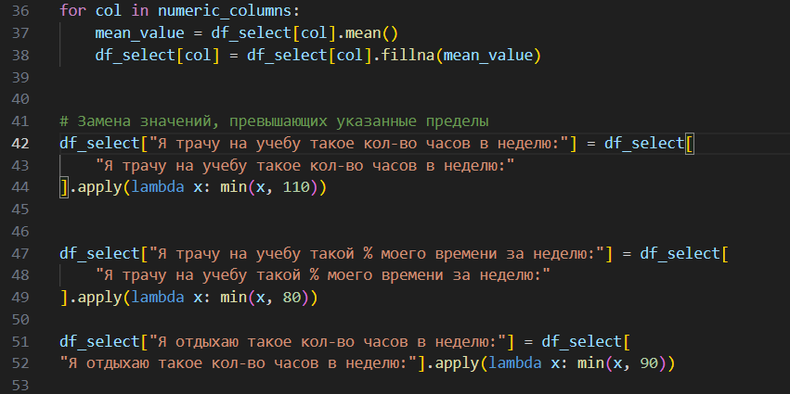

2. Находим все корреляции между данными и вывели матрицу корреляции:

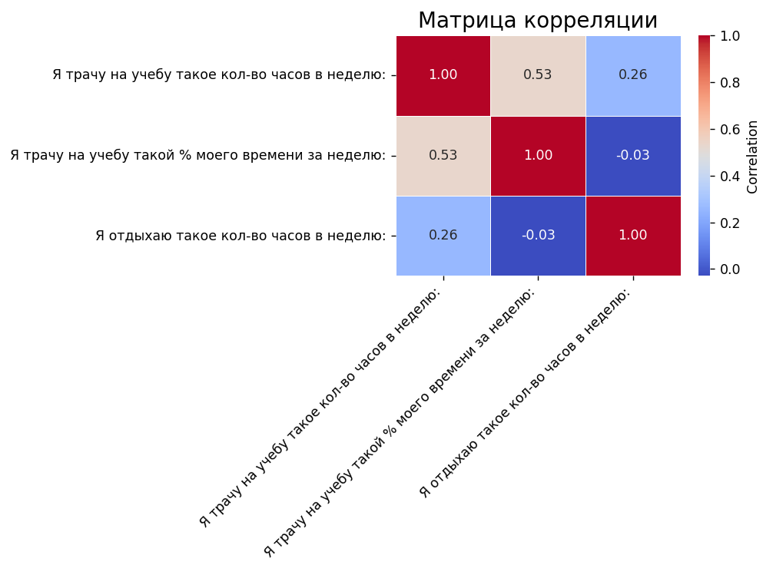

Код:

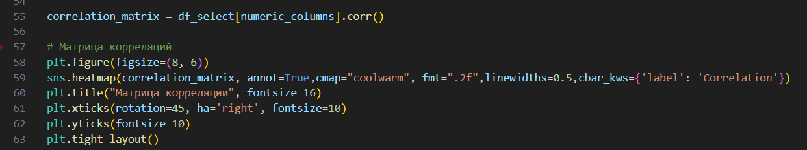

It was assumed that the relationship between the values I spend so many hours a week on learning and I rest such how many hours a week would be inverse, and the correlation should be negative, correspondingly the same result was expected for percent of time spent. But in the end it turned out that correlations are positive and direct dependence.

3. We will graphically display the data. Relationship between course and clock respectively:

Код:

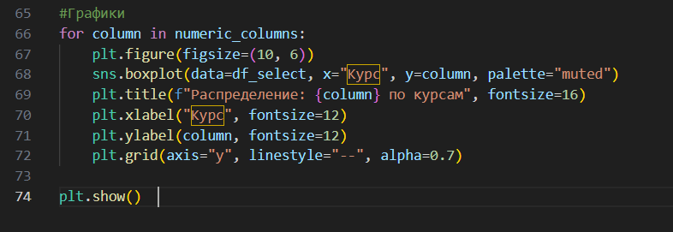

Графики:

I rest for so many hours a week and Course: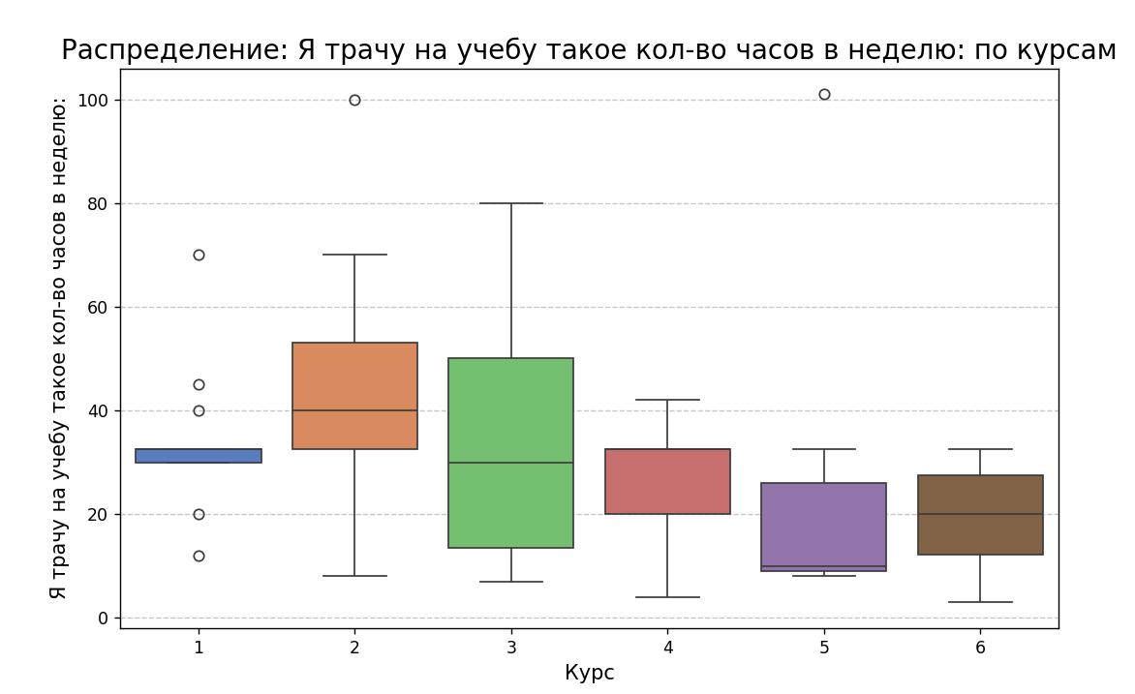

Я трачу на учебу такой % процент часов в неделю и Курс:

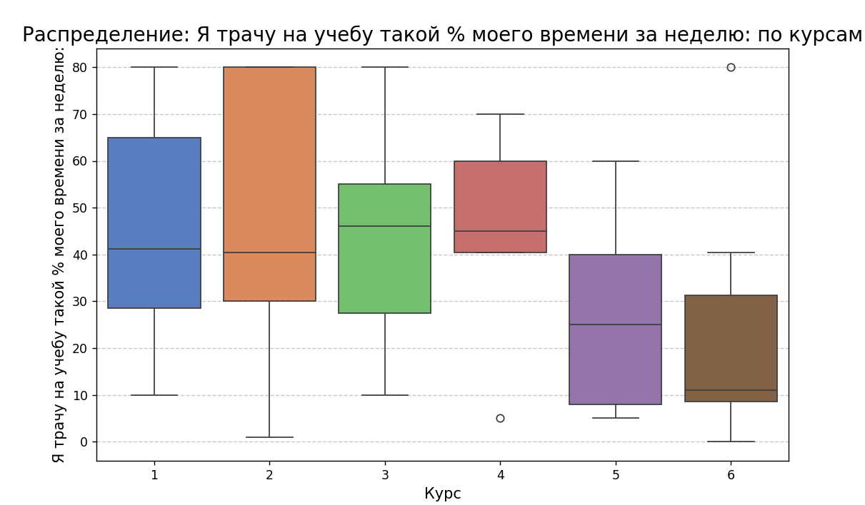

Я трачу на отдых такое кол-во часов и Курс:

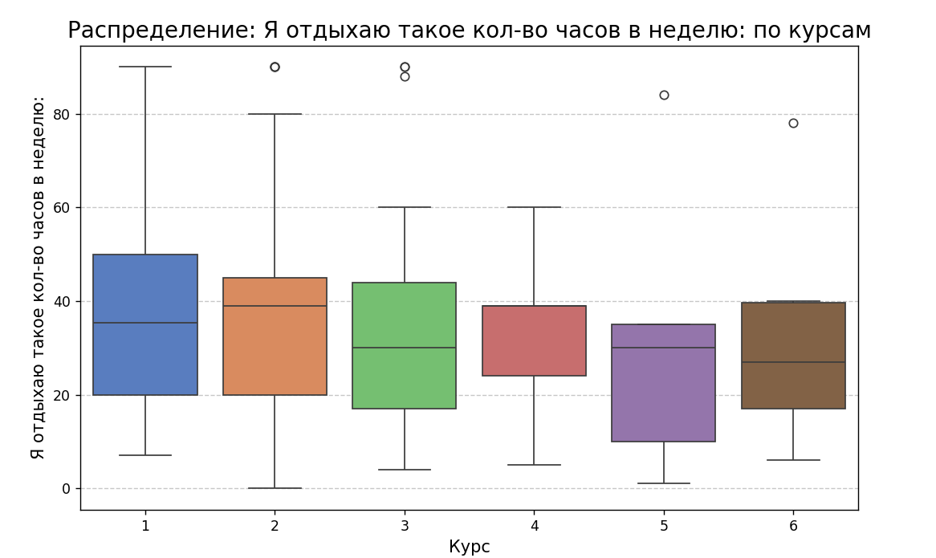

**Conclusion: according to the graphs, the first 3 courses spend most of their time on study and less time on rest, senior 4 - 6 courses, and study, and leisure all almost equal.**