Freight Rate Prediction
Machine Learning Engineer assessment

The task is to predict posted_rate — the price a truckload shipment goes for — from its lane, distance, equipment type, weight, date and two market signals. The model is trained on 48,000 loads covering January to October 2025, and must price 12,000 loads in November and December, a period it has never seen.
That last point shapes everything below. Because every load to be predicted falls after every load used for training, this is a forecasting problem rather than an ordinary prediction problem, and both the validation design and the choice of model follow from it.

Headline result
 | All held-out rows | Uncorrupted labels only
Mean absolute error | $114.05 | $61.80
Median absolute % error | 2.09% | 2.06%
Mean absolute % error | 4.84% | 2.49%
Bias | -$21.82 | +$9.49

Roughly 1.4% of the labels in the development data are deliberately corrupted and cannot be predicted by any model, so two columns are shown. The left is what a grader scoring the raw file would see; the right is what the model achieves on loads whose recorded price is genuine. Both are estimates from held-out time periods inside the training window — the true score is computed by Spotter after submission.

1. What the data looks like
Each row is one shipment. The first thing to check is how price relates to the most obvious driver, distance.
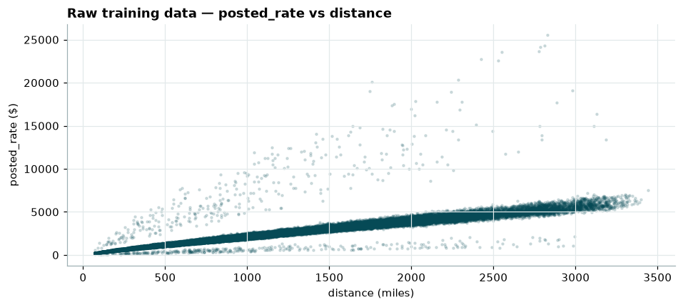
Figure 1 — Raw training data. Price rises almost linearly with distance.
Most loads sit on a clean, near-straight band: freight is priced roughly as a rate per mile. Two things stand out immediately. The band widens as distance grows, meaning error is proportional rather than fixed — a 10% miss on a 2,500-mile haul is worth far more dollars than a 10% miss on a 250-mile one. And a scatter of points sits well above and below the band, which turns out to be a data-quality problem rather than unusual pricing.
Weight, by contrast, tells us almost nothing — the same chart against weight is a shapeless cloud, with a mirrored copy of the data sitting below zero:
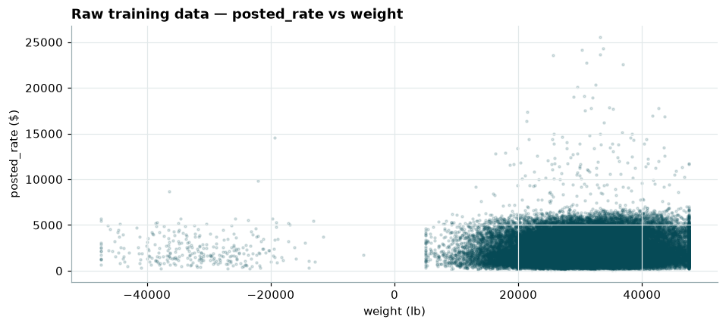
Figure 2 — Price against weight. No relationship, and negative weights on the left.
Those negative weights are the first defect, covered in section 2. The absence of a pattern here is itself useful: weight correlates with price per mile at only r = 0.09, so it never needed elaborate handling.
Because price scales multiplicatively rather than additively, the model is fitted on the logarithm of the rate. That turns a skewed distribution into a symmetric one:
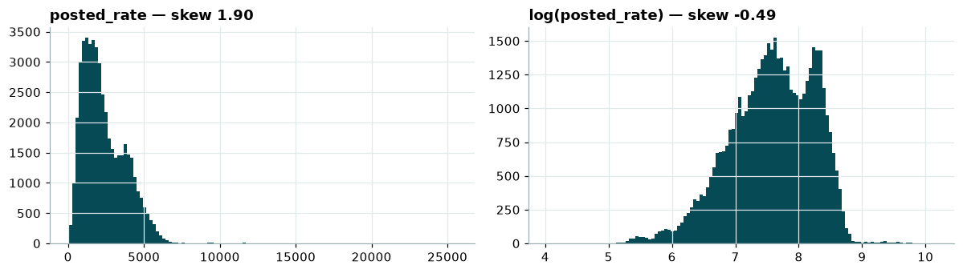
Figure 3 — The target before and after a log transform (skew 1.90 to -0.49).

2. Data quality
Four defects were found. All are handled in code, and none required discarding a load we are asked to predict.
Issue | Rows (train / validation) | Treatment
Sign-flipped weight | 292 / 145 | Take the magnitude
Missing weight | 300 / 165 | Median
Missing market_index | 374 / 249 | Mean of the same calendar day
Corrupted posted_rate | 677 / — | Excluded from fitting, kept in scoring

Sign-flipped weights
437 loads carry a negative weight. Their magnitudes span exactly the valid range (5,000–47,500 lb), and the histogram is a clean mirror image about zero — so only the sign was lost, and taking the magnitude recovers them. Dropping these rows instead would have thrown away 145 loads we are required to predict.

Missing market index
This behaves as a market-wide daily level: its spread within any one day never exceeds 0.03, against a range of 0.68 to 1.47 across days. So other loads on the same date pin a missing value down almost exactly. Tested by hiding 2,000 known values and re-imputing, the day's own mean was seven times closer than a global median (error 0.020 against 0.140).

Corrupted prices — the significant one
To judge whether a price is anomalous it must be compared with comparable loads, not with the whole dataset — a 300-mile refrigerated load and a 2,400-mile dry van are priced differently per mile. Each load was therefore expressed as a ratio to the median price per mile of its own peer group (equipment type crossed with distance band).
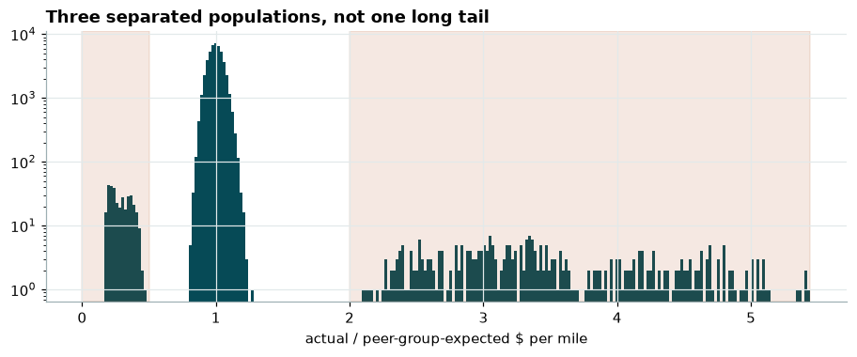
Figure 4 — Each load's price relative to its peer group. Three separate populations, not one long tail.
The chart shows three cleanly separated clusters on a log-count scale:
- 99% of loads price within ±16% of their peer group — ordinary variation.
- 340 loads (0.71%) are inflated by a median of 3.4 times.
- 337 loads (0.69%) are deflated to a median of 0.28 times.

The two tails are near-symmetric in count, the multipliers are near reciprocals, and the rate is flat across all ten months. The flagged rows are also statistically identical to the rest on every input feature — only the label differs, which rules out a genuine premium segment such as expedited freight. This is injected label noise.
They are excluded when fitting, where they would teach a pattern that does not exist, but deliberately kept when scoring, since the held-out data used to grade the submission is presumably contaminated the same way and removing them would flatter the result. The 0.5x–2.0x threshold is not tuned: any cut-off between 1.5x and 2.0x flags exactly the same 677 rows, because the gap between the populations is genuinely empty.

Cities never seen in training
Eight cities and 736 lanes appear only in the data to be predicted. Any feature keyed on a city or lane name would have nothing to say about those loads, so every geographic feature is derived from coordinates instead — straight-line distance, route directness and direction of travel. Coordinates are an exact per-city lookup, and the unseen cities sit inside the geographic envelope of the known ones, so the model interpolates rather than guesses.

3. Time — the finding that shaped the model
Two supplied signals move the price over time. Plotting them daily shows clear structure:
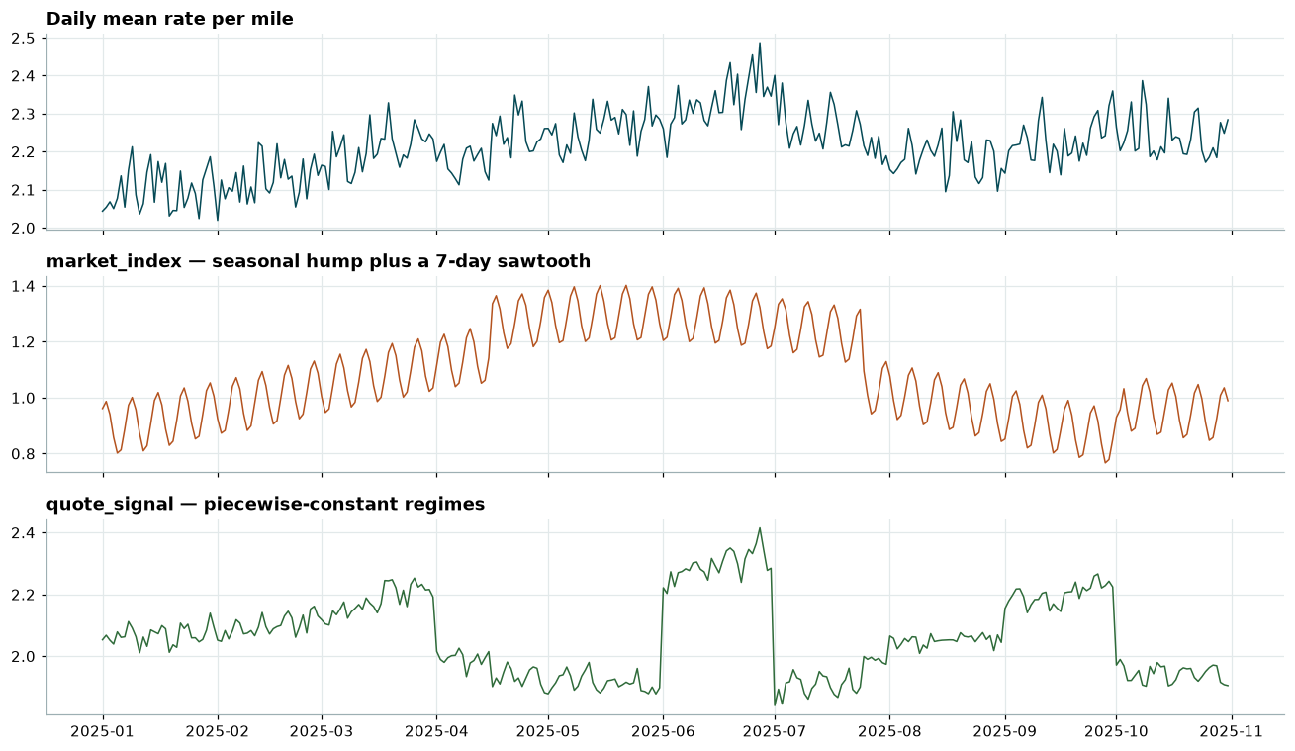
Figure 5 — Daily price per mile, market index and quote signal across the training period.
The market index is the strongest single driver of the daily average price, and carries both a slow seasonal hump peaking in June and a clean seven-day cycle. The quote signal steps between flat regimes at roughly monthly boundaries. The question that matters is what remains after both are accounted for.
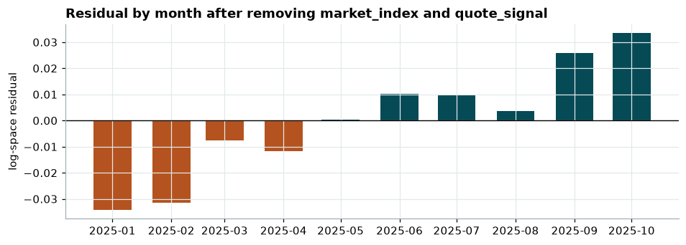
Figure 6 — What the two market signals do not explain, averaged by month.
A steady upward drift survives: prices in October run about 7% higher than January for reasons neither signal captures. This is the crux of the assessment. The December chart holds every input constant except the date, so its shape is determined entirely by whatever the model believes about the passage of time — and November and December fall outside every date the model has ever seen.

4. Validation approach and data split
The development data ends on 31 October and every load to be scored falls after it. A random train/test split would therefore answer the wrong question: with neighbouring days on both sides of every held-out load, it would score far better than the real submission can, and would reward features that quietly fail on future dates. Every split is on time instead.
The cut-off walks forward across three folds with an expanding training window, so the model is judged three times on a stretch of future it has not seen:
Fold | Trained on | Tested on | Test loads
1 | 1 Jan – 1 Jul | 2 Jul – 31 Aug | 9,536
2 | 1 Jan – 31 Jul | 1 Aug – 30 Sep | 9,429
3 | 1 Jan – 31 Aug | 1 Sep – 31 Oct | 9,523

- Each test window is 61 days, matching the real November–December horizon. This matters: on one-month windows the same model scores $49.18 rather than $61.80, so a shorter window would have flattered the result.
- Training always starts at the first date and only the cut-off moves, mirroring the real setup where the model is fitted on all available history before forecasting forward.
- Every fold is checked directly for overlap between its training and test windows, rather than assuming correctness from the date arithmetic.
- Reported metrics are the mean across the three folds.

One consequence is worth stating: because the corrupted labels are kept when scoring, RMSE is dominated by them ($621 against $92 on clean labels) while mean absolute error barely moves. Median absolute percentage error is therefore the metric used to compare models — it is a percentage, so long and short hauls count equally, and being a median it is not dragged by whichever corrupted rows happened to land in a fold.

5. The model
Two candidates were tested first. Both beat a simple rate-per-mile baseline by a wide margin, and gradient boosting was the more accurate of the two on every fold. But fold scores cannot answer the question that matters here, because every fold tests on dates inside the range the model was trained on.
So the question was asked directly: hold one load fixed, freeze the market signals at constants so nothing but time can move, and step the date across the year.
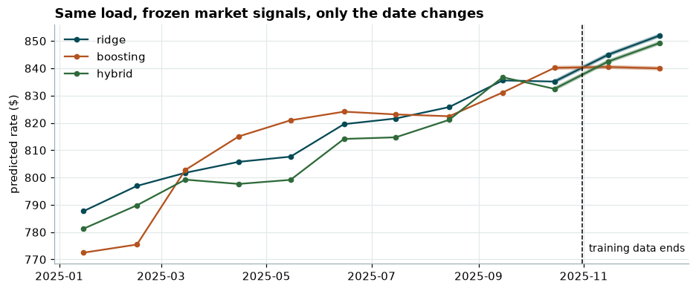
Figure 7 — One fixed load, market signals frozen, only the date changing.
Gradient boosting learns the trend perfectly well inside the training window and then stops dead the moment it passes 31 October. This is not a tuning failure and no setting fixes it: a decision tree splits on thresholds it observed during training, so any later date falls on the same side of every split as the last day it saw, lands in the same place, and receives the same answer. A linear model keeps moving because time enters as a coefficient rather than a threshold.
The submission model therefore uses both, in sequence:
- Stage 1 — ridge regression fits the log price, including a linear time trend. This is the part that carries the trend forward.
- Stage 2 — gradient boosting fits what stage 1 got wrong, recovering the load-specific detail a straight line misses.
- The prediction is the two stages added together, then converted back to dollars.

Measured on the same folds, on uncorrupted labels:
Model | MAE | Median APE | Trend past October
Rate-per-mile baseline | $205.68 | 7.89% | none
Ridge only | $74.81 | 2.90% | +2.0%
Gradient boosting only | $61.79 | 2.15% | -0.0%
Hybrid (submitted) | $61.80 | 2.06% | +2.0%

Boosting alone matches the hybrid on absolute error to within a cent — and would have produced a flat December chart. The hybrid keeps that accuracy, improves the median percentage error, and is the only one of the two that carries the trend forward. Each stage does work the other cannot.

6. The December chart
The chart asks for 31 predictions on one fixed load — Lexington to Fort Wayne, 360 miles, dry van, 32,000 lb — where only the date changes. The supplied file omits both market signals, but the model prices partly from them.
Rather than forecast those signals, note that the validation file contains roughly 200 real loads on each of those same 31 December dates. Averaging their market index per date recovers the level actually observed. This is a lookup of recorded conditions, not a projection. Coordinates come from the city lookup the same way. Both fills use only data that was provided, and neither touches the target.
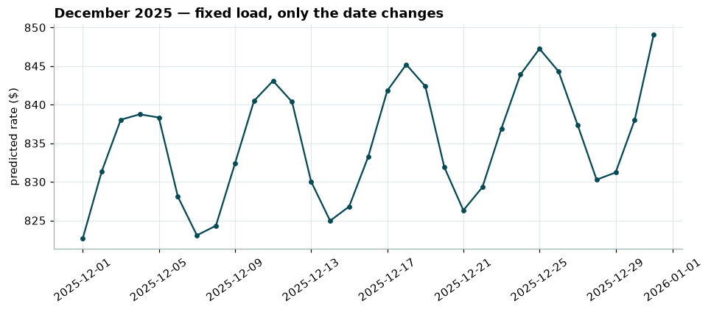
Figure 8 — Produced by the provided score.py, from the same fitted model that wrote validation_predictions.csv.
The series runs from $822.64 to $849.07, +3.2% from the first day to the last. Two effects are visible at once: five peaks, one per week, from the market index's seven-day cycle; and a gentle rise across the month from the trend term. A boosting-only model would have drawn the weekly cycle but no rise, because the cycle comes from a feature whose December values sit inside the training range while the trend does not.

7. Reproducing this
The repository contains the full pipeline, six notebooks with their outputs saved, and both output files. Two commands reproduce everything from a clean checkout:
python -m src.predict
python score.py --predictions validation_predictions.csv --december-predictions data/december_chart_inputs.csv
The whole pipeline runs in about 11 seconds on a laptop CPU, every random seed is fixed, and re-running it reproduces both output files byte for byte. The same cleaning and feature code runs for training, for validation and for the December chart, so there is no separate prediction path that could drift from the one that was tested.

