CSE 140 Project Report

Team ID : Joshua Lee and Zach English
Date: May 10th, 2026
- Single-cycle RISC-V CPU
  - Overview
// Different stages of the CPU are organized away into separate files, and written as distinct functions with occasional global variables shared between them. The `main.py` file contains a function which takes in the program to be run, sets an initial state, and then repeatedly calls each stage of the CPU with the relevant arguments set from the program. When the writeback component completes its tasks, it also logs what it does, providing the output.
  - Code Structure
// Explain the detailed code structure that shows the functions and variables with how you implemented and how those are interacting with the other functions or variables.
    - Functions
- load_instruction_memory(): takes in a filename for the program and converts it into a readable list of the lines within it for the program to use.
- run_cpu(): takes in the list of instructions from load_instruction_memory(). Sets initial values of register and memory arrays, hardcoded for each sample. Starts an infinite loop, which is broken if the PC reaches the end of the program or some other invalid state is attained. In order, it calls fetch, decode, execute, mem, and writeback. If there are multiple versions of one of those functions, it selects the appropriate one based on the current instruction. Finally, it prints any relevant information which isn’t already printed by writeback.
- Fetch(): Selects and returns an instruction based on the PC.
- Decode.handleRType(), handleIType(), etc: different versions of the same function to sort an instruction into its relevant fields, based off of the previous homework assignment to do the same thing.
- controlUnit(): takes in the fields of an instruction and sets the various control signals as relevant.
- aluControl() takes in the fields of an instruction and sets the four alu control bits as relevant.
- Decode(): calls the relevant handler function for the instruction type, before then calling the controlUnit to make decisions from that output.
- Execute(): takes in all the information gathered during decode, including control signals and ALU control, and performs the desired computation, returning a documented result.
- mem(): takes in the control signals from decode as well as the results from execute, and either reads from or writes to the memory array. Has two global variables to denote what location in the memory was changed.
- WriteBack(): takes in the result of all previous work and assigns that to the destination register, if necessary. It also announces what changes were made that cycle, and increments total_clock_cycles, announcing how many cycles the total program took.
    - Variables
- Decode.rf: an array representing the registers of the CPU.
- Mem.d_mem: an array representing memory locations.
- Control signal variables: communicate to different points in the program whether a specific action should be necessary.
  - regWrite
  - memRead
  - memWrite
  - ALUsrc
  - memToReg
  - ALUop
  - Alu_ctrl
- Address and Index: as part of Mem, these keep track of what memory address was accessed most recently, and what index in the array that corresponds to.
- total_clock_cycles: Tracks how many clock cycles have passed. Increments every time WriteBack is reached.
  - Execution Results
- Comment/Uncomment the block of initial state code in run_cpu() which matches the sample being run.
- Run main.py.
- Input the filename of the sample program.
- 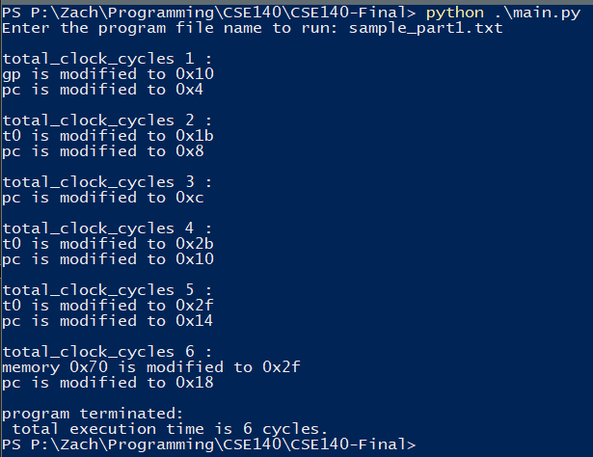
  - Challenges and Limitations
//certain elements, such as the address and index, might be achievable without additional global variables. I believe that there are lots of subtle ways to optimize the program further.

- Extended RISC-V CPU
  - Overview
// Added global variables which dictate which of several variables to use for the next PC. Expanded each function to decode JAL and JALR instructions and calculate the addresses they contain. Expanded code for incrementing PC to now be capable of changing it conditionally based on the above global variables.
  - Baseline Code Structure
// Explain the detailed code structure for JAL and JALR.
    - Functions
- Decode(): Now includes code for UJ-type instructions, in addition to previous types.
- Execute(): now includes code to calculate jump/branch destination based on new control signals from Decode.
    - Variables
- branch_taken, branch_target, jump, jump_target: within main.py, tells the program which option to pull from in order to increment the PC for the next instruction.
- jump/jumpReg: for JAL and JALR, an additional control signal for selecting whether to jump and in which way.
  - Execution Results
- Execution is unchanged from previous version.
- 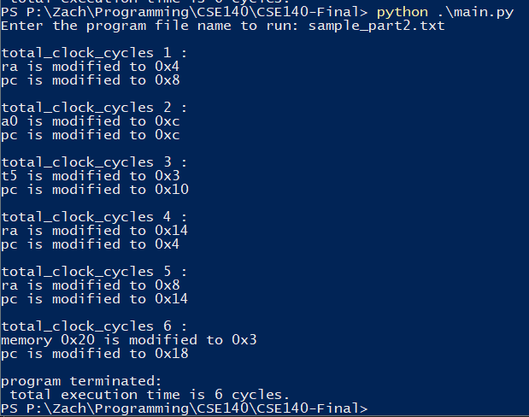
  - Challenges and Limitations
No new issues with the program introduced via the new instructions. They operate mostly independently from the rest of the program.

