**ECE1779 Introduction to Cloud Computing**

**ASSIGNMENT 2 Amazon Web Services**

**Ge Zhang 1004460610**

**Hanwen Liang 1003868291**

**Nov 16th,2018**

## Project prerequisites:

Isntall Python (3.5.2)

Install Python Wand ImageMagick bindings

Install gunicorn

**(Important)** Configure AWS command line interface with access key pair(assume you already install AWS command line interface):

* type ‘AWS configure’ in shell.
* Type ‘access key Id’ and ‘secret access key’ we provide.
* Type ‘us-east-1’ as region.
* Type ’json’ as output type.

## Architecture

### **1. The architecture of file**

### UserUI:

/Desktop/web-development-Cloud-Computing/webapp

|--- app

| |---static

| |---templates # folder for storing all html files

| |---welcome.html # welcome page of “Image Bay”

| |---signup.html # where new users sign up

| |---signin.html # old users sign in to personal page

| |---homepage.html # personal page with upload function

| |---imagedetail.html # where displays full-size image

| |---testupload.html # assists TA for testing functions

| |---__init__.py #Initialization

| |---config.py # setting for connecting to the database

| |---Welcome.py # Welcome page of “Image Bay”

| |---SignUp.py # sign up for new users

| |---SingIn.py # sign in for old users

| |---ImageProcess.py # implement 3 image transformations

| |---ImgDetail.py # show original and transformed images

| |---HomePage.py # personal page for each user

| |---sql.py # connect to database

| |---TestUpload.py # realize test upload for TA

|--- run.py

|---webapp.sql # the schema of database

### ManagerUI:

/Desktop/Web-application_ImageBay/manager

|--- app

| |---static

|---flot # file for java scrpit

| |---templates # folder for storing all html files

| |---base.html # base html

| |---manager.html # main page for manager UI

| |---view.html # view the details of a instance

| |---__init__.py # Initialization

| |---config.py # setting for connecting to the database

| |---AWS_config.py # setting of AWS

| |---check_func.py # to check CPU every few seconds

| |---ec2_Process.py # to create or delete instances

| |---sql_del.py # empty database and S3 bucket

| |---sql.py # connect to database

|--- run.py

|---webapp.sql # the schema of database

### DataBase:

**userInfo ( userName, userEmail, userPwd, userSalt)**

This table is used to save user name, user email and their encrypted password and per-user salt.

**user2Images (userName, Thumbnail, original, trans_a, trans_b, trans_c)**

This table is used to save image links, including original image, thumbnail and 3 transformations images. Each image will be related to a user.

**Example of database:**

1. userInfo:



1. user2Images:

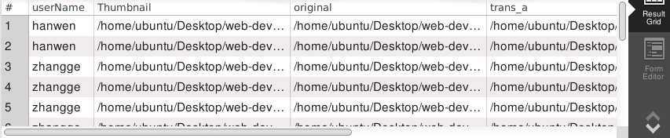

**2. the architecture of framework**

For now, one instance is running managerUI, another one is running userUI. The database is running on manager instance, which means all userUI will access database remotely. All userUI are connected to a load balancer so that user can access our application by typing the DNS name of load balancer.

## Deployment Instruction

To use application, just type load balancer’s DNS name **‘ECE1779A2-1878993872.us-east-1.elb.amazonaws.com’** in web browser. Enjoy.

To check manager instance:

* Use .pem file we provided to ssh into manager instance. The IP address of manager instance is ‘34.230.62.41’**.** The password is ‘ece1779pass’.

The managerUI should already be there. However, to restart managerUI:

* type ‘cd /home/ubuntu/Desktop/Web_application_ImageBay/manager’ in shell
* then type ‘python3 run.py’ in shell.
* then type ‘127.0.0.1:5000’ in web browser to check managerUI.

To check the database on manager instance:

* type ‘mysql-workbench’ and then login as ‘root’ user with password ‘ece1779pass’.

To check the worker instance:

* since we randomly delete worker instance in shrink process, so it is hard a provide a static IP address for worker instance. But basically, the userUI is the same as A1 except we save images to S3 bucket.

## Application Usage Instructions

To use userUI:

* Create a new account (Notice: username and email address cannot be identical to other users) or sign in as an existing user. After Signin or Signup user will be in their personal ‘homepage’.
* The ‘homepage’ enables authenticated users to browse uploaded images and upload new images.
* After uploading, your image will display as a thumbnail in homepage (thumbnails are created by ImageMagick tool).
* Clicking on a image’s thumbnail could produce full resolution version of the photo as well as its three transformations (enhance saturation, hue transfer and decrease brightness).
* You could click on “Logout” button on top right corner to log your account out.

To use managerUI:

* The control panel is shown at left side of managerUI. Worker pool is shown at right side.
* The maximum number of instances is set to be 10, and the minimum is set to be 1.
* For default, the auto scaling is off. But you can set the parameter and turn it on in managerUI.
* You can manual delete or create a work instance. You can also delete specific instance in worker pool.
* By click the ‘detail’ button, you can view the CPU utilization for specific instance.
* By click ‘delete all data’ button, you can delete all data in database together with images in S3 bucket.