**《高级语言程序设计进阶》综合设计实验报告**

学号：E12214013 姓名：王天心 年级：大一 专业：计算机科学与技术

项目名称：基于easyx的图形化小型教务系统 完成日期：2023年5月6日

一、实验目的

信息维护：要求：学生信息数据要以文件的形式保存，能实现学生信息数据的维护。此模块包括子模块有：增加学生信息、删除学生信息、修改学生信息。

信息查询：要求：查询时可实现按姓名查询、按学号查询

成绩统计：要求：A输入任意的一个课程名（如数学）和一个分数段（如60--70），统计出在此分数段的学生情况。

排序：能对用户指定的任意课程名，按成绩升序或降序排列学生数据并显示排序结果（使用表格的形式显示排序后的输出结果）

整个系统均用C语言（C++）实现；

系统具有输入、显示、查询（查询时可实现按姓名查询、按学号查询）、删除、排序、插入，保存、读取基本功能；

系统的各个功能模块都用函数的形式来实现；

学生信息数据要以文件的形式保存，能实现学生信息数据的维护。此模块包括子模块有：增加学生信息、删除学生信息、修改学生信息；文件要求至少有十条记录；

可以输入任意的一个课程名（如数学）和一个分数段（如60--70），统计出在此分数段的学生情况；

能对用户指定的任意课程名，按成绩升序或降序排列学生数据并显示排序结果；

可以将学生信息从文件中读取出来。

至少采用文本菜单界面（如果能采用图形菜单界面更好）

二、实验内容

编译环境：easyx、gcc 12.2.0 工具：Clion、InnoSetup

实验流程：实现文本界面→设计ui及界面逻辑→通过easyx图形库实现图形化界面→通过InnoSetup对数据文件（data.txt）、相关资源文件（easyx图形库、图片等）打包为安装程序

三、系统设计

系统主要函数如下：

使用vector对学生数据进行存储，list链表进行辅助，二者的优势在于可以动态分配存储空间

接下来按部分解释源码：

1.头文件

#include<bits/stdc++.h>  
#include<graphics.h>  
#include<conio.h>  
using namespace **std**;

分别为cpp万能头文件以及easyx的两个相关头文件

2.数据节点（学生）

//数据节点（学生）  
typedef struct **stu** {  
 string name;//学生姓名  
 string id;//学生学号  
 double ls[100]{};//学生各科成绩  
 string gender;//学生性别  
 double score = 0;//学生总分  
}stu;  
string lessonList[100]; //各科目名称  
**vector**<stu> s;

3.全局变量及一些封装函数

**ExMessage** msg;//鼠标信息结构体  
int lessonNumber;//当前科目总数

//输出函数封装（字体颜色，字号，字体，输出位置）  
void ot(int x, int y, COLORREF color, int nH, int nW, LPCTSTR str, LPCTSTR st){  
 settextcolor(color);  
 settextstyle(nH,nW,st);  
 outtextxy(x, y, str);  
}

//按钮效果封装  
void button_animation(**ExMessage** m, int l, int t, int r, int b, COLORREF colort, COLORREF colorf){  
 if(m.x >= l && m.x <= r && msg.y >= t && msg.y <= b){  
 setlinecolor(colort);  
 roundrect(l + 1, t + 1, r - 1, b - 1, 10, 10);  
 }else{  
 setlinecolor(colorf);  
 roundrect(l + 1, t + 1, r - 1, b - 1, 10, 10);  
 }  
}

即检测鼠标位置，当鼠标坐标在按钮位置的图形范围坐标内时在按钮图形轮廓向内缩一像素画颜色为colort的轮廓，移出范围时画颜色为colorf（即按钮本身颜色）的轮廓

//界面跳转  
int choose = 1;  
int qchoose;  
int choosegraph(int mx, int my){  
 if(mx >= 0 && mx <= 170){  
 if(my >= 25 && my <= 115){  
 return 1;//所有学生信息PrintAll()  
 }  
 else if(my >= 115 && my <= 205){  
 return 2;//添加学生信息AddStudent()  
 }  
 else if(my >= 205 && my <= 295){  
 return 3;//查找学生信息SearchStudent()  
 }  
 else if(my >= 295 && my <= 385){  
 return 4;//选择排名方式Sort_or_Score()  
 }  
 else if(my >= 385 && my <= 475){  
 return 5;//修改学生信息ChangeStudent()  
 }  
 else if(my >= 475 && my <= 565){  
 return 6;//删除学生信息DelStudent()  
 }  
 else if(my >= 565 && my <= 645){  
 return 7;//设置Setting()  
 }  
 else if(my >= 645 && my <= 720){  
 qchoose = choose;  
 return 8;//退出Quitgraph()  
 }  
 }  
}

界面跳转：传入光标坐标，在各个按钮上时传回对应的数值，保存给全局变量choose，退回到主函数后根据choose进入对应函数，qchoose用来保存上次的choose值，以便恢复当前页面

//左侧菜单列表  
void menu(int n){  
 cleardevice();  
 setlinecolor(RGB(50, 100, 200));  
 setfillcolor(RGB(50,100,200));  
 fillrectangle(0, 0, 170, 720);  
 setlinecolor(RGB(70, 120, 210));  
 setfillcolor(RGB(70, 120, 210));  
 fillrectangle(0, 25 + (n - 1) * 90, 170, 25 + n * 90);  
 **IMAGE** ah;  
 loadimage(&ah,R"(.\ahu.jpg)", 180, 55, false);  
 putimage(870, 5, &ah);  
 ot(20,60,WHITE,20,0,"所有学生信息", "宋体");  
 ot(20,150,WHITE,20,0,"添加学生信息", "宋体");  
 ot(20,240,WHITE,20,0,"查找学生信息", "宋体");  
 ot(20,330,WHITE,20,0,"统计课程信息", "宋体");  
 ot(20,420,WHITE,20,0,"修改学生信息", "宋体");  
 ot(20,510,WHITE,20,0,"删除学生信息", "宋体");  
 ot(55,600,WHITE,20,0,"设置", "宋体");  
 ot(55,680,WHITE,20,0,"退出", "宋体");  
}

左侧菜单图形绘制，即：

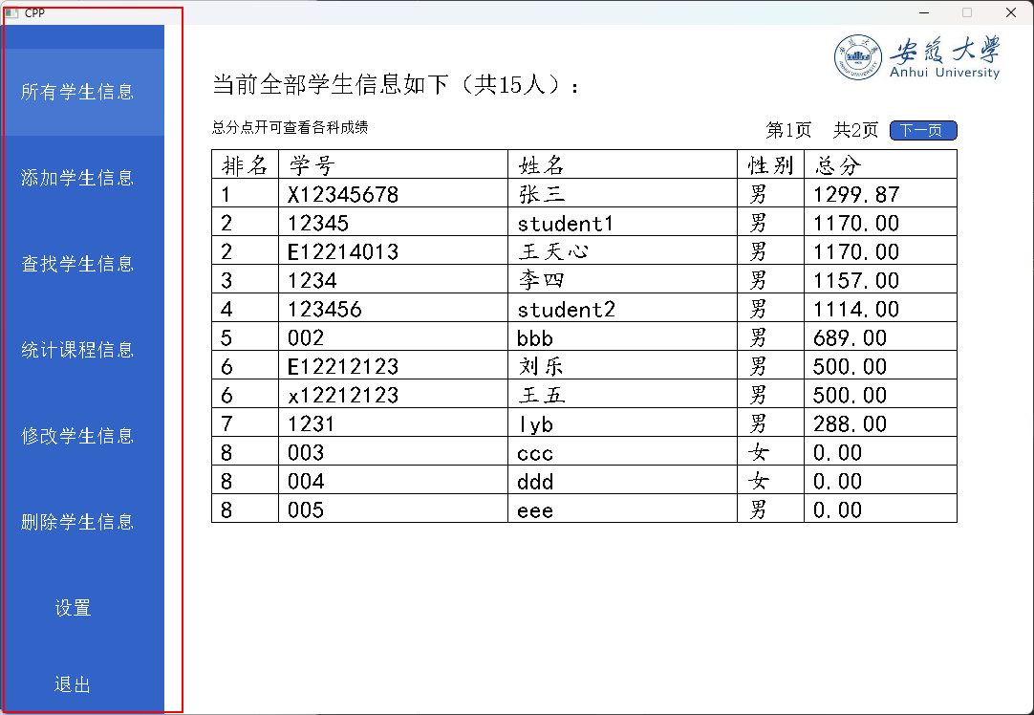

传入当前所在页面的choose值，将此按钮对应位置在画完菜单主体后覆盖代表选中的浅色

//菜单动画  
void menuanimation(int mx, int my, int n){  
 if(msg.x >= 0 && msg.x <= 170 && msg.y >= 25 && msg.y <= 115 && n != 1) ot(20,60,YELLOW,20,0,"所有学生信息", "宋体");  
 else ot(20,60,WHITE,20,0,"所有学生信息", "宋体");  
 if(msg.x >= 0 && msg.x <= 170 && msg.y >= 115 && msg.y <= 205 && n != 2) ot(20,150,YELLOW,20,0,"添加学生信息", "宋体");  
 else ot(20,150,WHITE,20,0,"添加学生信息", "宋体");  
 if(msg.x >= 0 && msg.x <= 170 && msg.y >= 205 && msg.y <= 295 && n != 3) ot(20,240,YELLOW,20,0,"查找学生信息", "宋体");  
 else ot(20,240,WHITE,20,0,"查找学生信息", "宋体");  
 if(msg.x >= 0 && msg.x <= 170 && msg.y >= 295 && msg.y <= 385 && n != 4) ot(20,330,YELLOW,20,0,"统计课程信息", "宋体");  
 else ot(20,330,WHITE,20,0,"统计课程信息", "宋体");  
 if(msg.x >= 0 && msg.x <= 170 && msg.y >= 385 && msg.y <= 475 && n != 5) ot(20,420,YELLOW,20,0,"修改学生信息", "宋体");  
 else ot(20,420,WHITE,20,0,"修改学生信息", "宋体");  
 if(msg.x >= 0 && msg.x <= 170 && msg.y >= 475 && msg.y <= 565 && n != 6) ot(20,510,YELLOW,20,0,"删除学生信息", "宋体");  
 else ot(20,510,WHITE,20,0,"删除学生信息", "宋体");  
 if(msg.x >= 0 && msg.x <= 170 && msg.y >= 565 && msg.y <= 645 && n != 7) ot(55,600,YELLOW,20,0,"设置", "宋体");  
 else ot(55,600,WHITE,20,0,"设置", "宋体");  
 if(msg.x >= 0 && msg.x <= 170 && msg.y >= 645 && msg.y <= 720 && n != 8) ot(55,680,YELLOW,20,0,"退出", "宋体");  
 else ot(55,680,WHITE,20,0,"退出", "宋体");  
}

即光标移动到对应按钮上时文字变为黄色以对光标位置进行反馈并提示按钮可点击

//输入合法性检查  
bool check(char ch[]){  
 bool flag = false;  
 for (int i = 0; i < strlen(ch); ++i) {  
 if(ch[i] != '.' && ch[i] < '0' || ch[i] > '9'){  
 flag = true;  
 break;  
 }  
 }  
 if(!flag) return true;  
 else return false;  
}

对InputBox输入的字符串进行检查，如果内部含有非“.”或0-9的字符便报错，防止非法输入

4.主要函数

（1）查找学生信息

界面及功能：

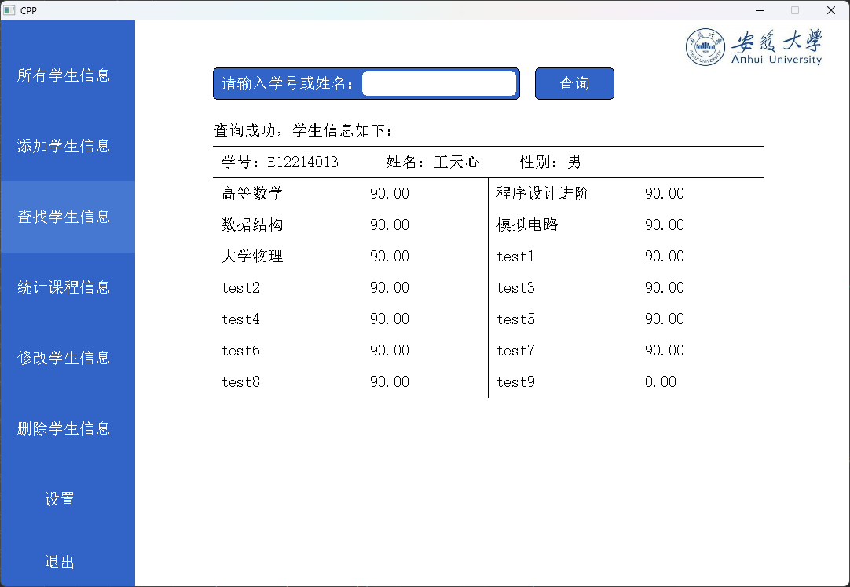

可输入学生姓名/学号后查找，如果找到便输出信息，未找到便报错

函数代码：

//查找学生信息  
void SearchStudent() {  
 menu(3);  
 setfillcolor(RGB(50, 100, 200));  
 setlinecolor(BLACK);  
 fillroundrect(270, 60, 660, 100, 10, 10);  
 ot(280, 70, WHITE, 20, 0, "请输入学号或姓名：", "宋体");  
 fillroundrect(680, 60, 780, 100, 10, 10);  
 ot(710, 70, WHITE, 20, 0, "查询", "宋体");  
 //菜单和界面绘制  
  
 string input = "No_Input_Information";//输入字符串初始化  
 char cinput[100];  
 while(true){  
 msg = getmessage(EM_MOUSE);  
 menuanimation(msg.x, msg.y, 3);//菜单动画  
  
 button_animation(msg, 680, 60, 780, 100, WHITE, RGB(50, 100, 200));//按钮动画  
  
 if(msg.x >= 460 && msg.x <= 655 && msg.y >= 65 && msg.y <= 95){  
 setfillcolor(RGB(200, 200, 200));  
 solidroundrect(460, 65, 655, 95, 10, 10);  
 }else{  
 setfillcolor(WHITE);  
 solidroundrect(460, 65, 655, 95, 10, 10);  
 }  
 if(input != "No_Input_Information") ot(470, 70, BLACK, 20, 0, cinput, "宋体");  
 //显示输入信息  
  
 switch (msg.message) {  
 case WM_LBUTTONDOWN:{  
 //界面跳转  
 if (msg.x >= 0 && msg.x <= 170 && msg.y >= 25 && msg.y <= 720) {  
 choose = choosegraph(msg.x, msg.y);  
 if (choose != 3) {  
 flushmessage(EM_MOUSE);  
 return;  
 }  
 }  
  
 //输入学生学号/姓名，如果找到便输出信息，历遍s后未找到便报错  
 if(msg.x >= 460 && msg.x <= 655 && msg.y >= 65 && msg.y <= 95) {  
 InputBox(cinput, 100, "输入学生学号/姓名");  
 input = cinput;  
 }  
 if(msg.x >= 680 && msg.x <= 780 && msg.y >= 60 && msg.y <= 100){  
 clearrectangle(270, 130, 970, 720);  
 bool find = false;  
 for (auto & i : s) {  
 if(i.id == input || i.name == input){  
 find = true;  
 ot(270, 130, BLACK, 20, 0, "查询成功，学生信息如下：", "宋体");  
 input = "No_Input_Information";  
 char output[1000];  
 setlinecolor(BLACK);  
 line(270, 160, 970, 160);  
 line(270, 200, 970, 200);  
 sprintf(output, "%s%s %s%s %s%s", "学号：", i.id.c_str(), "姓名：", i.name.c_str(), "性别：", i.gender.c_str());  
 ot(280, 170, BLACK, 20, 0, output, "宋体");  
 line(620, 200, 620, 200 + (lessonNumber + 1) / 2 * 40);  
 for (int j = 0; j < lessonNumber; ++j) {  
 char les[100];  
 char les_score[20];  
 sprintf(les, "%s", lessonList[j].c_str());  
 sprintf(les_score, "%.2lf", i.ls[j]);  
 if(j % 2 == 0){  
 ot(280, 210 + j / 2 * 40, BLACK, 20, 0, les, "宋体");  
 ot(470, 210 + j / 2 * 40, BLACK, 20, 0, les_score, "宋体");  
 }else{  
 ot(630, 210 + j / 2 * 40, BLACK, 20, 0, les, "宋体");  
 ot(820, 210 + j / 2 * 40, BLACK, 20, 0, les_score, "宋体");  
 }  
 }  
 }  
 }  
 if(!find){  
 HWND er = GetHWnd();  
 MessageBox(er, "未找到该学生，请确认信息输入是否正确", "错误", MB_OK);  
 input = "No_Input_Information";  
 }  
 }  
 }  
 }  
 }  
}

（2）添加学生信息

界面及功能：

输入成绩时输入信息不为数字/超过0-100的范围也会提示输入不合法

所有信息齐全时即可添加

当课程数量≤10时直接在左侧显示各科成绩框，＞10个的时候左侧十个输入框右侧显示剩余，最多21个科目

函数代码：

//添加学生信息  
void AddStudent() {  
 menu(2);  
 char xh[20] = " ", xm[100] = " ", xb[10] = " ", cj[30][10] = {};  
 setlinecolor(BLACK);  
 setfillcolor(RGB(50, 100, 200));  
 fillroundrect(280, 60, 655, 100, 10, 10);  
 ot(290, 72, WHITE, 20, 0, "学生学号:", "宋体");  
 fillroundrect(280, 120, 655, 160, 10, 10);  
 ot(290, 132, WHITE, 20, 0, "学生姓名:", "宋体");  
 fillroundrect(280, 180, 655, 220, 10, 10);  
 ot(290, 192, WHITE, 20, 0, "学生性别:", "宋体");  
 if(lessonNumber <= 10)  
 fillroundrect(280, 240, 675, 280 + (lessonNumber) * 35, 10, 10);  
 else{  
 fillroundrect(280, 240, 675, 280 + 10 * 35, 10, 10);  
 fillroundrect(685, 240, 1075, 245 + (lessonNumber - 10) * 35, 10, 10);  
 }  
  
 ot(290, 252, WHITE, 20, 0, "学生成绩: 总分：", "宋体");  
 fillroundrect(675, 60, 785, 100, 10, 10);  
 ot(690, 72, WHITE, 20, 0, "确认添加", "宋体");  
 fillroundrect(675, 120, 785, 160, 10, 10);  
 ot(708, 132, WHITE, 20, 0, "重置", "宋体");  
 //界面绘制  
  
 //初始化临时节点t  
 stu t;  
 for (int i = 0; i < lessonNumber; ++i) {  
 t.ls[i] = -1;  
 }  
 t.id = "No_Input_id";  
 t.name = "No_Input_name";  
 t.gender = "No_Input_gender";  
 char tid[100], tname[100], tls[30][10];  
 char tscore[100];  
 bool male = false;  
 bool female = false;  
 while(true){  
 msg = getmessage(EM_MOUSE);  
 menuanimation(msg.x, msg.y, 2);  
  
 button_animation(msg, 675, 60, 785, 100, WHITE, RGB(50, 100, 200));  
 button_animation(msg, 675, 120, 785, 160, WHITE, RGB(50, 100, 200));  
  
 if(t.id != "No_Input_id") sprintf(tid, "%s", t.id.c_str());  
 if(t.name != "No_Input_name") sprintf(tname, "%s", t.name.c_str());  
 sprintf(tscore, "%.2lf", t.score);  
 setfillcolor(WHITE);  
 solidroundrect(495, 245, 670, 275, 10, 10);  
 ot(505, 250, BLACK, 20, 0, tscore, "宋体");  
 if(msg.x >= 400 && msg.x <= 650 && msg.y >= 65 && msg.y <= 95){  
 setfillcolor(RGB(200, 200, 200));  
 solidroundrect(400, 65, 650, 95, 10, 10);  
 }else{  
 setfillcolor(WHITE);  
 solidroundrect(400, 65, 650, 95, 10, 10);  
 }  
 if(t.id != "No_Input_id") ot(410, 72, BLACK, 20, 0, tid, "宋体");  
  
 if(msg.x >= 400 && msg.x <= 650 && msg.y >= 125 && msg.y <= 155){  
 setfillcolor(RGB(200, 200, 200));  
 solidroundrect(400, 125, 650, 155, 10, 10);  
 }else{  
 setfillcolor(WHITE);  
 solidroundrect(400, 125, 650, 155, 10, 10);  
 }  
 if(t.name != "No_Input_name") ot(410, 132, BLACK, 20, 0, tname, "宋体");  
  
 if(msg.x >= 400 && msg.x <= 520 && msg.y >= 185 && msg.y <= 215 && !male){  
 setfillcolor(RGB(200, 200, 200));  
 solidroundrect(400, 185, 520, 215, 10, 10);  
 }else if(!male){  
 setfillcolor(WHITE);  
 solidroundrect(400, 185, 520, 215, 10, 10);  
 }  
 ot(450, 190, BLACK, 20, 0, "男", "宋体");  
 if(msg.x >= 530 && msg.x <= 650 && msg.y >= 185 && msg.y <= 215 && !female){  
 setfillcolor(RGB(200, 200, 200));  
 solidroundrect(530, 185, 650, 215, 10, 10);  
 }else if(!female){  
 setfillcolor(WHITE);  
 solidroundrect(530, 185, 650, 215, 10, 10);  
 }  
 ot(580, 190, BLACK, 20, 0, "女", "宋体");  
  
 if(male){  
 setfillcolor(RGB(180, 180, 180));  
 solidroundrect(400, 185, 520, 215, 10, 10);  
 ot(450, 190, BLACK, 20, 0, "男", "宋体");  
 }  
 if(female){  
 setfillcolor(RGB(180, 180, 180));  
 solidroundrect(530, 185, 650, 215, 10, 10);  
 ot(580, 190, BLACK, 20, 0, "女", "宋体");  
 }  
 //选中动画及输入信息输出  
  
 if(lessonNumber <= 10) {  
 for (int i = 0; i < lessonNumber; ++i) {  
 char st[100];  
 sprintf(st, "%s", lessonList[i].c_str());  
 if (msg.x >= 430 && msg.x <= 670 && msg.y >= 280 + i * 35 && msg.y <= 310 + i * 35){  
 setfillcolor(RGB(200, 200, 200));  
 solidroundrect(430, 280 + i * 35, 670, 310 + i * 35, 10, 10);  
 }else{  
 setfillcolor(WHITE);  
 solidroundrect(430, 280 + i * 35, 670, 310 + i * 35, 10, 10);  
 }  
 if(t.ls[i] >= 0){  
 sprintf(tls[i], "%.2lf", t.ls[i]);  
 ot(440, 285 + i * 35, BLACK, 20, 0, tls[i], "宋体");  
 }  
 ot(290, 282 + i * 35, WHITE, 20, 0, st, "宋体");  
 }  
 }  
 else{  
 for (int i = 0; i < 10; ++i) {  
 char st[100];  
 sprintf(st, "%s", lessonList[i].c_str());  
 if (msg.x >= 430 && msg.x <= 670 && msg.y >= 280 + i * 35 && msg.y <= 310 + i * 35){  
 setfillcolor(RGB(200, 200, 200));  
 solidroundrect(430, 280 + i * 35, 670, 310 + i * 35, 10, 10);  
 }else{  
 setfillcolor(WHITE);  
 solidroundrect(430, 280 + i * 35, 670, 310 + i * 35, 10, 10);  
 }  
 if(t.ls[i] >= 0){  
 sprintf(tls[i], "%.2lf", t.ls[i]);  
 ot(440, 285 + i * 35, BLACK, 20, 0, tls[i], "宋体");  
 }  
 ot(290, 282 + i * 35, WHITE, 20, 0, st, "宋体");  
 }  
 for (int i = 0; i < lessonNumber - 10; ++i) {  
 char st[100];  
 sprintf(st, "%s", lessonList[i + 10].c_str());  
 if (msg.x >= 830 && msg.x <= 1070 && msg.y >= 245 + i * 35 && msg.y <= 275 + i * 35){  
 setfillcolor(RGB(200, 200, 200));  
 solidroundrect(830, 245 + i * 35, 1070, 275 + i * 35, 10, 10);  
 }else{  
 setfillcolor(WHITE);  
 solidroundrect(830, 245 + i * 35, 1070, 275 + i * 35, 10, 10);  
 }  
 if(t.ls[i + 10] >= 0){  
 sprintf(tls[i + 10], "%.2lf", t.ls[i + 10]);  
 ot(840, 250 + i * 35, BLACK, 20, 0, tls[i + 10], "宋体");  
 }  
 ot(690, 247 + i * 35, WHITE, 20, 0, st, "宋体");  
 }  
 }  
  
 switch (msg.message) {  
 case WM_LBUTTONDOWN:{  
 if (msg.x >= 0 && msg.x <= 170 && msg.y >= 25 && msg.y <= 720) {  
 choose = choosegraph(msg.x, msg.y);  
 if (choose != 2) {  
 flushmessage(EM_MOUSE);  
 return;  
 }  
 }  
 //和已有学生重复时报错  
 if(msg.x >= 400 && msg.x <= 650 && msg.y >= 65 && msg.y <= 95){  
 char txh[100];  
 InputBox(txh, 100, "请输入学生学号");  
 bool exist = false;  
 for (auto & i : s) {  
 if(i.id == txh){  
 HWND er = GetHWnd();  
 char txs[100];  
 sprintf(txs, "错误，该学生已存在：\n%s %s", i.id.c_str(), i.name.c_str());  
 MessageBox(er, txs, "错误", MB_OK);  
 exist = true;  
 break;  
 }  
 }  
 if(!exist){  
 t.id = txh;  
 }  
 }  
 if(msg.x >= 400 && msg.x <= 650 && msg.y >= 125 && msg.y <= 155){  
 char txm[100];  
 InputBox(txm, 100, "请输入学生姓名");  
 bool exist = false;  
 for (auto & i : s) {  
 if(i.name == txm){  
 HWND er = GetHWnd();  
 char txs[100];  
 sprintf(txs, "错误，该学生已存在：\n%s %s", i.id.c_str(), i.name.c_str());  
 MessageBox(er, txs, "错误", MB_OK);  
 exist = true;  
 break;  
 }  
 }  
 if(!exist){  
 t.name = txm;  
 }  
 }  
 if(msg.x >= 400 && msg.x <= 520 && msg.y >= 185 && msg.y <= 215){  
 male = true;  
 female = false;  
 t.gender = "男";  
 }  
 if(msg.x >= 530 && msg.x <= 650 && msg.y >= 185 && msg.y <= 215){  
 female = true;  
 male = false;  
 t.gender = "女";  
 }  
 //输入不合法时报错，其他情况正常存入  
 if(lessonNumber <= 10){  
 for (int i = 0; i < lessonNumber; ++i) {  
 char st[100];  
 sprintf(st, "%s%s%s", "请输入该学生 ", lessonList[i].c_str(), " 成绩");  
 if (msg.x >= 430 && msg.x <= 670 && msg.y >= 280 + i * 35 && msg.y <= 310 + i * 35){  
 InputBox(tls[i], 100, st);  
 if(!check(tls[i])){  
 HWND er = GetHWnd();  
 MessageBox(er, "输入应为数字", "错误", MB_OK);  
 break;  
 }  
 if(stod(tls[i]) < 0 || stod(tls[i]) > 100){  
 HWND er = GetHWnd();  
 MessageBox(er, "成绩应在0-100之间", "错误", MB_OK);  
 t.ls[i] = -1;  
 break;  
 }  
 t.score -= max(t.ls[i], double(0));  
 t.ls[i] = stod(tls[i]);  
 t.score += t.ls[i];  
 }  
 }  
 }  
 else{  
 for (int i = 0; i < lessonNumber; ++i) {  
 char st[100];  
 sprintf(st, "%s%s%s", "请输入该学生 ", lessonList[i].c_str(), " 成绩");  
 if (msg.x >= 430 && msg.x <= 670 && msg.y >= 280 + i * 35 && msg.y <= 310 + i * 35){  
 InputBox(tls[i], 100, st);  
 if(!check(tls[i])){  
 HWND er = GetHWnd();  
 MessageBox(er, "输入应为数字", "错误", MB_OK);  
 break;  
 }  
 if(stod(tls[i]) < 0 || stod(tls[i]) > 100){  
 HWND er = GetHWnd();  
 MessageBox(er, "成绩应在0-100之间", "错误", MB_OK);  
 t.ls[i] = -1;  
 break;  
 }  
 t.score -= max(t.ls[i], double(0));  
 t.ls[i] = stod(tls[i]);  
 t.score += t.ls[i];  
 }  
 }  
 for (int i = 0; i < lessonNumber - 10; ++i) {  
 char st[100];  
 sprintf(st, "%s%s%s", "请输入该学生 ", lessonList[i + 10].c_str(), " 成绩");  
 if (msg.x >= 830 && msg.x <= 1070 && msg.y >= 245 + i * 35 && msg.y <= 275 + i * 35){  
 InputBox(tls[i + 10], 100, st);  
 if(!check(tls[i + 10])){  
 HWND er = GetHWnd();  
 MessageBox(er, "输入应为数字", "错误", MB_OK);  
 break;  
 }  
 if(stod(tls[i + 10]) < 0 || stod(tls[i + 10]) > 100){  
 HWND er = GetHWnd();  
 MessageBox(er, "成绩应在0-100之间", "错误", MB_OK);  
 t.ls[i + 10] = -1;  
 }  
 t.score -= max(t.ls[i + 10], double(0));  
 t.ls[i + 10] = stod(tls[i + 10]);  
 t.score += t.ls[i + 10];  
 }  
 }  
 }  
   
 //如果有未填写信息即报错，没有则将t存入s并初始化t  
 if(msg.x >= 675 && msg.x <= 785 && msg.y >= 60 && msg.y <= 100){  
 bool all = false;  
 if(t.id == "No_Input_id" || t.name == "No_Input_name" || t.gender == "No_Input_gender") all = true;  
 for (int i = 0; i < lessonNumber; ++i) {  
 if(t.ls[i] < 0){  
 all = true;  
 break;  
 }  
 }  
 if(all) {  
 HWND er = GetHWnd();  
 MessageBox(er, "有信息未填写", "错误", MB_OK);  
 }  
 else{  
 HWND res = GetHWnd();  
 MessageBox(res, "添加成功", "提示", MB_OK);  
 s.push_back(t);  
 for (int i = 0; i < lessonNumber; ++i) {  
 t.ls[i] = -1;  
 }  
 t.id = "No_Input_id";  
 t.name = "No_Input_name";  
 t.gender = "No_Input_gender";  
 t.score = 0;  
 male = false;  
 female = false;  
 }  
 }  
   
 //重置按钮，初始化t  
 if(msg.x >= 675 && msg.x <= 785 && msg.y >= 120 && msg.y <= 160){  
 for (int i = 0; i < lessonNumber; ++i) {  
 t.ls[i] = -1;  
 }  
 t.id = "No_Input_id";  
 t.name = "No_Input_name";  
 t.gender = "No_Input_gender";  
 t.score = 0;  
 male = false;  
 female = false;  
 HWND res = GetHWnd();  
 MessageBox(res, "已重置", "提示", MB_OK);  
 }  
 }  
 }  
 }  
}

（3）删除学生信息

界面及功能：

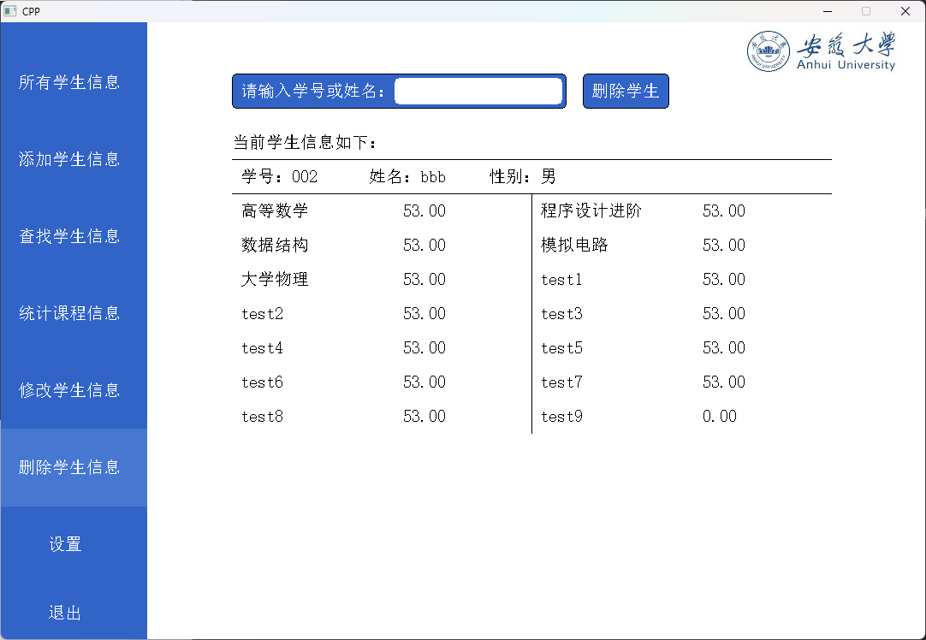

点击删除弹出窗口，确认删除则从s中移除此节点，否则退回到原界面

函数代码：

//删除学生信息  
void DelStudent() {  
 menu(6);  
  
 setfillcolor(RGB(50, 100, 200));  
 setlinecolor(BLACK);  
 fillroundrect(270, 60, 660, 100, 10, 10);  
 ot(280, 70, WHITE, 20, 0, "请输入学号或姓名：", "宋体");  
 fillroundrect(680, 60, 780, 100, 10, 10);  
 ot(690, 70, WHITE, 20, 0, "删除学生", "宋体");  
 //绘制界面  
   
 //前一部分同查找学生  
 string input = "No_Input_Information";  
 char cinput[100] = "No_Input";  
 while(true){  
 msg = getmessage(EM_MOUSE);  
 menuanimation(msg.x, msg.y, 6);  
  
 button_animation(msg, 680, 60, 780, 100, WHITE, RGB(50, 100, 200));  
 if(msg.x >= 460 && msg.x <= 655 && msg.y >= 65 && msg.y <= 95){  
 setfillcolor(RGB(200, 200, 200));  
 solidroundrect(460, 65, 655, 95, 10, 10);  
 }else{  
 setfillcolor(WHITE);  
 solidroundrect(460, 65, 655, 95, 10, 10);  
 }  
 if(input != "No_Input_Information") ot(470, 70, BLACK, 20, 0, cinput, "宋体");  
  
 switch (msg.message) {  
 case WM_LBUTTONDOWN:{  
 if (msg.x >= 0 && msg.x <= 170 && msg.y >= 25 && msg.y <= 720) {  
 choose = choosegraph(msg.x, msg.y);  
 if (choose != 3) {  
 flushmessage(EM_MOUSE);  
 return;  
 }  
 }  
  
 if(msg.x >= 460 && msg.x <= 655 && msg.y >= 65 && msg.y <= 95) {  
 InputBox(cinput, 100, "输入学生学号/姓名");  
 input = cinput;  
 clearrectangle(270, 130, 970, 720);  
 bool find = false;  
 for (auto &i: s) {  
 if (i.id == input || i.name == input) {  
 find = true;  
 ot(270, 130, BLACK, 20, 0, "当前学生信息如下：", "宋体");  
 input = "No_Input_Information";  
 char output[1000];  
 setlinecolor(BLACK);  
 line(270, 160, 970, 160);  
 line(270, 200, 970, 200);  
 sprintf(output, "%s%s %s%s %s%s", "学号：", i.id.c_str(), "姓名：", i.name.c_str(),  
 "性别：", i.gender.c_str());  
 ot(280, 170, BLACK, 20, 0, output, "宋体");  
 line(620, 200, 620, 200 + (lessonNumber + 1) / 2 * 40);  
 for (int j = 0; j < lessonNumber; ++j) {  
 char les[100];  
 char les_score[20];  
 sprintf(les, "%s", lessonList[j].c_str());  
 sprintf(les_score, "%.2lf", i.ls[j]);  
 if (j % 2 == 0) {  
 ot(280, 210 + j / 2 * 40, BLACK, 20, 0, les, "宋体");  
 ot(470, 210 + j / 2 * 40, BLACK, 20, 0, les_score, "宋体");  
 } else {  
 ot(630, 210 + j / 2 * 40, BLACK, 20, 0, les, "宋体");  
 ot(820, 210 + j / 2 * 40, BLACK, 20, 0, les_score, "宋体");  
 }  
 }  
 }  
 }  
 if (!find) {  
 HWND er = GetHWnd();  
 MessageBox(er, "未找到学生，请确认信息输入是否正确", "错误", MB_OK);  
 input = "No_Input_Information";  
 }  
 }  
   
 //当点击“删除学生”时，弹出二级窗口询问，选择取消则清空界面并重新绘制窗口，重新显示学生信息，选择确认即从s中移除此节点  
 if(msg.x >= 680 && msg.x <= 780 && msg.y >= 60 && msg.y <= 100){  
 setlinecolor(RGB(50, 100, 200));  
 setfillcolor(RGB(50, 100, 200));  
 fillrectangle(500, 240, 720, 270);  
 setfillcolor(WHITE);  
 fillrectangle(500, 270, 720, 400);  
 setfillcolor(RGB(50, 100, 200));  
 setlinecolor(BLACK);  
 fillroundrect(510, 290, 710, 330, 10, 10);  
 fillroundrect(510, 340, 710, 380, 10, 10);  
 ot(510, 245, WHITE, 20, 0, "确认删除该学生？", "宋体");  
 ot(570, 300, WHITE, 20, 0, "确认删除", "宋体");  
 ot(590, 350, WHITE, 20, 0, "取消", "宋体");  
 flushmessage(EM_MOUSE);  
 bool ewhile = false;  
 while(true){  
 if(ewhile) break;  
 msg = getmessage(EM_MOUSE);  
 button_animation(msg, 510, 290, 710, 330, WHITE, RGB(50, 100, 200));  
 button_animation(msg, 510, 340, 710, 380, WHITE, RGB(50, 100, 200));  
 switch (msg.message) {  
 case WM_LBUTTONDOWN:{  
 if(msg.x >= 510 && msg.x <= 710 && msg.y >= 290 && msg.y <= 330){  
 input = cinput;  
 auto p = s.begin();  
 bool find = false;  
 for (auto & i : s) {  
 if(i.id == input || i.name == input){  
 find = true;  
 input = "No_Input_Information";  
 s.erase(p);  
 HWND res = GetHWnd();  
 MessageBox(res, "已删除该学生", "提示", MB_OK);  
 choose = 6;  
 return;  
 }  
 p++;  
 }  
 }  
  
 if(msg.x >= 510 && msg.x <= 710 && msg.y >= 340 && msg.y <= 380){  
 clearrectangle(270, 100, 970, 720);  
 input = cinput;  
 bool find = false;  
 for (auto &i: s) {  
 if (i.id == input || i.name == input) {  
 find = true;  
 ot(270, 130, BLACK, 20, 0, "当前学生信息如下：", "宋体");  
 input = "No_Input_Information";  
 char output[1000];  
 setlinecolor(BLACK);  
 line(270, 160, 970, 160);  
 line(270, 200, 970, 200);  
 sprintf(output, "%s%s %s%s %s%s", "学号：", i.id.c_str(), "姓名：", i.name.c_str(),  
 "性别：", i.gender.c_str());  
 ot(280, 170, BLACK, 20, 0, output, "宋体");  
 line(620, 200, 620, 200 + (lessonNumber + 1) / 2 * 40);  
 for (int j = 0; j < lessonNumber; ++j) {  
 char les[100];  
 char les_score[20];  
 sprintf(les, "%s", lessonList[j].c_str());  
 sprintf(les_score, "%.2lf", i.ls[j]);  
 if (j % 2 == 0) {  
 ot(280, 210 + j / 2 * 40, BLACK, 20, 0, les, "宋体");  
 ot(470, 210 + j / 2 * 40, BLACK, 20, 0, les_score, "宋体");  
 } else {  
 ot(630, 210 + j / 2 * 40, BLACK, 20, 0, les, "宋体");  
 ot(820, 210 + j / 2 * 40, BLACK, 20, 0, les_score, "宋体");  
 }  
 }  
 }  
 }  
 ewhile = true;  
 }  
 }  
 }  
 }  
 }  
 }  
 }  
 }  
}

（4）修改学生信息

界面及功能：

输入学生学号/姓名，点击查询即可查找学生，找不到便报错，找到便在下方显示学生对应信息，点击即可进行修改，点击保存修改即删除当前节点并将新的临时节点t插入s中，点击重置便初始化临时节点t

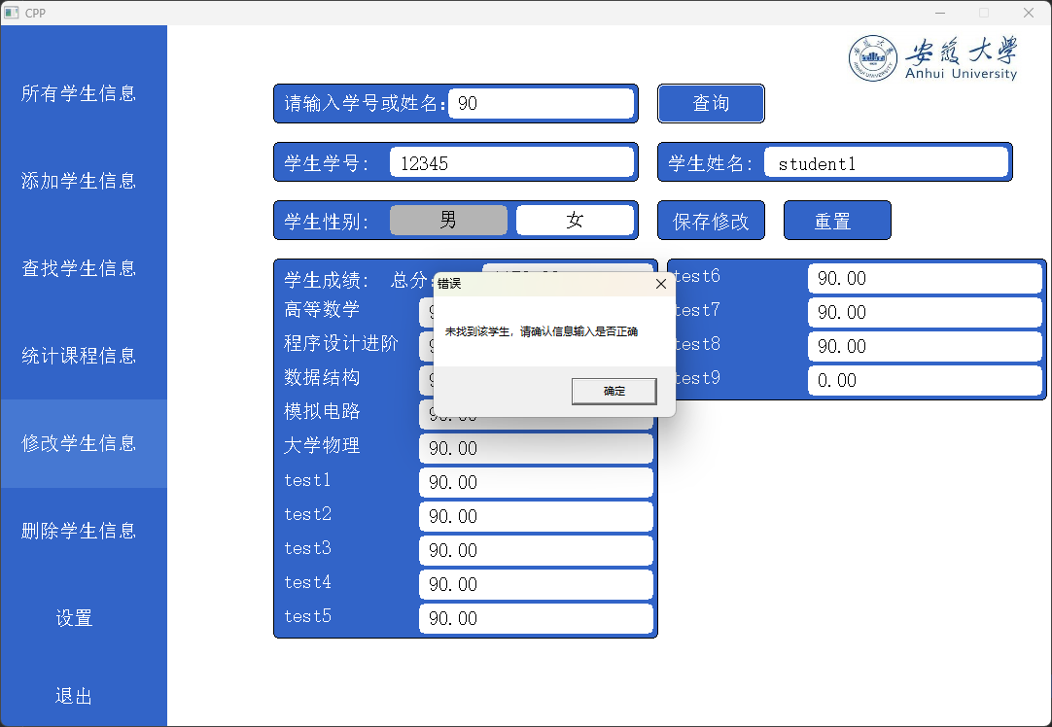

同样的，当课程数量lessonNumber≤10时左侧显示科目，＞10时左侧显示10个科目右侧显示剩余科目，最多21个科目

函数代码：

//修改学生信息  
void ChangeStudent() {  
 menu(5);  
 setfillcolor(RGB(50, 100, 200));  
 setlinecolor(BLACK);  
 fillroundrect(280, 60, 655, 100, 10, 10);  
 ot(290, 70, WHITE, 20, 0, "请输入学号或姓名：", "宋体");  
 fillroundrect(675, 60, 785, 100, 10, 10);  
 ot(710, 70, WHITE, 20, 0, "查询", "宋体");  
 char xh[20] = " ", xm[100] = " ", xb[10] = " ", cj[30][10] = {};  
 fillroundrect(280, 120, 655, 160, 10, 10);  
 ot(290, 132, WHITE, 20, 0, "学生学号:", "宋体");  
 fillroundrect(675, 120, 1040, 160, 10, 10);  
 ot(685, 132, WHITE, 20, 0, "学生姓名:", "宋体");  
 fillroundrect(280, 180, 655, 220, 10, 10);  
 ot(290, 192, WHITE, 20, 0, "学生性别:", "宋体");  
 if(lessonNumber <= 10)  
 fillroundrect(280, 240, 675, 280 + (lessonNumber) * 35, 10, 10);  
 else{  
 fillroundrect(280, 240, 675, 280 + 10 * 35, 10, 10);  
 fillroundrect(685, 240, 1075, 245 + (lessonNumber - 10) * 35, 10, 10);  
 }  
  
 ot(290, 252, WHITE, 20, 0, "学生成绩: 总分：", "宋体");  
 fillroundrect(675, 180, 785, 220, 10, 10);  
 ot(690, 192, WHITE, 20, 0, "保存修改", "宋体");  
 fillroundrect(805, 180, 915, 220, 10, 10);  
 ot(835, 192, WHITE, 20, 0, "重置", "宋体");  
   
 string input = "No_Input_Information";  
 char cinput[100];  
 stu t;  
 for (int i = 0; i < lessonNumber; ++i) {  
 t.ls[i] = -1;  
 }  
 t.id = "No_Input_id";  
 t.name = "No_Input_name";  
 t.gender = "No_Input_gender";  
 char tid[100], tname[100], tls[30][10];  
 char tscore[100];  
 bool male = false;  
 bool female = false;  
 auto p = s.begin();  
 while(true){  
 msg = getmessage(EM_MOUSE);  
 menuanimation(msg.x, msg.y, 5);  
  
 button_animation(msg, 675, 60, 785, 100, WHITE, RGB(50, 100, 200));  
  
 button_animation(msg, 675, 180, 785, 220, WHITE, RGB(50, 100, 200));  
 button_animation(msg, 805, 180, 915, 220, WHITE, RGB(50, 100, 200));  
  
 if(t.id != "No_Input_id") sprintf(tid, "%s", t.id.c_str());  
 if(t.name != "No_Input_name") sprintf(tname, "%s", t.name.c_str());  
 sprintf(tscore, "%.2lf", t.score);  
 setfillcolor(WHITE);  
 solidroundrect(495, 245, 670, 275, 10, 10);  
 ot(505, 250, BLACK, 20, 0, tscore, "宋体");  
 if(msg.x >= 400 && msg.x <= 650 && msg.y >= 125 && msg.y <= 155){  
 setfillcolor(RGB(200, 200, 200));  
 solidroundrect(400, 125, 650, 155, 10, 10);  
 }else{  
 setfillcolor(WHITE);  
 solidroundrect(400, 125, 650, 155, 10, 10);  
 }  
 if(t.id != "No_Input_id") ot(410, 132, BLACK, 20, 0, tid, "宋体");  
  
 if(msg.x >= 785 && msg.x <= 1035 && msg.y >= 125 && msg.y <= 155){  
 setfillcolor(RGB(200, 200, 200));  
 solidroundrect(785, 125, 1035, 155, 10, 10);  
 }else{  
 setfillcolor(WHITE);  
 solidroundrect(785, 125, 1035, 155, 10, 10);  
 }  
 if(t.name != "No_Input_name") ot(800, 132, BLACK, 20, 0, tname, "宋体");  
  
 if(msg.x >= 400 && msg.x <= 520 && msg.y >= 185 && msg.y <= 215 && !male){  
 setfillcolor(RGB(200, 200, 200));  
 solidroundrect(400, 185, 520, 215, 10, 10);  
 }else if(!male){  
 setfillcolor(WHITE);  
 solidroundrect(400, 185, 520, 215, 10, 10);  
 }  
 ot(450, 190, BLACK, 20, 0, "男", "宋体");  
 if(msg.x >= 530 && msg.x <= 650 && msg.y >= 185 && msg.y <= 215 && !female){  
 setfillcolor(RGB(200, 200, 200));  
 solidroundrect(530, 185, 650, 215, 10, 10);  
 }else if(!female){  
 setfillcolor(WHITE);  
 solidroundrect(530, 185, 650, 215, 10, 10);  
 }  
 ot(580, 190, BLACK, 20, 0, "女", "宋体");  
  
 if(male){  
 setfillcolor(RGB(180, 180, 180));  
 solidroundrect(400, 185, 520, 215, 10, 10);  
 ot(450, 190, BLACK, 20, 0, "男", "宋体");  
 }  
 if(female){  
 setfillcolor(RGB(180, 180, 180));  
 solidroundrect(530, 185, 650, 215, 10, 10);  
 ot(580, 190, BLACK, 20, 0, "女", "宋体");  
 }  
  
 if(msg.x >= 460 && msg.x <= 650 && msg.y >= 65 && msg.y <= 95){  
 setfillcolor(RGB(200, 200, 200));  
 solidroundrect(460, 65, 650, 95, 10, 10);  
 }else{  
 setfillcolor(WHITE);  
 solidroundrect(460, 65, 650, 95, 10, 10);  
 }  
 if(input != "No_Input_Information") ot(470, 70, BLACK, 20, 0, cinput, "宋体");  
  
 if(lessonNumber <= 10) {  
 for (int i = 0; i < lessonNumber; ++i) {  
 char st[100];  
 sprintf(st, "%s", lessonList[i].c_str());  
 if (msg.x >= 430 && msg.x <= 670 && msg.y >= 280 + i * 35 && msg.y <= 310 + i * 35){  
 setfillcolor(RGB(200, 200, 200));  
 solidroundrect(430, 280 + i * 35, 670, 310 + i * 35, 10, 10);  
 }else{  
 setfillcolor(WHITE);  
 solidroundrect(430, 280 + i * 35, 670, 310 + i * 35, 10, 10);  
 }  
 if(t.ls[i] >= 0){  
 sprintf(tls[i], "%.2lf", t.ls[i]);  
 ot(440, 285 + i * 35, BLACK, 20, 0, tls[i], "宋体");  
 }  
 ot(290, 282 + i * 35, WHITE, 20, 0, st, "宋体");  
 }  
 }  
 else{  
 for (int i = 0; i < 10; ++i) {  
 char st[100];  
 sprintf(st, "%s", lessonList[i].c_str());  
 if (msg.x >= 430 && msg.x <= 670 && msg.y >= 280 + i * 35 && msg.y <= 310 + i * 35){  
 setfillcolor(RGB(200, 200, 200));  
 solidroundrect(430, 280 + i * 35, 670, 310 + i * 35, 10, 10);  
 }else{  
 setfillcolor(WHITE);  
 solidroundrect(430, 280 + i * 35, 670, 310 + i * 35, 10, 10);  
 }  
 if(t.ls[i] >= 0){  
 sprintf(tls[i], "%.2lf", t.ls[i]);  
 ot(440, 285 + i * 35, BLACK, 20, 0, tls[i], "宋体");  
 }  
 ot(290, 282 + i * 35, WHITE, 20, 0, st, "宋体");  
 }  
 for (int i = 0; i < lessonNumber - 10; ++i) {  
 char st[100];  
 sprintf(st, "%s", lessonList[i + 10].c_str());  
 if (msg.x >= 830 && msg.x <= 1070 && msg.y >= 245 + i * 35 && msg.y <= 275 + i * 35){  
 setfillcolor(RGB(200, 200, 200));  
 solidroundrect(830, 245 + i * 35, 1070, 275 + i * 35, 10, 10);  
 }else{  
 setfillcolor(WHITE);  
 solidroundrect(830, 245 + i * 35, 1070, 275 + i * 35, 10, 10);  
 }  
 if(t.ls[i + 10] >= 0){  
 sprintf(tls[i + 10], "%.2lf", t.ls[i + 10]);  
 ot(840, 250 + i * 35, BLACK, 20, 0, tls[i + 10], "宋体");  
 }  
 ot(690, 247 + i * 35, WHITE, 20, 0, st, "宋体");  
 }  
 }  
 //选中反馈动画  
   
 switch (msg.message) {  
 case WM_LBUTTONDOWN:{  
 if (msg.x >= 0 && msg.x <= 170 && msg.y >= 25 && msg.y <= 720) {  
 choose = choosegraph(msg.x, msg.y);  
 if (choose != 5) {  
 flushmessage(EM_MOUSE);  
 return;  
 }  
 }  
  
 //输入学生姓名/学号进行查找，找不到报错  
 if(msg.x >= 460 && msg.x <= 650 && msg.y >= 65 && msg.y <= 95) {  
 InputBox(cinput, 100, "输入学生学号/姓名");  
 input = cinput;  
 }  
 if(msg.x >= 675 && msg.x <= 785 && msg.y >= 60 && msg.y <= 100){  
 bool find = false;  
 p = s.begin();  
 for (auto & i : s) {  
 if(i.id == input || i.name == input){  
 find = true;  
 input = "No_Input_Information";  
 t = i;  
 if(t.gender == "男") male = true;  
 else female = true;  
 break;  
 }  
 ++p;  
 }  
 if(!find){  
 HWND er = GetHWnd();  
 MessageBox(er, "未找到该学生，请确认信息输入是否正确", "错误", MB_OK);  
 input = "No_Input_Information";  
 }  
 }  
 //修改时逻辑同添加学生，如果当前学号或姓名已存在便报错  
 if(msg.x >= 400 && msg.x <= 650 && msg.y >= 125 && msg.y <= 155){  
 char txh[100];  
 InputBox(txh, 100, "请输入学生学号");  
 bool exist = false;  
 for (auto & i : s) {  
 if(i.id == txh){  
 HWND er = GetHWnd();  
 char txs[100];  
 sprintf(txs, "错误，该学生已存在：\n%s %s", i.id.c_str(), i.name.c_str());  
 MessageBox(er, txs, "错误", MB_OK);  
 exist = true;  
 break;  
 }  
 }  
 if(!exist){  
 t.id = txh;  
 }  
 }  
 if(msg.x >= 785 && msg.x <= 1035 && msg.y >= 125 && msg.y <= 155){  
 char txm[100];  
 InputBox(txm, 100, "请输入学生姓名");  
 bool exist = false;  
 for (auto & i : s) {  
 if(i.name == txm){  
 HWND er = GetHWnd();  
 char txs[100];  
 sprintf(txs, "错误，该学生已存在：\n%s %s", i.id.c_str(), i.name.c_str());  
 MessageBox(er, txs, "错误", MB_OK);  
 exist = true;  
 break;  
 }  
 }  
 if(!exist){  
 t.name = txm;  
 }  
 }  
 if(msg.x >= 400 && msg.x <= 520 && msg.y >= 185 && msg.y <= 215){  
 male = true;  
 female = false;  
 t.gender = "男";  
 }  
 if(msg.x >= 530 && msg.x <= 650 && msg.y >= 185 && msg.y <= 215){  
 female = true;  
 male = false;  
 t.gender = "女";  
 }  
  
 //存入数据，不合法数据报错  
 if(lessonNumber <= 10){  
 for (int i = 0; i < lessonNumber; ++i) {  
 char st[100];  
 sprintf(st, "%s%s%s", "请输入该学生 ", lessonList[i].c_str(), " 成绩");  
 if (msg.x >= 430 && msg.x <= 670 && msg.y >= 280 + i * 35 && msg.y <= 310 + i * 35){  
 InputBox(tls[i], 100, st);  
 if(!check(tls[i])){  
 HWND er = GetHWnd();  
 MessageBox(er, "输入应为数字", "错误", MB_OK);  
 break;  
 }  
 if(stod(tls[i]) < 0 || stod(tls[i]) > 100){  
 HWND er = GetHWnd();  
 MessageBox(er, "成绩应在0-100之间", "错误", MB_OK);  
 t.ls[i] = -1;  
 break;  
 }  
 t.score -= max(t.ls[i], double(0));  
 t.ls[i] = stod(tls[i]);  
 t.score += t.ls[i];  
 }  
 }  
 }  
 else{  
 for (int i = 0; i < lessonNumber; ++i) {  
 char st[100];  
 sprintf(st, "%s%s%s", "请输入该学生 ", lessonList[i].c_str(), " 成绩");  
 if (msg.x >= 430 && msg.x <= 670 && msg.y >= 280 + i * 35 && msg.y <= 310 + i * 35){  
 InputBox(tls[i], 100, st);  
 if(!check(tls[i])){  
 HWND er = GetHWnd();  
 MessageBox(er, "输入应为数字", "错误", MB_OK);  
 break;  
 }  
 if(stod(tls[i]) < 0 || stod(tls[i]) > 100){  
 HWND er = GetHWnd();  
 MessageBox(er, "成绩应在0-100之间", "错误", MB_OK);  
 t.ls[i] = -1;  
 break;  
 }  
 t.score -= max(t.ls[i], double(0));  
 t.ls[i] = stod(tls[i]);  
 t.score += t.ls[i];  
 }  
 }  
 for (int i = 0; i < lessonNumber - 10; ++i) {  
 char st[100];  
 sprintf(st, "%s%s%s", "请输入该学生 ", lessonList[i + 10].c_str(), " 成绩");  
 if (msg.x >= 830 && msg.x <= 1070 && msg.y >= 245 + i * 35 && msg.y <= 275 + i * 35){  
 InputBox(tls[i + 10], 100, st);  
 if(!check(tls[i + 10])){  
 HWND er = GetHWnd();  
 MessageBox(er, "输入应为数字", "错误", MB_OK);  
 break;  
 }  
 if(stod(tls[i + 10]) < 0 || stod(tls[i + 10]) > 100){  
 HWND er = GetHWnd();  
 MessageBox(er, "成绩应在0-100之间", "错误", MB_OK);  
 t.ls[i + 10] = -1;  
 }  
 t.score -= max(t.ls[i + 10], double(0));  
 t.ls[i + 10] = stod(tls[i + 10]);  
 t.score += t.ls[i + 10];  
 }  
 }  
 }  
  
 //检查是否所有信息已填写，如果是则将当前t插入s并删除查找到的节点，反之报错  
 if(msg.x >= 675 && msg.x <= 785 && msg.y >= 180 && msg.y <= 220){  
 bool all = false;  
 if(t.id == "No_Input_id" || t.name == "No_Input_name" || t.gender == "No_Input_gender") all = true;  
 for (int i = 0; i < lessonNumber; ++i) {  
 if(t.ls[i] < 0){  
 all = true;  
 break;  
 }  
 }  
 if(all) {  
 HWND er = GetHWnd();  
 MessageBox(er, "有信息未填写", "错误", MB_OK);  
 }  
 else{  
 HWND res = GetHWnd();  
 MessageBox(res, "修改成功", "提示", MB_OK);  
 s.erase(p);  
 s.push_back(t);  
 for (int i = 0; i < lessonNumber; ++i) {  
 t.ls[i] = -1;  
 }  
 t.id = "No_Input_id";  
 t.name = "No_Input_name";  
 t.gender = "No_Input_gender";  
 t.score = 0;  
 male = false;  
 female = false;  
 }  
 }  
 //重置即初始化t，不对s进行操作  
 if(msg.x >= 805 && msg.x <= 915 && msg.y >= 180 && msg.y <= 220){  
 for (int i = 0; i < lessonNumber; ++i) {  
 t.ls[i] = -1;  
 }  
 t.id = "No_Input_id";  
 t.name = "No_Input_name";  
 t.gender = "No_Input_gender";  
 t.score = 0;  
 male = false;  
 female = false;  
 p = s.begin();  
 }  
 }  
 }  
 }  
}

（5）指定分数段排名

界面及功能：

可用下拉栏对查询课程进行选择，手动输入分数范围即可查询，如果有未填写信息则报错

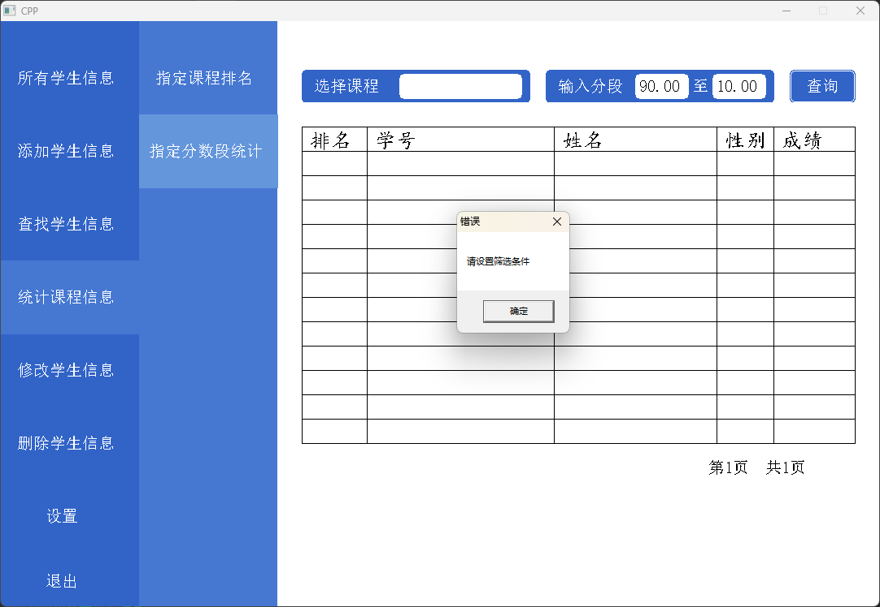

如果没有则显示分数段内学生信息，并统计分段内学生个数和该分段人数占总人数的百分比，一页最多显示12个学生信息，再多需要翻页，分数范围前后相对大小不需注意，会自动判别

函数代码：

int ppage = 0;  
int tsit[100];  
**vector**<stu> SSlist;  
//排序方式  
int object;//当前学科  
bool CmpUp(const stu& a, const stu& b) {  
 return a.ls[object] > b.ls[object];  
}//课程成绩降序  
bool CmpDown(const stu& a, const stu& b) {  
 return a.ls[object] < b.ls[object];  
}//课程成绩升序  
bool Cmp(const stu& a, const stu& b) {  
 return a.id < b.id;  
}//学号升序  
bool CmpScore(const stu& a, const stu& b){  
 return a.score > b.score;  
}//总分降序  
//指定分数段排名  
//基础界面绘制  
void ScoreStatisticsGraph(){  
 clearrectangle(370, 100, 1080, 720);  
 setlinecolor(BLACK);  
 setfillcolor(WHITE);  
 fillrectangle(370, 130, 450, 160);  
 fillrectangle(450, 130, 680, 160);  
 fillrectangle(680, 130, 880, 160);  
 fillrectangle(880, 130, 950, 160);  
 fillrectangle(950, 130, 1050, 160);  
 ot(380, 135, BLACK, 25, 0, "排名", "楷体");  
 ot(460, 135, BLACK, 25, 0, "学号", "楷体");  
 ot(690, 135, BLACK, 25, 0, "姓名", "楷体");  
 ot(890, 135, BLACK, 25, 0, "性别", "楷体");  
 ot(960, 135, BLACK, 25, 0, "成绩", "楷体");  
 for (int i = 0; i < 12; ++i) {  
 fillrectangle(370, 160 + i * 30, 450, 190 + i * 30);  
 fillrectangle(450, 160 + i * 30, 680, 190 + i * 30);  
 fillrectangle(680, 160 + i * 30, 880, 190 + i * 30);  
 fillrectangle(880, 160 + i * 30, 950, 190 + i * 30);  
 fillrectangle(950, 160 + i * 30, 1050, 190 + i * 30);  
 }  
 setfillcolor(RGB(50, 100, 200));  
 if(ppage != 0) {  
 fillroundrect(790, 540, 860, 560, 10, 10);  
 ot(800, 543, WHITE, 15, 0, "上一页", "宋体");  
 }  
 if(ppage != (int(SSlist.size()) + 11) / 12 - 1 && int(SSlist.size() + 11) / 12 != 0) {  
 fillroundrect(1000, 540, 1070, 560, 10, 10);  
 ot(1010, 543, WHITE, 15, 0, "下一页", "宋体");  
 }  
 //判断是否显示翻页按钮  
 char tpage[100];  
 sprintf(tpage, "第%d页 共%d页", ppage + 1, max(1, (int(SSlist.size() + 11) / 12)));  
 ot(870, 540, BLACK, 20, 0, tpage, "宋体");  
}  
void ScoreStatistics() {  
 clearrectangle(340, 0, 1080, 720);  
 setfillcolor(RGB(100, 150, 220));  
 setlinecolor(RGB(100, 150, 220));  
 fillrectangle(170, 115, 340, 205);  
 ot(182, 150, WHITE, 20, 0, "指定分数段统计", "宋体");  
 setfillcolor(RGB(50, 100, 200));  
 setlinecolor(RGB(50, 100, 200));  
 fillroundrect(370, 60, 650, 100, 10, 10);  
 fillroundrect(670, 60, 950, 100, 10, 10);  
 fillroundrect(970, 60, 1050, 100, 10, 10);  
 setfillcolor(WHITE);  
 setlinecolor(WHITE);  
 ot(385, 70, WHITE, 20, 0, "选择课程", "宋体");  
 ot(685, 70, WHITE, 20, 0, "输入分段", "宋体");  
 ot(850, 70, WHITE, 20, 0, "至", "宋体");  
 ot(990, 70, WHITE, 20, 0, "查询", "宋体");  
 ScoreStatisticsGraph();  
 object = int(s.size()) + 1;  
 char lesson[100];  
 char score_input[100];  
 bool tflag = false;  
 bool cs1 = false, cs2 = false, cs3 = false;  
 double max_score = -1, min_score = -1, fn = -1, sn = -1;  
 char tfn[100] = " ", tsn[100] = " ";  
 while(true){  
 msg = getmessage(EM_MOUSE);  
 menuanimation(msg.x, msg.y, 4);  
 button_animation(msg, 970, 60 ,1050, 100, WHITE, RGB(50, 100, 200));  
 if(ppage != 0) button_animation(msg, 790, 540, 860, 560, WHITE, RGB(50, 100, 200));  
 if(ppage != (int(SSlist.size()) + 11) / 12 - 1 && int(SSlist.size() + 11) / 12 != 0) button_animation(msg, 1000, 540, 1070, 560, WHITE, RGB(50, 100, 200));  
  
 sprintf(lesson, "%s", lessonList[object].c_str());  
 if(fn >= 0 && sn >= 0){  
 max_score = max(fn, sn);  
 min_score = min(fn, sn);  
 }  
 if(fn >= 0) sprintf(tfn, "%.2lf", fn);  
 if(sn >= 0) sprintf(tsn, "%.2lf", sn);  
 if(msg.x >= 170 && msg.x <= 340 && msg.y >= 25 && msg.y <= 115)  
 ot(190, 60, YELLOW, 20, 0, "指定课程排名", "宋体");  
 else ot(190, 60, WHITE, 20, 0, "指定课程排名", "宋体");  
 if(msg.x >= 490 && msg.x <= 640 && msg.y >= 65 && msg.y <= 95){  
 setfillcolor(RGB(230, 230, 230));  
 solidroundrect(490, 65, 640, 95, 10, 10);  
 ot(495, 72, BLACK, 20, 0, lesson, "宋体");  
 }else{  
 setfillcolor(WHITE);  
 solidroundrect(490, 65, 640, 95, 10, 10);  
 ot(495, 72, BLACK, 20, 0, lesson, "宋体");  
 }  
 if(msg.x >= 780 && msg.x <= 845 && msg.y >= 65 && msg.y <= 95){  
 setfillcolor(RGB(200, 200, 200));  
 solidroundrect(780, 65, 845, 95, 10, 10);  
 }else{  
 setfillcolor(WHITE);  
 solidroundrect(780, 65, 845, 95, 10, 10);  
 }ot(785, 70, BLACK, 20, 0, tfn, "宋体");  
 if(msg.x >= 875 && msg.x <= 940 && msg.y >= 65 && msg.y <= 95){  
 setfillcolor(RGB(200, 200, 200));  
 solidroundrect(875, 65, 940, 95, 10, 10);  
 }else{  
 setfillcolor(WHITE);  
 solidroundrect(875, 65, 940, 95, 10, 10);  
 }ot(880, 70, BLACK, 20, 0, tsn, "宋体");  
  
 switch (msg.message) {  
 case WM_LBUTTONDOWN: {  
 if (msg.x >= 0 && msg.x <= 170 && msg.y >= 25 && msg.y <= 720) {  
 choose = choosegraph(msg.x, msg.y);  
 if (choose != 4) {  
 flushmessage(EM_MOUSE);  
 return;  
 }  
 }  
 if (msg.x >= 170 && msg.x <= 340 && msg.y >= 25 && msg.y <= 115) {  
 flushmessage(EM_MOUSE);  
 choose = 4;  
 return;  
 }  
 if (msg.x >= 790 && msg.x <= 860 && msg.y >= 540 && msg.y <= 560 && ppage != 0){  
 ppage --;  
 ScoreStatisticsGraph();  
 break;  
 }  
 if (msg.x >= 1000 && msg.x <= 1070 && msg.y >= 540 && msg.y <= 560 && ppage != (int(s.size()) + 11) / 12 - 1 && int(SSlist.size() + 11) / 12 != 0){  
 ppage ++;  
 ScoreStatisticsGraph();  
 break;  
 }  
 if (msg.x >= 780 && msg.x <= 845 && msg.y >= 60 && msg.y <= 100){  
 cs2 = true;  
 InputBox(tfn, 20, "请输入分数范围：");  
 if(!check(tfn)){  
 HWND er = GetHWnd();  
 MessageBox(er, "输入应为数字", "错误", MB_OK);  
 break;  
 }  
 if(stod(tfn) < 0 || stod(tfn) > 100){  
 HWND er = GetHWnd();  
 MessageBox(er, "成绩应在0-100之间", "错误", MB_OK);  
 break;  
 }  
 ScoreStatisticsGraph();  
 tflag = false;  
 fn = stod(tfn);  
 }  
 if (msg.x >= 875 && msg.x <= 940 && msg.y >= 60 && msg.y <= 100){  
 cs3 = true;  
 InputBox(tsn, 20, "请输入分数范围：");  
 if(!check(tsn)){  
 HWND er = GetHWnd();  
 MessageBox(er, "输入应为数字", "错误", MB_OK);  
 break;  
 }  
 if(stod(tsn) < 0 || stod(tsn) > 100){  
 HWND er = GetHWnd();  
 MessageBox(er, "成绩应在0-100之间", "错误", MB_OK);  
 break;  
 }  
 ScoreStatisticsGraph();  
 tflag = false;  
 sn = stod(tsn);  
 }  
 if (msg.x >= 970 && msg.x <= 1050 && msg.y >= 60 && msg.y <= 100){  
 if(cs1 && cs2 && cs3) {  
 tflag = true;  
 }else{  
 HWND er = GetHWnd();  
 MessageBox(er, "请设置筛选条件", "错误", MB_OK);  
 }  
 }  
 //下拉选择课程  
 if (msg.x >= 490 && msg.x <= 640 && msg.y >= 65 && msg.y <= 95) {  
 bool ewhile = false;  
 while (true) {  
 flushmessage(EM_MOUSE);  
 msg = getmessage(EM_MOUSE);  
 setlinecolor(WHITE);  
 if (msg.x < 490 || msg.x > 640 || msg.y < 65 || msg.y > lessonNumber * 20 + 95) {  
 break;  
 }  
 for (int i = 0; i < lessonNumber; ++i) {  
 char st1[100];  
 sprintf(st1, "%s", lessonList[i].c_str());  
 if (msg.x >= 490 && msg.x <= 640 && msg.y > 95 + i * 20 && msg.y <= 95 + (i + 1) * 20) {  
 setfillcolor(RGB(128, 128, 128));  
 fillrectangle(490, 95 + i * 20, 640, 95 + (i + 1) * 20);  
 ot(495, 100 + i * 20, BLACK, 15, 0, st1, "宋体");  
 } else {  
 setfillcolor(RGB(200, 200, 200));  
 fillrectangle(490, 95 + i * 20, 640, 95 + (i + 1) * 20);  
 ot(495, 100 + i * 20, BLACK, 15, 0, st1, "宋体");  
 }  
 }  
 switch (msg.message) {  
 case WM_LBUTTONDOWN:{  
 for (int i = 0; i < lessonNumber; ++i) {  
 if(msg.x >= 490 && msg.x <= 640 && msg.y > 95 + i * 20 && msg.y <= 95 + (i + 1) * 20){  
 object = i;  
 flushmessage(EM_MOUSE);  
 ScoreStatisticsGraph();  
 tflag = false;  
 ewhile = true;  
 cs1 = true;  
 break;  
 }  
 }  
 }  
 }  
 if(ewhile) break;  
 }  
 clearrectangle(370, 95, 1080, 720);  
 ScoreStatisticsGraph();  
 setfillcolor(RGB(50, 100, 200));  
 setlinecolor(RGB(50, 100, 200));  
 fillroundrect(370, 60, 650, 100, 10, 10);  
 fillroundrect(670, 60, 950, 100, 10, 10);  
 fillroundrect(970, 60, 1050, 100, 10, 10);  
 ot(385, 70, WHITE, 20, 0, "选择课程", "宋体");  
 ot(685, 70, WHITE, 20, 0, "输入分段", "宋体");  
 ot(850, 70, WHITE, 20, 0, "至", "宋体");  
 ot(990, 70, WHITE, 20, 0, "查询", "宋体");  
 }  
 }  
 }  
 if(!tflag) continue;//tflag标记是否对当前筛选条件进行了筛选，如果没有修改则不对输出内容进行重新输出以防止内容闪烁  
  
 //将输入的两个数中较大较小的分开，并作为筛选条件  
 max_score = max(fn, sn);  
 min_score = min(fn, sn);  
 SSlist.clear();  
 int situation = 0;  
 for (auto & i : s) {  
 if(i.ls[object] <= max_score && i.ls[object] >= min_score){  
 SSlist.push_back(i);  
 ++situation;  
 }  
 }  
 sort(SSlist.begin(), SSlist.end(), CmpUp);  
 ScoreStatisticsGraph();  
 setlinecolor(BLACK);  
 setfillcolor(WHITE);  
 fillrectangle(370, 130, 450, 160);  
 fillrectangle(450, 130, 680, 160);  
 fillrectangle(680, 130, 880, 160);  
 fillrectangle(880, 130, 950, 160);  
 fillrectangle(950, 130, 1050, 160);  
 ot(380, 135, BLACK, 25, 0, "排名", "楷体");  
 ot(460, 135, BLACK, 25, 0, "学号", "楷体");  
 ot(690, 135, BLACK, 25, 0, "姓名", "楷体");  
 ot(890, 135, BLACK, 25, 0, "性别", "楷体");  
 ot(960, 135, BLACK, 25, 0, "成绩", "楷体");  
 auto cmp = SSlist[max(0, ppage * 12 - 1)];  
 int site;  
 //确定当前页面显示的学生个数  
 if(ppage == 0) site = 1;  
 else site = 0;  
 int point;  
 if(ppage == (int(SSlist.size() + 11) / 12) - 1) point = int(SSlist.size()) % 12;  
 else point = 12;  
 //输出当前页面  
 for (int i = 0; i < point; ++ i) {  
 if (cmp.ls[object] != SSlist[i + ppage * 12].ls[object]) ++site;  
 fillrectangle(370, 160 + i * 30, 450, 190 + i * 30);  
 fillrectangle(450, 160 + i * 30, 680, 190 + i * 30);  
 fillrectangle(680, 160 + i * 30, 880, 190 + i * 30);  
 fillrectangle(880, 160 + i * 30, 950, 190 + i * 30);  
 fillrectangle(950, 160 + i * 30, 1050, 190 + i * 30);  
 char pm[10],xh[100],xm[100],cj[100],xb[100];  
 sprintf(pm, "%d", site + tsit[ppage - 1]);  
 sprintf(xh, "%s", SSlist[i + ppage * 12].id.c_str());  
 sprintf(xm, "%s", SSlist[i + ppage * 12].name.c_str());  
 sprintf(xb, "%s", SSlist[i + ppage * 12].gender.c_str());  
 sprintf(cj, "%.2lf", SSlist[i + ppage * 12].ls[object]);  
 ot(380, 165 + i * 30, BLACK, 25, 0, pm, "楷体");  
 ot(460, 165 + i * 30, BLACK, 25, 0, xh, "楷体");  
 ot(690, 165 + i * 30, BLACK, 25, 0, xm, "楷体");  
 ot(890, 165 + i * 30, BLACK, 25, 0, xb, "楷体");  
 ot(960, 165 + i * 30, BLACK, 25, 0, cj, "楷体");  
 cmp = SSlist[i + ppage * 12];  
 }  
 tsit[ppage] = site + tsit[ppage - 1];  
  
 char ratio[100];  
 sprintf(ratio, "当前分段内共%d人，在总人数（%d）中占：", situation, int(s.size()));  
 ot(380, 540, BLACK, 20, 0, ratio, "宋体");  
 setlinecolor(BLACK);  
 setfillcolor(WHITE);  
 fillrectangle(380, 570, 680, 595);  
 setfillcolor(RGB(50, 100, 200));  
 fillrectangle(380, 570, 380 + int(double(situation) / double(s.size()) * 100) * 3, 595);  
 sprintf(ratio, "%d%%", int(double(situation) / double(s.size()) * 100));  
 ot(370 + int(double(situation) / double(s.size()) * 100) * 3, 600, BLACK, 20, 0, ratio, "宋体");  
 }  
}

（6）指定课程排名

界面及功能：

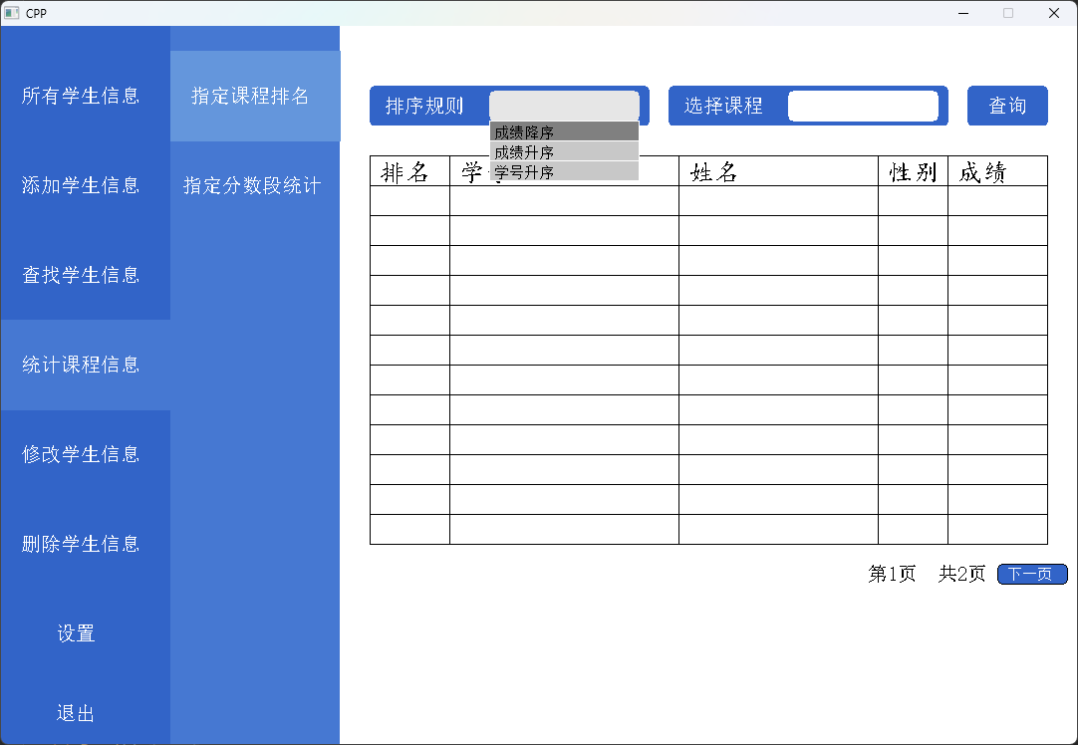图形用户界面, 表格

下拉栏选择排序规则（成绩升序、成绩降序、学号降序），下拉栏选择课程并点击查询即可显示所有学生的排名情况，同样12人一页，可翻页

函数代码：

//指定课程排名  
//基础界面绘制  
void SortPrintGraph(){  
 clearrectangle(370, 100, 1080, 720);  
 setlinecolor(BLACK);  
 setfillcolor(WHITE);  
 fillrectangle(370, 130, 450, 160);  
 fillrectangle(450, 130, 680, 160);  
 fillrectangle(680, 130, 880, 160);  
 fillrectangle(880, 130, 950, 160);  
 fillrectangle(950, 130, 1050, 160);  
 ot(380, 135, BLACK, 25, 0, "排名", "楷体");  
 ot(460, 135, BLACK, 25, 0, "学号", "楷体");  
 ot(690, 135, BLACK, 25, 0, "姓名", "楷体");  
 ot(890, 135, BLACK, 25, 0, "性别", "楷体");  
 ot(960, 135, BLACK, 25, 0, "成绩", "楷体");  
 for (int i = 0; i < 12; ++i) {  
 fillrectangle(370, 160 + i * 30, 450, 190 + i * 30);  
 fillrectangle(450, 160 + i * 30, 680, 190 + i * 30);  
 fillrectangle(680, 160 + i * 30, 880, 190 + i * 30);  
 fillrectangle(880, 160 + i * 30, 950, 190 + i * 30);  
 fillrectangle(950, 160 + i * 30, 1050, 190 + i * 30);  
 }  
 setfillcolor(RGB(50, 100, 200));  
 if(ppage != 0) {  
 fillroundrect(790, 540, 860, 560, 10, 10);  
 ot(800, 543, WHITE, 15, 0, "上一页", "宋体");  
 }  
 if(ppage != (int(s.size()) + 11) / 12 - 1) {  
 fillroundrect(1000, 540, 1070, 560, 10, 10);  
 ot(1010, 543, WHITE, 15, 0, "下一页", "宋体");  
 }  
 char tpage[100];  
 sprintf(tpage, "第%d页 共%d页", ppage + 1, (int(s.size() + 11) / 12));  
 ot(870, 540, BLACK, 20, 0, tpage, "宋体");  
}  
void SortPrint() {  
 clearrectangle(340, 0, 1080, 720);  
 setfillcolor(RGB(100, 150, 220));  
 setlinecolor(RGB(100, 150, 220));  
 fillrectangle(170, 25, 340, 115);  
 ot(190, 60, WHITE, 20, 0, "指定课程排名", "宋体");  
 setfillcolor(RGB(50, 100, 200));  
 setlinecolor(RGB(50, 100, 200));  
 fillroundrect(370, 60, 650, 100, 10, 10);  
 fillroundrect(670, 60, 950, 100, 10, 10);  
 fillroundrect(970, 60, 1050, 100, 10, 10);  
 setfillcolor(WHITE);  
 setlinecolor(WHITE);  
 ot(385, 70, WHITE, 20, 0, "排序规则", "宋体");  
 ot(685, 70, WHITE, 20, 0, "选择课程", "宋体");  
 ot(990, 70, WHITE, 20, 0, "查询", "宋体");  
 SortPrintGraph();  
 int cs;  
 object = int(s.size()) + 1;  
 char lesson[100];  
 char cmppath[100];  
 bool tflag = false;  
 bool cs1 = false, cs2 = false;  
 while(true){  
 msg = getmessage(EM_MOUSE);  
 if(cs == 1) sprintf(cmppath, "%s", "成绩降序");  
 else if(cs == 2) sprintf(cmppath, "%s", "成绩升序");  
 else if(cs == 3) sprintf(cmppath, "%s", "学号升序");  
 else sprintf(cmppath, "%s", " ");  
 sprintf(lesson, "%s", lessonList[object].c_str());  
 menuanimation(msg.x, msg.y, 4);  
 if(msg.x >= 170 && msg.x <= 340 && msg.y >= 115 && msg.y <= 205)  
 ot(182, 150, YELLOW, 20, 0, "指定分数段统计", "宋体");  
 else ot(182, 150, WHITE, 20, 0, "指定分数段统计", "宋体");  
 if(msg.x >= 490 && msg.x <= 640 && msg.y >= 65 && msg.y <= 95){  
 setfillcolor(RGB(230, 230, 230));  
 solidroundrect(490, 65, 640, 95, 10, 10);  
 ot(495, 72, BLACK, 20, 0, cmppath, "宋体");  
 }else{  
 setfillcolor(WHITE);  
 solidroundrect(490, 65, 640, 95, 10, 10);  
 ot(495, 72, BLACK, 20, 0, cmppath, "宋体");  
 }  
 if(msg.x >= 790 && msg.x <= 940 && msg.y >= 65 && msg.y <= 95){  
 setfillcolor(RGB(230, 230, 230));  
 solidroundrect(790, 65, 940, 95, 10, 10);  
 ot(795, 72, BLACK, 20, 0, lesson, "宋体");  
 }else{  
 setfillcolor(WHITE);  
 solidroundrect(790, 65, 940, 95, 10, 10);  
 ot(795, 72, BLACK, 20, 0, lesson, "宋体");  
 }  
 button_animation(msg, 970, 60, 1050, 100, WHITE, RGB(50, 100, 200));  
 //判断是否显示按钮动画  
 if(ppage != 0) button_animation(msg, 790, 540, 860, 560, WHITE, RGB(50, 100, 200));  
 if(ppage != (int(s.size()) + 11) / 12 - 1) button_animation(msg, 1000, 540, 1070, 560, WHITE, RGB(50, 100, 200));  
  
 switch (msg.message) {  
 case WM_LBUTTONDOWN: {  
 if (msg.x >= 0 && msg.x <= 170 && msg.y >= 25 && msg.y <= 720) {  
 choose = choosegraph(msg.x, msg.y);  
 if (choose != 4) {  
 flushmessage(EM_MOUSE);  
 return;  
 }  
 }  
 if (msg.x >= 170 && msg.x <= 340 && msg.y >= 115 && msg.y <= 205) {  
 flushmessage(EM_MOUSE);  
 choose = 4;  
 return;  
 }  
 if (msg.x >= 790 && msg.x <= 860 && msg.y >= 540 && msg.y <= 560 && ppage != 0){  
 ppage --;  
 SortPrintGraph();  
 break;  
 }  
 if (msg.x >= 1000 && msg.x <= 1070 && msg.y >= 540 && msg.y <= 560 && ppage != (int(s.size()) + 11) / 12 - 1){  
 ppage ++;  
 SortPrintGraph();  
 break;  
 }  
 if (msg.x >= 970 && msg.x <= 1050 && msg.y >= 60 && msg.y <= 100){  
 if(cs1 && cs2) {  
 tflag = true;  
 cs1 = false;  
 cs2 = false;  
 }  
 else{  
 HWND er = GetHWnd();  
 MessageBox(er, "请设置筛选条件", "错误", MB_OK);  
 }  
 }  
 if (msg.x >= 490 && msg.x <= 640 && msg.y >= 65 && msg.y <= 95) {  
 bool ewhile = false;  
 while (true) {  
 flushmessage(EM_MOUSE);  
 msg = getmessage(EM_MOUSE);  
 setlinecolor(WHITE);  
 if (msg.x > 640 || msg.x < 490 || msg.y > 155 || msg.y < 65) {  
 break;  
 }  
 if (msg.y >= 95 && msg.y <= 115 && msg.x >= 490 && msg.x <= 640) {  
 setfillcolor(RGB(128, 128, 128));  
 fillrectangle(490, 95, 640, 115);  
 ot(495, 100, BLACK, 15, 0, "成绩降序", "宋体");  
 } else {  
 setfillcolor(RGB(200, 200, 200));  
 fillrectangle(490, 95, 640, 115);  
 ot(495, 100, BLACK, 15, 0, "成绩降序", "宋体");  
 }  
 if (msg.y >= 115 && msg.y <= 135 && msg.x >= 490 && msg.x <= 640) {  
 setfillcolor(RGB(128, 128, 128));  
 fillrectangle(490, 115, 640, 135);  
 ot(495, 120, BLACK, 15, 0, "成绩升序", "宋体");  
 } else {  
 setfillcolor(RGB(200, 200, 200));  
 fillrectangle(490, 115, 640, 135);  
 ot(495, 120, BLACK, 15, 0, "成绩升序", "宋体");  
 }  
 if (msg.y >= 135 && msg.y <= 155 && msg.x >= 490 && msg.x <= 640) {  
 setfillcolor(RGB(128, 128, 128));  
 fillrectangle(490, 135, 640, 155);  
 ot(495, 140, BLACK, 15, 0, "学号升序", "宋体");  
 } else {  
 setfillcolor(RGB(200, 200, 200));  
 fillrectangle(490, 135, 640, 155);  
 ot(495, 140, BLACK, 15, 0, "学号升序", "宋体");  
 }  
 //下拉栏动画  
 switch (msg.message) {  
 case WM_LBUTTONDOWN: {  
 if (msg.x >= 490 && msg.x <= 640 && msg.y >= 95 && msg.y <= 115) {  
 cs = 1;  
 flushmessage(EM_MOUSE);  
 ppage = 0;  
 SortPrintGraph();  
 tflag = false;  
 ewhile = true;  
 cs1 = true;  
 }  
 if (msg.x >= 490 && msg.x <= 640 && msg.y >= 115 && msg.y <= 135) {  
 cs = 2;  
 flushmessage(EM_MOUSE);  
 ppage = 0;  
 SortPrintGraph();  
 tflag = false;  
 ewhile = true;  
 cs1 = true;  
 }  
 if (msg.x >= 490 && msg.x <= 640 && msg.y >= 135 && msg.y <= 155) {  
 cs = 3;  
 flushmessage(EM_MOUSE);  
 ppage = 0;  
 SortPrintGraph();  
 tflag = false;  
 ewhile = true;  
 cs1 = true;  
 }  
 }  
 }  
 if (ewhile) break;  
 }  
 clearrectangle(370, 95, 1080, 720);  
 SortPrintGraph();  
 setfillcolor(RGB(50, 100, 200));  
 setlinecolor(RGB(50, 100, 200));  
 fillroundrect(370, 60, 650, 100, 10, 10);  
 fillroundrect(670, 60, 950, 100, 10, 10);  
 fillroundrect(970, 60, 1050, 100, 10, 10);  
 ot(385, 70, WHITE, 20, 0, "排序规则", "宋体");  
 ot(685, 70, WHITE, 20, 0, "选择课程", "宋体");  
 ot(990, 70, WHITE, 20, 0, "查询", "宋体");  
 }  
 //下拉栏选择课程  
 if (msg.x >= 790 && msg.x <= 940 && msg.y >= 65 && msg.y <= 95) {  
 bool ewhile = false;  
 while (true) {  
 flushmessage(EM_MOUSE);  
 msg = getmessage(EM_MOUSE);  
 setlinecolor(WHITE);  
 if (msg.x < 790 || msg.x > 940 || msg.y < 65 || msg.y > lessonNumber * 20 + 95) {  
 break;  
 }  
 for (int i = 0; i < lessonNumber; ++i) {  
 char st1[100];  
 sprintf(st1, "%s", lessonList[i].c_str());  
 if (msg.x >= 790 && msg.x <= 940 && msg.y > 95 + i * 20 && msg.y <= 95 + (i + 1) * 20) {  
 setfillcolor(RGB(128, 128, 128));  
 fillrectangle(790, 95 + i * 20, 940, 95 + (i + 1) * 20);  
 ot(795, 100 + i * 20, BLACK, 15, 0, st1, "宋体");  
 } else {  
 setfillcolor(RGB(200, 200, 200));  
 fillrectangle(790, 95 + i * 20, 940, 95 + (i + 1) * 20);  
 ot(795, 100 + i * 20, BLACK, 15, 0, st1, "宋体");  
 }  
 }  
 switch (msg.message) {  
 case WM_LBUTTONDOWN:{  
 for (int i = 0; i < lessonNumber; ++i) {  
 if(msg.x >= 790 && msg.x <= 940 && msg.y > 95 + i * 20 && msg.y <= 95 + (i + 1) * 20){  
 object = i;  
 flushmessage(EM_MOUSE);  
 ppage = 0;  
 SortPrintGraph();  
 tflag = false;  
 ewhile = true;  
 cs2 = true;  
 break;  
 }  
 }  
 }  
 }  
 if(ewhile) break;  
 }  
 clearrectangle(370, 95, 1080, 720);  
 SortPrintGraph();  
 setfillcolor(RGB(50, 100, 200));  
 setlinecolor(RGB(50, 100, 200));  
 fillroundrect(370, 60, 650, 100, 10, 10);  
 fillroundrect(670, 60, 950, 100, 10, 10);  
 fillroundrect(970, 60, 1050, 100, 10, 10);  
 ot(385, 70, WHITE, 20, 0, "排序规则", "宋体");  
 ot(685, 70, WHITE, 20, 0, "选择课程", "宋体");  
 ot(990, 70, WHITE, 20, 0, "查询", "宋体");  
 }  
 }  
 }  
 flushmessage(EM_MOUSE);  
  
 if(!tflag) continue;//同分数段统计，tflag代表筛选条件是否有更改  
  
 //按选择的排序规则对学生进行排序  
 if (cs == 1) sort(s.begin(), s.end(), CmpUp);  
 else if (cs == 2) sort(s.begin(), s.end(), CmpDown);  
 else sort(s.begin(), s.end(), Cmp);  
  
 setlinecolor(BLACK);  
 setfillcolor(WHITE);  
 fillrectangle(370, 130, 450, 160);  
 fillrectangle(450, 130, 680, 160);  
 fillrectangle(680, 130, 880, 160);  
 fillrectangle(880, 130, 950, 160);  
 fillrectangle(950, 130, 1050, 160);  
 ot(380, 135, BLACK, 25, 0, "排名", "楷体");  
 ot(460, 135, BLACK, 25, 0, "学号", "楷体");  
 ot(690, 135, BLACK, 25, 0, "姓名", "楷体");  
 ot(890, 135, BLACK, 25, 0, "性别", "楷体");  
 ot(960, 135, BLACK, 25, 0, "成绩", "楷体");  
 auto cmp = s[max(0, ppage * 12 - 1)];  
 int site;  
 if(ppage == 0) site = 1;  
 else site = 0;  
 int point;  
 if(ppage == (int(s.size() + 11) / 12) - 1) point = int(s.size()) % 12;  
 else point = 12;  
  
 for (int i = 0; i < point; ++ i) {  
 if (cmp.ls[object] != s[i + ppage * 12].ls[object]) ++site;  
 fillrectangle(370, 160 + i * 30, 450, 190 + i * 30);  
 fillrectangle(450, 160 + i * 30, 680, 190 + i * 30);  
 fillrectangle(680, 160 + i * 30, 880, 190 + i * 30);  
 fillrectangle(880, 160 + i * 30, 950, 190 + i * 30);  
 fillrectangle(950, 160 + i * 30, 1050, 190 + i * 30);  
 char pm[10],xh[100],xm[100],cj[100],xb[100];  
 sprintf(pm, "%d", site + tsit[ppage - 1]);  
 sprintf(xh, "%s", s[i + ppage * 12].id.c_str());  
 sprintf(xm, "%s", s[i + ppage * 12].name.c_str());  
 sprintf(xb, "%s", s[i + ppage * 12].gender.c_str());  
 sprintf(cj, "%.2lf", s[i + ppage * 12].ls[object]);  
 ot(380, 165 + i * 30, BLACK, 25, 0, pm, "楷体");  
 ot(460, 165 + i * 30, BLACK, 25, 0, xh, "楷体");  
 ot(690, 165 + i * 30, BLACK, 25, 0, xm, "楷体");  
 ot(890, 165 + i * 30, BLACK, 25, 0, xb, "楷体");  
 ot(960, 165 + i * 30, BLACK, 25, 0, cj, "楷体");  
 cmp = s[i + ppage * 12];  
 }  
 tsit[ppage] = site + tsit[ppage - 1];  
 }  
}

（7）输出所有学生信息

界面及功能：

同样一页12人，默认按总分从高到低排序，点击每个人的总分即可查看各科的详细成绩

函数代码：

int page = 0;  
int sit[100];  
//输出学生成绩  
void PrintScore(int li){  
 int p = 1;  
 for (int i = 0; i < li; ++ i){  
 char zf[10];  
 sprintf(zf, "%.2lf", s[i + page * 12].score);  
 fillrectangle(840, 130 + p * 30, 1000, 160 + p * 30);  
 ot(850, 135 + p * 30, BLACK, 25, 0, zf, "楷体");  
 ++p;  
 }  
}  
//输出所有学生信息  
void PrintAll() {  
 menu(1);  
 char st[100];  
 sprintf(st, "%s%d%s", "当前全部学生信息如下（共", int(s.size()), "人）：");  
 ot(220, 50, BLACK, 25, 0, st, "宋体");  
 ot(220, 100, BLACK, 15, 0, "总分点开可查看各科成绩", "宋体");  
 char tpage[100];  
 sprintf(tpage, "第%d页 共%d页", page + 1, (int(s.size()) + 11) / 12);  
 ot(800, 100, BLACK, 20, 0, tpage, "宋体");  
 sort(s.begin(), s.end(), CmpScore);  
 setlinecolor(BLACK);  
 setfillcolor(RGB(50, 100, 200));  
 //判断是否显示翻页按钮  
 if(page != 0) {  
 fillroundrect(720, 100, 790, 120, 10, 10);  
 ot(730, 103, WHITE, 15, 0, "上一页", "宋体");  
 }  
 else if(page != (int(s.size()) + 11) / 12 - 1) {  
 fillroundrect(930, 100, 1000, 120, 10, 10);  
 ot(940, 103, WHITE, 15, 0, "下一页", "宋体");  
 }  
 setlinecolor(BLACK);  
 setfillcolor(WHITE);  
 fillrectangle(220, 130, 290, 160);  
 fillrectangle(290, 130, 530, 160);  
 fillrectangle(530, 130, 770, 160);  
 fillrectangle(770, 130, 840, 160);  
 fillrectangle(840, 130, 1000, 160);  
 ot(230, 135, BLACK, 25, 0, "排名", "楷体");  
 ot(300, 135, BLACK, 25, 0, "学号", "楷体");  
 ot(540, 135, BLACK, 25, 0, "姓名", "楷体");  
 ot(780, 135, BLACK, 25, 0, "性别", "楷体");  
 ot(850, 135, BLACK, 25, 0, "总分", "楷体");  
 //判断当前页面需要显示的学生个数  
 int point;  
 if(page == (int(s.size()) + 11) / 12 - 1) point = int(s.size()) % 12;  
 else point = 12;  
 int site;  
 if(page == 0) site = 1;  
 else site = 0;  
 auto cmp = s[max(page * 12 - 1, 0)];//临时比较用节点，用来计算排名  
 //绘制表格  
 for (int i = 0; i < point; ++ i) {  
 if(s[i + page * 12].score != cmp.score) ++ site;  
 fillrectangle(220, 160 + i * 30, 290, 190 + i * 30);  
 fillrectangle(290, 160 + i * 30, 530, 190 + i * 30);  
 fillrectangle(530, 160 + i * 30, 770, 190 + i * 30);  
 fillrectangle(770, 160 + i * 30, 840, 190 + i * 30);  
 char pm[10],xh[100],xm[100],xb[10];  
 sprintf(pm, "%d", site + sit[page - 1]);  
 sprintf(xh, "%s", s[i + page * 12].id.c_str());  
 sprintf(xm, "%s", s[i + page * 12].name.c_str());  
 sprintf(xb, "%s", s[i + page * 12].gender.c_str());  
 ot(230, 165 + i * 30, BLACK, 25, 0, pm, "楷体");  
 ot(300, 165 + i * 30, BLACK, 25, 0, xh, "楷体");  
 ot(540, 165 + i * 30, BLACK, 25, 0, xm, "楷体");  
 ot(780, 165 + i * 30, BLACK, 25, 0, xb, "楷体");  
 cmp = s[i + page * 12];  
 }  
 sit[page] = site + sit[page - 1];//当前页面的第一位排名是上一页面的最后一位学生排名的值+0或1（取决于是否与上一页最后一个同学总分相同）  
 PrintScore(point);  
 bool ewhile = false;  
 while(true){  
 msg = getmessage(EM_MOUSE);  
 menuanimation(msg.x, msg.y, 1);  
  
 if(page != 0) button_animation(msg, 720, 100, 790, 120, WHITE, RGB(50, 100, 200));  
 if(page != (int(s.size()) + 11) / 12 - 1) button_animation(msg, 930, 100, 1000, 120, WHITE, RGB(50, 100, 200));  
  
 for (int i = 0; i < point; ++i) {  
 char zf[100];  
 if(msg.x >= 840 && msg.x <= 1000 && msg.y > 160 + i * 30 && msg.y <= 190 + i * 30){  
 setlinecolor(BLACK);  
 line(990, 170 + i * 30, 982, 180 + i * 30);  
 line(990, 171 + i * 30, 982, 181 + i * 30);  
 line(975, 170 + i * 30, 982, 180 + i * 30);  
 line(975, 171 + i * 30, 982, 181 + i * 30);  
 }else{  
 setlinecolor(WHITE);  
 line(990, 170 + i * 30, 982, 180 + i * 30);  
 line(990, 171 + i * 30, 982, 181 + i * 30);  
 line(975, 170 + i * 30, 982, 180 + i * 30);  
 line(975, 171 + i * 30, 982, 181 + i * 30);  
 }  
 }  
 switch (msg.message) {  
 case WM_LBUTTONDOWN: {  
 if (msg.x >= 0 && msg.x <= 170 && msg.y >= 25 && msg.y <= 720) {  
 choose = choosegraph(msg.x, msg.y);  
 if (choose != 1) {  
 flushmessage(EM_MOUSE);  
 return;  
 }  
 }  
  
 if(msg.x >= 720 && msg.x <= 790 && msg.y >= 100 && msg.y <= 120 && page != 0){  
 page--;  
 return;  
 }  
 if(msg.x >= 930 && msg.x <= 1000 && msg.y >= 100 && msg.y <= 120 && page != (int(s.size()) + 11) / 12){  
 page++;  
 return;  
 }  
  
 //显示各科成绩  
 for (int i = 0; i < point; ++i) {  
 if(msg.x >= 840 && msg.x <= 1000 && msg.y > 160 + i * 30 && msg.y <= 190 + i * 30) {  
 setfillcolor(RGB(200, 200, 200));  
 solidrectangle(440 , 190 + i * 30, 1060, 190 + i * 30 + ((lessonNumber + 2) / 3) * 30);  
 setlinecolor(WHITE);  
 line(645, 190 + i * 30, 645, 190 + i * 30 + ((lessonNumber + 2) / 3) * 30);  
 line(646, 190 + i * 30, 646, 190 + i * 30 + ((lessonNumber + 2) / 3) * 30);  
 line(845, 190 + i * 30, 845, 190 + i * 30 + ((lessonNumber + 2) / 3) * 30);  
 line(846, 190 + i * 30, 846, 190 + i * 30 + ((lessonNumber + 2) / 3) * 30);  
 for (int j = 0; j < lessonNumber; ++j) {  
 char tmp1[100],tmp2[10];  
 sprintf(tmp1, "%s", lessonList[j].c_str());  
 sprintf(tmp2, "%.2lf", s[i + page * 12].ls[j]);  
 ot(450 + j % 3 * 200, 195 + i * 30 + j / 3 * 30, BLACK, 20, 0, tmp1, "楷体");  
 ot(580 + j % 3 * 200, 195 + i * 30 + j / 3 * 30, BLACK, 20, 0, tmp2, "楷体");  
 line(440, 220 + i * 30 + j / 3 * 30, 1060, 220 + i * 30 + j / 3 * 30);  
 line(440, 221 + i * 30 + j / 3 * 30, 1060, 221 + i * 30 + j / 3 * 30);  
 }  
 while(true){  
 flushmessage(EM_MOUSE);  
 msg = getmessage(EM_MOUSE);  
 if(msg.y >= 160 + i * 30 && msg.y <= 190 + i * 30 && msg.x < 840 || msg.y >= 160 + i * 30 && msg.y <= 190 + i * 30 && msg.x > 1000 || msg.y < 160 + i * 30 || msg.y > 220 + i * 30 + lessonNumber / 3 * 30 || msg.y >= 190 + i * 30 && msg.y <= 220 + i * 30 + lessonNumber / 3 * 30 && msg.x < 440 || msg.y >= 190 + i * 30 && msg.y <= 220 + i * 30 + lessonNumber / 3 * 30 && msg.x > 1060){  
 return;  
 }  
 }  
 }  
 }  
 }  
 }  
 }  
}

（8）设置、保存、读取

界面及功能：

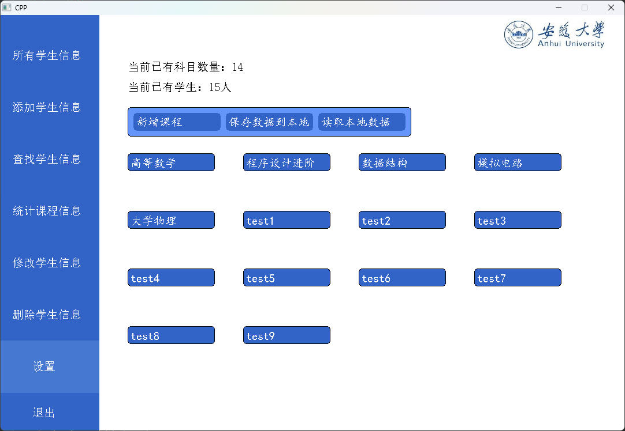

可新增课程，保存数据到本地或从本地读取数据，同时对每个课程可以单独选择修改课程名称或者删除此课程

函数代码：

//保存数据到本地  
void Save() {  
 ofstream outfile;  
 outfile.open("data.txt");  
 outfile << s.size() << " " << lessonNumber << endl;  
 for (int i = 0; i < lessonNumber; ++i) {  
 outfile << lessonList[i] << " ";  
 }outfile << endl;  
 for (const auto& i : s) {  
 outfile << i.id << " " << i.name << " " << i.gender << " ";  
 for (int j = 0; j < lessonNumber; ++j) {  
 outfile << i.ls[j] << " ";  
 }outfile << endl;  
 }  
 outfile.close();  
}  
  
//从本地读取数据  
void Read() {  
 ifstream infile;  
 infile.open("data.txt");  
 int vsize;  
 infile >> vsize >> lessonNumber;  
 for (int i = 0; i < lessonNumber; ++i) {  
 infile >> lessonList[i];  
 }  
 stu t;  
 while(!empty(s)) s.pop_back();  
 for (int i = 0; i < vsize; ++i) {  
 infile >> t.id >> t.name >> t.gender;  
 for (int j = 0; j < lessonNumber; ++j) {  
 infile >> t.ls[j];  
 }  
 s.push_back(t);  
 }  
 for (auto & i : s){  
 for (int j = 0; j < lessonNumber; ++j) {  
 i.score += i.ls[j];  
 }  
 }  
 infile.close();  
}  
  
//设置界面绘制  
void settinggraph(){  
 menu(7);  
 char ts1[100];  
 sprintf(ts1, "%s%d","当前已有科目数量：", lessonNumber);  
 ot(220, 80, BLACK, 20, 0, ts1, "宋体");  
 char ts2[100];  
 sprintf(ts2, "%s%zu%s", "当前已有学生：", s.size(), "人");  
 ot(220, 115, BLACK, 20, 0, ts2, "宋体");  
  
 setfillcolor(RGB(100, 150, 250));  
 setlinecolor(BLACK);  
 fillroundrect(220, 160, 710, 210, 10, 10);  
 setfillcolor(RGB(50, 100, 200));  
 solidroundrect(230, 170, 380, 200, 10, 10);  
 solidroundrect(390, 170, 540, 200, 10, 10);  
 solidroundrect(550, 170, 700, 200, 10, 10);  
 ot(235, 176, WHITE, 20, 0, "新增课程", "楷体");  
 ot(395, 176, WHITE, 20, 0, "保存数据到本地", "楷体");  
 ot(555, 176, WHITE, 20, 0, "读取本地数据", "楷体");  
 for (int i = 0; i < lessonNumber; ++i) {  
 fillroundrect(220 + i % 4 * 200, 240 + i / 4 * 100, 370 + i % 4 * 200, 270 + i / 4 * 100, 10, 10);  
 char st[100];  
 sprintf(st, "%s", lessonList[i].c_str());  
 ot(225 + i % 4 * 200, 247 + i / 4 * 100, WHITE, 20, 0, st, "楷体");  
 }  
}  
//设置  
void Setting() {  
 settinggraph();  
 while(true){  
 if(peekmessage(&msg, EM_MOUSE)){  
 menuanimation(msg.x, msg.y, 7);  
  
 button_animation(msg, 230, 170, 380, 200, WHITE, RGB(50, 100, 200));  
 button_animation(msg, 390, 170, 540, 200, WHITE, RGB(50, 100, 200));  
 button_animation(msg, 550, 170, 700, 200, WHITE, RGB(50, 100, 200));  
 for (int i = 0; i < lessonNumber; ++i) {  
 int tx = i % 4 * 200;  
 int ty = i / 4 * 100;  
 if(msg.x >= 220 + tx && msg.x <= 370 + tx && msg.y > 240 + ty && msg.y <= 270 + ty){  
 setlinecolor(WHITE);  
 roundrect(221 + tx, 241 + ty, 369 + tx, 269 + ty, 10, 10);  
 }else{  
 setlinecolor(RGB(50,100,200));  
 roundrect(221 + tx, 241 + ty, 369 + tx, 269 + ty, 10, 10);  
 }  
 }  
 switch (msg.message) {  
 case WM_LBUTTONDOWN:  
 if(msg.x >= 0 && msg.x <= 170 && msg.y >= 25 && msg.y <= 720){  
 choose = choosegraph(msg.x, msg.y);  
 if(choose != 7){  
 flushmessage(EM_MOUSE);  
 return;  
 }  
 }  
 if(msg.x >= 230 && msg.x <= 380 && msg.y >= 170 && msg.y <= 200){  
 if(lessonNumber == 20){  
 HWND er = GetHWnd();  
 MessageBox(er, "添加失败，课程数已超过上限（20）", "错误", MB_OK);  
 break;  
 }  
 char st[100];  
 InputBox(st, 100, "请输入课程名称");  
 bool flag = false;  
 for (int i = 0; i < lessonNumber; ++i) {  
 if(lessonList[i] == st){  
 HWND er = GetHWnd();  
 MessageBox(er, "添加失败，课程已存在", "错误", MB_OK);  
 flag = true;  
 break;  
 }  
 }  
 if(flag) break;  
 lessonNumber++;  
 lessonList[lessonNumber-1] = st;  
 flushmessage(EM_MOUSE);  
 settinggraph();  
 }  
 if(msg.x >= 390 && msg.x <= 540 && msg.y >= 170 && msg.y <= 200) {  
 Save();  
 HWND res = GetHWnd();  
 MessageBox(res, "保存成功", "提示", MB_OK);  
 settinggraph();  
 }  
 if(msg.x >= 550 && msg.x <= 700 && msg.y >= 170 && msg.y <= 200){  
 Read();  
 if(lessonNumber == 0 && s.empty()){  
 HWND er = GetHWnd();  
 MessageBox(er, "本地无数据，读取失败", "错误", MB_OK);  
 }  
 else if(lessonNumber == 0){  
 HWND er = GetHWnd();  
 MessageBox(er, "当前课程数量为零，增加课程", "提示", MB_OK);  
  
 }  
 else{  
 HWND er = GetHWnd();  
 char ch[100];  
 sprintf(ch, "%s", "读取成功，数据已更新");  
 MessageBox(er, ch, "提示", MB_OK);  
 }  
 settinggraph();  
 }  
 for (int i = 0; i < lessonNumber; ++i) {  
 int tx = i % 4 * 200;  
 int ty = i / 4 * 100;  
 if(msg.x >= 220 + tx && msg.x <= 370 + tx && msg.y > 240 + ty && msg.y <= 270 + ty){  
 setfillcolor(RGB(200,200,200));  
 setlinecolor(BLACK);  
 fillrectangle(220 + tx, 270 + ty, 370 + tx, 295 + ty);  
 fillrectangle(220 + tx, 295 + ty, 370 + tx, 320 + ty);  
 ot(225 + tx, 275 + ty, BLACK, 15, 0, "修改名称", "宋体");  
 ot(225 + tx, 300 + ty, BLACK, 15, 0, "删除", "宋体");  
 flushmessage(EM_MOUSE);  
 setlinecolor(WHITE);  
 while(true) {  
 msg = getmessage(EM_MOUSE);  
 if (msg.x < 220 + tx || msg.x > 370 + tx || msg.y < 240 + ty || msg.y > 320 + ty) {  
 clearrectangle(220 + tx, 270 + ty, 370 + tx, 320 + ty);  
 break;  
 }  
 if (msg.y <= 295 + ty && msg.y > 270 + ty){  
 setfillcolor(RGB(128,128,128));  
 fillrectangle(220 + tx, 270 + ty, 370 + tx, 295 + ty);  
 ot(225 + tx, 275 + ty, BLACK, 15, 0, "修改名称", "宋体");  
 }else{  
 setfillcolor(RGB(200,200,200));  
 fillrectangle(220 + tx, 270 + ty, 370 + tx, 295 + ty);  
 ot(225 + tx, 275 + ty, BLACK, 15, 0, "修改名称", "宋体");  
 }  
 if (msg.y <= 320 + ty && msg.y > 295 + ty){  
 setfillcolor(RGB(128,128,128));  
 fillrectangle(220 + tx, 295 + ty, 370 + tx, 320 + ty);  
 ot(225 + tx, 300 + ty, BLACK, 15, 0, "删除", "宋体");  
 }else{  
 setfillcolor(RGB(200,200,200));  
 fillrectangle(220 + tx, 295 + ty, 370 + tx, 320 + ty);  
 ot(225 + tx, 300 + ty, BLACK, 15, 0, "删除", "宋体");  
 }  
 switch (msg.message) {  
 case WM_LBUTTONDOWN:{  
 if(msg.y <= 295 + ty && msg.y > 270 + ty && msg.x <= 370 + tx && msg.x >= 220 + tx){  
 char st[100];  
 InputBox(st,100,"修改后的课程名称");  
 lessonList[i] = st;  
 settinggraph();  
 }  
 //删除后从每个人的总成绩中减去此课程的成绩，并将后面课程的成绩向前移动，将lessonNumber - 1  
 if(msg.y <= 320 + ty && msg.y > 295 + ty && msg.x <= 370 + tx && msg.x >= 220 + tx){  
 for (int j = i; j < lessonNumber - 1; ++j) {  
 lessonList[j] = lessonList[j + 1];  
 }  
 for (auto & j : s) {  
 j.score -= j.ls[i];  
 for (int k = i; k < lessonNumber - 1; ++k) {  
 j.ls[k] = j.ls[k + 1];  
 }  
 }lessonList[lessonNumber] = " ";  
 lessonNumber --;  
 HWND res = GetHWnd();  
 MessageBox(res, "删除成功", "提示", MB_OK);  
 settinggraph();  
 }  
 }  
 }  
 }  
 }  
 }  
 }  
 flushmessage(EM_MOUSE);  
 }  
 }  
}

（9）退出界面

界面及功能：

点击左下角退出后会在当前界面中心弹出窗口，可选择保存并退出、直接退出和取消

如果选择保存并退出，那么便先Save()再关闭窗口，直接退出便省去Save()，如果取消，则将界面退回到qchoose存储的上一级界面

函数代码：

//退出界面  
void Quit(){  
 setlinecolor(RGB(50, 100, 200));  
 setfillcolor(RGB(50, 100, 200));  
 fillrectangle(500, 230, 720, 260);  
 setfillcolor(WHITE);  
 fillrectangle(500, 260, 720, 410);  
 setfillcolor(RGB(50, 100, 200));  
 fillroundrect(520, 280, 700, 310, 10, 10);  
 fillroundrect(520, 320, 700, 350, 10, 10);  
 fillroundrect(520, 360, 700, 390, 10, 10);  
 ot(505, 235, WHITE, 20, 0, "退出系统？", "宋体");  
 ot(560, 285, WHITE, 20, 0, "保存并退出", "宋体");  
 ot(570, 325, WHITE, 20, 0, "直接退出", "宋体");  
 ot(585, 365, WHITE, 20, 0, "取消", "宋体");  
 while(true){  
 msg = getmessage(EM_MOUSE);  
 button_animation(msg, 520, 280, 700, 310, WHITE, RGB(50, 100, 200));  
 button_animation(msg, 520, 320, 700, 350, WHITE, RGB(50, 100, 200));  
 button_animation(msg, 520, 360, 700, 390, WHITE, RGB(50, 100, 200));  
  
 switch (msg.message) {  
 case WM_LBUTTONDOWN:{  
 if(msg.x >= 520 && msg.x <= 700 && msg.y >= 280 && msg.y <= 310){  
 Save();  
 choose = 10;  
 closegraph();  
 return;  
 }  
 if(msg.x >= 520 && msg.x <= 700 && msg.y >= 320 && msg.y <= 350){  
 choose = 10;  
 closegraph();  
 return;  
 }  
 //如果选择取消，则将界面恢复到进入退出界面前的界面，即qchoose对应的界面  
 if(msg.x >= 520 && msg.x <= 700 && msg.y >= 360 && msg.y <= 390){  
 choose = qchoose;  
 flushmessage(EM_MOUSE);  
 return;  
 }  
 }  
 }  
 }  
}

（10）开始界面/首次进入界面

界面及功能：

如果可选择进入系统或者退出，如果选择进入系统，则可选直接进入设置进行课程自定义或者从本地读取数据，也就是首次进入界面

函数代码：

//开始界面绘制  
bool endsystem;  
void startgraph() {  
 flushmessage(EM_MOUSE);  
 **IMAGE** ah;  
 loadimage(&ah,R"(.\ahu.jpg)", 250, 80, false);  
 putimage(400, 150, &ah);  
 setlinecolor(BLACK);  
 rectangle(380,250,700,295);  
 ot(390, 260, BLACK, 30, 0, "欢迎使用小型教务系统", "楷体");  
  
 setfillcolor(RGB(50,100,200));  
 fillroundrect(450, 320, 630, 355, 10, 10);  
 fillroundrect(450, 370, 630, 405, 10, 10);  
  
 ot(500, 330, WHITE, 20, 0, "进入系统", "楷体");  
 ot(520, 378, WHITE, 20, 0, "退出", "楷体");  
 while(true){  
 if(peekmessage(&msg, EM_MOUSE)){  
 if(msg.x >= 450 && msg.x <= 630 && msg.y >= 320 && msg.y <= 355){  
 setlinecolor(WHITE);  
 roundrect(451, 321, 629, 354, 10, 10);  
 }  
 else {  
 setlinecolor(RGB(50, 100, 200));  
 roundrect(451, 321, 629, 354, 10, 10);  
 }  
 if(msg.x >= 450 && msg.x <= 630 && msg.y >= 370 && msg.y <= 405){  
 setlinecolor(WHITE);  
 roundrect(451, 371, 629, 404, 10, 10);  
 }  
 else {  
 setlinecolor(RGB(50, 100, 200));  
 roundrect(451, 371, 629, 404, 10, 10);  
 }  
  
 switch(msg.message){  
 case WM_LBUTTONDOWN:  
 if(msg.x >= 450 && msg.x <= 630 && msg.y >= 320 && msg.y <= 355){  
 flushmessage(EM_MOUSE);  
 return;  
 }  
 if(msg.x >= 450 && msg.x <= 630 && msg.y >= 370 && msg.y <= 405){  
 endsystem = true;  
 closegraph();  
 return;  
 }  
 }  
 }  
 }  
}

//首次进入界面绘制  
void askinggraph() {  
 flushmessage(EM_MOUSE);  
 cleardevice();  
 ot(230, 230, BLACK, 25, 0, "当前系统无数据,可选择读取本地数据或进行初始化设置", "楷体");  
 setfillcolor(RGB(50, 100, 200));  
 setlinecolor(BLACK);  
 fillroundrect(450, 280, 630, 325, 10, 10);  
 fillroundrect(450, 355, 630, 400, 10, 10);  
 ot(480, 293, WHITE, 20, 0, "读取本地数据", "楷体");  
 ot(500, 368, WHITE, 20, 0, "进入设置", "楷体");  
 while (true) {  
 msg = getmessage(EM_MOUSE);  
 if (msg.x >= 450 && msg.x <= 630 && msg.y >= 280 && msg.y <= 325) {  
 setlinecolor(WHITE);  
 roundrect(451, 281, 629, 324, 10, 10);  
 } else {  
 setlinecolor(RGB(50, 100, 200));  
 roundrect(451, 281, 629, 324, 10, 10);  
 }  
 if (msg.x >= 450 && msg.x <= 630 && msg.y >= 330 && msg.y <= 375) {  
 setlinecolor(WHITE);  
 roundrect(451, 356, 629, 399, 10, 10);  
 } else {  
 setlinecolor(RGB(50, 100, 200));  
 roundrect(451, 356, 629, 399, 10, 10);  
 }  
  
 switch (msg.message) {  
 case WM_LBUTTONDOWN:  
 if (msg.x >= 450 && msg.x <= 630 && msg.y >= 280 && msg.y <= 325) {  
 Read();  
 if (lessonNumber == 0 && s.empty()) {  
 HWND er = GetHWnd();  
 MessageBox(er, "本地无数据，将进入设置", "错误", MB_OK);  
 flushmessage(EM_MOUSE);  
 Setting();  
 return;  
 } else if (lessonNumber == 0) {  
 HWND er = GetHWnd();  
 MessageBox(er, "当前课程数量为零，请进入设置增加课程", "提示", MB_OK);  
 flushmessage(EM_MOUSE);  
 Setting();  
 return;  
 } else {  
 HWND er = GetHWnd();  
 char ch[100];  
 sprintf(ch, "%s%d%s%d%s", "读取成功，当前有", int(s.size()), "名学生，", lessonNumber,  
 "门课程");  
 flushmessage(EM_MOUSE);  
 MessageBox(er, ch, "提示", MB_OK);  
 return;  
 }  
 }  
 if (msg.x >= 450 && msg.x <= 630 && msg.y >= 355 && msg.y <= 400) {  
 endsystem = true;  
 flushmessage(EM_MOUSE);  
 Setting();  
 return;  
 }  
 }  
 }  
}

（11）统计信息二级菜单

界面及功能：

即选择“统计学生信息”功能后的二级菜单界面，可选择进入按指定课程排名或者按指定分数段统计

函数代码：

//统计信息二级菜单  
void Sort_or_Score(){  
 menu(4);  
 setlinecolor(RGB(70,120,210));  
 setfillcolor(RGB(70,120,210));  
 fillrectangle(170, 0, 340, 720);  
 ot(190, 60, WHITE, 20, 0, "指定课程排名", "宋体");  
 ot(182, 150, WHITE, 20, 0, "指定分数段统计", "宋体");  
 while(true) {  
 if (peekmessage(&msg, EM_MOUSE)) {  
 menuanimation(msg.x, msg.y, 4);  
 if (msg.x >= 170 && msg.x <= 340 && msg.y >= 25 && msg.y <= 115) ot(190, 60, YELLOW, 20, 0, "指定课程排名", "宋体");  
 else ot(190, 60, WHITE, 20, 0, "指定课程排名", "宋体");  
 if(msg.x >= 170 && msg.x <= 340 && msg.y >= 115 && msg.y <= 205) ot(182, 150, YELLOW, 20, 0, "指定分数段统计", "宋体");  
 else ot(182, 150, WHITE, 20, 0, "指定分数段统计", "宋体");  
 }  
 switch (msg.message) {  
 case WM_LBUTTONDOWN:{  
 if(msg.x >= 0 && msg.x <= 170 && msg.y >= 25 && msg.y <= 720){  
 choose = choosegraph(msg.x, msg.y);  
 if(choose != 4) {  
 flushmessage(EM_MOUSE);  
 return;  
 }  
 }  
 if(msg.x >= 170 && msg.x <= 340 && msg.y >= 25 && msg.y <= 115){  
 flushmessage(EM_MOUSE);  
 choose = 9;  
 return;  
 }  
 if(msg.x >= 170 && msg.x <= 340 && msg.y >= 115 && msg.y <= 205){  
 flushmessage(EM_MOUSE);  
 choose = 0;  
 return;  
 }  
 }  
 }  
 }  
}

5.主函数

即int main()

int main() {  
 initgraph(1080, 720 | EX_SHOWCONSOLE);  
 setbkcolor(WHITE);  
 setbkmode(TRANSPARENT);  
 cleardevice();  
 //初始化窗口  
  
 startgraph();//主界面  
 flushmessage(EM_MOUSE);  
 if(endsystem) return 0;//主界面退出  
  
 if (lessonNumber == 0 && s.empty()) {  
 askinggraph();  
 }//初始化界面  
  
 //界面跳转  
 while (true) {  
 switch (choose) {  
 case 1:  
 PrintAll(); break;  
 case 2:  
 AddStudent(); break;  
 case 3:  
 SearchStudent(); break;  
 case 4:  
 Sort_or_Score(); break;  
 case 5:  
 ChangeStudent(); break;  
 case 6:  
 DelStudent(); break;  
 case 7:  
 Setting(); break;  
 case 8:  
 Quit(); break;  
 case 9:  
 SortPrint(); break;  
 case 0:  
 ScoreStatistics(); break;  
 case 10:  
 return 0;  
 default: break;  
 }  
 }  
}

6.系统功能框架及ui设计逻辑

**四、总结**

在完成基于easyx图形库的小型教务系统的过程中，我获得了很多宝贵的经验和体验。这个项目让我深入了解了C++编程语言以及图形用户界面的设计和实现。

过程中，我初步了解了如何使用easyx图形库创建各种图形界面元素，如按钮、文本框和列表框等。这使得我的教务系统能够以直观、友好的方式与用户进行交互。我发现，良好的用户界面设计能够提升用户的体验，并相比控制台有效增加系统的易用性。同时，我了解了如何设计和实现一个简单的数据库系统来存储和管理学生、课程和成绩等信息。通过使用文件读写操作，我能够将数据持久化保存，并在程序启动时加载数据，实现了数据的长期存储和管理。

在编写代码的过程中，我也遇到了一些挑战和困难。例如，处理用户输入并正确转换类型、判断输入是否合法和验证数据的正确性都是重要的问题。经过不断尝试后我最终找到了解决方案，并会根据用户输入给予适当的提示和反馈。

通过这个项目，我不仅提升了自己的编程能力和解决问题的能力，还加深了对软件开发流程并对大型项目的编写有了一定的初步概念。过程中也深刻切身体悟到很多工程代码中的要求从何而来，又因何而起。例如为什么变量和函数要写全名，因为避免重复和模糊的变量名混淆自己的逻辑，或者造成编写时的误判；再例如为什么要将程序的功能封装函数，因为只有这样才能有效降低编写难度，并提高可维护性，在项目后期也更容易debug；还有就是宝贵的项目开发经验，体会如何到从零开始设计一个项目和如何逐步实现项目等等。我相信这些经验和知识将对我未来的学习和工作有着积极的影响。