SocietyFlow — Account Creation & Approval Lifecycles
Visual Overview: Society Management, Property Owner & Tenant Onboarding Lifecycles

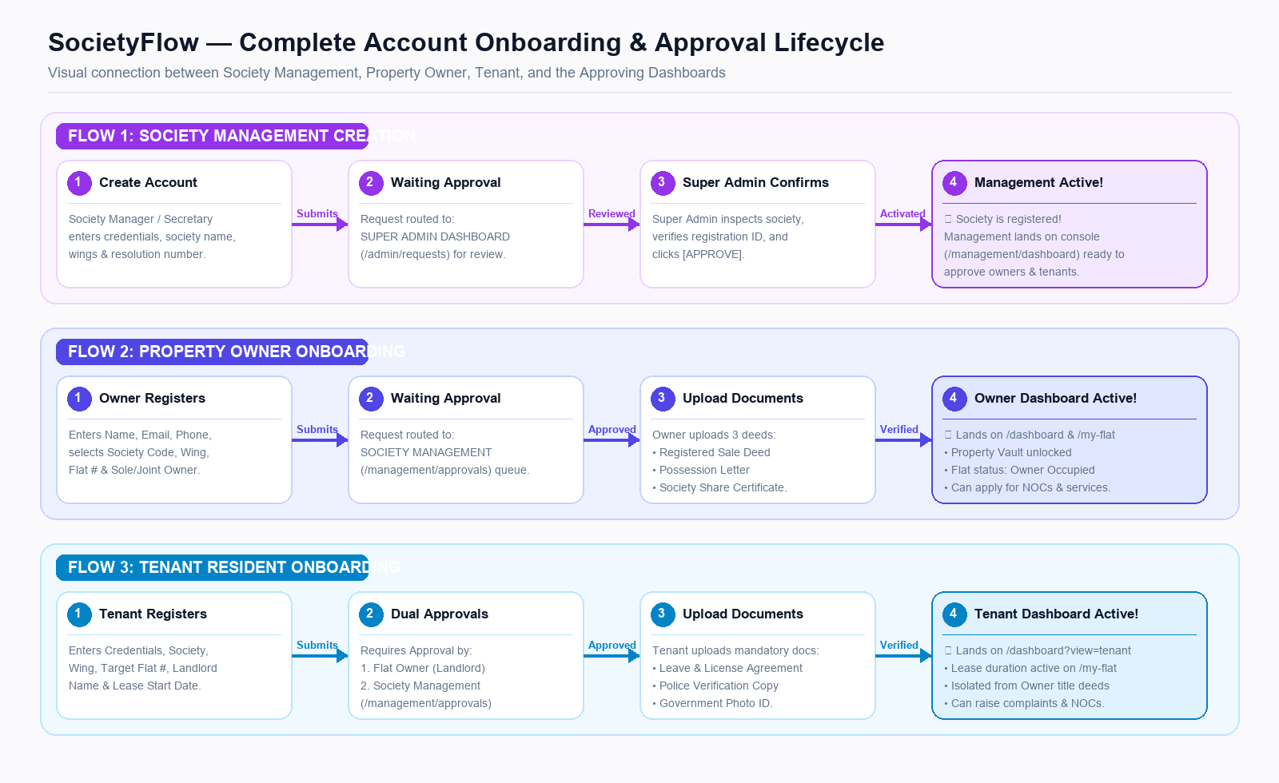
Summary of the 3 Key Onboarding Funnels
Account Type | Waiting Approval On | Mandatory Document Upload | Landed Dashboard
Society Management | Super Admin Dashboard (/admin/requests) | Society registration certificate, bye-laws, and committee resolution | /management/dashboard (Full management console activated)
Property Owner | Society Management Dashboard (/management/approvals) | Sale Deed, Possession Letter, Society Share Certificate | /dashboard & /my-flat (Property vault unlocked)
Tenant Resident | Dual Approval: 1. Flat Owner + 2. Society Management | Leave & License Agreement, Police Verification, Govt ID | /dashboard?view=tenant (Isolated from owner deeds)
SocietyFlow Digital Governance Engine • MCS Act 1960 Visual Flow Reference

