Improving TS-RAG Using Maximal Marginal Relevance

Zoe Rochelle
Intelligent Systems – Dr. Sahoo
Quinnipiac University
zrochelle@quinnipiac.edu

Abstract— This paper evaluates whether Maximal Marginal Relevance (MMR) can improve TS-RAG by reducing redundant retrieval in time-series forecasting. MMR was added as a reranking step after similarity search to increase diversity among retrieved historical segments. Results on ETTh1 and ETTh2 showed that retrieval changed, but MSE and MAE changed only slightly. Overall, MMR was easy to integrate, but its effect on forecasting performance in this setup was limited.
Keywords— time-series forecasting, retrieval-augmented generation, TS-RAG, Maximal Marginal Relevance, diversity-aware retrieval, zero-shot forecasting

Introduction
Time-series forecasting is used in many important areas such as weather prediction, electricity usage, and traffic analysis. Because of this, researchers continue to study ways to improve forecasting accuracy, especially in zero-shot settings where a model is expected to perform well without task-specific retraining. One recent approach is retrieval-augmented forecasting, where the model retrieves similar historical patterns and uses them as extra context during prediction. TS-RAG is one example of this idea, combining time-series forecasting with retrieval of past time-series segments.
A possible weakness of retrieval-based systems is redundancy. In retrieval-augmented models, the system may return many results that are highly similar to each other, which reduces how much useful information retrieval adds [1]. In TS-RAG, this means that the retriever might return several nearly identical historical windows. Even if each retrieved segment is relevant, the group as a whole may not provide much variety. As a result, retrieval may become less informative and may have limited impact on the final forecast.
This project studies whether retrieval diversity can be improved in TS-RAG by adding Maximal Marginal Relevance (MMR). MMR is a reranking method that balances relevance and diversity, selecting items that are both useful and not overly repetitive [2]. The goal of this project was to modify the retrieval stage of TS-RAG so that the system would choose historical patterns that were still similar to the input, but less redundant. The scope of the work was limited to retrieval only. The backbone forecasting model and embedding process were not retrained or replaced.

BACKGROUND AND RELATED WORK
Retrieval-augmented systems have become an important area of research because they allow models to use external information instead of relying only on what is already encoded in model parameters. In natural language processing, retrieval has been shown to improve performance on knowledge-intensive tasks by supplying relevant passages at inference time [1], [4]. However, one challenge is that highly similar retrieved items may not add much new information. This makes diversity-aware retrieval an interesting direction.
MMR is a well-known method for this purpose. Carbonell and Goldstein introduced MMR as a way to rerank results so that the selected items are both relevant to the query and different from one another [2]. In simple terms, MMR does not just ask, “Which result is closest?” It also asks, “Is this result too similar to what has already been chosen?” This balance makes MMR a practical option when retrieval systems produce redundant results.
For this project, MMR was a good choice for three reasons. First, it is a well-established method in information retrieval [2]. Second, it is relatively easy to implement because it works as a reranking step rather than requiring retraining. Third, it fits naturally into an existing retrieval pipeline such as FAISS. Additional discussion of MMR’s advantages, drawbacks, and relation to other retrieval methods appears in [3].

Methodology
The project began by reviewing the TS-RAG repository and identifying a possible area for improvement in the retriever. The original retrieval process uses FAISS similarity search to find the top-k historical windows that are closest to the current input window. This means retrieval is based on similarity alone.
To understand the issue, it helps to look at time-series patterns in simple terms. A time-series segment such as 10 → 12 → 15 → 14 → 18 can be described as “going up, slight dip, then going up again.” Another segment such as 30 → 28 → 25 → 23 → 20 can be described as “steadily going down.” These examples show that time-series retrieval is really about finding similar shapes or trends, not just exact values. If many retrieved segments all show nearly the same shape, the system may be seeing repeated evidence instead of varied useful context.
The same idea can be shown with a simplified input window example. Suppose the input time-series window follows the pattern “up, up, down, up.” In the original TS-RAG retriever, the returned matches might look like this:
1. up, up, down, up
2. up, up, down, up
3. up, up, down, up
4. up, up, down, slightly up

These results are relevant because they are close to the query, but they are also highly redundant. The retriever keeps selecting very similar historical segments because it is focused only on similarity.
To address this, MMR was added after the FAISS search step. In the updated pipeline, FAISS first returns a candidate pool of similar historical windows. Then MMR re-ranks those candidates by considering both relevance to the input window and diversity relative to already selected windows [2]. With MMR, the same input pattern “up, up, down, up” might return results such as:
1. up, up, down, up
2. up, down, down, up
3. up, up, flat, up
4. up, up, down, strong up

These results are still related to the input, but they are not all near-duplicates. This is the key idea behind diversity-aware retrieval. Observe the alteration to the retrieval step in Figures 1 and 2 below:
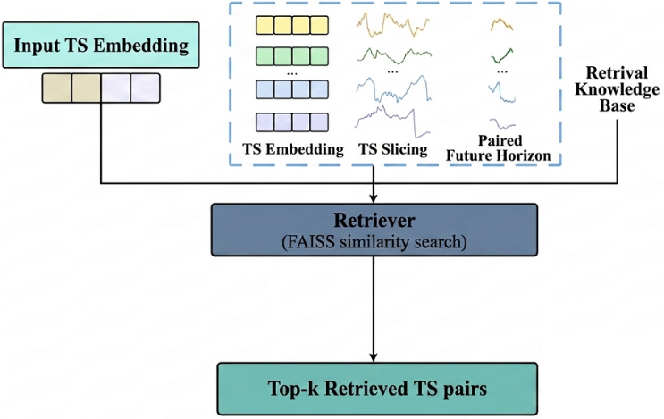
Figure 1 - Base TS-RAG retrieval step
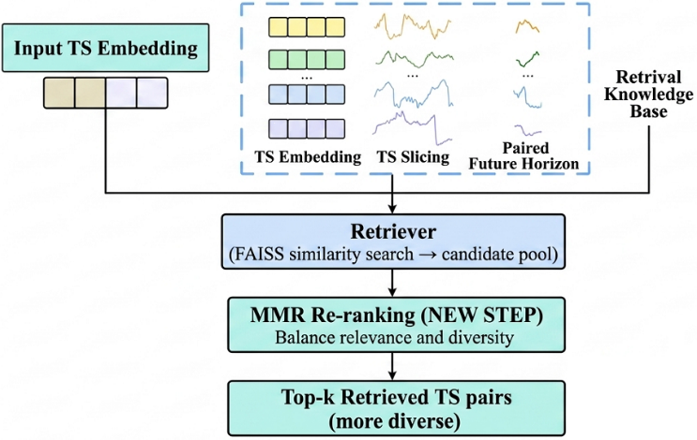
Figure 2 - Retrieval step with MMR
In architectural terms, the original system can be described as: input time-series embedding → FAISS similarity search → top-k retrieved time-series pairs. The modified system becomes: input time-series embedding → FAISS similarity search → candidate pool → MMR reranking → top-k retrieved time-series pairs. This change is relatively small, but it allows the retriever to consider both closeness and variety without changing the forecasting backbone.

Results and Discussion
The experiment was evaluated using Mean Squared Error (MSE) and Mean Absolute Error (MAE), which are standard forecasting metrics. The broader zero-shot setup successfully ran several datasets, including ETTh1, ETTh2, ETTm1, ETTm2, and Weather, but the direct original-versus-MMR comparison in the final report focused on ETTh1 and ETTh.
The experimental results (Figure 3) showed that MMR did change the retrieved results, but the impact on forecasting accuracy was small. On ETTh1, the original system produced an MSE of 0.3556 and an MAE of 0.3623, while the MMR version produced an MSE of 0.3556 and an MAE of 0.3624. On ETTh2, the original system produced an MSE of 0.2451 and an MAE of 0.2981, while the MMR version produced an MSE of 0.2449 and an MAE of 0.2975. This means ETTh1 was essentially unchanged, while ETTh2 showed only a very small improvement.
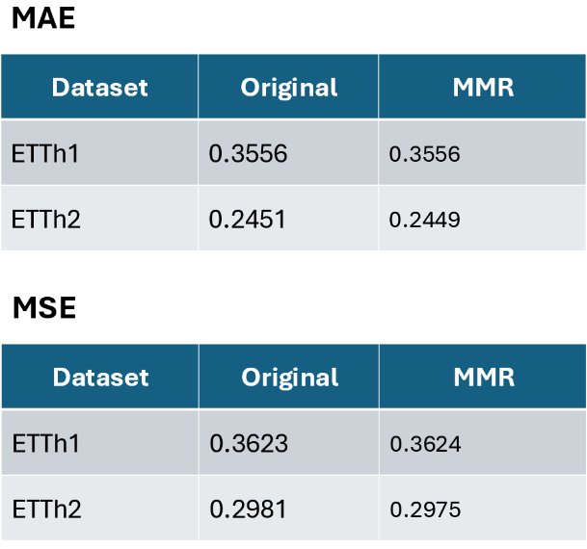
Figure 3 - results comparison
Even though the final metric changes were limited, the output logs showed that the retrieval process itself was changing. The logs printed both the original indices from similarity search and the final MMR indices after reranking. Because these index lists were different, the results confirmed that MMR was actively replacing some redundant retrieved segments with different ones. In other words, the modified retriever was functioning as intended, even if the effect on MSE and MAE was modest.
There are several possible reasons why the improvement was small. First, the original similarity based retrieval may already have been strong enough that reducing redundancy did not help much. Second, more diverse retrieved segments are not automatically more useful for forecasting. A segment may be different from the others, but that does not guarantee it improves prediction quality. Third, the usefulness of MMR may depend on factors such as the dataset, forecast horizon, top-k value, or the relevance-diversity balance chosen during reranking [3].
This outcome is still meaningful. The project demonstrates that retrieval in TS-RAG can be modified in a simple and low-risk way using MMR. It also shows that changing retrieval behavior does not always lead to a large improvement in final forecasting metrics. That is an important result because it helps clarify where future tuning efforts may be needed.

Conclusion
This project explored whether Maximal Marginal Relevance could improve TS-RAG by reducing redundancy in retrieved time-series segments. The modification was successful at the retrieval level: MMR changed which historical windows were selected by balancing relevance and diversity. This confirmed that the new reranking step worked as intended.
However, the effect on forecasting performance was small. ETTh1 showed almost no change, and ETTh2 showed only a slight improvement. Based on these findings, MMR appears to be a reasonable method for making retrieval more diverse, but its impact on forecasting accuracy in this setup was limited. One limitation of this study is that the final comparison was performed on only a small number of datasets and one main retrieval setting.

Future Work
Future work could expand this experiment in several ways. First, the MMR-enhanced retriever should be tested on additional datasets such as ETTm1, ETTm2, and Weather to see whether diversity-aware retrieval has a stronger effect in other forecasting settings. Second, future experiments could vary the MMR relevance-diversity weight to better understand how that balance affects retrieval quality and forecasting accuracy. It would also be useful to compare different top-k values, such as 5, 10, 20, and 64, since the number of retrieved segments may influence how much benefit diversity provides. Finally, longer forecast horizons such as 96, 192, 336, and 720 should be evaluated to determine whether MMR becomes more helpful on more difficult prediction tasks.

References
- P. Lewis *et al*., “Retrieval-augmented generation for knowledge-intensive NLP tasks,” in *Advances in Neural Information Processing Systems (NeurIPS)*, vol. 33, 2020, pp. 9459–9474. [Online]. Available: [https://arxiv.org/abs/2005.11401](https://arxiv.org/abs/2005.11401)
- J. Carbonell and J. Goldstein, “The use of MMR, diversity-based reranking for reordering documents and producing summaries,” in *Proc. 21st Annu. Int. ACM SIGIR Conf. Research and Development in Information Retrieval*, 1998, pp. 335–336.
- A. Gupta, “Retriever in RAG,” *Medium*, Mar. 2024. [Online]. Available: [https://medium.com/@ayushigupta9723/retriever-in-rag-4c25cd2cf2c0](https://medium.com/@ayushigupta9723/retriever-in-rag-4c25cd2cf2c0). [Accessed: Apr. 29, 2026].
- G. Izacard and E. Grave, “Leveraging passage retrieval with generative models for open domain question answering,” *arXiv preprint* arXiv:2007.01282, 2021. [Online]. Available: [https://arxiv.org/pdf/2007.01282](https://arxiv.org/pdf/2007.01282). [Accessed: Apr. 29, 2026].

