EXPLANATION
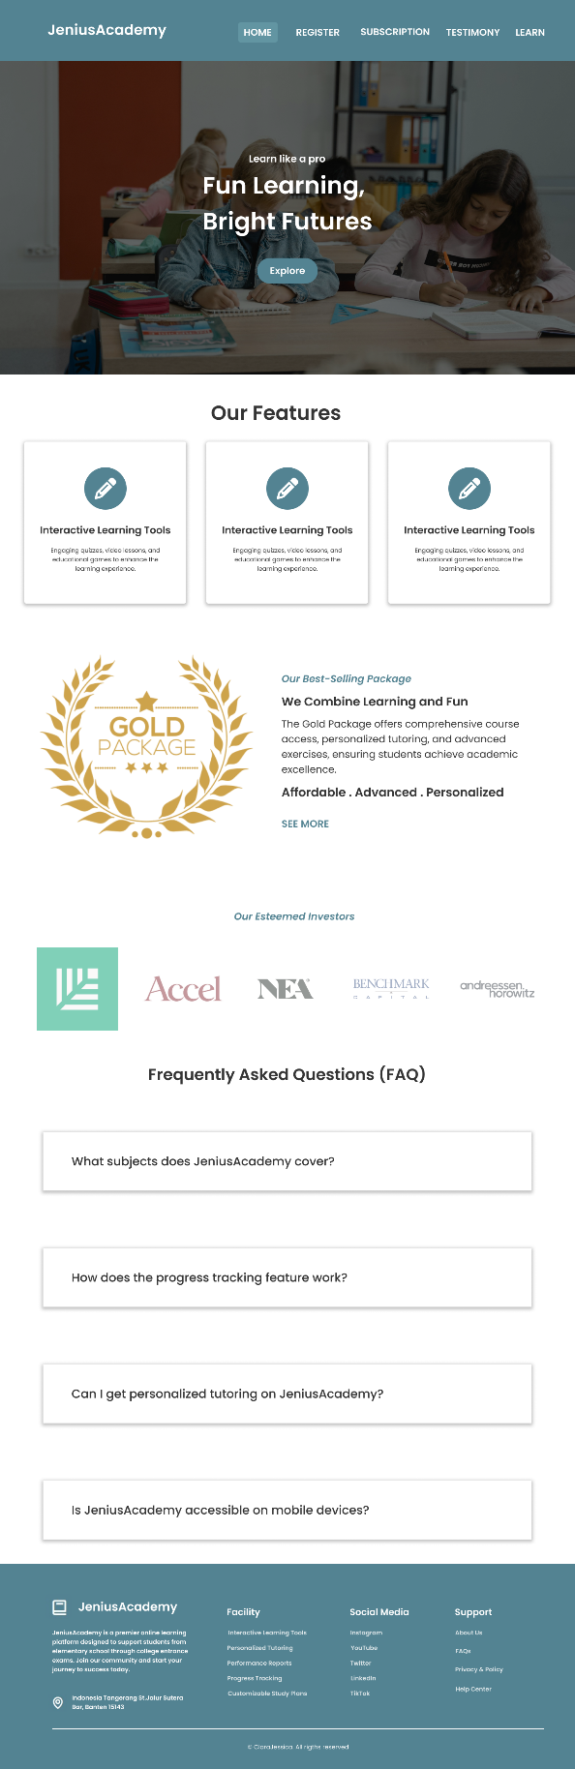 | Home Page  Main Section: There is a website slogan accompanied by an explore button that, when clicked, will direct to the feature section on the home page.  Feature Section: Displays the 3 main features of the website.  Best-Seller Section: Shows the best-selling packages along with information, also accompanied by a see more button that, when clicked, will direct the user to the subscription page.  Investor Section: Displays the 5 largest investors of the website.  FAQs Section: Displays some frequently asked questions from users; if a question is clicked, it will display the answer.
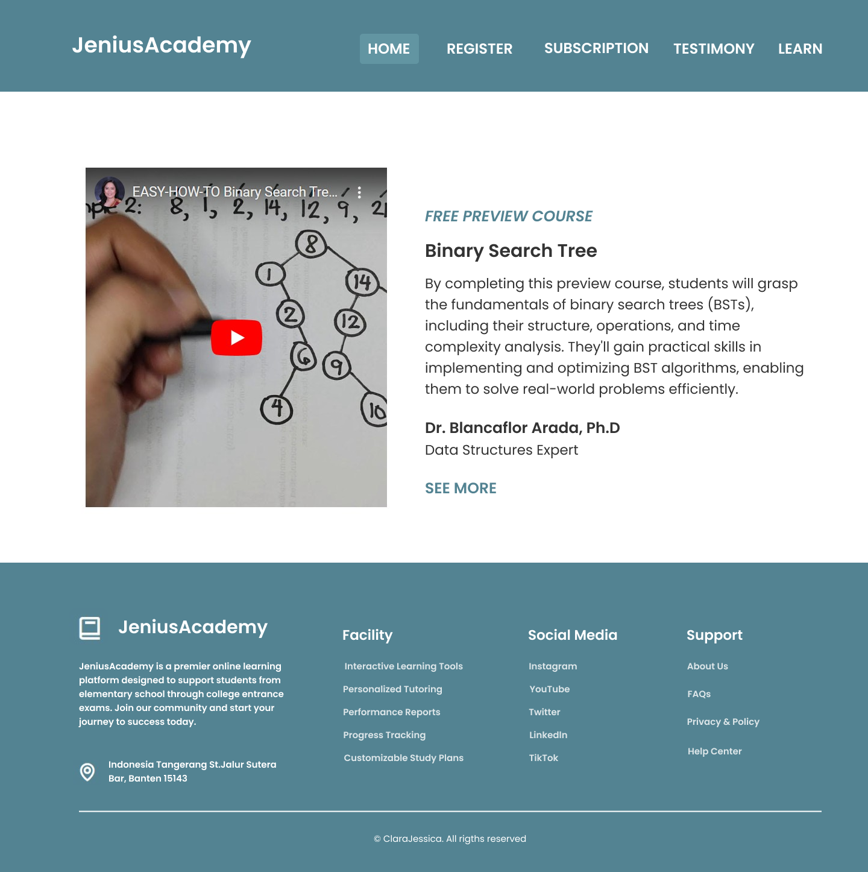
Learn Page
Displays a free preview of the course, along with the learning objectives of the course, course videos, instructor, and instructor's qualifications. There is also a see more button that, when clicked, will direct the user to the registration page.
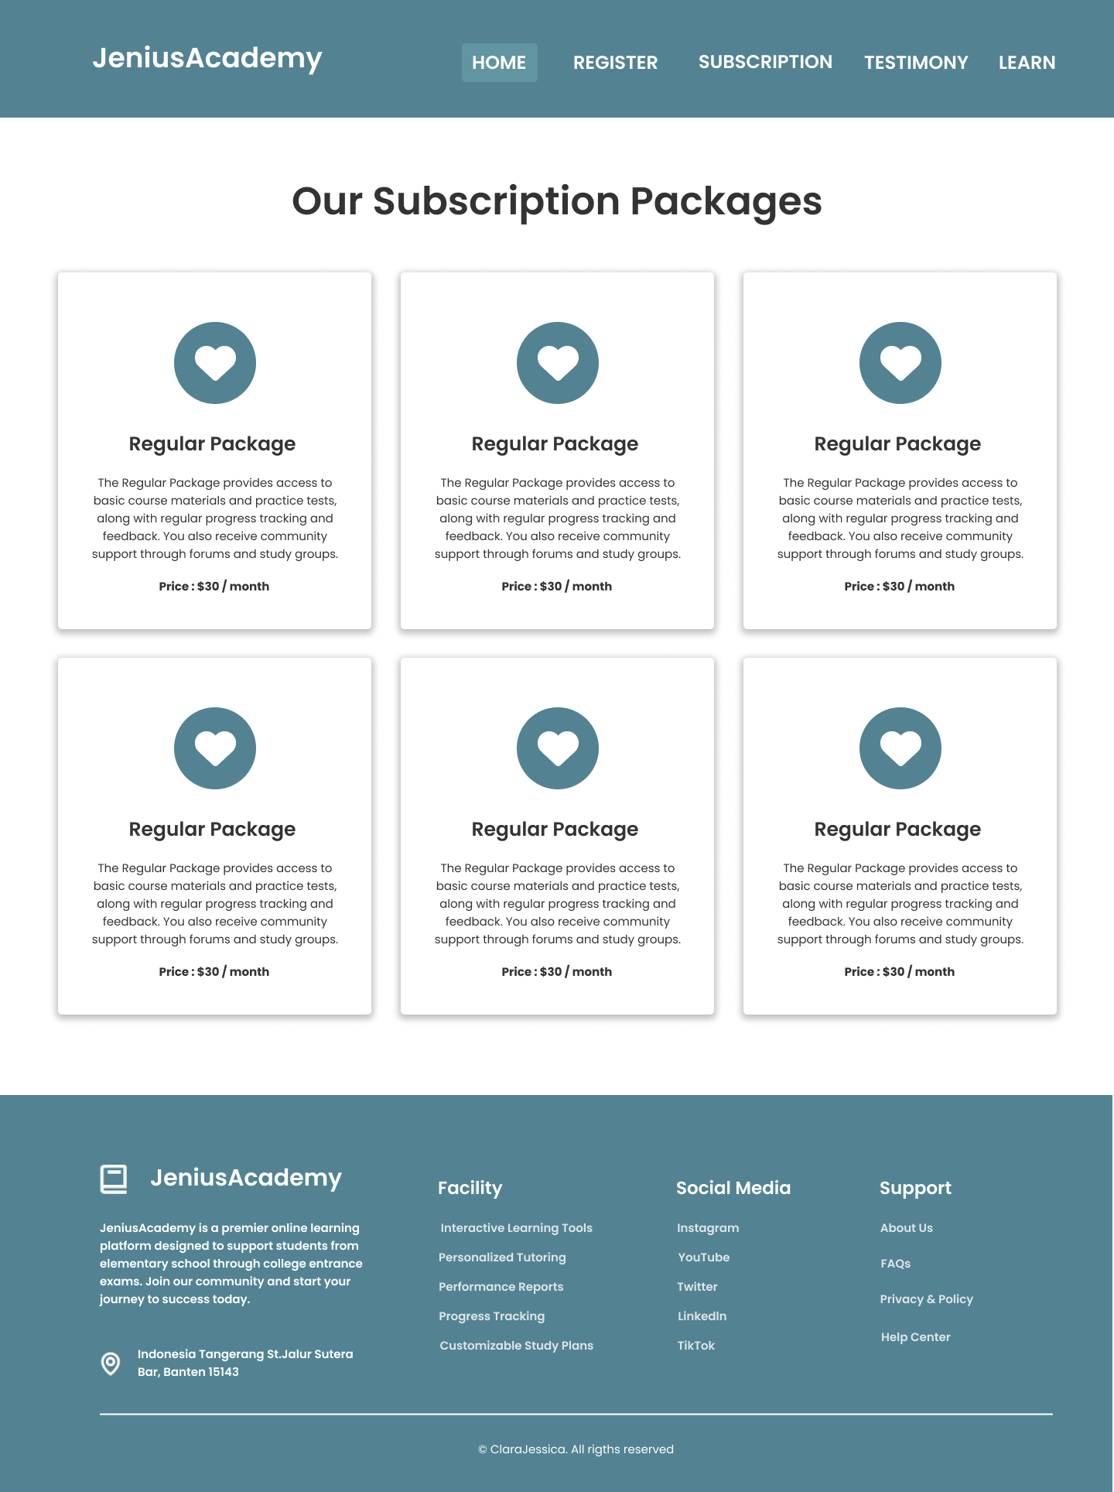
Subscription Page
Displays all available subscription packages, along with their benefits and prices.
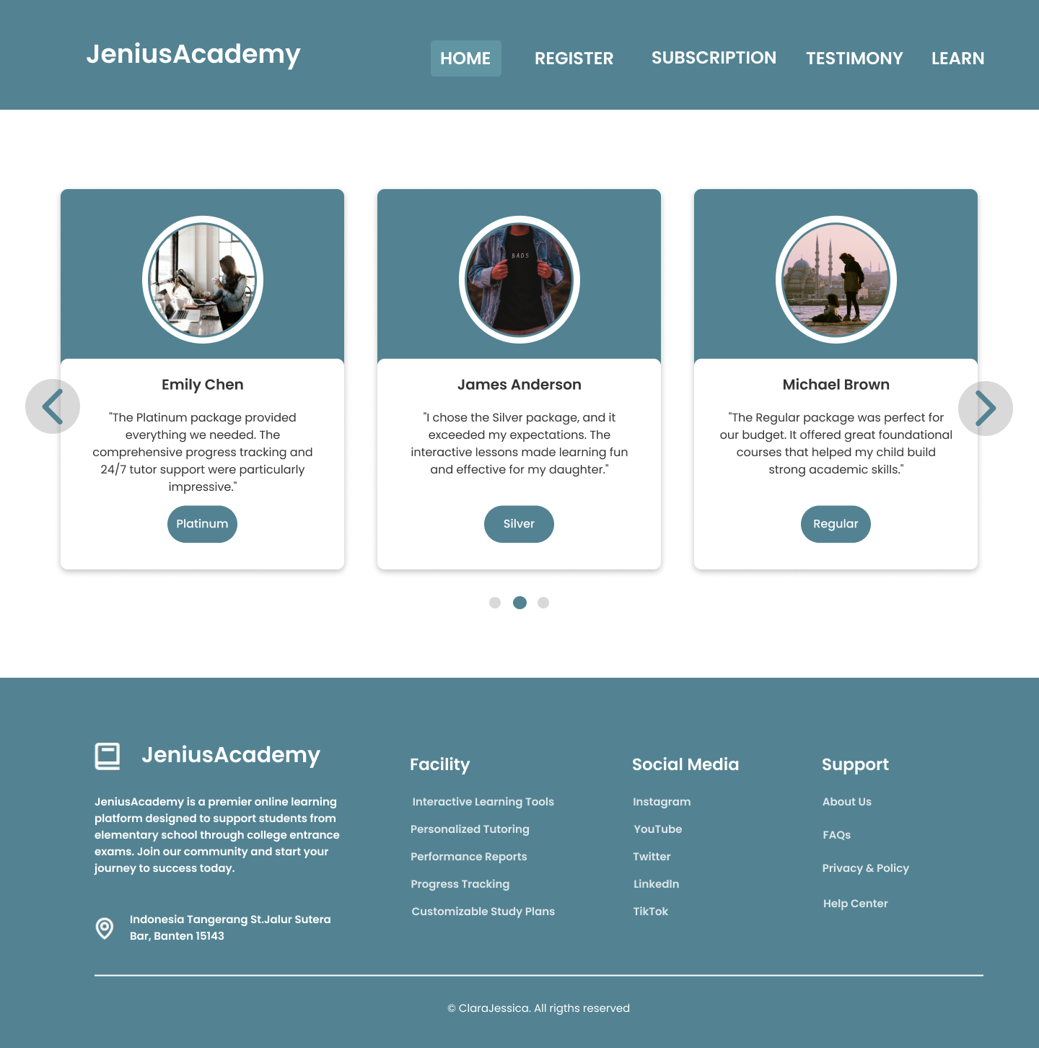
Testimony Page
Displays customer reviews, including the customer's name, the package they purchased, and their comments, in the form of a card carousel slider.

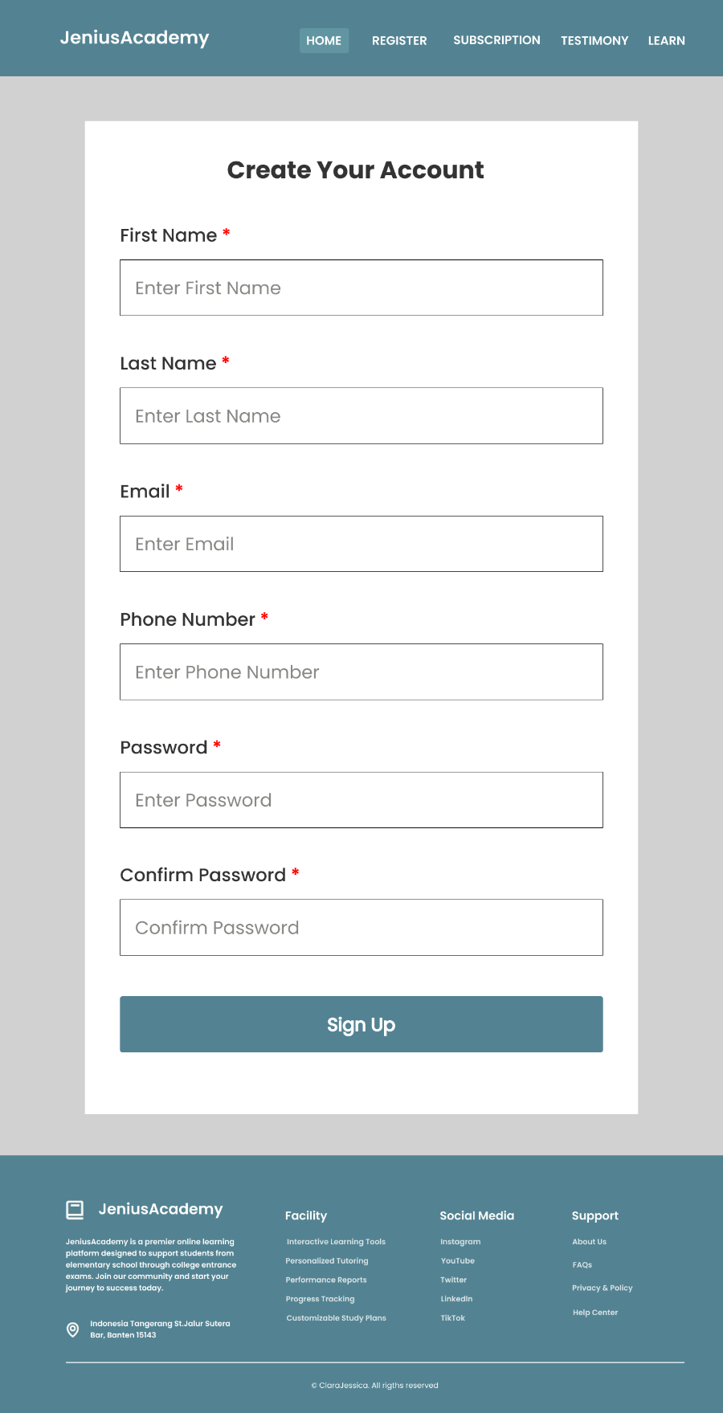 | Register Page  Displays a form for creating an account, which includes six components, each with JavaScript validation. An error message will appear if the user's input is invalid, such as empty fields, invalid email, invalid password, password and confirmation password not matching, name containing digits, and phone number containing letters.

REFERENCE
Icons : https://fontawesome.com/
- Home Page :
Main-banner : https://images.pexels.com/photos/5427651/pexels-photo-5427651.jpeg?auto=compress&cs=tinysrgb&w=600
Best-Seller : https://vipshisha.co.uk/wp-content/uploads/2017/06/gold.png
Investor logo :
- https://pbs.twimg.com/profile_images/1468287449130422278/kv_Og2d2_400x400.png
- https://www.theindianwire.com/wp-content/uploads/2018/07/accel-1200x1200.jpg
- https://assets-global.website-files.com/63dc099d352018653241b1a7/63fda276bb779c7edc7313c9_NEA-Logo-Site.jpg
- https://cdn.worldvectorlogo.com/logos/benchmark-capital.svg
- https://growthequityinterviewguide.com/wp-content/uploads/2023/05/image-34.png
- Testimonial Page :
- https://images.pexels.com/photos/2682452/pexels-photo-2682452.jpeg?auto=compress&cs=tinysrgb&w=600
- https://images.pexels.com/photos/1105058/pexels-photo-1105058.jpeg?auto=compress&cs=tinysrgb&w=600
- https://images.pexels.com/photos/20506739/pexels-photo-20506739/free-photo-of-kota-wanita-perempuan-kaum-wanita.jpeg?auto=compress&cs=tinysrgb&w=600
- https://images.pexels.com/photos/994605/pexels-photo-994605.jpeg?auto=compress&cs=tinysrgb&w=600
- https://images.pexels.com/photos/237272/pexels-photo-237272.jpeg?auto=compress&cs=tinysrgb&w=600
- https://images.pexels.com/photos/189349/pexels-photo-189349.jpeg?auto=compress&cs=tinysrgb&w=600
- https://images.pexels.com/photos/844297/pexels-photo-844297.jpeg?auto=compress&cs=tinysrgb&w=600
- https://images.pexels.com/photos/11177428/pexels-photo-11177428.jpeg?auto=compress&cs=tinysrgb&w=600
- https://images.pexels.com/photos/20494292/pexels-photo-20494292/free-photo-of-pria-laki-laki-lelaki-potret.jpeg?auto=compress&cs=tinysrgb&w=600
- Learn Page : https://youtu.be/J-NDoE7lxHc?si=Y-ReD2yDhJ65DcIW

