UI Report

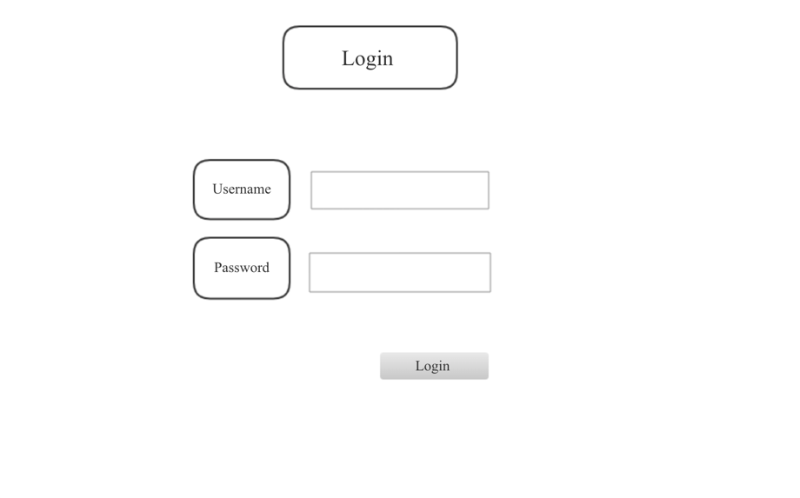

First picture is a login page. Users need to fill in the username and password to log into the account.

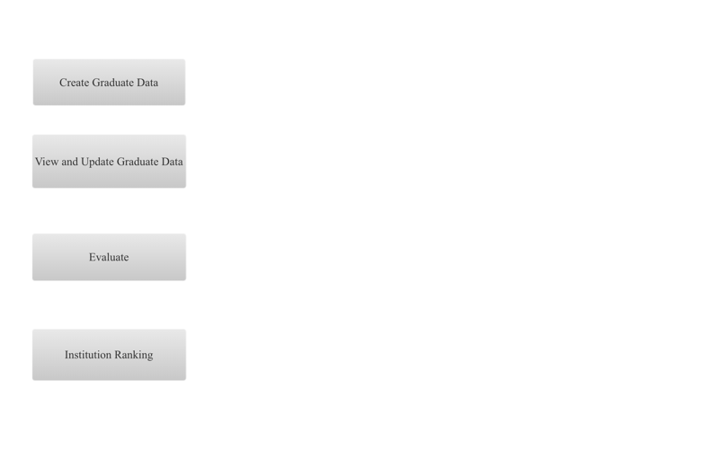

Second image is a main page. Graduate data can be created by click the create button and can be viewed by the view button. If users want to update the data, she can do it in the view graduate data page. Also, there is a evaluate button for users to assess the graduate and its course and faculty. In the bottom, it is an institution ranking button which can show the ranking of institution over the world.

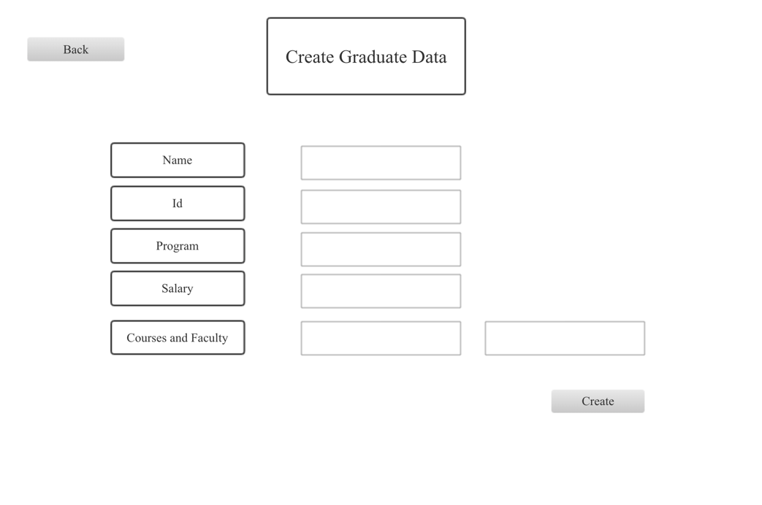

Third picture is a create graduate data page. Graduate’s name, id, program, salary, courses and faculty can be filled in here. Also, there are back and create buttons which allow users to go back or create data.

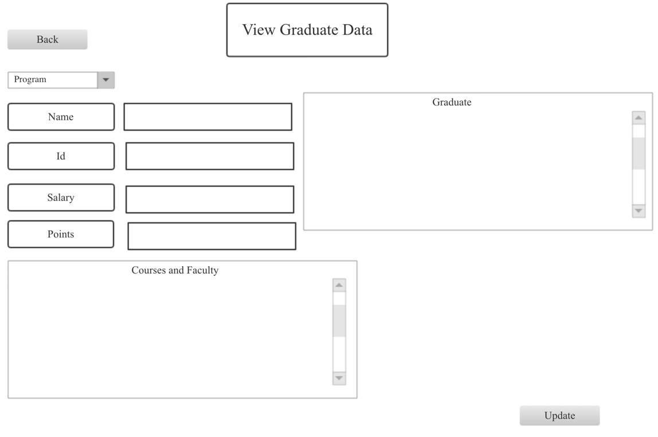

Fourth image is a view and update data page. Users from different programs can view the graduates’ salary, points, courses and faculty. Plus, it has update and back button which allows users to change the data and go back.

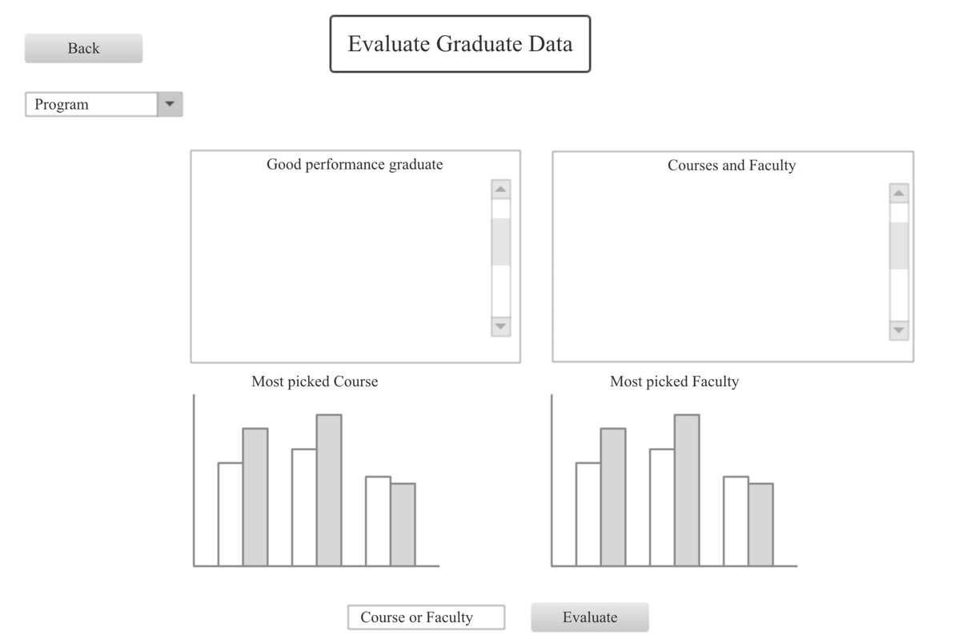

Then, fifth picture is the evaluate graduate data page. Different program’s user can see the good performance graduate and its courses and faculty. Besides, there is a ranking for courses registration rate from high to low. Similarly, there is a ranking for faculty. In the bottom, it is button that allows user to navigate to specific course or faculty.

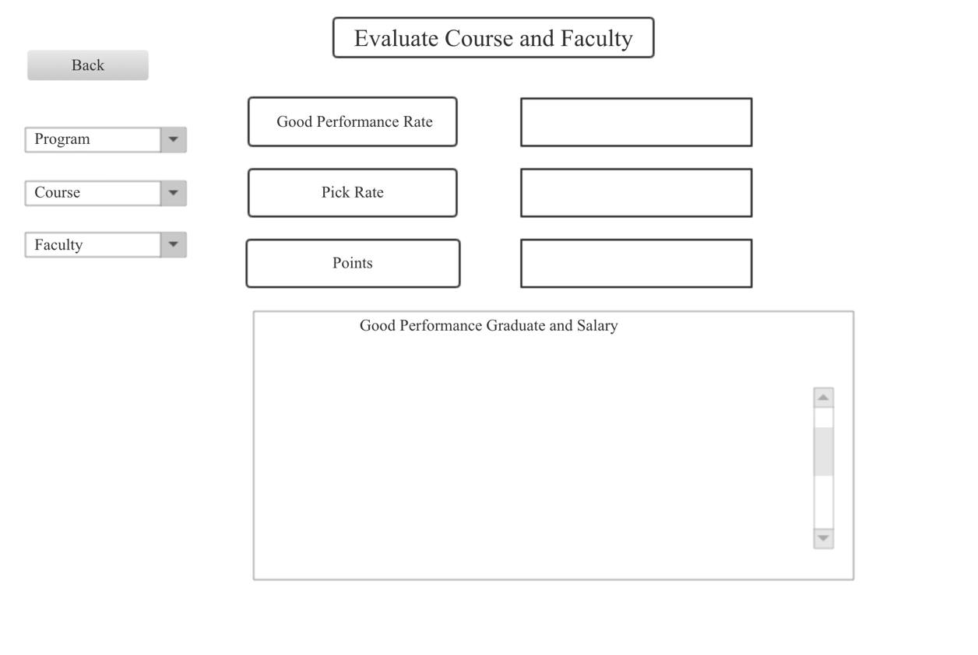

The sixth image is the evaluate course and faculty page. Users can choose different program, course and faculty in the left. After selecting the program, it will show the good performance graduate rate for this program. After selecting the course, the right will show the rate for good performance graduate, course registration and course points. Faculty button is similar to the course button.

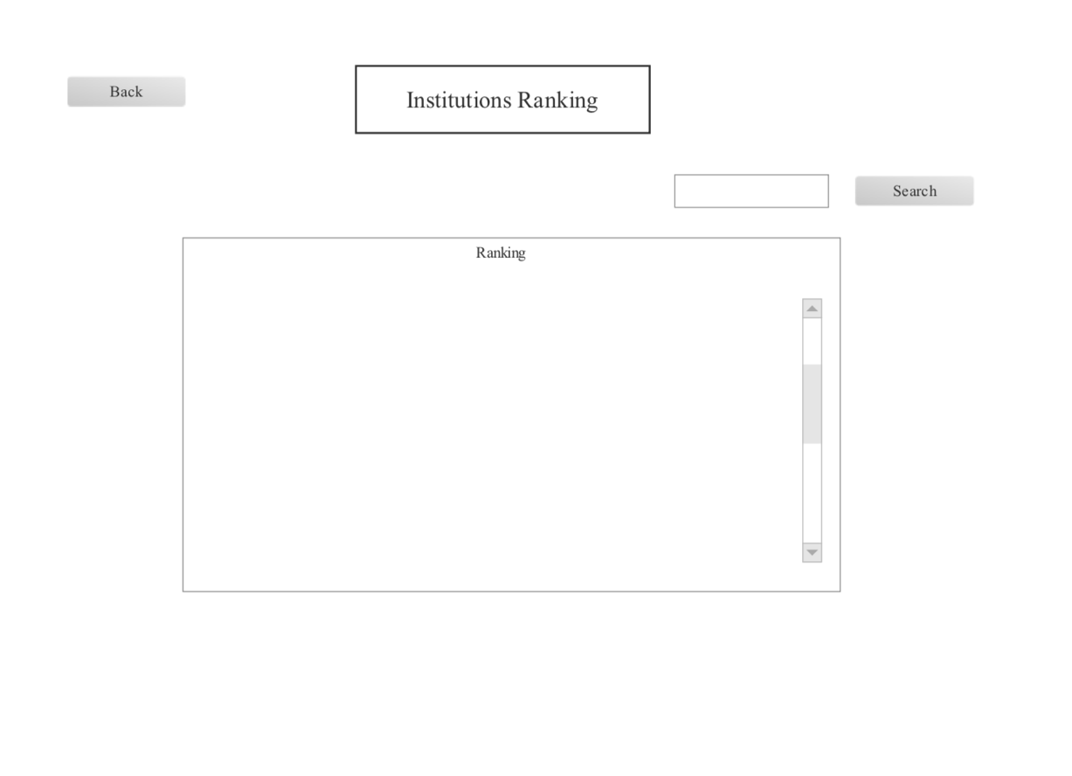

The last picture is an institution ranking. Users can search the institution by name.