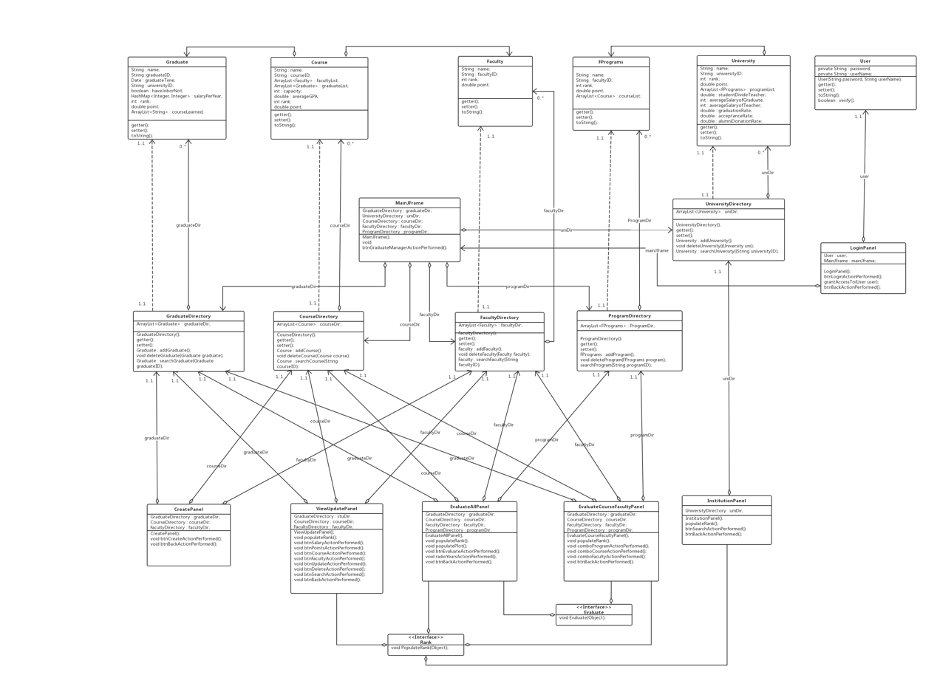

In software engineering, a class diagram in the Unified Modeling Language (UML) is a type of static structure diagram that describes the structure of a system by showing the system's classes, their attributes, operations (or methods), and the relationships among objects.

In the class diagram, dotted lines with arrows indicate dependencies (for example, Graduate and GraduateDirectory are dependencies). Solid lines with diamonds indicate aggregation relationships (for example, CourseDirectory and CreatePanel are aggregation relationships). Solid lines with open triangles indicate implementation relationships (such as the EvaluateAllPanel and Rank interfaces). Solid lines with arrows indicate associations (for example, Course and CourseDirectory are associations).