Application Engineering Design Assignment 1

*Bochao Wang NUID: 001087950*

*Kai Zhang NUID: 001306003*

*Fang Guo NUID: 001326849*

**· Background**

The objective of this assignment is to instill in you the techniques for turning an object model into a machine for information gathering and data aggregation. We want to use software engineering

techniques to improve the quality of education anywhere and hold people accountable for improving the quality of life through education, learning to learn, and feedback.

**· Solution Outline**

To solve the above problems, we have developed a graduate evaluation system to measure the quality of the education they deliver to their students. The system is divided into four parts: 1) Create Graduate Data; 2) View and Update Graduate Data; 3) Evaluation; 4) Institutions Ranking.

To solve the above problems, we have developed a graduate evaluation system to measure the quality of the education they deliver to their students. The system has a total of four functional interfaces: 1) Create Graduate Data; 2) View and Update Graduate Data; 3) Evaluation; 4) Institutions Ranking. Next, we will introduce the specific functions of each interface.

First, the users of this system are university administrators. They enter the management system with a username and password. Into the management system, managers can choose four different functions of the system: 1) Create Graduate Data; 2) View and Update Graduate Data; 3) Evaluation; 4) Institutions Ranking.

In the Create Graduate Data interface, managers can create new graduate data, including their name, ID, Program, salary, course, and more. Among them, the salary is the salary of each graduate within five years of graduation, which can be used to extract the promotion after graduation.

In the View and Update Graduate Data interface, university administrators can view specific data for graduates in different projects, including their names, IDs, salary, points, courses, and tutors. Among them, Points is the student's comprehensive score, and is also an important basis for student ranking. In order to ensure the fairness of the graduates employed in different countries, Points' formula is as follows:

$${Points}_{graduate}=\frac{\sum_{i=0}^{years}{Salary(i)}}{years}×\frac{1}{Average Salary of Country}$$

In the formula, the student's Points is equal to the average annual salary since the graduate graduated, and then divided by the average annual salary of the country where he works. If graduates work in multiple countries, this denominator should be the average annual average wage for each country.

In the Evaluation interface, university administrators can view student evaluation results for different programs. The results of the evaluation include student information with the highest points and its course teachers, the most popular courses, and the most popular teachers. If the manager wants to see the specific course or teacher's evaluation, you can go to the Course or Faculty Evaluation interface to view specific Program Points, Course Points and Faculty Points. Program Points, Course Points and Faculty Points are calculated as follows:

$${Points}_{course}=\frac{\sum_{i=0}^{number of Graduate in course}{{Points}_{graduate}(i)}}{number of Graduate in course}$$

$${Points}_{faculty}=\frac{\sum_{i=0}^{number of Graduate taught by faculty}{{Points}_{graduate}(i)}}{number of Graduate taught by faculty}$$

$${Points}_{program}=\frac{\sum_{i=0}^{number of course in program}{{Points}_{course}(i)}}{number of course in program}$$

As can be seen from the formula, the Point of Course is equal to the average Point of the students who have taken this course. By the same token, Faculty's Point is equal to the average Point of the students taught by this Faculty. The Point of Program is equal to the average Point of Courses in this program.

In the Institutions Ranking interface, university administrators can view and search the rankings of different universities around the world. The ranking of the university is determined by the university's rating, which is calculated as follows:

${Points}_{University}=（k_{1}×\frac{\sum_{i=0}^{number of program}{{Points}_{program}\left(i\right)}}{number of program}+k_{2}×\frac{number of student}{number of faculty}+k_{3}×\frac{Average Salary of faculty}{Average Salary of country}+k_{4}×\frac{Average Salary of graduate}{Average Salary of country}+k_{5}×graduation rate+k_{6}×acceptance rate+k_{7}×alumni donation rate)×\frac{1}{\frac{GDP of Country}{GDP of World}}$ (k1+k2+k3+…+k7=1)

As can be seen from the formula, a school's ranking comes from multiple indicators: average points of program, teacher-student ratio, average wage of faculty, average salary of graduates, graduation rate, admission rate, and alumni donation rate. Each indicator has a coefficient k, and the sum of these coefficients k is 1.

**· Dashboard**

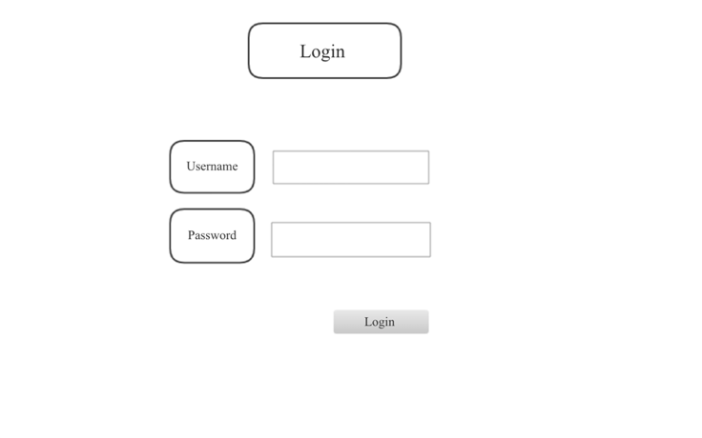

**Picture 1 Login panel**

First picture is a login page. Users need to fill in the username and password to log into the account.

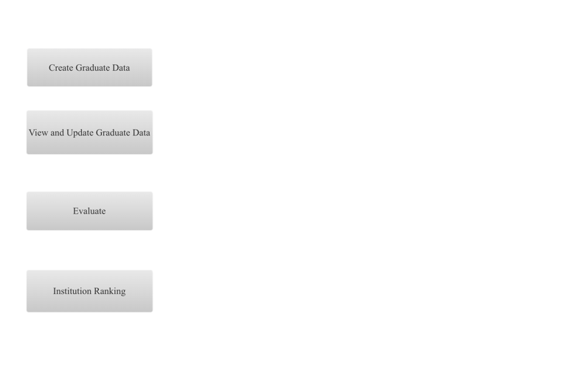

**Picture 2 main panel**

Second image is a main page. Graduate data can be created by click the create button and can be viewed by the view button. If users want to update the data, she can do it in the view graduate data page. Also, there is a evaluate button for users to assess the graduate and its course and faculty. In the bottom, it is an institution ranking button which can show the ranking of institution over the world.

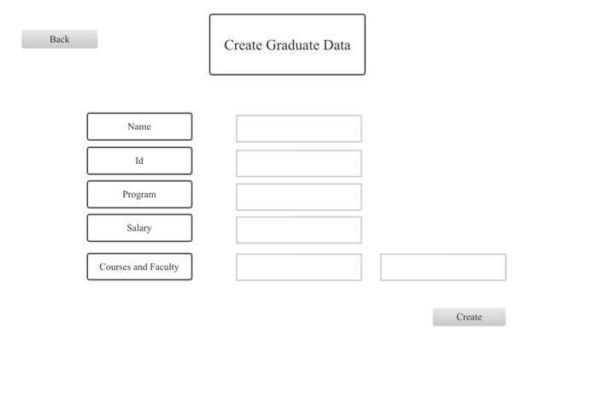

**Picture 3 create panel**

Third picture is a create graduate data page. Graduate’s name, id, program, salary, courses and faculty can be filled in here. Also, there are back and create buttons which allow users to go back or create data.

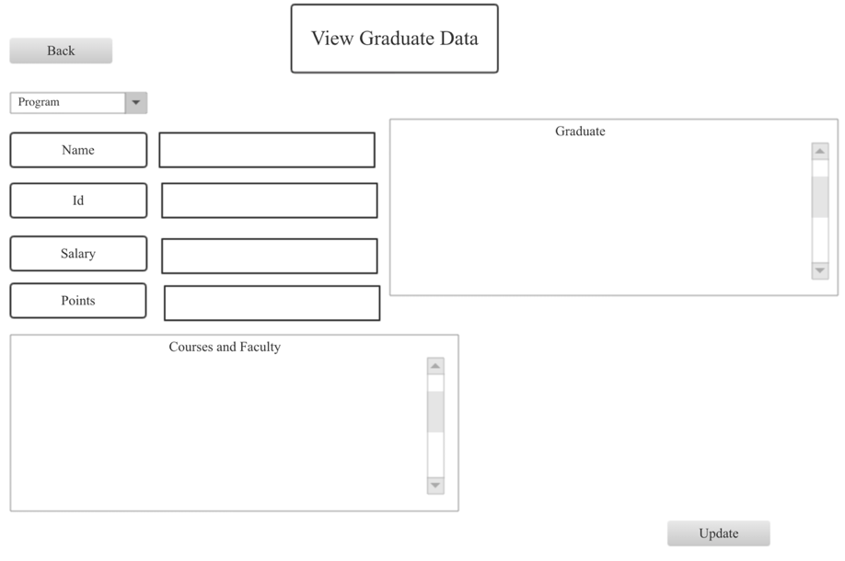

**Picture 4 view panel**

Fourth image is a view and update data page. Users from different programs can view the graduates’ salary, points, courses and faculty. Plus, it has update and back button which allows users to change the data and go back.

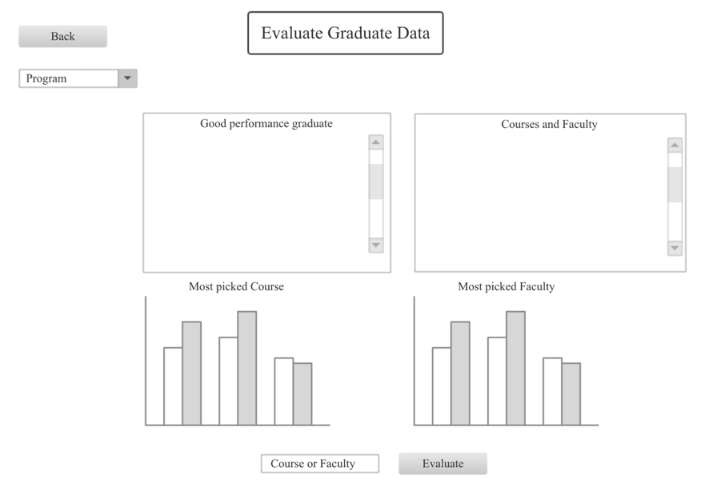

**Picture 5 Evaluate graduate panel**

Then, fifth picture is the evaluate graduate data page. Different program’s user can see the good performance graduate and its courses and faculty. Besides, there is a ranking for courses registration rate from high to low. Similarly, there is a ranking for faculty. In the bottom, it is button that allows user to navigate to specific course or faculty.

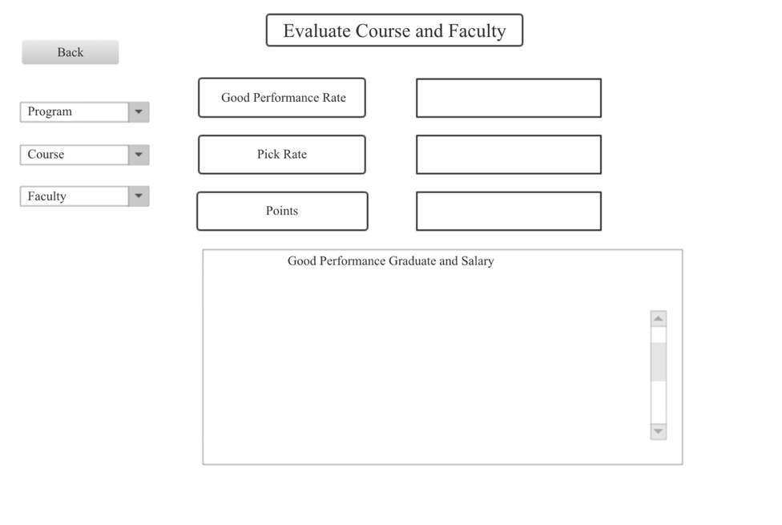

**Picture 6 Evaluate course and faculty panel**

The sixth image is the evaluate course and faculty page. Users can choose different program, course and faculty in the left. After selecting the program, it will show the good performance graduate rate for this program. After selecting the course, the right will show the rate for good performance graduate, course registration and course points. Faculty button is similar to the course button.

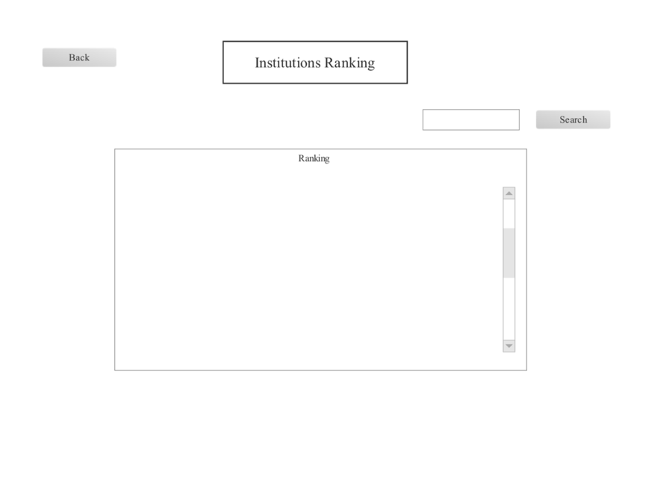

**Picture 7 Institutions Ranking panel**

The last picture is an institution ranking. Users can search the institution by name.

**· UML Sequence Diagram**

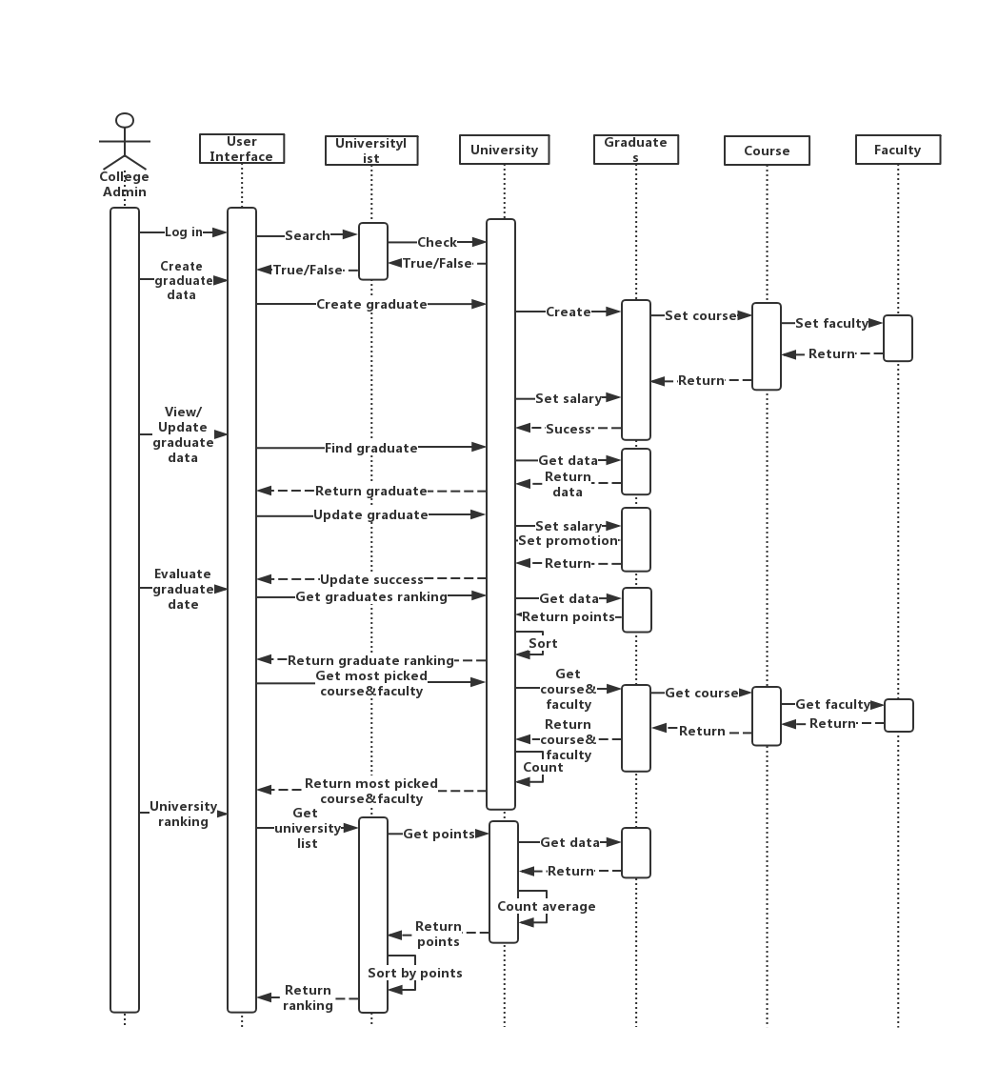

**Picture 8 UML sequence diagram**

The sequence diagram represents an interaction diagram that reflects the message passing time relationship of each object. It embodies the flow of system data and provides a clear idea for the detailed design and implementation of the system in the future. Figure VIII is a sequence diagram of the university management staff using the graduate management system.

**· UML Class Diagram**

In software engineering, a class diagram in the Unified Modeling Language (UML) is a type of static structure diagram that describes the structure of a system by showing the system's classes, their attributes, operations (or methods), and the relationships among objects.

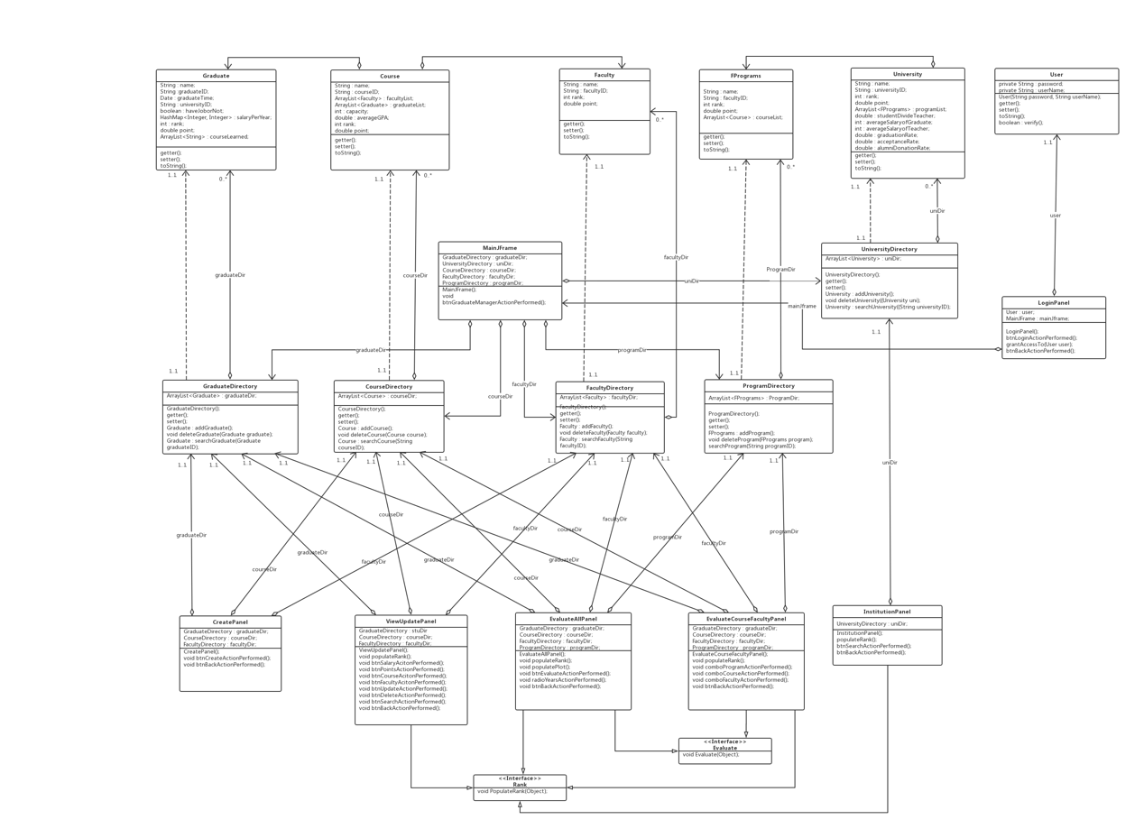

**Picture 9 UML class diagram**

In the class diagram, dotted lines with arrows indicate dependencies (for example, Graduate and GraduateDirectory are dependencies). Solid lines with diamonds indicate aggregation relationships (for example, CourseDirectory and CreatePanel are aggregation relationships). Solid lines with open triangles indicate implementation relationships (such as the EvaluateAllPanel and Rank interfaces). Solid lines with arrows indicate associations (for example, Course and CourseDirectory are associations).