Chore App Deployment
Part A
Create front end with react; Create back end with flask and sqlite.
Under react folder run commands
npm install
npm start

Under flask folder run commands
pip3 install -r requirements.txt
python3 main.py

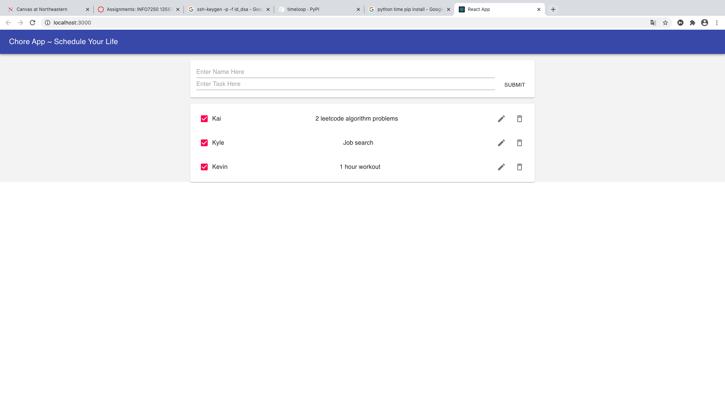
Part B
Create new ssh private key and public key and change the passphrase.
ssh-keygen
ssh-keygen -p -f id_dsa

Use Terraform to build AWS instance for back end.
terraform init
terraform plan
terraform apply

Get public IP of server, change all localhost in frontend code to server’s IP.
Log in to VM.
ssh ec2-user@ec2-54-88-155-50.compute-1.amazonaws.com

Install packages for back end server.
sudo yum install python3
cd chore-backend
sudo python3 -m pip install -r requirements.txt

Run server.
python3 main.py
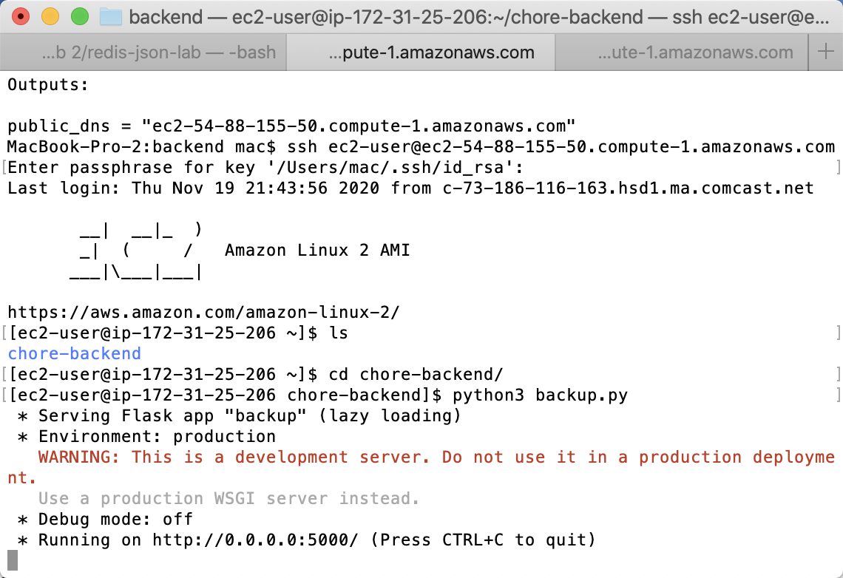
Use Terraform to build AWS instance for front end.
terraform init
terraform plan
terraform apply

Log in to VM.
ssh ec2-user ec2-54-145-206-153.compute-1.amazonaws.com

Install packages and npm start client.
curl -sL https://rpm.nodesource.com/setup_10.x | sudo bash -
sudo yum install nodejs
cd chore-frontend
sudo npm install
sudo npm start
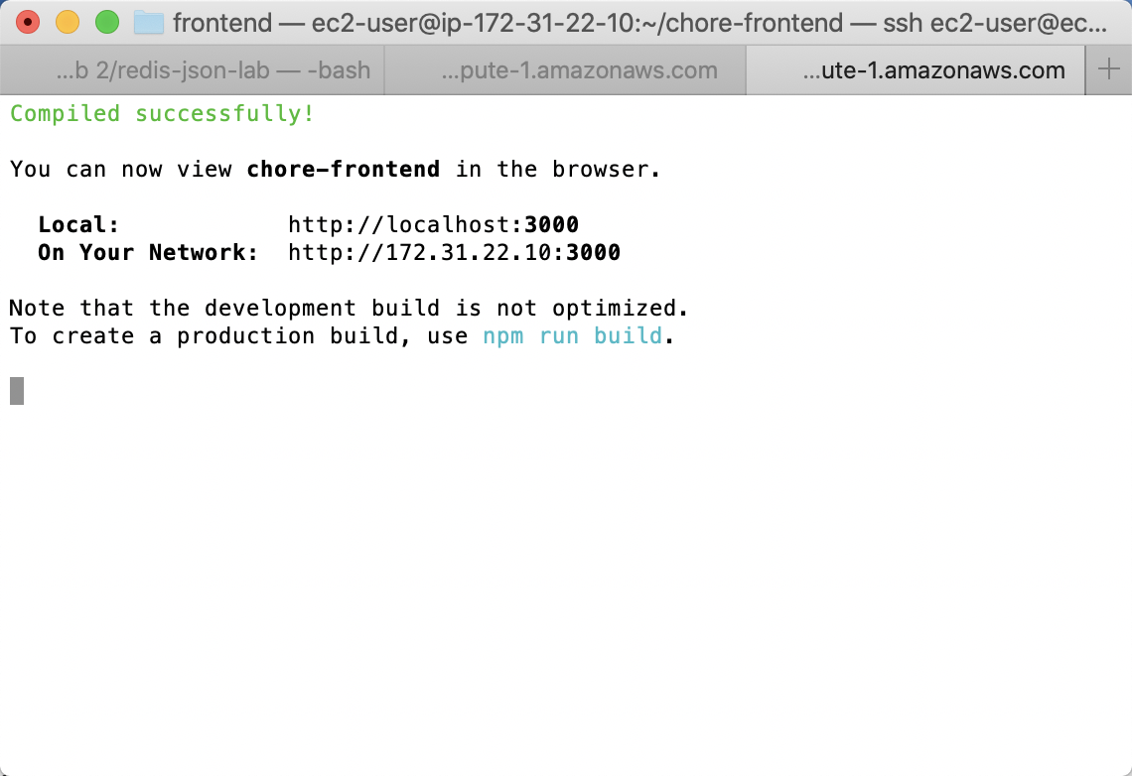
Open it in browser with front end’s public IP.
http://54.145.206.153:3000/
Success!
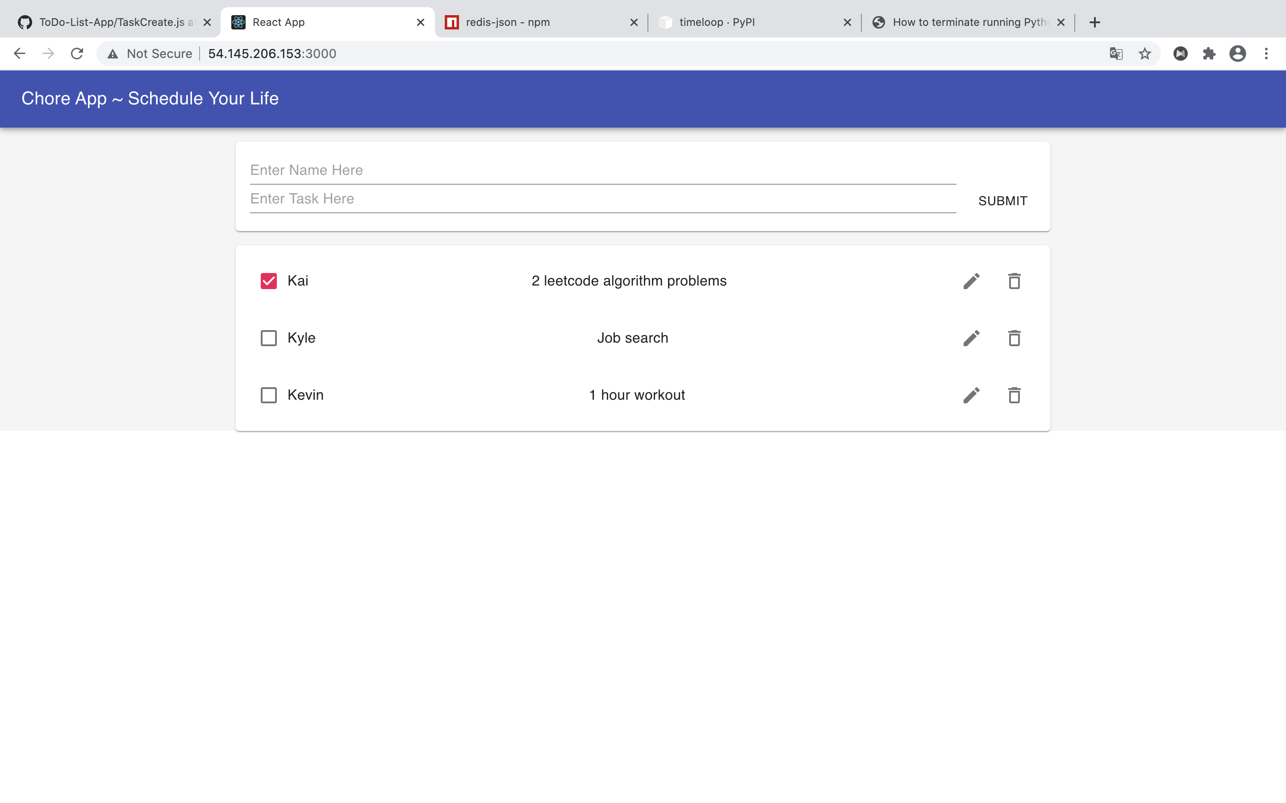
Finally, destroy both front end and back end.
terraform destroy

Part C
Docker
Under chore-frontend folder create Dockerfile and .dockerignore.
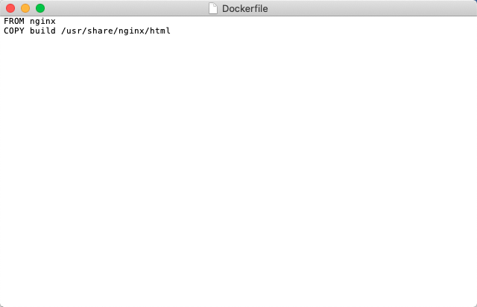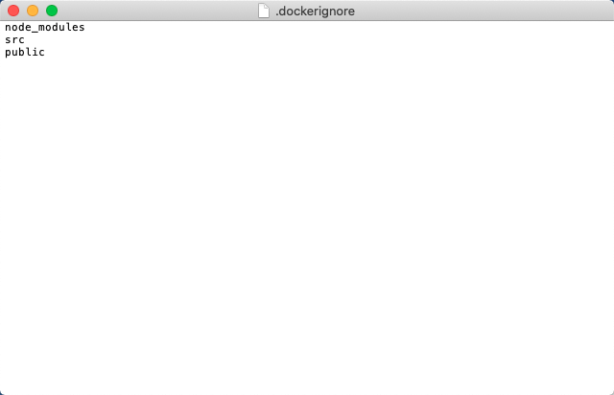
Under chore-backend-redis create Dockerfile.
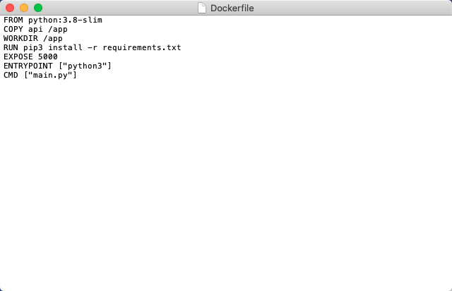
Under midterm folder create docker-compose.yml
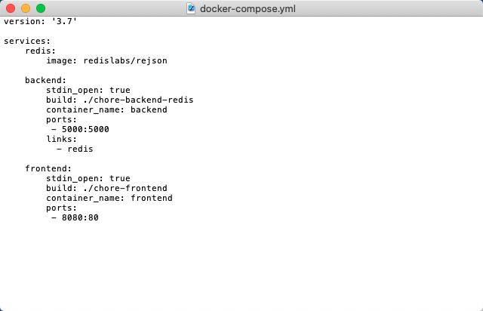
Run command in terminal
docker-compose build
docker-compose up
Open http://localhost:8080 in browser
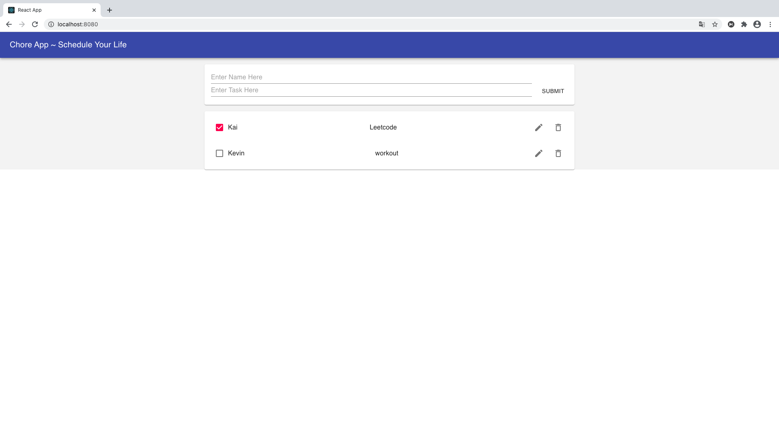

Kubernetes

Create .yaml file and use “kubectl apply -t” to create service and deployment.

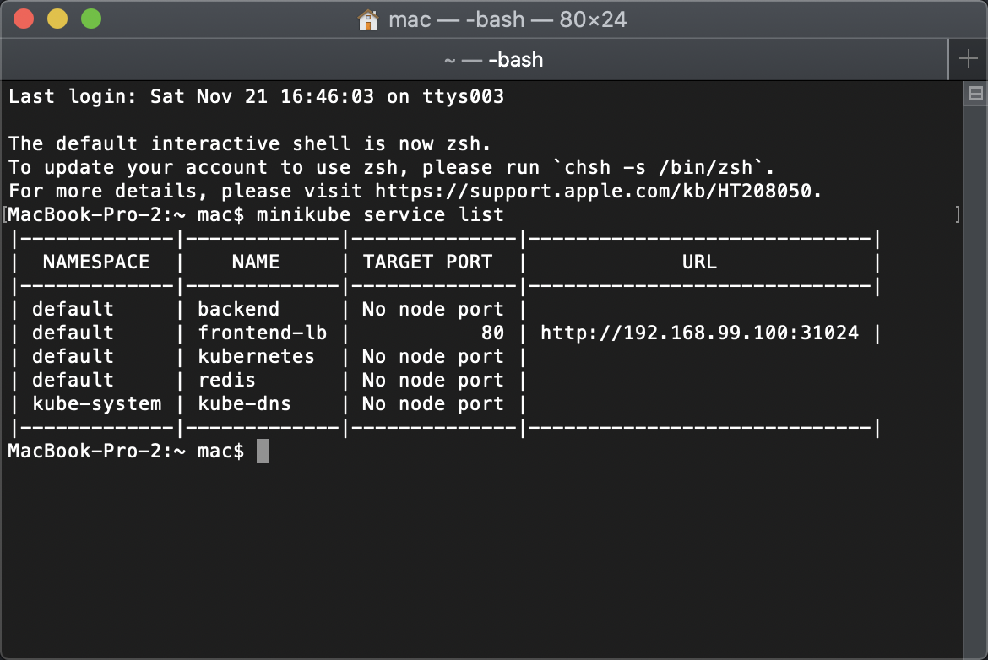

minikube service frontend
