Backbone: CliqueNet (some modify)

<< Convolutional Neural Networks with Alternately Updated Clique >>



Tricks:

Attention



Deformable Convolutional

<<Deformable Convolutional Networks>>

Decoupled Networks

<<Decoupled Networks>>

DepthToSpace FPN



Multiscale and Random Hide Training

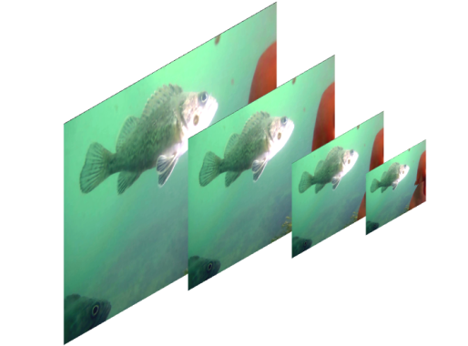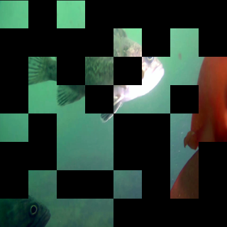

Step:

1、VOC-like Data prepare

2、generate anchors

(1) modify the root:

generate_anchors.py🡪line 90 and line 101

(2) python generate_anchors.py

(3) modify the anchors:

CliqueDecoupledConvFPN.py🡪line 200

train.py🡪line 32

3、Train

(1) modify the root:

Train.py🡪line 75 and line 94

(2) prepare test images

Prepare test images in folder test_images/detection

(3) python train.py

Some results:

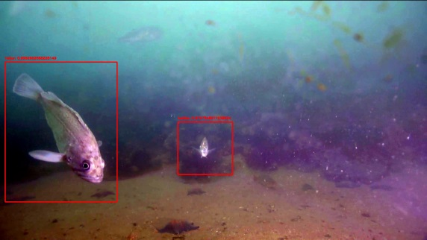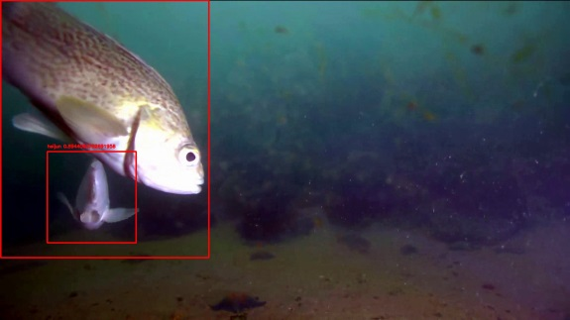

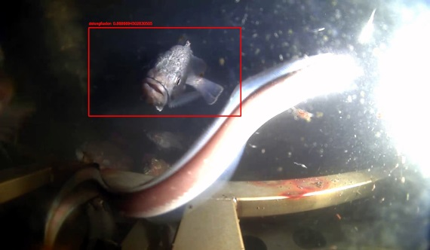 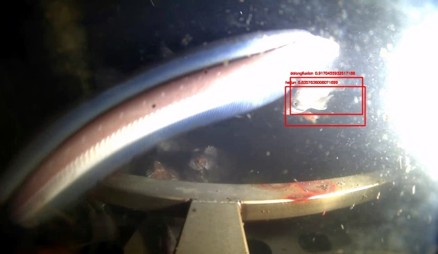

(notice: we have no label in dataset for Huang Wei)