Electron Tomography Data Collection (Using BIS-Tomo)
Authors: Yan Zeng^{1,2}, Mingming Han^{1,2}, Chao Zhao³, Xiaojun Huang^{1,2}
Affiliations: ¹Institute of Biophysics, Chinese Academy of Sciences; ²Multimodal Cross-Scale Biomedical Imaging Facility; ³ University of Chinese Academy of Sciences
Microscope: CFEG, Selectris X + Falcon 4/4i;
Software: SerialEM, BIS-Tomo script, EPU
BIS-Tomo script: https://github.com/ZHANGXinzheng-LAB/CR-BIS

Before starting, go to Script → load new package in the SerialEM menu and select “BIS-TOMO_AutoMdoc_20260707_script.txt”. Edit macro21 to ensure the file paths for “mdoc_for_serialemScripts.py” and the system “python.exe”, tilt-axis angle are correctly specified, so that mdoc files can be generated automatically.

1 Common Parameter Settings
Data collection follows the steps: acquire atlas map, select positions, start acquisition.
First, confirm the data collection conditions in advance and fill them in the parameter script (Fig. 1). This script must be placed first in the script sequence and cannot be reordered.
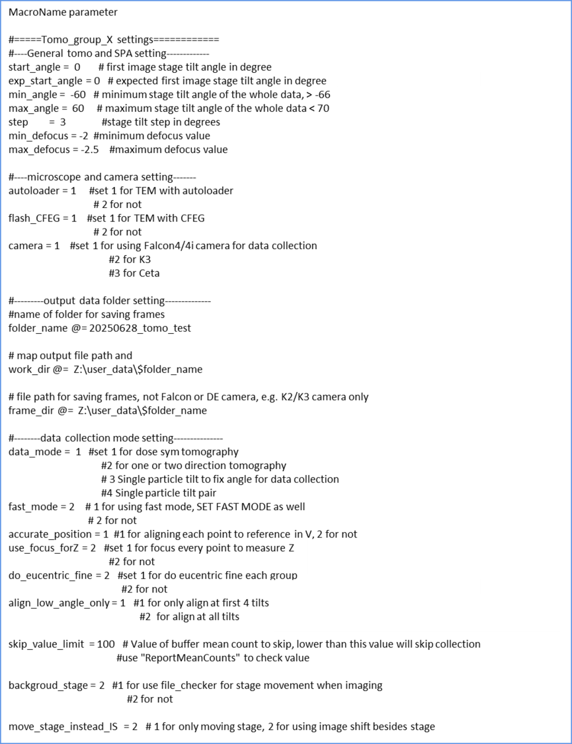
Fig. 1 Parameter settings

2 Acquire Atlas and Draw Map Region

2.1Acquire atlas using EPU
Record coordinates of target positions:Right-click on the EPU atlas, select “move stage here” to move the stage, then record all target regions on the microscope UI..
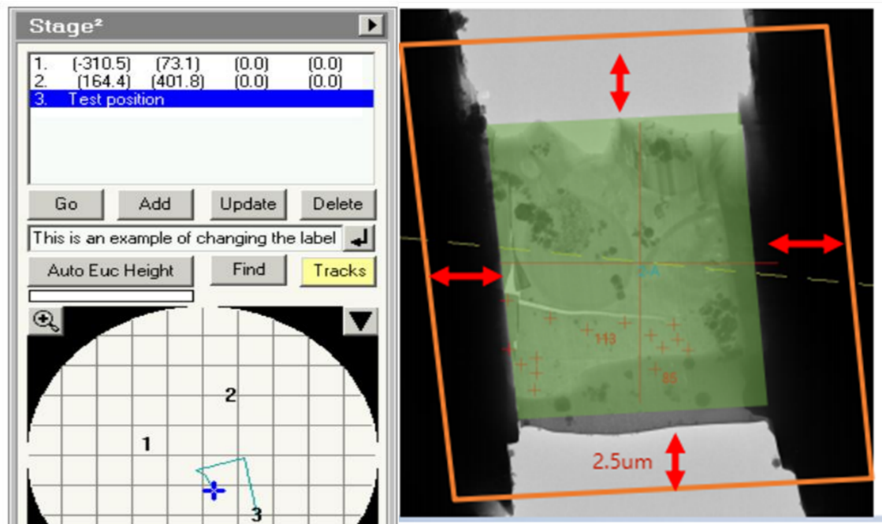
After confirming high/low magnification alignment (see Appendix), for each target position (α=0°): Goto XY, then on SerialEM take a Search image, then open Navigator, use Add Polygon to draw the map region (as shown by the orange box below, finally click End Polygon(The map selection should extend at least 2.5 μm beyond the sample area).
Fig. 2 Recording positions and drawing map region

2.2 Map Acquisition Workflow
Before acquiring maps, confirm the “start_angle” value in the parameter script,, and mark each Polygon row in Navigator with “AF” (i.e., check “Acquire” and “New file at item”), see Fig.3. After clicking OK, a map file save dialog will appear; please save in a format like: Z:/user_data/202?????/map01 . Open SerialEM Navigator acquire at items, Configure as shown below and click “Go” to start map acquisition.

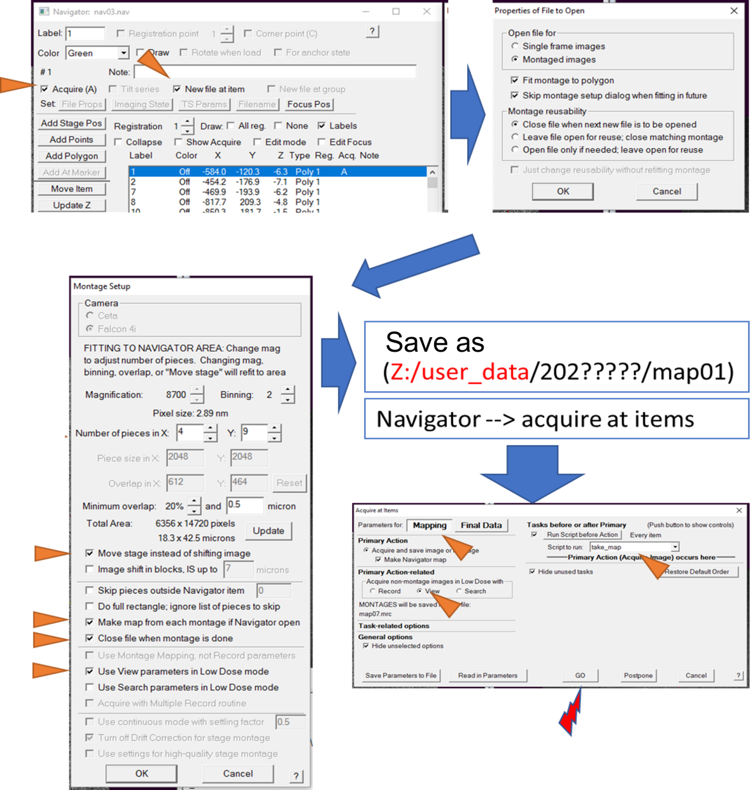
Fig. 3 Map acquisition setup workflow

3 Position Selection (Select Acquisition Sites)
1.Double-click to open the Map in Navigator. Follow these principles for position selection:
2.Select positions in groups: click “Add Points” to start, click “Stop Adding” to end the current group(Fig. 4)..
3.The first point in each group is not used for data acquisition — it serves as the alignment and focus position.
4.Other points in the group should not be too far from the first point (recommended < 6 um).
5.Spacing between positions should be larger than the beam size.
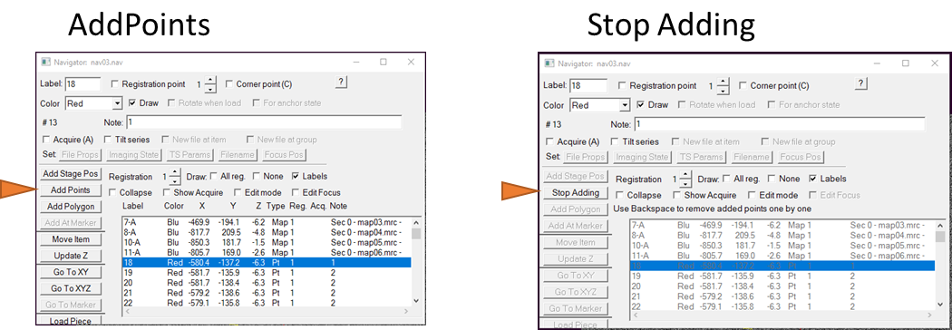
Fig 4 Position selection start and end

4 Start Data Collection
Mark all maps and points with Acquire(A). Remove the “A” from any polygons if present. See Fig.5:
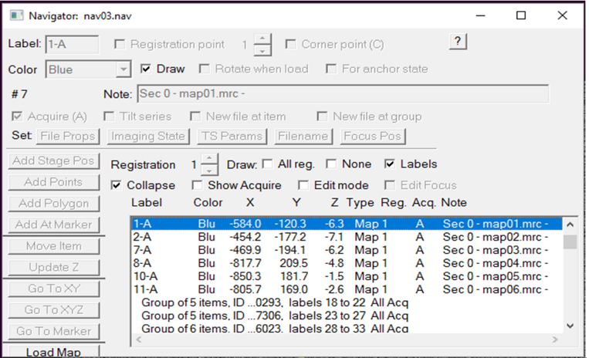
Fig. 5 Mark all maps and points with “A”

Run “Acquire at items”, in the Final Data panel, under Run script select Tomo_goup_V_p1.
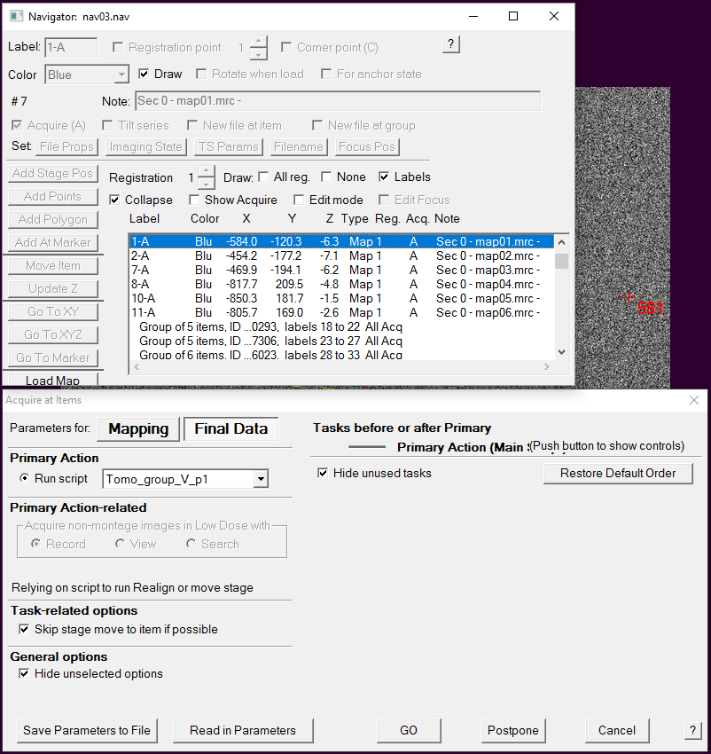
Fig. 6 Run Tomo_group_V_P1

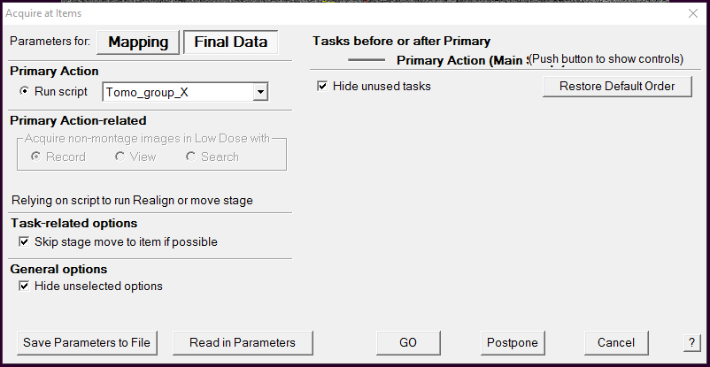
Run “Acquire at items”, in the Final Data panel, under Run script select Tomo_goup_X.
Fig. 7 Running Tomo_group_X

Appendix

Aligning High- and Low-Magnification Images (in SerialEM)
1. Find an area with fiducial markers and confirm image in View mode
2. Tasks > Rough Eucentricity
3. Autofocus
4. Acquire image in high magnification, note the position of the central marker
5. Acquire image in low magnification, right-click and drag the image to center the high-mag marker, under offsets for (select the current low-mag mode), click Shift: set.
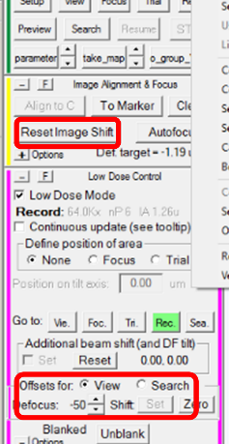
6. Click OK in the dialog, then click Reset Image Shit (Reset IS)

Fig. 8 Buttons for high/low magnification alignment

Appendix

Tomo Microscope Alignment Procedure

1) Load settings (serialEM-settings-open)
Load existing settings if available; otherwise configure directly.

2) Beam Alignment
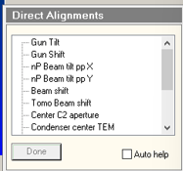
1. Find the carbon film area, view confirm the image, in the Tasks panel select Rough Eucentricity, Autofocus, reset_X, Insert the fluorescent screen.
Fig 9 Beam alignmentrelated buttons
2. Select nP Beam tilt pp X, adjust multifunction x to minimize beam wobble; select nP Beam tilt pp Y, still adjust multifunction x, to minimize beam wobble. This step can be repeated.
3. Select Beam shift, adjust multifunction x/y to center the beam.
4. Click SerialEM > Focus/Tune > Correct Astigmatism by CTF
5. Click SerialEM > Focus/Tune > Coma-free Alignment by CTF
6.Save alignment parameters:
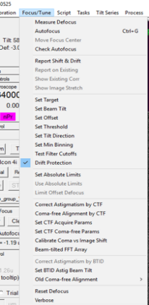
Read current values: comment out the last two lines of the reset_X script last two lines: ( i.e., #SetObjectiveStigmator XXX XXX and#SetBeamTilt xxx xxx), then run reset_X.
Fig 10 Adjust Astigatismand coma
Record values: copy the log window’soutput results to the last two lines and remove the comment character “#”. Run reset_X.
- If any issue occurs in subsequent operations, simply run the reset_X script to reset to the current state.
- In View mode, move the sample to the carbon film area, click SerialEM > Focus/Tune > Calibrate Coma vs Image Shift. In the pop-up window, adjust the Rotation of measurement vectors so that all four probe-points land on the carbon film area. Then run the reset_X script to switch to Record mode. Click the Run Calibration button in the Coma vs Image Shift Calibration pop-up window and wait for the process to complete.

