**Python实验报告10**

7.1

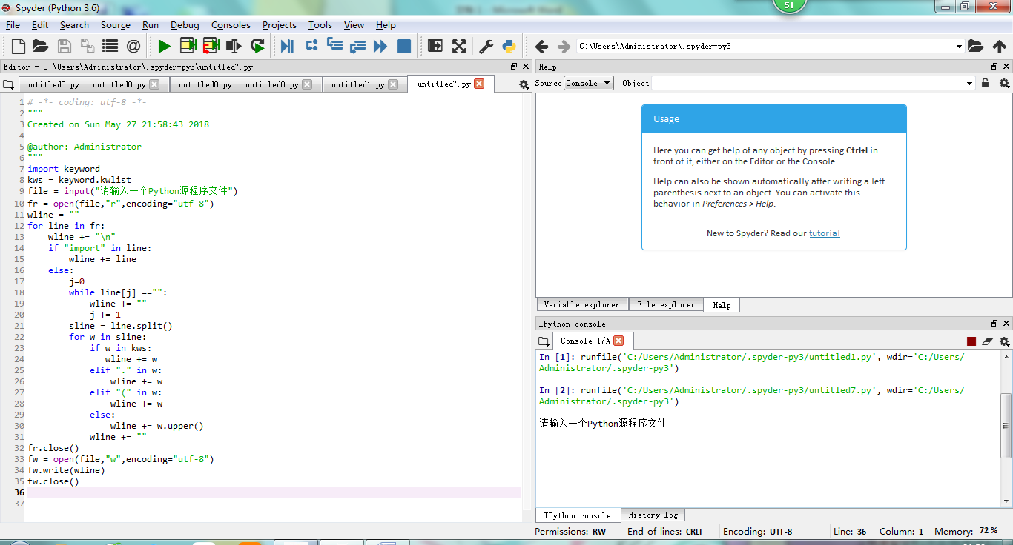

7.2

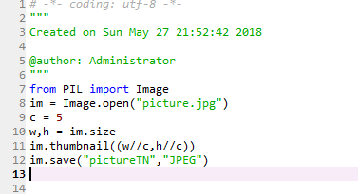

from PIL import Image

im = Image.open("picture.jpg")

c = 5

w,h = im.size

im2 = Image.open("picture.jpg")

im2.resize((w//c,h//c)).save("picture.jpg","JPEG")

7.5

