VCU118 Rev 1.1 Change Doc

- Fan Circuit updates:
  - update the MAX6643 Symbol as the _B should be removed from FULLSPEED_B per Lou.
  - Connect FULLSPEED to GND
  - Also, Add 4.7K resistor between pins J73.2 and J73.3

- FAN_I2C nets:
  - Remove FAN_I2C nets FAN_I2C_SDA & FAN_I2C_SCL as they are not used anywhere
  - Do not change I2C ordering on the Mux, just leaveFAN_I2C nets n.c. on the Mux

- SGMII TI PHY Address ‘00011” modification:
  - Stuff resisters R69, R71 with 1K 0402 resistors.

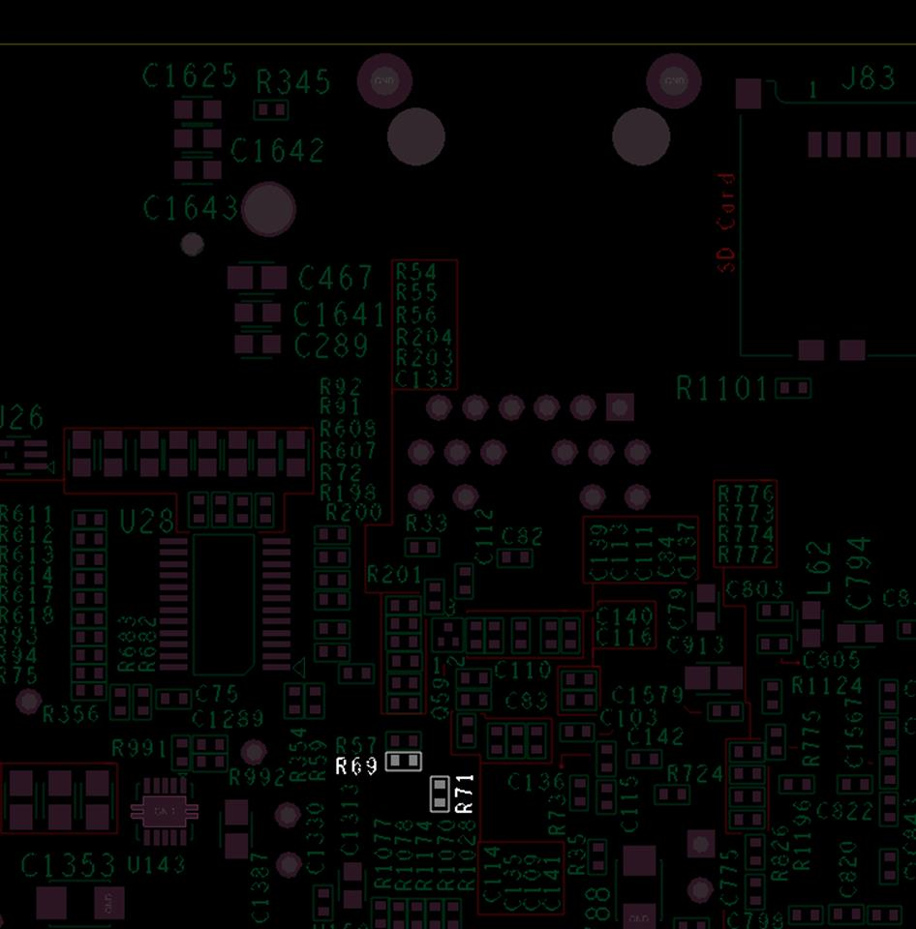
Figure 3 Bottom of PCBA
Label board with C.2 sticker

