VCU118 Rev 2.0 Change Doc

- BPI-> QSPI flash change
  - Replace the BPI device U133 (MT28GU01GAAA1EGC-0SIT) with Dual QSPI devices, MT25QU01GBBB8ESF-0SIT.
    - Copy KCU116
  - Remove BPI Revision select jumper, J29.

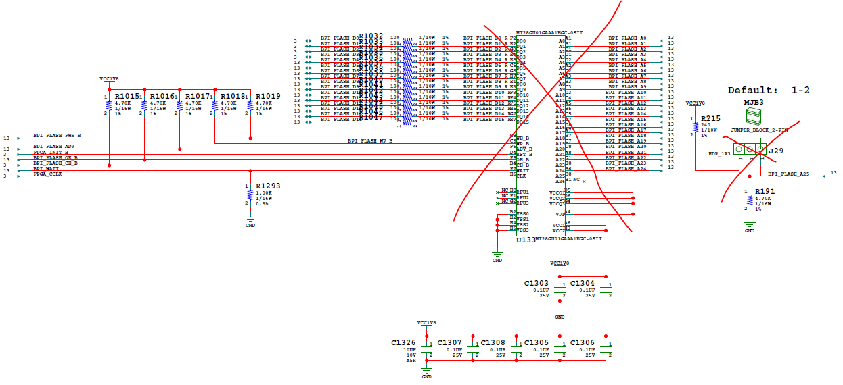

UG570
https://www.xilinx.com/support/documentation/user_guides/ug570-ultrascale-configuration.pdf
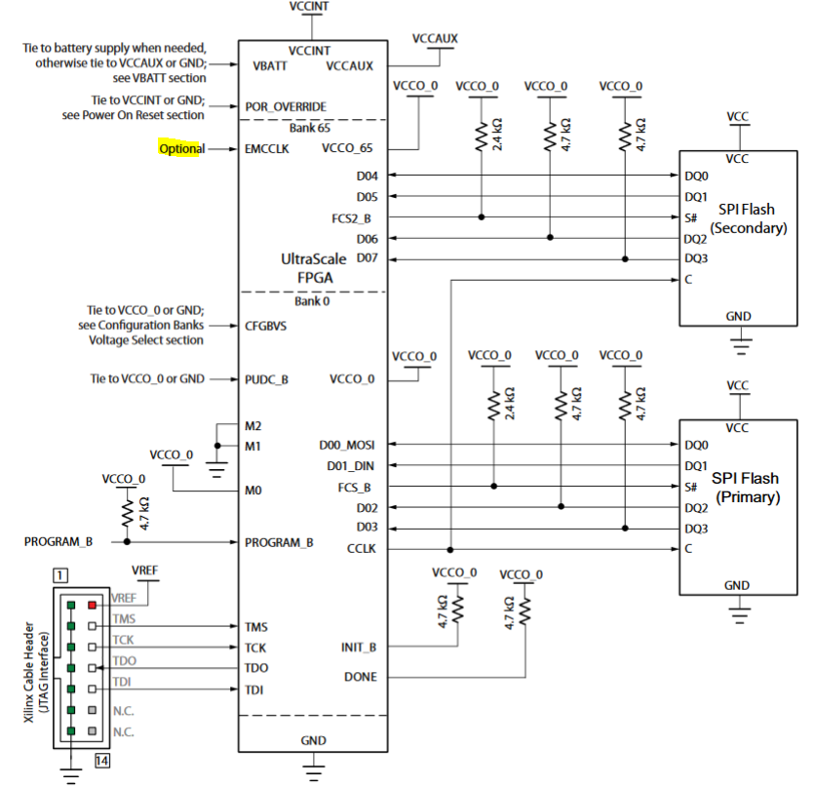

- BPI-> Dual QSPI flash change
Replace the BPI device U133 (MT28GU01GAAA1EGC-0SIT)
with Dual QSPI devices, MT25QU01GBBB8ESF-0SIT https://www.micron.com/~/media/documents/products/data-sheet/nor-flash/serial-nor/mt25q/die-rev-b/mt25q_qlkt_u_01g_bbb_0.pdf

- Layout: Correct spacing on FMC connectors. Need to meet the FMC VITA57.1 spacing requirements for double wide Mezzanine Card.

- Layout: Silk change to Rev2.0

- TSS: Update XML. VCCINT from 0.72V to 0.85V for Production boards.

- TSS: update system controller firmware and SCUI

