The system design document

ZHANG Yubo 19079784d

1. *Storytelling*

**From previous analysis in “The problem analysis and requirements document”, using storytelling, there are the following roles in this system.**

First, user was welcomed by the system’s welcome message. User can choose start order or exit order system.

Second, if user choose start order, the system will show the menu, and ask user to select 1st item from the menu.

Third, after user select an item, system provide user with 3 choices: check out, order another item or edit ordered items. If user choose to edit ordered items, system will enter the “edit ordered items” subpart. User can delete any ordered items in this subpart.

Fourth, user exit the “edit ordered items” subpart and then select other items. Finally, user choose to check out and system will print user’s order with some required information mentioned in the assignment documents.

1. *Storyboard*

Print welcome message

Enter System command

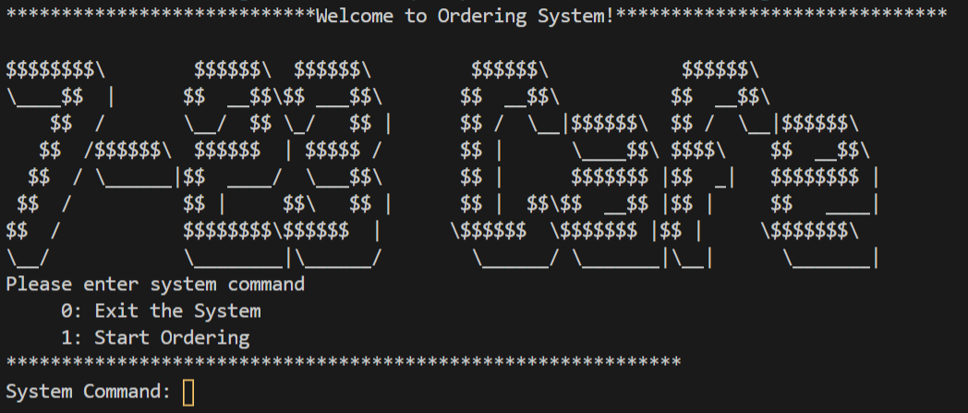

~~~~~~~~~~~~~~~~~~~~~~~~~~~~~~~~~~~~~~~~~~~~~~~~~~~~~~~~~~~

If input wrong command, then ask users to input again

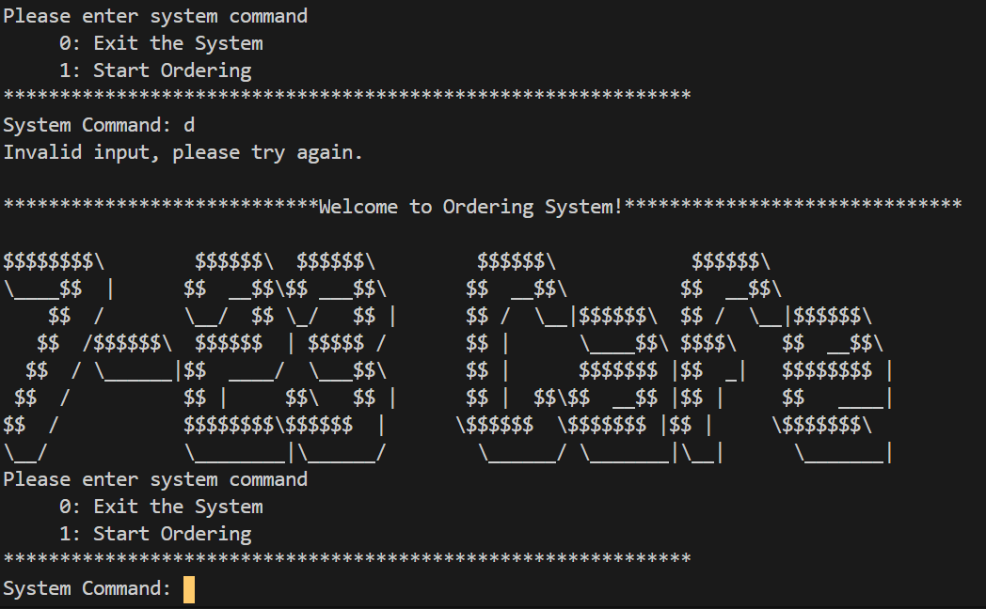

Note: The “Check input command whether is valid” function for the following boards are omitted

~~~~~~~~~~~~~~~~~~~~~~~~~~~~~~~~~~~~~~~~~~~~~~~~~~~~~~~~~~~

Start Ordering

First input an Order Identification String.

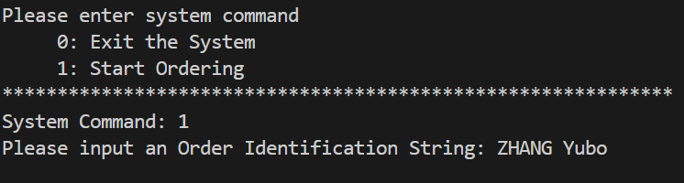

~~~~~~~~~~~~~~~~~~~~~~~~~~~~~~~~~~~~~~~~~~~~~~~~~~~~~~~~~~~

Print Menu

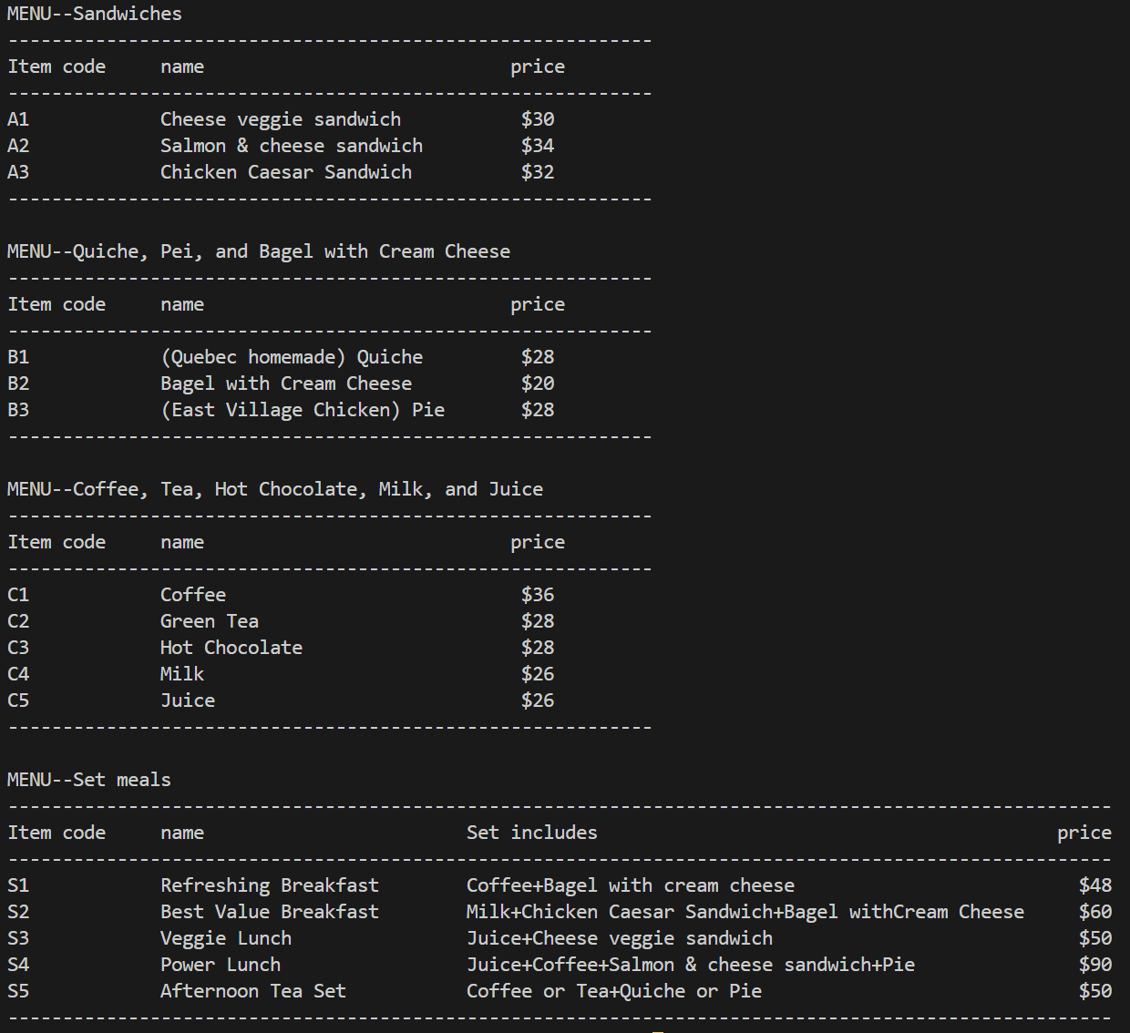

Select 1st item using item code.

E.g. S1

And then choose Order Command

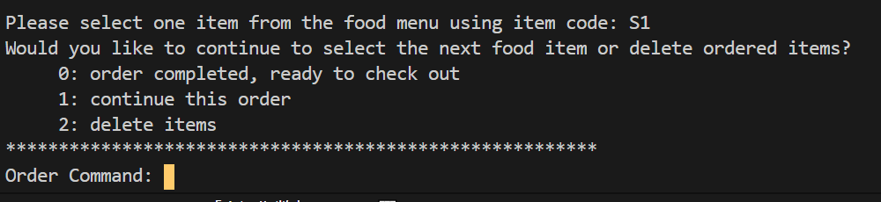

~~~~~~~~~~~~~~~~~~~~~~~~~~~~~~~~~~~~~~~~~~~~~~~~~~~~~~~~~~~

If choose to continue this order, then select another item. E.g. S5

And then select S5’s combination.

E.g. Coffee + Quiche

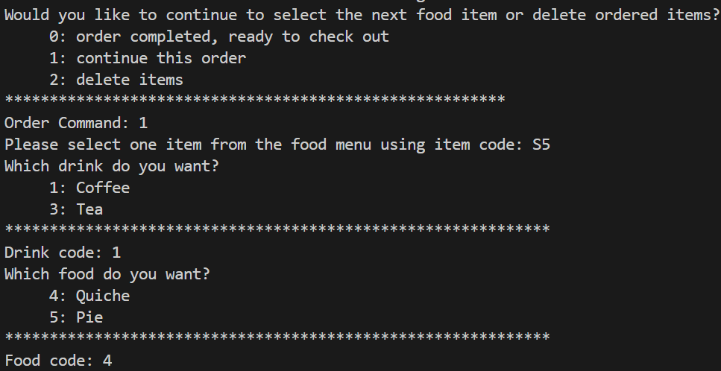

~~~~~~~~~~~~~~~~~~~~~~~~~~~~~~~~~~~~~~~~~~~~~~~~~~~~~~~~~~~

Next, if choose to delete items, then enter which item users want to delete. E.g. S1

Then System ask user “would you like to delete another item?”

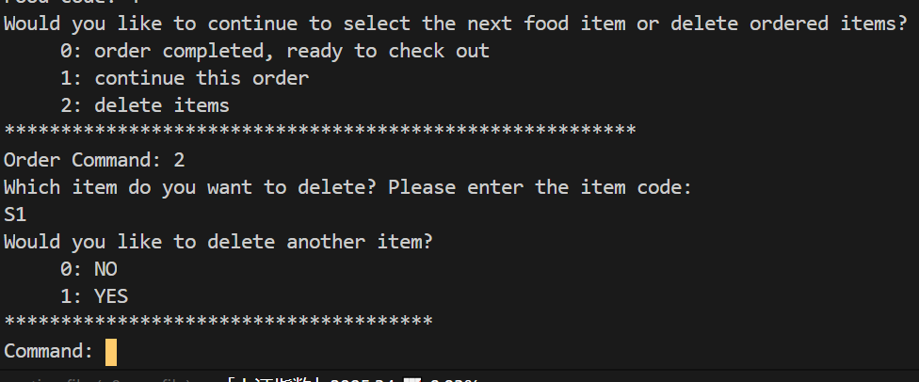

~~~~~~~~~~~~~~~~~~~~~~~~~~~~~~~~~~~~~~~~~~~~~~~~~~~~~~~~~~~

If don’t delete another item and don’t order any other items, then choose to check out.

System print “ZHANG Yubo” order.

The system will automatically package items as set meals and give a 0.95 discount if price>100.

Finally, the system will ask users “Would you like to start a new order?”

