PROJECT PROPOSAL

Date of proposal:
24 September 2026
Project Title:
Indoor Dog Behaviour and Human-Dog Interaction Recognition Using Multimodal Video and Skeleton Features
Group ID (As Enrolled in Canvas Class Groups):
28
Group Members (name , Student ID):
Zhao Jiayi, A0329873M
Sun Wenjing, A0326610N

Sponsor/Client:
Not applicable. This is an academic course project with no external sponsor.

Background/Aims/Objectives:
Background: In recent years, pet ownership has increased, and many owners regard their dogs as family members and want to know how they are doing while away from home. Pet cameras have therefore become increasingly popular. According to Grand View Research, the global pet monitoring camera market was valued at approximately USD 198 million in 2024 and is expected to reach about USD 454 million by 2030, with a compound annual growth rate of approximately 12.6%. The report also identifies the growing view of pets as family members, together with owners' desire to ensure their safety and well-being while away, as a major driver of market growth.
Most current pet cameras, however, mainly help owners see where a pet is: they detect a cat or dog, pan to follow it, or send an alert when movement or barking is detected. Owners actually want to know what the dog is doing, whether it is eating and resting properly, and whether family members or carers have fed it or played with it. Answering these questions still requires owners to review recorded footage. A single frame also makes it difficult to distinguish similar situations, such as eating versus sniffing with the head lowered, sleeping versus ordinary lying, or petting versus simply standing nearby. These differences are often reflected in how motion changes over time and in the relationships among the person, dog, and surrounding objects.
This project therefore aims to move indoor cameras beyond tracking where a pet is towards understanding what the pet is doing and how it is interacting with people, better addressing owners' concerns about their pet's health and companionship.
Overall objective: Develop a working indoor camera video-analysis prototype. After a user uploads a video with audio, the system will output dog behaviour and human-dog interaction classes, together with confidence scores, a timeline, and visualised results.
Research objectives:
- Evaluate the AP-10K-pretrained RTMPose model for pose estimation in indoor dog videos, then fine-tune it with dog samples from APT-36K and a small amount of self-collected indoor data to improve keypoint accuracy and provide reliable skeleton information for subsequent behaviour analysis.
- Recognise everyday dog behaviours from temporal changes in the dog skeleton, including standing or walking, sitting, lying, eating, and playing.
- Recognise human-dog interactions by combining human skeletons, dog skeletons, spatial relationships, and audio information. The interaction classes include no interaction, feeding, petting, and playing together.
- Compare different models and modality combinations. Pose estimation will compare the official AP-10K-pretrained model, a version fine-tuned on APT-36K dog samples, and a version further fine-tuned with self-collected data. Dog behaviour recognition will compare LSTM as the baseline with ST-GCN. Human-dog interaction recognition will compare skeleton-only input, skeletons with relationship features, and skeletons with relationship features and audio.
- Establish reproducible training, evaluation, and demonstration procedures, together with a complete user workflow in which a user uploads a video, the system analyses it automatically, and the interface presents the dog's behaviour, interaction class, confidence score, and timeline.
Project Descriptions:
- Project Scope
The system focuses on indoor videos containing primarily one dog. Initial dog-behaviour classes are standing or walking, sitting, lying or sleeping, eating or drinking, playing alone, and other. Human-dog interaction classes are no active interaction, feeding, petting, and playing together. Command training may be added as an extension if sufficient data are available. Each video clip may have both a dog-behaviour label and an interaction label; for example, the dog behaviour may be eating while the interaction is feeding.
- Datasets and Annotation
- Pose data will comprise dog samples from APT-36K and self-collected data. The project will use the AP-10K-pretrained RTMPose-M as the initial model and specialise it for dog pose estimation using dog samples from the APT-36K training set. After preparation, all APT frames will be 1920 × 1080 pixels (Full HD, 16:9), with one JSON annotation file per frame containing its keypoint labels. The self-collected data will come from authorised videos; sampled frames will be manually annotated with a bounding box and 17 keypoints for each dog. The same frame-level JSON format as APT will be used so that both sources can be loaded and trained consistently. Training, validation, and test sets will be split by dog or complete video to prevent data leakage.
- After pose estimation, RTMPose will automatically extract continuous dog-skeleton sequences from the videos. Video clips will be annotated with dog-behaviour classes such as standing, sitting, lying, eating, and playing. Human-pet interactions will be annotated separately as no interaction, feeding, petting, and playing together, allowing the same clip to carry both a dog-behaviour label and a human-pet interaction label.
- Audio data will mainly come from InterPet4D and Dog Play Pant. InterPet4D provides human-pet interaction audio and pre-extracted audio features, while Dog Play Pant provides audio and canine-vocalisation annotations from human-dog play sessions. Audio will be fused with human skeleton, dog skeleton, and video features to support recognition of specific human-pet interactions.
- System Workflow and Model Design
- During detection and tracking, RTMDet will detect people and dogs in the video, while ByteTrack will maintain consistent identities across consecutive frames. The detected boxes will be used to crop target regions for subsequent human and dog pose estimation. Detection of food bowls and toys will provide auxiliary information for distinguishing similar behaviours such as eating, petting, and playing together.
- RTMPose will be used for pose estimation. The dog-pose branch will load the official RTMPose-M AP-10K-pretrained weights and be fine-tuned using dog samples from the APT-36K training set and self-collected indoor dog data. The human-pose branch will use a pretrained human RTMPose model. For each frame, the models will output human and dog keypoint coordinates and confidence scores; tracking, interpolation, and normalisation will then produce continuous skeleton sequences.
- Dog behaviour recognition will use continuous dog skeletons as input. Each clip will be represented as a T × 17 × 3 sequence, where the three values are the horizontal coordinate, vertical coordinate, and keypoint confidence. ST-GCN will learn the spatial relationships among the dog's joints and how they change over time, and will output behaviour classes such as standing, sitting, lying, eating, and playing. An LSTM or skeleton Transformer may be used as a comparison model.
- Human-dog interaction recognition will use both human and dog skeletons. Two skeleton branches will separately extract temporal features and combine them with relationship features, including the distance between the human and dog centres, relative velocity, the distance from the hand to the dog's head or body, and the distance from the dog to a food bowl or toy. The model will classify interactions such as no interaction, feeding, petting, and playing together.
- Audio will serve as an auxiliary modality for human-dog interaction recognition. MERT or YAMNet will extract features from the InterPet4D and Dog Play Pant audio, which will then be late-fused with human-skeleton, dog-skeleton, and relationship features. The final classifier will combine motion and sound information to predict the interaction class. If a video has no audio or poor-quality audio, the system will still be able to make predictions using skeleton features alone.
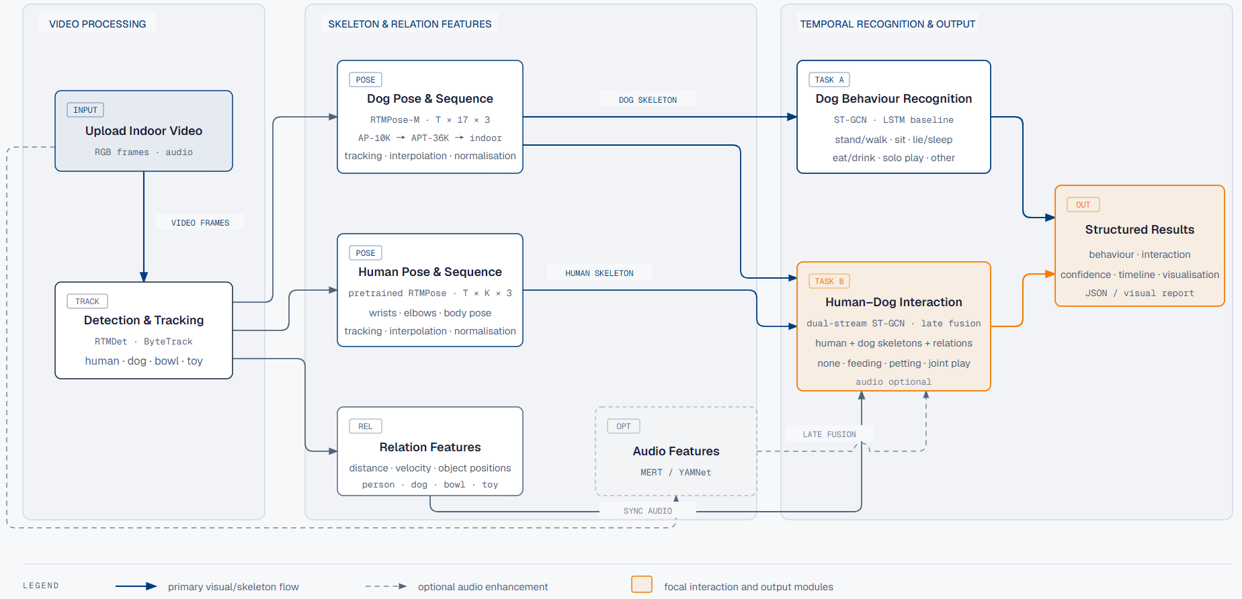
- Training Strategy
- Dog Pose Model Training
The dog-pose model will load the official RTMPose-M AP-10K-pretrained weights and be fine-tuned using dog samples from the APT-36K training set and self-collected indoor dog keypoint data. During training, the dog region will be cropped from each 1920 × 1080 frame using its bounding box and resized to the input dimensions specified by the pretrained RTMPose-M configuration. Predicted keypoints will then be mapped back to the original frame coordinates. Training will use mixed precision and a small batch size. Data augmentation will include horizontal flipping with left-right keypoint swapping, scale and rotation changes, and moderate occlusion. The validation set will be used for model selection, while the test set will be reserved for final evaluation.
- Dog Behaviour Recognition Model Training
The fine-tuned pose model will be frozen, and RTMDet, ByteTrack, and RTMPose will be used to extract continuous skeleton sequences for the same dog offline and save them as JSON or NPY files. Low-confidence or temporarily missing keypoints will be handled through masking, interpolation, and smoothing. LSTM will serve as the baseline, while ST-GCN will be the main model. The input will be a continuous dog-skeleton sequence, and the output will be behaviour classes such as standing, sitting, lying, eating, and playing. Weighted cross-entropy will address class imbalance. Skeleton augmentation will include small keypoint perturbations, random temporal cropping, keypoint masking, and frame masking.
- Human-Pet Interaction Recognition Model Training
A pretrained human RTMPose model and the fine-tuned animal RTMPose model will separately extract continuous human and dog skeletons. A dual-stream ST-GCN will encode the two skeletons and fuse them with relationship features, including human-dog distance, relative velocity, hand-to-dog-head or hand-to-dog-body distance, and dog-to-bowl or dog-to-toy distance. MERT or YAMNet will extract synchronised audio features, which will be late-fused into the interaction classifier to predict no interaction, feeding, petting, and playing together. Training will use weighted cross-entropy or focal loss, while random temporal shifts, volume changes, and background-noise mixing will augment the audio data.
- Experiments and Evaluation
Pose estimation: Use COCO AP, AP@0.5, AP@0.75, and PCK to evaluate overall and body-part keypoints. Compare the official RTMPose-M, the version fine-tuned on APT-36K dog samples, and the version further fine-tuned with self-collected data.
Dog behaviour recognition: Report macro F1, balanced accuracy, per-class precision, recall, and F1, the confusion matrix, and segment-level F1. Compare LSTM with ST-GCN and conduct ablations on confidence, velocity, missing-keypoint handling, and skeleton augmentation.
Human-pet interaction recognition: Use the same metrics and compare skeleton-only input, skeletons with relationship features, and further audio fusion. Split the data by dog and complete video, test on unseen dogs or scenes, and analyse errors caused by occlusion, missing keypoints, multiple people or dogs, missing objects or audio, and confusion between similar classes.

