# Word Embedding Results

## Pairwise Cosine Similarities

entrepreneurial - creative: 0.6627

entrepreneurial - innovative: 0.6281

entrepreneurial - trailblazing: 0.3107

creative - innovative: 0.7453

creative - trailblazing: 0.0815

innovative - trailblazing: 0.2642

## Removed Root Word

Removed word: trailblazing

## Average Vector (First 5 Dimensions)

[ 0.3962573 -0.063214 -0.56419 0.06663132 0.45804334]

## Cosine Similarities to Average Vector

entrepreneurial: 0.8562

creative: 0.9075

innovative: 0.8955

# 2D Visualization of Dictionary Words

The following plot shows the 2D projection of dictionary words using t-SNE:

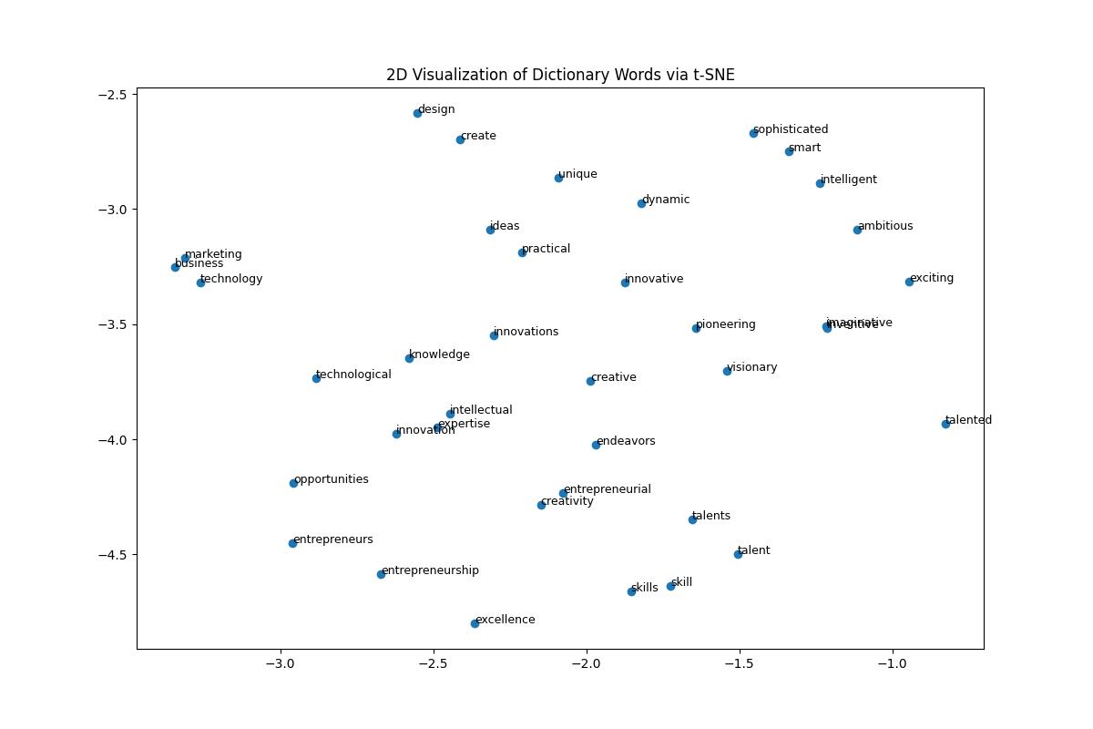

Based on the 2D visualization of dictionary words via t-SNE, several notable patterns emerge. First, there are distinct clusters of words that indicate semantic similarity. For example, **"entrepreneurial," "creativity," "innovation,"** and **"expertise"** are positioned closely together, reinforcing the conceptual relationship among these terms. Additionally, words related to skills and talents, such as **"talent," "skills,"** and **"excellence,"** form another tight grouping.

Some words appear farther from the main clusters, such as **"design"** and **"exciting,"** suggesting they may have slightly different contextual meanings or applications compared to the rest of the dictionary. Meanwhile, words like **"business," "marketing,"** and **"technology"** are positioned near each other, reflecting their shared relevance in entrepreneurial contexts.

Overall, the visualization suggests that the dictionary effectively captures the relationships among relevant terms. The presence of well-formed clusters indicates that the selected words share meaningful conceptual overlap, while the dispersed words highlight potential nuances within the domain. This analysis confirms the dictionary's quality, with opportunities for refinement by reassessing outliers and ensuring that all included terms contribute cohesively to the construct of entrepreneurial language.