CSE 5524, Prof. Jim Davis

Author: Yi Zhao (zhao.2175)

1. Here is the result for similitude momentum.

|  |  |  |  |  |  |  |  |
| --- | --- | --- | --- | --- | --- | --- | --- |
| IMG\SM | 02 | 03 | 11 | 12 | 20 | 21 | 30 |
| boxIm1.bmp | 0.1653 | 0 | 0 | 0 | 0.6455 | 0 | 0 |
| boxIm2.bmp | 0.1653 | 0 | 0 | 0 | 0.6455 | 0 | 0 |
| boxIm3.bmp | 0.1658 | 0 | 0 | 0 | 0.6435 | 0 | 0 |
| boxIm4.bmp | 0.6455 | 0 | 0 | 0 | 0.1653 | 0 | 0 |

The result implied that image 1-3 has same similitude on all momentum, which quite make sense because they look similar in shape. Image2 has same size with img1, but it’s in different location. Image3 has same shape with image2, but it has different size. From the result above, we can see that similitude moment is invariant to scaled and translated images. The image4 has the same shape and size with image1 but it is rotated by 90 degree. Thus, the momentum 02 and 20 are switched since x, y is switched.

Here is the origin image of ***boxIm1.bmp*** vs. similitude moment (before sum).

 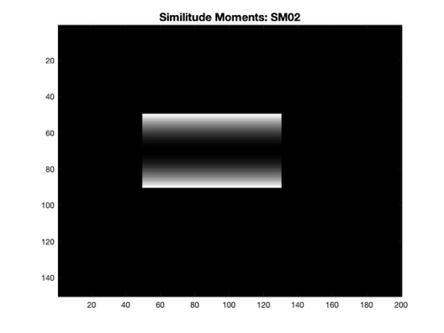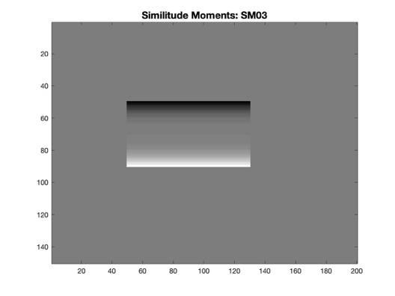­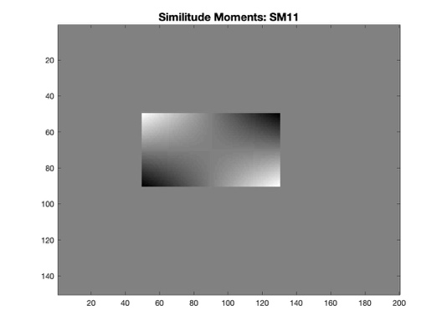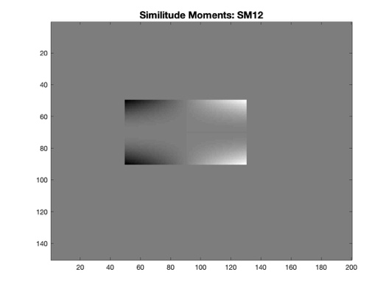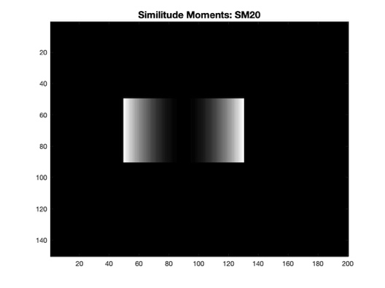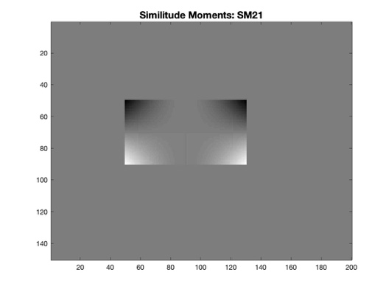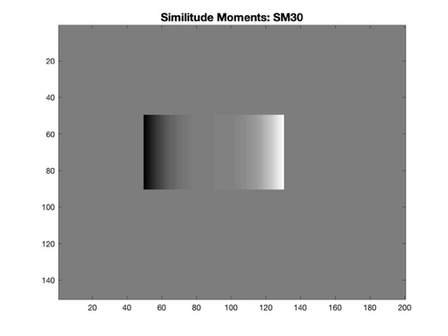

1. Just copy the code and run to get the image below.

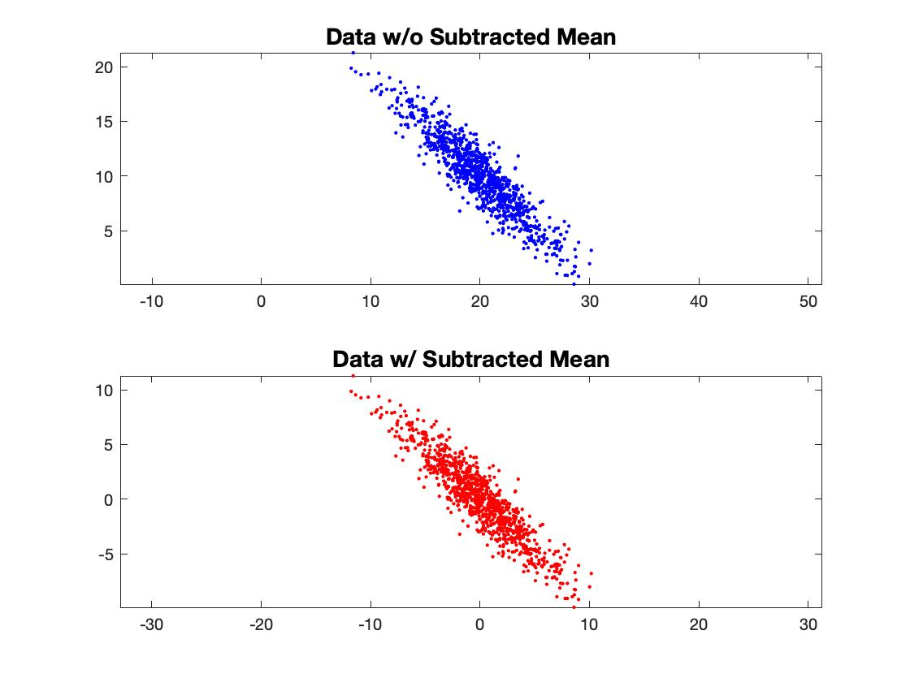

1. The eigenvalue and eigenvector are calculated using built-in function. MATLAB sort the eigenvalue in ascending order, so it looks different from the example given on the note. The eigenvectors point to the axes of the eclipse, and the length of vector is 3σ.

Result: U = [-0.7016 -0.7126; -0.7126 0.7016], V = [1.0142 0; 0 24.1385]

Plot: See image below

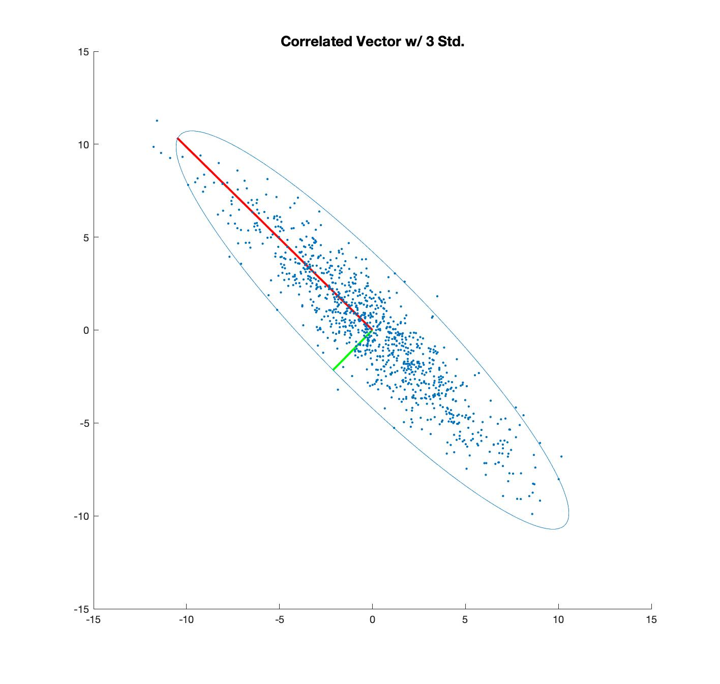

1. The uncorrelated Y are shown below. Dots are projected by multiplying to the eigenvector. The resulted Y are decorrelated. Obviously, the dots are aligned across the Y axis, and the eclipse are rotated.

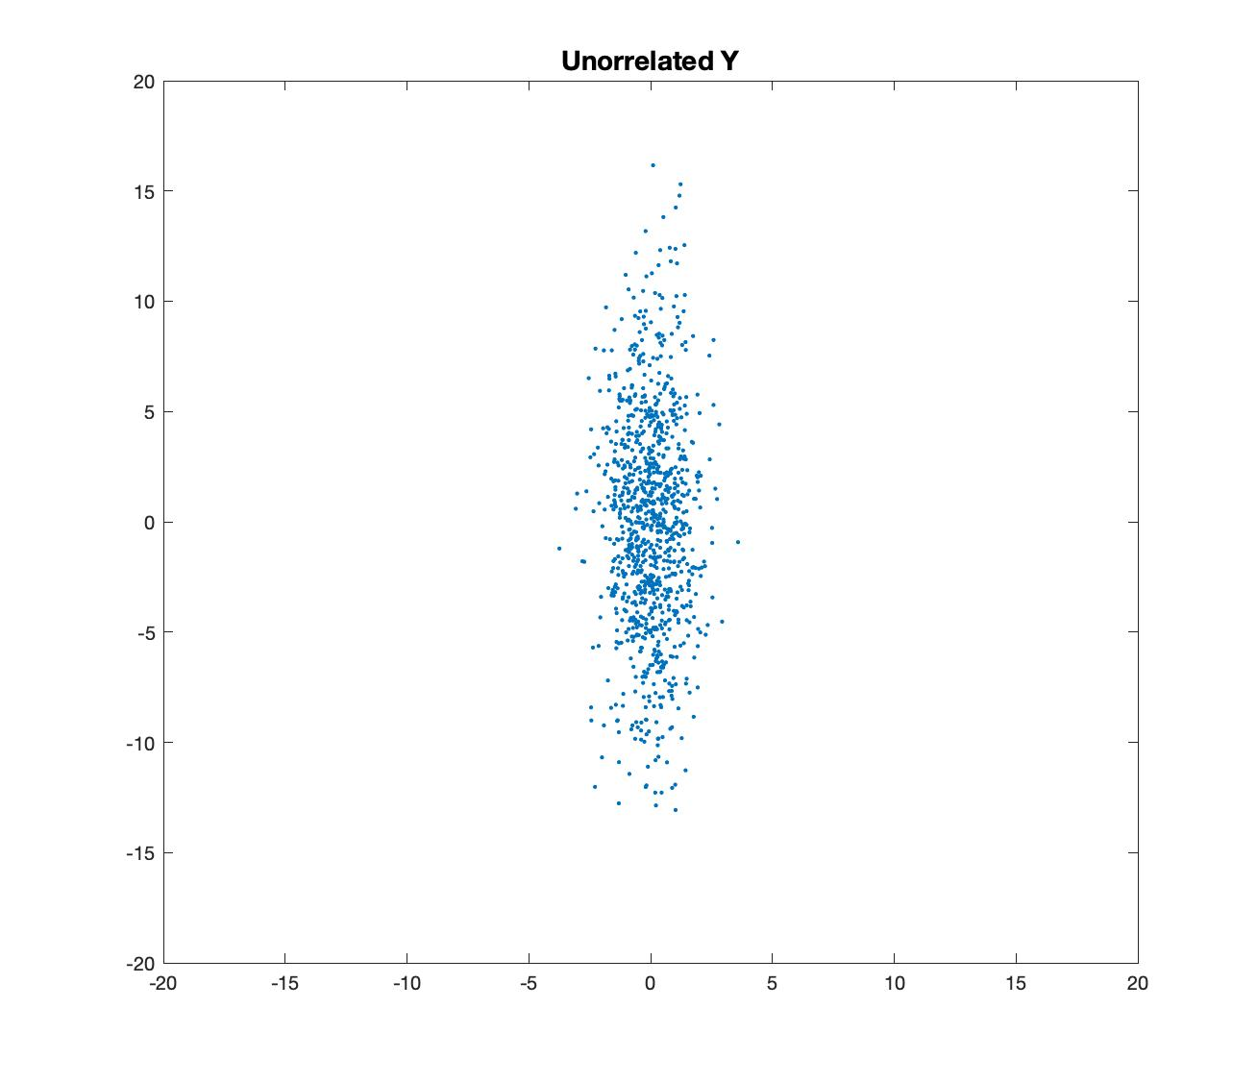

% Author: Yi Zhao

% CSE 5524, HW4

% 09/21/2019

%%%%%%%%%%%%%%%%%%%%%%%%%%%%%%%

%% Problem 1

for i = 1:4

% read image (in double): boxIm[1-4].bmp

im = double(imread(sprintf('./data/boxIm%d.bmp',i)));

% display 7 similituyde moment for each of image

disp(similitudeMoments(im))

end

%%%%%%%%%%%%%%%%%%%%%%%%%%%%%%%

%% Problem 2

% Load the data

clear; close all;

load('./data/eigdata.txt');

X = eigdata;

subplot(2,1,1);

plot(X(:,1),X(:,2),'b.');

axis('equal');

% mean-subtract data

m = mean(X);

Y = X - ones(size(X,1),1)*m;

subplot(2,1,2);

plot(Y(:,1),Y(:,2),'r.');

axis('equal');

pause;

close all;

%%%%%%%%%%%%%%%%%%%%%%%%%%%%%%%

%% Problem 3

K = cov(Y);

[coeff,score,latent,~,explained] = pca(Y);

[U, V] = eig(K);

c = 9;

len1 = sqrt(c*V(1,1));

len2 = sqrt(c*V(2,2));

hold on

plot([U(1,1),0]*len1,[U(2,1),0]*len1, 'g','LineWidth',2)

plot([U(1,2),0]*len2,[U(2,2),0]*len2, 'r','LineWidth',2)

plot(Y(:,1),Y(:,2),'.')

title('Correlated Vector w/ 3 Std.','FontSize', 14)

ellipse(len1,len2,atan(U(1,1)/U(2,1)),0,0)

pause;

%%%%%%%%%%%%%%%%%%%%%%%%%%%%%%%

%% Problem 4

close all;

Y2 = Y * U';

plot(Y2(:,1),Y2(:,2),'.')

axis([-20 20 -20 20])

title('Unorrelated Y','FontSize', 14)

%%%%%%%%%%%%%%%%%%%%%%%%%%%%%%%

%% Problem 1 Helper function

function Nvals = similitudeMoments(im)

Nvals = [];

% initialize matrix for row index, col index, x average and y average.

xind = repmat(1:size(im,2),size(im,1),1); % col => x

yind = repmat((1:size(im,1))', 1, size(im,2)); % row => y

m00 = sum(im, 'all');

m10 = sum(xind.*im, 'all');

m01 = sum(yind.*im, 'all');

xbar = ones(size(im)) * m10/m00;

ybar = ones(size(im)) * m01/m00;

% iteratively calculate 7 similitude moments

for i = 0:3

for j = max(0,(2-i)):(3-i)

% 2 <= (i+j) <= 3

nij = sum(((xind - xbar).^i).*((yind - ybar).^j).*im,'all')/(m00.^((i+j)/2+1));

Nvals = [Nvals, nij];

end

end

end