CSE 5524 HW6

Author: Yi Zhao

Professor: Jim Davis

1. The covariance tracking runs pretty fast and the result is focusing on this guy below. The location of best match is at the position: [255,26], with covariance of 0.7061.

The distance matrix indicates that the right top corner has a dark region, which has the lowest distance. The index of darkest point is around [20, 200] which match our result.

When we compare the distance matrix with the origin image, there is several dark regions on distance matrix. When we find these corresponding dark regions on origin image, we found similar color composition with our result.

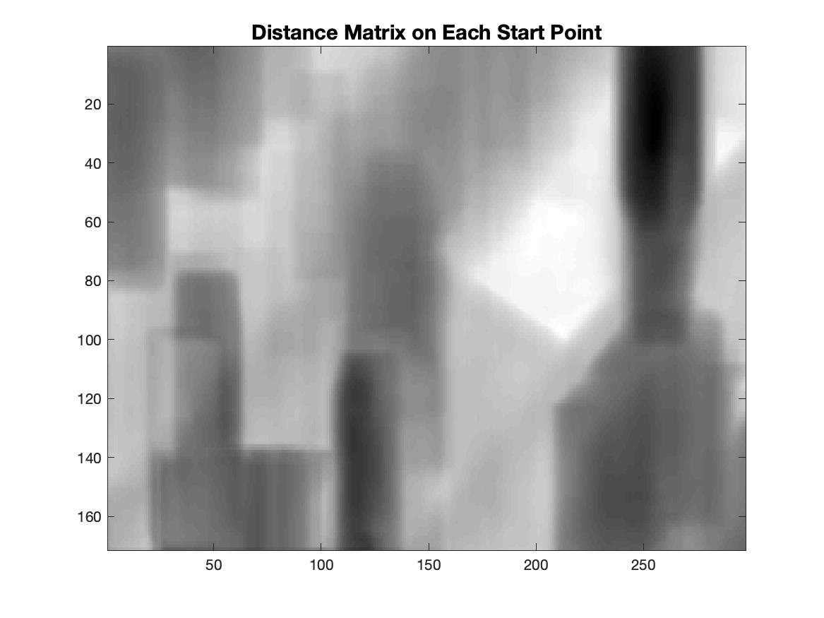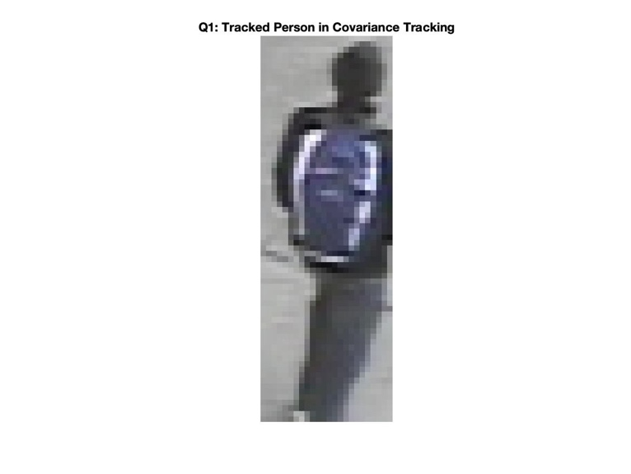

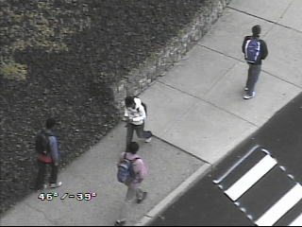

1. The model with circle on location [150, 175] is shown below.

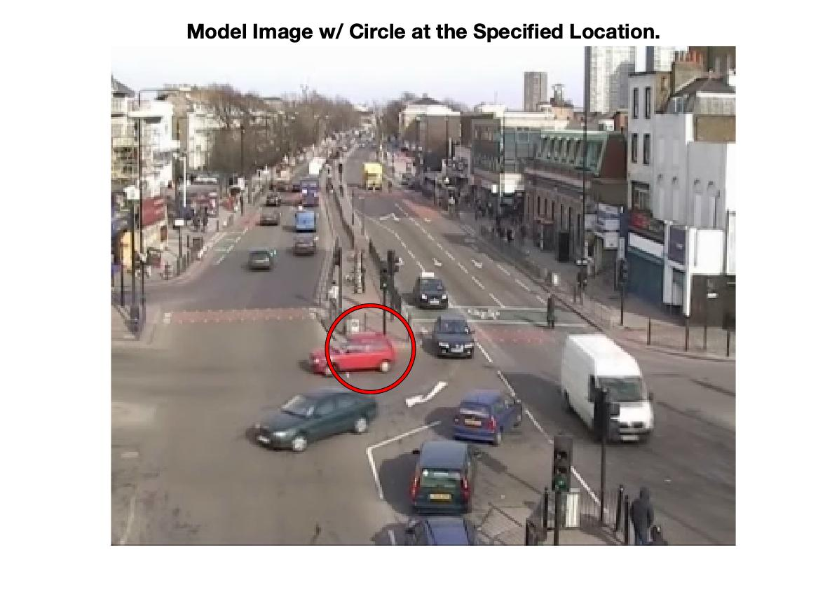

The final location is: [137.650896, 175.281092], with distance: 0.011138. Please see image below.

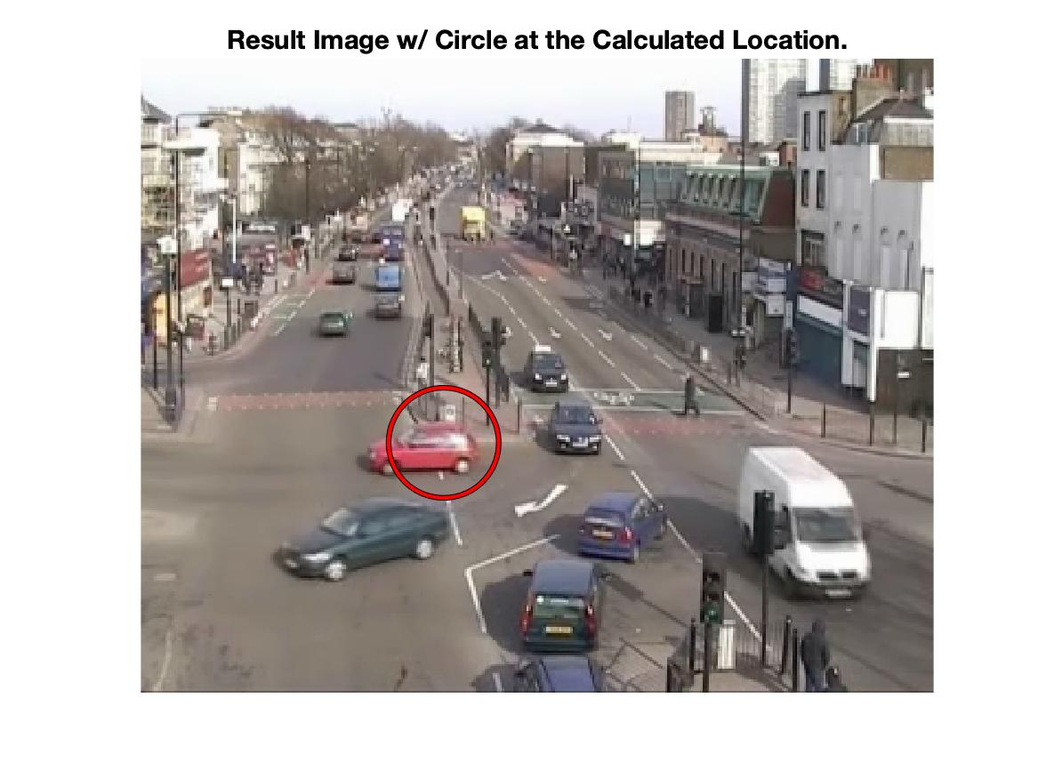

The red circle is focused on the body of red car, which was shifted from x=150 to x=137. Zoom in the image and you can see the element in both circles are almost identical. The red circle crosses the front tire, covering the garbage can and the edge of roads, which quite make sense. The final distance is 0.01 which indicates the convergence of iteration. I also did experiments with iterations = 100, and the final result is around [137.6374, 175.2953] with distance = 1.39*e-12, which is almost zero. I rounded the result to [138, 175] and drew the circle with radius = 25, as you see in the figure.

% Author: Yi Zhao

% CSE 5524, HW6

% 10/03/2019

%%%%%%%%%%%%%%%%%%%%%%%%%%%%%%%

%% Problem 1

% import raw image in double

raw = double(imread("./data/target.jpg"));

xind = double(repmat(1:size(raw,2),size(raw,1),1)); % col => x

yind = double(repmat((1:size(raw,1))', 1, size(raw,2))); % row => y

target = cat(3,xind,yind,raw); % concate x index and y index to image

% import model cov matrix

modelCovMatrix = [47.917 0 -146.636 -141.572 -123.269;

0 408.250 68.487 69.828 53.479;

-146.636 68.487 2654.285 2621.672 2440.381;

-141.572 69.828 2621.672 2597.818 2435.368;

-123.269 53.479 2440.381 2435.368 2404.923];

% iteratively test all 1-pixel overlapping windows (70*24)

res = [1,1,realmax('single')];

for r = 1:(240-70+1)

for c = 1:(320-24+1)

cm = covMatrix(target, r, c, 70, 24);

dm = distMatrix(cm, modelCovMatrix);

if dm <= res(3)

res = [r, c, dm];

end

end

end

x = res(1);

y = res(2);

disp(res)

resim = double(imread("./data/target.jpg"));

resim = resim(res(1):res(1)+69, res(2):res(2)+23,:);

imshow(resim/255, 'InitialMagnification','fit')

title('Q1: Tracked Person in Covariance Tracking')

saveas(gcf,'./output/Part1.jpg')

pause;

%%%%%%%%%%%%%%%%%%%%%%%%%%%%%%%

%% Problem 2

% See function at the bottom

%%%%%%%%%%%%%%%%%%%%%%%%%%%%%%%

%% Problem 3

% See function at the bottom

%%%%%%%%%%%%%%%%%%%%%%%%%%%%%%%

%% Problem 4

% See function at the bottom

%%%%%%%%%%%%%%%%%%%%%%%%%%%%%%%

%% Problem 5

im1 = double(imread("./data/img1.jpg"));

im2 = double(imread("./data/img2.jpg"));

location = [150.0 175.0]; % (x, y)

previous_loc = location;

X_model = circularNeighbors(im1, 175.0, 150.0, 25.0);

q_model = colorHistogram(X_model, 16, 175.0, 150.0, 25.0);

for i = 1:25

X_test = circularNeighbors(im2, location(2), location(1), 25.0);

p_test = colorHistogram(X_test, 16, location(2), location(1), 25.0);

% update parameter

weight = meanshiftWeights(X_test, q_model, p_test, 16);

location = weightedAverage(X_test, weight);

% display distance and location

dist = pdist([previous_loc; location], 'euclidean');

fprintf(sprintf('Location: %f, %f. Dist: %f \n', location, dist))

previous_loc = location;

end

imshow(im1/255, 'InitialMagnification','fit')

viscircles([150 175], 25)

title('Model Image w/ Circle at the Specified Location.', 'FontSize',14)

saveas(gcf,'./output/Model.jpg')

pause;

imshow(im2/255, 'InitialMagnification','fit')

viscircles(round(location), 25)

title('Result Image w/ Circle at the Calculated Location.', 'FontSize',14)

saveas(gcf,'./output/Test.jpg')

%%%%%%%%%%%%%%%%%%%%%%%%%%%%%%%

%% Helper function

% Return distance matrix of model and test window

function dm = distMatrix(m1, m2)

e = eig(m1, m2);

e(e <= 0) = 1; % convert log(0 or neg) => log(1) = 0

dm = sqrt(sum(log(e).^2, 'all'));

end

% Return the covariance matrix of fk, with start point (row,col) and size(rl, cl)

function cm = covMatrix(fk,row,col,rl,cl)

window = fk(row:(row+rl-1), col:(col+cl-1), :);

window = reshape(window, [], size(fk, 3));

cm = cov(window, 1);

end

% Return the feature vector of all pixels in circular (dim = ?*5)

% Rows in X: [x(col), y(row), r, g, b]

function X = circularNeighbors(img, r, c, radius)

X = [];

for i = 1:size(img,2) % x, column

for j = 1:size(img,1) % y, row

if pdist([i j; c r], 'euclidean') <= radius

line = double([i, j, reshape(img(j, i, :), 1, 3)]);

X = cat(1, line, X);

end

end

end

end

% Return a cube (dim = bins*bins*bins) histogram of X.

function hist = colorHistogram(X, bins, row, col, h)

hist = zeros([bins bins bins]);

interval = 256.0/bins; % [0*gap - 1*gap), [1*gap - 2*gap), ...

for i = 1:size(X, 1)

dist = pdist([X(i, 2) X(i, 1); row col], 'euclidean');

k = max(0, 1-(dist/h)^2); % weight

r = floor(X(i, 3)/interval)+1;

g = floor(X(i, 4)/interval)+1;

b = floor(X(i, 5)/interval)+1;

hist(r,g,b) = hist(r,g,b) + k;

end

hist = hist / sum(hist, 'all');

end

% Return the weights vector.

function weight = meanshiftWeights(X, q_model, p_test, bins)

weight = zeros([1, size(X,1)]);

interval = 256/bins; % [0*gap - 1*gap), [1*gap - 2*gap), ...

p_test(p_test<0) = 1.0; % prevent zero dividing

qube_weighted = sqrt(q_model./p_test);

for i = 1:size(X, 1)

r = floor(X(i, 3)/interval)+1;

g = floor(X(i, 4)/interval)+1;

b = floor(X(i, 5)/interval)+1;

weight(i) = weight(i) + qube_weighted(r,g,b);

end

end

% Return the next best location [x(col), y(row)].

function location = weightedAverage(X, weight)

ind = X(:, 1:2).* weight';

location = sum(ind) /sum(weight, 'all');

end