PRP-1 stack

Authors: S. Meier
Creation date: 08 February 2007
Version: 1.0.7
State: released

Contact address

Institute of Embedded Systems (InES)
Zurich University of Applied Sciences
Technikumstr. 22
Postfach
CH-8401 Winterthur

Tel: +41 58 934 75 25
Fax: +41 58 935 75 25

Mail: support.ines@zhaw.ch
http: ines.zhaw.ch/

Document

Distribution: ZHAW – InES

History

Version | Date | Author/Revisor | Description
1.0.1 | 08. Feb. 2007 | Meier Sven | Created
1.0.2 | 16. Mar. 2007 | Meier Sven | Changed the API etc
1.0.3 | 20. Mar. 2007 | Meier Sven | Updated some classes
1.0.4 | 19. Sep. 2007 | Meier Sven | SRP stuff added
1.0.5 | 13. Feb. 2008 | Meier Sven | Updated Graphics etc
1.0.6 | 01. Jul. 2011 | Weibel Hans
1.0.7 | 01. May 2012 | Walch Oliver | Updated to PRP-1

Contents

1 About this document 4
1.1 The PRP-1 Stack 4
2 Design 5
2.1 Block Diagram 5
2.2 Mode of operation 6
2.3 Layer Diagram 6
2.4 Components 6
3 Implementation 8
3.1 Object-oriented C 8
3.2 API and Interfaces 10
3.2.1 PRP_T 10
3.2.2 PRP_NetItf_T_linux 10
3.2.3 PRP_LogItf_T 10
3.2.4 PRP_OsItf_T 10
3.2.5 PRP_Environment_T 10
3.2.6 PRP_EnvironmentConfiguration_T 10
3.2.7 PRP_NodeTable_T 10
3.2.8 PRP_Node_T 10
3.2.9 PRP_Lock_T 10
3.2.10 PRP_Supervision_T 11
3.2.11 PRP_SupervisionFrame_T 11
3.2.12 PRP_Bridging_T 11
3.2.13 PRP_BridgingFrame_T 11
3.2.14 PRP_DiscardAlgorithm_T 11
3.2.15 PRP_FrameAnalyser_T 11
3.2.16 PRP_Frames_T 11
3.2.17 PRP_Trailer_T 11
3.2.18 PRP_RedundancyControlTrailer_T 11
3.2.19 PRP_Timer_T 11
3.3 Frame Path Diagrams 12
3.3.1 Normal frame receiving 12
3.3.2 Normal frame transmitting 13
3.3.3 Supervision frame receiving 14
3.3.4 Supervision frame transmitting 15
Integration in Linux 16
3.4 Example Userspace integration in Linux 16
3.5 Compile and run application 16
4 Graphic index 17

About this document
This is a design and implementation description of the Parallel Redundancy Protocol (PRP-1) Software.

The PRP-1 Stack
The requirements are as followed:

The Parallel Redundancy Protocol Stack shall support the whole PRP-1 standard.
It shall allow running IEEE1588/PTP.
It shall be manageable.
It shall be easy portable to other Operating Systems.
It shall be as fast as possible.
It shall use as little resources as possible.
It shall be extendable.
It shall have a clear API.

With these requirements in mind the design described in the following chapters was chosen.

Design

Block Diagram
Error: Reference source not found illustrates the relations between the different components of a PRP device.

Each PRP device owns a PRP Environment and a PRP Node Table, which is embedded into the PRP Environment. The PRP Environment provides the protocol functionalities like Discard Algorithm, Supervision or Redundancy Control Trailer as well as global and node specific data. The interfaces (PRP, PRP_xxxItf) decouple all the operating system dependent functions from the PRP software which is generic. These interfaces are implemented as singletons what means that every interface exists only once. The access layer PRP (API) is the communication path between user programs and the PRP software.

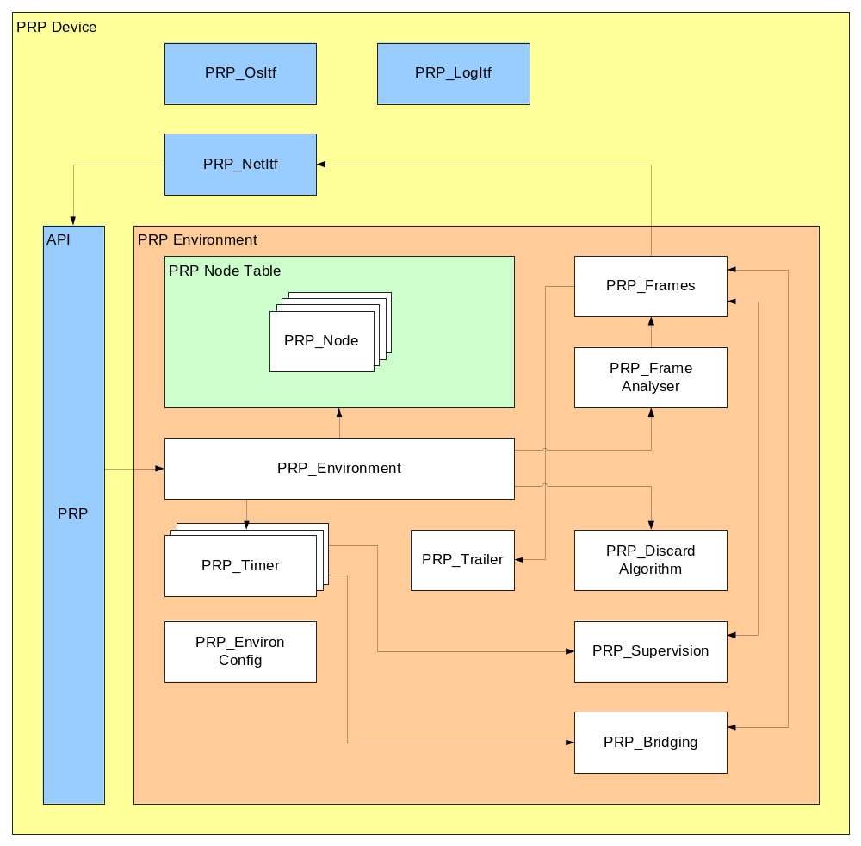
Figure 1 The components of the PRP software

Mode of operation
Basically the following steps are executed when an event occurs:

An event occurs (e.g. a frame was received).
The respective API function gets called (e.g. receive()).
The PRP_Environment invokes further actions depending on the current event (e.g. pass the received frame to the PRP_Frame_Analyser).

Layer Diagram
PRP-1 software mainly consists of two layers. One layer is the protocol engine – it’s generic and hasn’t got to be changed at all in order to run on a specific operating system. It’s implemented according to the PRP-1 standard. The other layer is the OS abstraction layer with the interfaces – this is where all the environment dependent code is located at. The interfaces have to be adapted to the OS so the protocol engine has access to the used resources which the OS -environment provides. The layers are shown in Error: Reference source not found

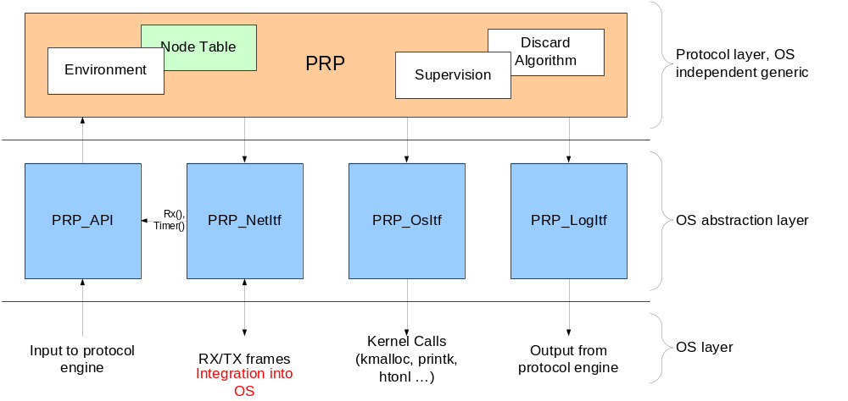
Figure 2 Layers and interaction

Components

PRP_Environment
The PRP_Environment is kind of a multiplexer. It forwards API calls coming from the PRP_API to the respective class.

PRP_Node_Table
The PRP_Node_Table is the entry point to the node table described in the standard. It has a pointer to the first and the last node (PRP_Node) in the table and provides functions to add/remove and search nodes in the table.

PRP_Node
The PRP_Node class contains general information about a remote node.

PRP_Frames
This is the actual core of the design. It gets nodes out of the table, adds or removes the RCT and creates duplicates in the transmission path.

PRP_Frame_Analyser
The PRP_Frame_Analyser checks the frame type, whether it is a normal, a ptp or a supervision frame, and forwards it to the respective handler.

PRP_Discard_Algorithm
This module implements the discard algorithm, the actual heart of the protocol.

PRP_Supervision
The PRP_Supervision block sends and receives supervision frames and checks the PRP_Node_Table for expired nodes.

PRP_Timer
This is the Timer needed for the supervision of the node table

PRP_Lock
This block is used to guarantee atomic access on shared resources.

PRP_Trailer
This module provides functions to get add and remove the RCT.

PRP_Environment_Configuration
The PRP_Environment_Configuration provides the general information about the protocol engine defined in the PRP-1 standard.

PRP
The PRP is the API of the PRP-1 software. It encapsulates the functions of the PRP_Environment that must be called from outside. It guarantees atomic access to the protocol engine.

PRP_Operating_System_Interface
The whole software runs in user space to get an OS independent protocol core.

PRP_Network_Interface
This PRP_network_Interface module provides functions to transmit and receive frames. It is the wrapper class around the protocol core. The integration into the network stack of the operating system is done here.

PRP_Log_Interface
The PRP_log_Interface is the output interface of the software.

Implementation
The implementation of PRP-1 is done with object-oriented C. So the advantages of object-oriented analysis / design / programming can be applied (also methodology, encapsulating, reusability etc.).

Object-oriented C
This clause shows how a C++ class is realised in C.

A C++ class:
/*** PRP_Timer class in C++ ***/  class PRP_Timer  {  /** Attributes */  private:  boolean enabled_;  Unsigned32 value_;  Unsigned32 timeout_;  /** Methods */  public:  PRP_Timer( Unsigned32 timeout );  ~PRP_Timer();  tick();  restart();  stop();  } | Constructor  Destructor

The same class PRP_Timer in C is realised as the following.
/*** PRP_Timer class in C ***/  typedef struct PRP_Timer_T PRP_Timer_T  {  /** Attributes */  boolean enabled_;  Unsigned32 value_;  Unsigned32 timeout_;  };  /** Methods */  PRP_Timer_Init( PRP_Timer_T *const me, Unsigned32 timeout );  PRP_Timer_Cleanup(PRP_Timer_T *const me );  PRP_Timer_tick(PRP_Timer_T *const me );  PTP_Timer_restart(PTP_Timer_T *const me );  PTP_Timer_stop(PTP_Timer_T *const me ); | Constructor  Destructor
The attributes of a class are encapsulated in a structure. To avoid the struct keyword, the class struct PRP_Timer is defined as a new type: typedef struct PRP_Timer. Because there is no this pointer in C, a pointer of type of this class is passed to every function of this class. The names of the methods (or functions) of a class shall always begin with the class name. Constructor and destructor shall be named <CLASSNAME>_Init and <CLASSNAME>_Cleanup respectively. Some classes own functions named <CLASSNAME>_Create and <CLASSNAME>_Destroy. The _Create function creates an instance of the class dynamically and the _Destroy function destroys the instance and frees the allocated memory. These two functions also call the _Init and _Cleanup functions.

API and Interfaces

PRP_T
This class represents the API of the PRP-1 stack and describes the functions which can be called from outside in order to impact it. PRP_T handles inputs to the stack as function calls. Every time an API function is called, it will pass a lock saved section, so every API call is atomic. This class is implemented as a singleton therefore there is no me* pointer.
In order to ensure an error free operation of the PRP-1 Stack, inputs have to be passed to the stack by (only) using the API functions. PRP_T is thread save and has not to be adapted for a specific OS.

PRP_NetItf_T_linux
The Network Interface integrates the protocol engine into the network stack and is therefore the wrapper class around the OS independent protocol engine. The NetItf must receive frames from the two Adapters and must be able to send to the two Adapters. All traffic to the two interfaces must pass this Interface. On receiving the OS depending receive function will call the API PTP_T_receive() function. In the sending path it will forward the frames coming from the upper layers to the API PTP_T_transmit() function. The protocol engine will call the PRP_NetItf_T_transmit() function.
This Interface also provides functions to change properties of the two adapters.
PRP_NetItf_T has to be adapted for a specific OS.

PRP_LogItf_T
This interface provides log macros for outputs of the protocol engine. There are several different log levels.
PRP_LogItf_T has not to be adapted for a specific OS (but maybe for a not GNU compliant C compiler because list of arguments is not supported by all compilers).

PRP_OsItf_T
The Operating System Interface abstracts functions like malloc, free etc.
PRP_OsItf_T has to be adapted for a specific OS.

PRP_Environment_T
The Environment is the central part of the protocol engine. It distributes function calls coming from the API to the respective classes. It also runs the timers.

PRP_EnvironmentConfiguration_T
The Environment Configuration contains general information about the protocol engine and its environment.

PRP_NodeTable_T
The Node Table consists of four sub classes, PRP_NodeTable_T, PRP_Node_T, PRP_DropWindowTable_T and PRP_DropWindow_T. This class provides functionality to search, add, delete, etc. nodes. The table is designed as a double linked, unsorted list. Therefore a search is always a linear search through the table. The design of the Node table can easily be changed without affecting the rest of the stack.

PRP_Node_T
The Node class contains general information about a remote node. It also has an instance of a PRP_DropWindowTable_T. It is an entry of the node table.

PRP_Lock_T
This class provides the functions to create locked sections.

PRP_Supervision_T
The Supervision class is one of the core classes it processes received Supervision frames as well as it send periodically Supervision by itself. This class also does the Supervision of the Node Table.

PRP_SupervisionFrame_T
This is an instance of a Supervision frame. It provides a function to set some specific field in the frame.

PRP_Bridging_T
The Bridging class is one of the core classes it processes received RSTP-BPDU frames as well as it answers them. It implements the SRP

PRP_BridgingFrame_T
This is an instance of a Supervision frame. It provides a function to set some specific field in the frame.

PRP_DiscardAlgorithm_T
This class is another core class it implements the discard algorithm specified in the standard. The decision whether to keep a frame or not is done here.

PRP_FrameAnalyser_T
The Frame Analyzer checks the frame type at forwards the frame to the respective frame handler.

PRP_Frames_T
The Frames class is the core class of the whole protocol engine. It adds/removes the RCT gets/adds nodes and drop windows to the Node Table, runs the discard algorithm, etc.

PRP_Trailer_T
The Trailer class provides functions to add/remove/get the RCT to/from the frame.

PRP_RedundancyControlTrailer_T
This is an instance of an RCT.

PRP_Timer_T
The Timer class is to run scheduled task like Supervision frame transmission or supervision of the Node Table.

Frame Path Diagrams

Normal frame receiving
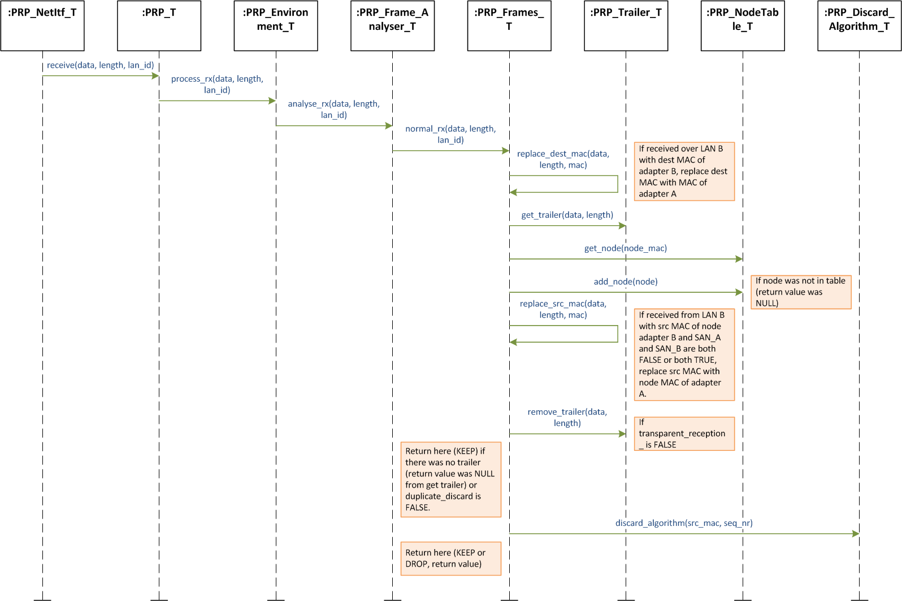
Figure 3 Reception of a normal frame

Normal frame transmitting

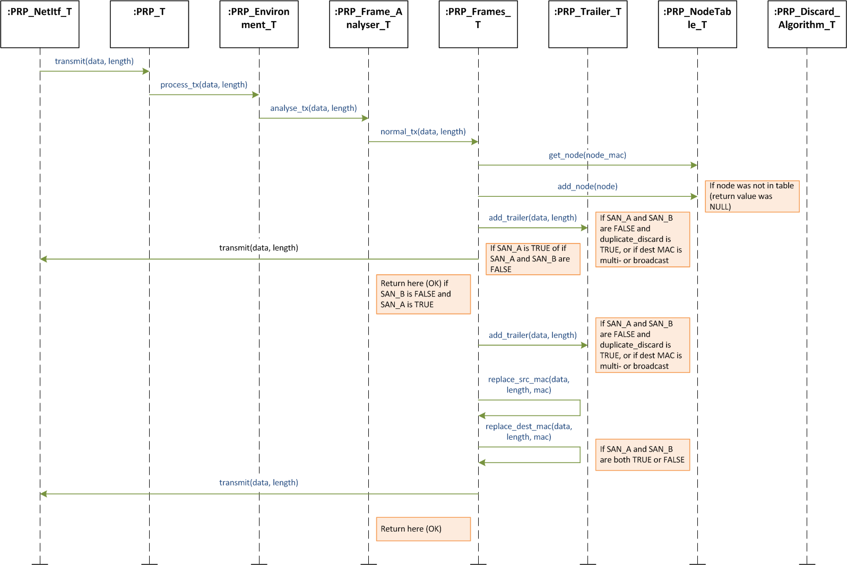
Figure 4 Transmission of a normal frame

Supervision frame receiving

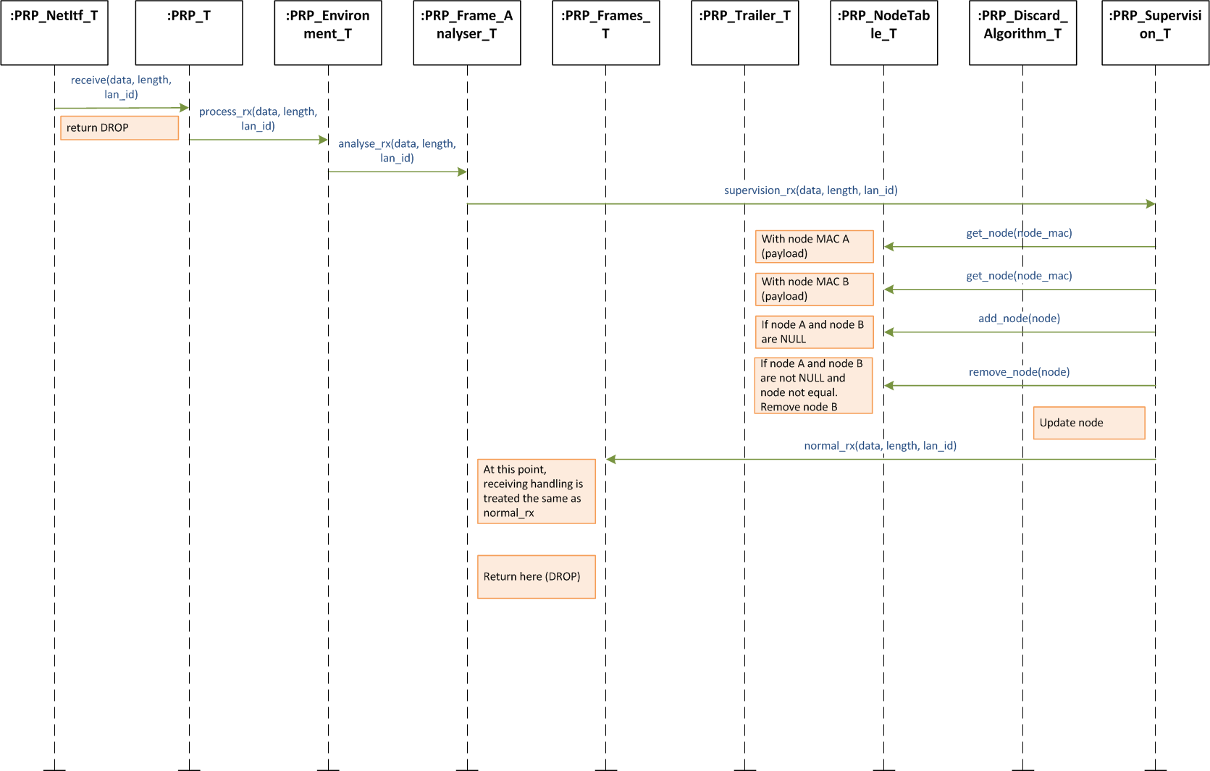
Figure 5 Reception of a supervision frame

Supervision frame transmitting

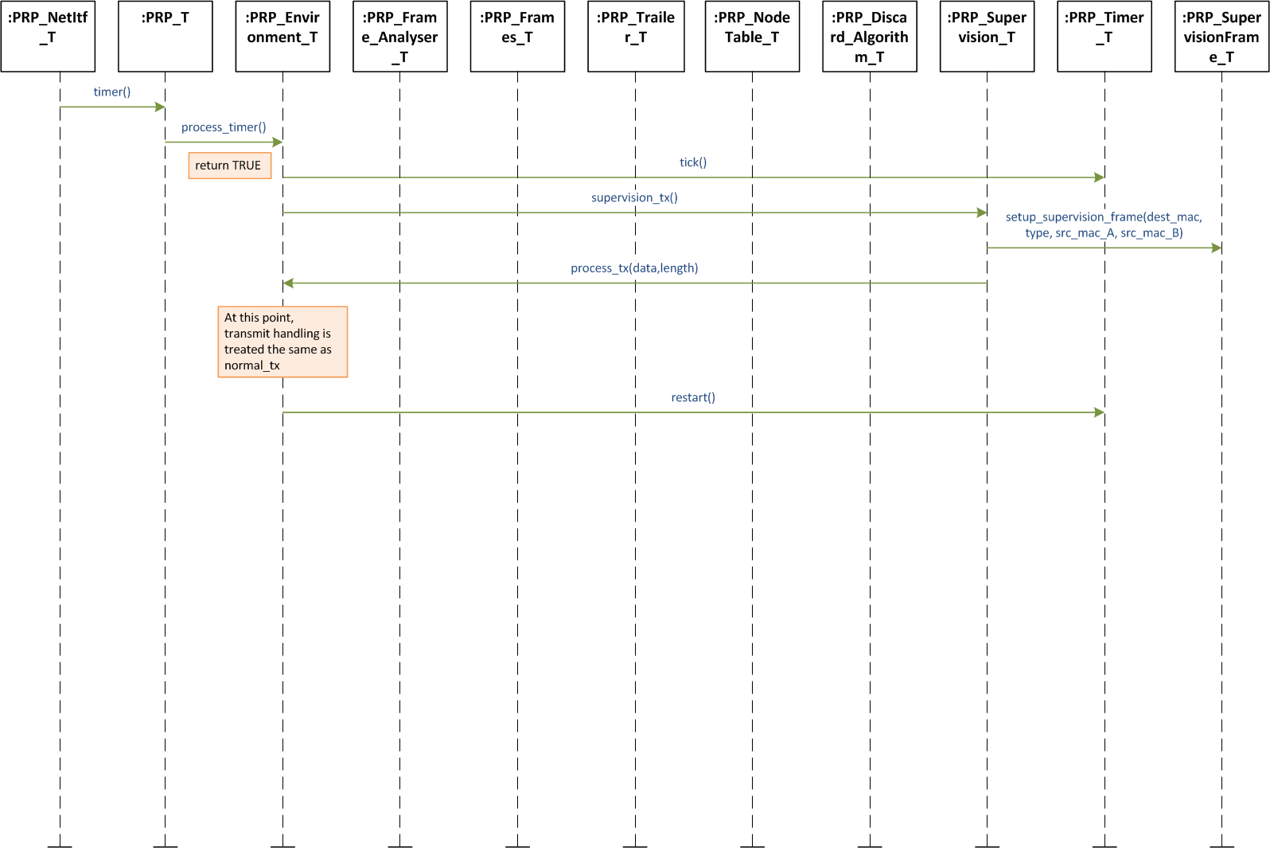
Figure 6 Transmission of a supervision frame

Integration in Linux

Example Userspace integration in Linux
The PRP protocol engine receives the frames from the two real Ethernet interfaces does the Duplicate elimination, and forwards it to a virtual network interface which forwards the frames back to the operating systems protocol engine. Therefore all applications are talking with the virtual network device.

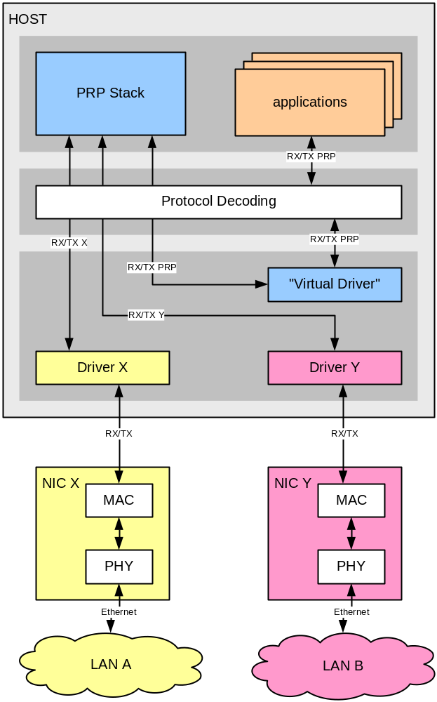
Figure 7 Linux Userspace integration

Compile and run application
The make file is located in the prp_pcap_tap_userspace directory. Change to this directory and build the PRP-1 SW-stack by calling make. If the application gets compiled successfully, the application prp_pcap_tap_userspace can be executed.

Graphic index

Figure 1 The components of the PRP software 5
Figure 2 Layers and interaction 6
Figure 3 Reception of a normal frame 12
Figure 4 Transmission of a normal frame 13
Figure 5 Reception of a supervision frame 14
Figure 6 Transmission of a supervision frame 15
Figure 7 Linux Userspace integration 16

