**Factors Influencing the Informatization Construction of Public University**

Candidate: Zhu Linnan（PCS213085）

Supervised by:

Dr. Mohd Shahizan Bin Othman

February 13, 2023

**Chapter 1: Introduction**

1. **Introduction**

With the large-scale improvement of the global level of science and technology, people have entered the era of big data. The development of various industries has been inseparable from information technology. Information construction is the mainstream trend of development in all fields of the world under the background of the information revolution, and it is also the key to promoting social progress. With the help of information technology and information resources, it can make the cross-regional information exchange become more efficient. At the same time, the productivity and lifestyle of human beings have changed totally.

The informatization construction of Chinese universities originated in the 1990s. With the development of information technology and network technology, the education department proposed to realize the goal of informatization of Education. In the article《China's Education Modernization 2035》, it is clearly proposes to accelerate the reform of education in the information age through Campus informatization. Campus informatization is to use of the combination of network technology, computer technology, and modern communication technology to manage instruction, research, office routine, educational administration, and student affairs. In higher education activities, information technology has become the conventional means and technical methods. Crossing over time and space to expand the traditional functions of the campus to a virtual campus, thus it greatly improved the level of campus information management and work efficiency. It is not only change the campus life style of higher education, but also continuously renovate in the educational theory and practice, showing a positive trend.

Information construction is the only way to achieve modernization and high-quality development in all fields, and also the key process for educational modernization. Under the background of increasingly fierce competition among colleges and universities, Chinese universities will pay more attention to the construction of education informatization. In addition, it can change the idea of talent training in universities and the traditional idea of exam-oriented education. In the article “Influencing Factors and Multiple Paths”, the author describe that it not only meets the needs of their own development but also meets the government's strategic deployment for higher education informatization (Yifan & Bei, 2022). Higher education informatization is an important means to enhance the national comprehensive competitiveness.

1. **Problem Background**

In the field of education, China has begun the construction of educational informatization since the 1990s. Especially with the popularization of computer science, the Internet, and other technologies, as well as the development of artificial intelligence, the Internet of things, cloud computing, and other technologies, the process of university information construction has been accelerating. The information construction of Chinese higher education started relatively late, but its development momentum is relatively fast.

According to the article “Higher education reform in China”, the author state that it has become an important strategy to promote modern education and realize a great-leap-forward development (Xiong et al., 2022). By using the advanced technology to achieve the reasonable allocation of instructional resources in universities and the teaching resource construction has constantly strengthened to create a large-scale information space. It breaks the restriction of time and space on educational work, enhances universities' serviceability, and improves the quality of personal training and universities' management ability. According to DevOps in Practice for Education Management Information System at ECNU, the author state that many colleges and universities at home and abroad have increased the strength of information construction, from the information environment to the information organization structure. They have developed their own plan with a detailed map to improving the level of information construction of universities (Yang et al., 2020). Moreover, the universities’ comprehensive strength has been increased. (See Figure 1)

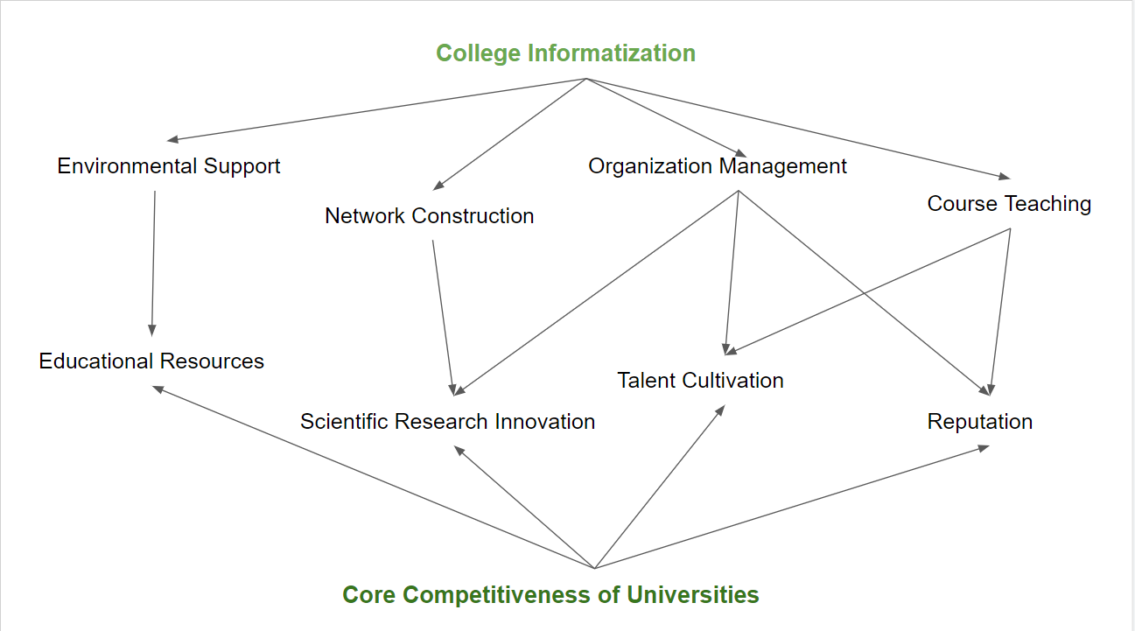

Figure1. The relationship between University informatization and University Competitiveness

The Chinese government requires all public universities have sharply increased enrollments, thus allowing many more people the chance of higher education. Under this policy what followed is the problem of too many students and the shortage of educational funds. The article Review of Digital School Construction and Development in China explains that inevitably the quality of university education has caused a certain degree of influence (Yan & Lan, 2013). Vigorously developing information construction, so that education resources can be better distributed in different developing regions, and timely feedback of the enrollment situation can help the country to carry out macro-control policies in time.

So that the existence of information systems (IS)is essential for the production and management of information during the teaching process. An IS is a database that is designed and built to store process and analyze information that helps an organization make effective decisions. These organized systems are composed of people, hardware, software, communication networks and data sources that collect, transfer and send information within an organization. The implementation and use of information systems by universities could result in them gaining a competitive advantage, in that it would improve the management performance and result in efficient work processes. Besides that, by using the information technology to built the teaching information management system can improve the quality and efficiency of curriculum management, reasonable analysis of the deficiencies of curriculum management in colleges and universities, can better achieve the purpose of teaching objectives, service college teaching, training in line with the requirements of the development of the new era of excellent talents. Under the influence of national policy, many universities have responded to establish the relevant education information system.

In recent decades, there has been a growing willingness on the part of private and public organizations to use IT, and in particular information systems. Under the influence of national policy, many universities have responded to establish the relevant education information system. However, in many cases, the implementation of information system has been associated with problems. In fact, the average level of development state of university informatization in China on information system is only 50% (See Figure 2). In order to develop and manage educational processes, China needs information systems,so it is important to pay attention to the causes and impact of the failed implementation of such costly IT projects.

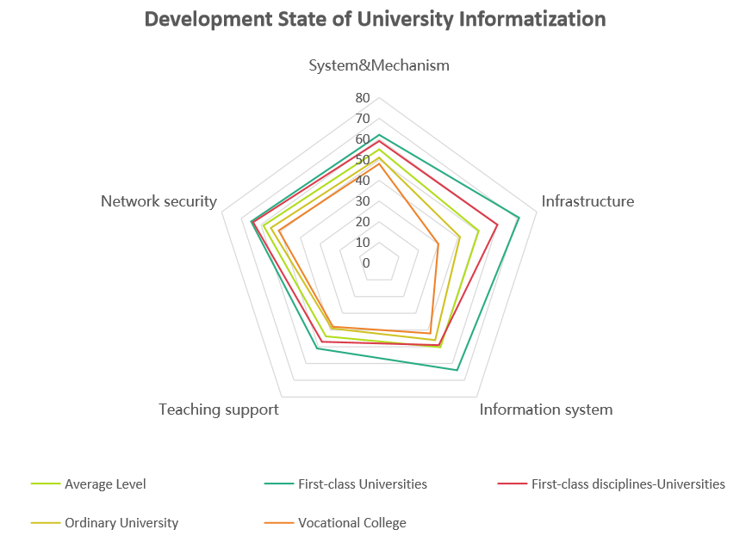

Figure 2. Development state of university informatization in China

In recent year, the most universities in China use an integrated information system, the aim being to include all the processes that take place at the universities. By collecting and storing data in a central database, these systems reduce the circulation time of documents. In fact, registration, easy access to information provided by students, professors, instructors, researchers and other personnel at a university, and linking that university to other organizations constitute some of the main advantages of information system used at universities in China. But the information technology and the different requirements for educational information systems in university are constantly changing and, when implementing an information system in any organization, there are several potential problems ,which in a number of cases, when done incorrectly,is likely to result in failure.

1. **Problem Statement**

With the advent of the era of big data, the construction of university information systems has gradually shifted from informatization to intelligence, and the focus of construction has shifted from traditional university management information. The system has gradually transformed into a smart campus construction centered on teachers and students. The business department has independently deployed multiple information systems such as personnel, scientific research, finance, and asset OA around its own business, which has greatly improved the efficiency of university management. For information system selection, there has significant differences in different universities. For example, the first-class universities and first-class discipline universities have basically achieved full coverage in the field of traditional school management information. There is a relatively large gap between the information system coverage rate of ordinary universities and the first two types of universities.

At present, the information management is relatively chaotic in some university. Most business systems are built in a scattered manner, and some functions are redundantly built, resulting in a large waste of resources. It was difficult to coordinate between departments when the system was connected, and it was difficult to get through the data flow and business flow. Because of the perspectives of these information system developer and user are different, it also restricts the construction of various information services.

At the national level, there is no special information system on construction and standard system, resulting in poor implementation of the information system construction process. The work of modernization construction and operation and maintenance is rarely included in the performance appraisal system of colleges and universities, thus; it is difficult for information system construction to achieve the expected results.

There are a number of reasons for the failure of information systems in China’s educational system, which can be divided in to the categories of project management,organization management,human-related, technical and so on. This paper using the Best-Worse method to identifg these factors and measuring their impact, it may be possible to provide a solution for future projects.

1. **Research Questions**

According to the aforementioned problem statement, four research questions to be answered in this study have been formulated as follows:

1. Are there any significant differences of information system selection and requirement in different universities ?
2. What factors have significantly influence of the information system selection ?
3. What are the factors leading to the failure of information systems ?
4. Do government policy, Information system development industry and performance appraisal moderate the relationship between information system requirement and selection in universities ?
5. **Research Objectives**

In order to answer the research questions and to provide suggestions to solve the research problems, four research objectives of this study have been formulated as follows:

1. 1.To explore significant differences in information system selection and requirement in different universities.
2. By reviewing relevant existing literature and then propose a framework of criteria that contribute to the failure of information systems.
3. After reviewing the background of information technology and information systems to determine the factors leading to the failure of information systems.
4. To examine the effects of government policy, industry of Information system development and performance appraisal on the relationship of information system selection.
5. **Scope**

This study aimed to investigate determine the factors leading to the failure of information systems, and which links the selection of information system with various moderating effects of government policy, industry of Information system development and performance appraisal. Therefore, the scope of this study is limited to four types universities:

First-class university, first-class disciplines university, ordinary university and vocational college. Due to the large number of universities, stratified random sampling is applied to select respondent universities from Beijing, Tianjin and Hebei regions.(BTH- Region) based on education development situations. In addition, as this study is based on the university of BTH region, the questionnaires are answered by the information technology experts working in different public universities or other staff who are familiar with information system practices in the IT Industry.

1. **Expected Contribution**

By reviewing relevant existing literature, we to propose a framework of criteria that contribute to the failure of information systems. And we discuss the methodology used in this study and discuss the results of weighting the criteria that play a role in the failure of information systems at the public of the Beijing-Tianjin-Hebei region in the past three years. Finally, we present our conclusions and suggestion on how to improve the implementation of information systems at the universities of the Beijing-Tianjin-Hebei region. And the conclusion of this paper can be used in other regions and countries facing the same problem.

**References**

Chen, L., & Su, Z. (2021). Integration of university information system under the background of Education Informatization 2.0. *Journal of Liaoning Teachers College (Natural Science Edition)*(03),23-25+82.

Kheybari, S., Rezaie, F. M., Naji, S. A., Javdanmehr, M., & Rezaei, J. (2020). Evaluation of factors contributing to the failure of information systems in public universities: The case of Iran. *Information Systems*, *92*, 101534. Retrieved from https://doi.org/10.1016/j.is.2020.101534

Liu, Z. (2022). Exploration of university information system construction under the background of big data. *Chinese Information Technology Education* (19),110-112.

Qiu, C. (2019). A brief discussion on the development status of college information education system. *Education Modernization* (19),109-111. doi:10.16541/j.cnki.2095-8420.2019.19.047.

Xiong, W., Yang, J., & Shen, W. (2022). Higher education reform in China: A comprehensive review of policymaking, implementation, and outcomes since 1978. *China Economic Review*, *72*, 101752. Retrieved from https://doi.org/10.

1016/j.chieco.2022.101752

Yan, D., & Lan, W. (2013). Review of Digital School Construction and Development in China. *Procedia - Social and Behavioral Sciences*, *103*, 781–790. Retrieved from https://doi.org/10.1016/j.sbspro.2013.10.399

Yang, D., Wang, D., Yang, D., Dong, Q., Wang, Y., Zhou, H., & Hong, D. (2020). DevOps in Practice for Education Management Information System at ECNU. *Procedia Computer Science*, *176*, 1382–1391. Retrieved from https://doi.org/10.

1016/j.procs.2020.09.148

Yifan, G., & Bei, L. (2022). Influencing Factors and Multiple Paths of Construction Ability of Digital Government: Qualitative Comparative Analysis Based on 31 Chinese Provinces. *Procedia Computer Science*, *199*, 1213–1220. Retrieved from https://doi.org/10.1016/j.procs.2022.01.154