**姓名：郑天骥 学号：01170227 专业：计算机应用技术**

**1 编程实现直方图均衡**

clc;

image = imread('pout.tif');

[height, width] = size(image);

NumPixel = zeros(1,256); % 建立一个256列的行向量，以统计各灰度级的像素个数

for i = 1 : height

for j = 1 : width

k = image(i,j); % k是像素点(i,j)的灰度值

NumPixel(k+1) = NumPixel(k+1) + 1; % 对应灰度值像素点数量加1

end

end

ProbPixel = zeros(1,256); % 统计各灰度级出现的频率

for i = 1 : 256

ProbPixel(i) = NumPixel(i) / (height * width);

end

CumPixel = cumsum(ProbPixel); % 这里的数组CumPixel大小也是1×256

CumPixel = uint8((256-1) .* CumPixel + 0.5);

outImage = uint8(zeros(height, width)); % 预分配数组

for i = 1 : height

for j = 1 : width

outImage(i,j) = CumPixel(image(i,j));

end

end

% 显示直方图均衡化前后的图像

imshowpair(image, outImage, 'montage');

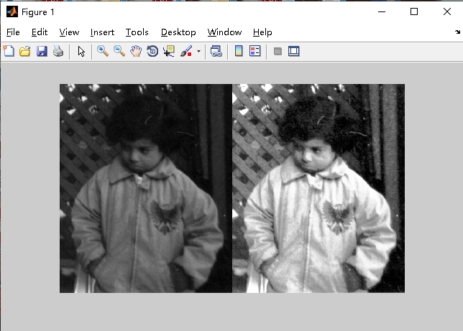

**2图像平滑的实现，不限定滤波器**

clc;

I = imread('coins.png');

Inoised = imnoise(I,'gaussian',0.1,0.005);%对图像进行高斯噪声加噪

%制定卷积核

h=ones(3,3)/5;

h(1,1) = 0;

h(1,3) = 0;

h(3,1) = 0;

h(1,3) = 0;

%平滑运算

I2=imfilter(Inoised,h);

subplot(1,3,1);imshow(I);

xlabel('(a)原始图像');

subplot(1,3,2);imshow(Inoised);

xlabel('(b)带噪声图像');

subplot(1,3,3);imshow(I2);

xlabel('(c)平滑后图像');

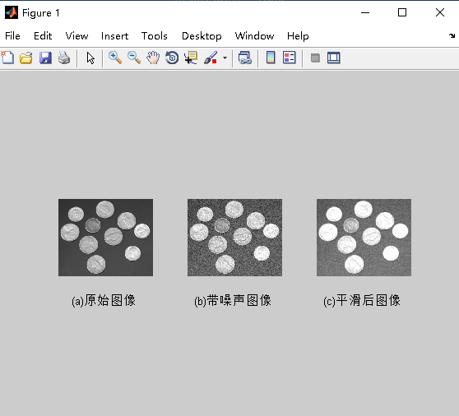

**3图像锐化的实现，不限定滤波器**

clc;

I = imread('pout.tif');

J = histeq(I,256);

imshowpair(I,J,'montage');

clear all;

I = imread('cameraman.tif');

subplot(2,2,1);imshow(I);

xlabel('(a)原始图像');

H = fspecial('motion',20,45);

MotionBlur = imfilter(I,H,'replicate');

subplot(2,2,2);imshow(MotionBlur);

xlabel('(b)运动模糊图像');

H=fspecial('disk',10);

blurred = imfilter(I,H,'replicate');

subplot(2,2,3);imshow(blurred);

xlabel('(c)模糊图像');

H=fspecial('unsharp');

sharpened = imfilter(I,H,'replicate');

subplot(2,2,4);imshow(sharpened);

xlabel('(d)锐化图像');

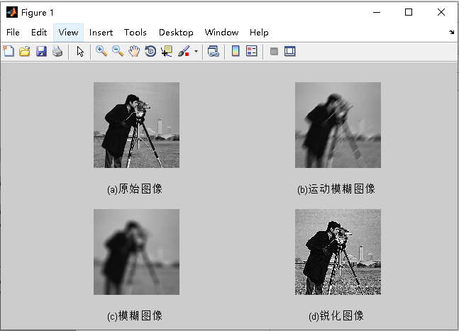

**4频率域图像平滑实现， 不限定滤波器**

f0=imread('pout.tif');

subplot(1,2,1);imshow(f0);title('原图');

sigma=3;

gausFilter=fspecial('gaussian',[3,3],sigma);

gaus=imfilter(f0,gausFilter,'replicate');

subplot(1,2,2);imshow(gaus);title('sigma=3');

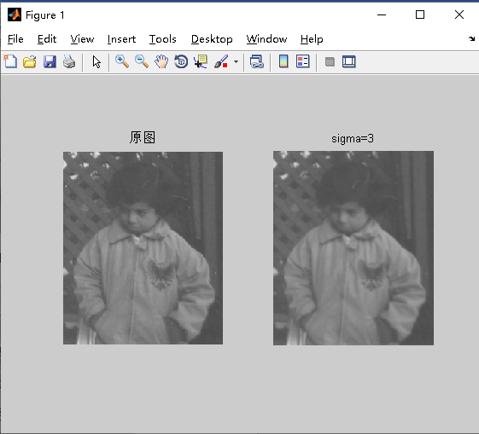

**5频率域图像锐化实现，不限定滤波器**

f = imread('tire.tif')

f=double(f);

[m,n]=size(f);

%a

figure(1)

imshow(f,[]);

title('origin')

p=2*m;

q=2*n;

A=zeros(p,q);

for i=1:m

for j=1:n

A(i,j)=f(i,j);

end

end

for i=1:p

for j=1:q

A(i,j)=A(i,j)*(-1)^(i+j);

end

end

I2=fft2(A);

for i=1:p

for j=1:q

D(i,j)=sqrt((i-p/2)^2+(j-q/2)^2);

end

end

X=zeros(p,q);

%pi=3.14

for i=1:p

for j=1:q

X(i,j)=-4*pi^2*D(i,j)^2;

Y(i,j)=X(i,j)*I2(i,j);

end

end

gp3=real(ifft2(Y));

for i=1:p

for j=1:q

gp3(i,j)=gp3(i,j).*(-1).^(i+j);

end

end

figure(3);

imshow(gp3,[]);

gp3max = max(gp3(:));

g3 = gp3(1:m,1:n);

k=10;

gs = f-k*g3/gp3max;

figure(2)

imshow(gs,[]),title('拉普拉斯锐化图')

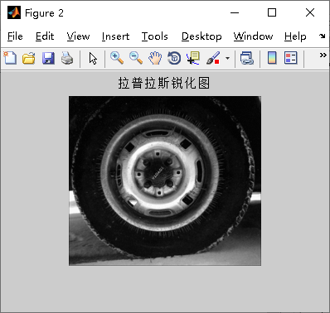

**6 RGB锐化**

clc;

rgb1= imread('football.jpg');

rgb=im2double(rgb1);

rgb_R=rgb(:,:,1);

rgb_G= rgb(:,:,2);

rgb_B= rgb(:,:,3);

lapMatrix=[1 1 1;1 -8 1;1 1 1];%模板1 1*8

Matrix2=[1 0 1;0 -4 0;1 0 1];%模板21*4

%模板1*8 3个不同的第三参数的锐化滤波

f_R=imfilter(rgb_R,lapMatrix,'replicate');

f_G=imfilter(rgb_G,lapMatrix,'replicate');

f_B=imfilter(rgb_B,lapMatrix,'replicate');

f_R2=imfilter(rgb_R,lapMatrix,'symmetric');

f_G2=imfilter(rgb_G,lapMatrix,'symmetric');

f_B2=imfilter(rgb_B,lapMatrix,'symmetric');

f_R3=imfilter(rgb_R,lapMatrix,'circular');

f_G3=imfilter(rgb_G,lapMatrix,'circular');

f_B3=imfilter(rgb_B,lapMatrix,'circular');

%模板 1*4 3个不同的第三参数的锐化滤波

f2_R=imfilter(rgb_R,Matrix2,'replicate');

f2_G=imfilter(rgb_G,Matrix2,'replicate');

f2_B=imfilter(rgb_B,Matrix2,'replicate');

f2_R2=imfilter(rgb_R,Matrix2,'symmetric');

f2_G2=imfilter(rgb_G,Matrix2,'symmetric');

f2_B2=imfilter(rgb_B,Matrix2,'symmetric');

f2_R3=imfilter(rgb_R,Matrix2,'circular');

f2_G3=imfilter(rgb_G,Matrix2,'circular');

f2_B3=imfilter(rgb_B,Matrix2,'circular');

%模板1 锐化后的3分量

rgb_tmp=cat(3,f_R,f_G,f_B);

rgb_tmp2=cat(3,f_R2,f_G2,f_B2);

rgb_tmp3=cat(3,f_R3,f_G3,f_B3);

%模板2 锐化后的3分量

rgb2_tmp=cat(3,f2_R,f2_G,f2_B);

rgb2_tmp2=cat(3,f2_R2,f2_G2,f2_B2);

rgb2_tmp3=cat(3,f2_R3,f2_G3,f2_B3);

%模板1 3种参数的处理结果与原图相减

rgb_sharped =imsubtract(rgb,rgb_tmp);

rgb_sharped2=imsubtract(rgb,rgb_tmp2);

rgb_sharped3=imsubtract(rgb,rgb_tmp3);

%模板2 3种参数的处理结果与原图相减

rgb2_sharped =imsubtract(rgb,rgb2_tmp);

rgb2_sharped2=imsubtract(rgb,rgb2_tmp2);

rgb2_sharped3=imsubtract(rgb,rgb2_tmp3);

figure;

subplot(341);imshow(rgb);title('原图');

subplot(342);imshow(rgb_R);title('R');

subplot(343);imshow(rgb_G);title('G');

subplot(344);imshow(rgb_B);title('B');

subplot(345);imshow(rgb_tmp);title('cat_r_g_b ');

subplot(346);imshow(rgb_tmp2);title('cat_r_g_b2');

subplot(347);imshow(rgb_tmp3);title('cat_r_g_b3');

subplot(348);imshow(rgb_sharped);title('1*8 replicate');

subplot(349);imshow(rgb_sharped2);title('1*8 symmetric');

subplot(3,4,10);imshow(rgb_sharped3);title('1*8 3 circular');

rgb_diff=imsubtract(rgb_sharped,rgb_sharped2);%replicate sub symmetric

subplot(3,4,11);imshow(rgb_diff);title('replicateSubSymmetric');

figure;

imshow(rgb3_diff);title('1*8Sub1*4');

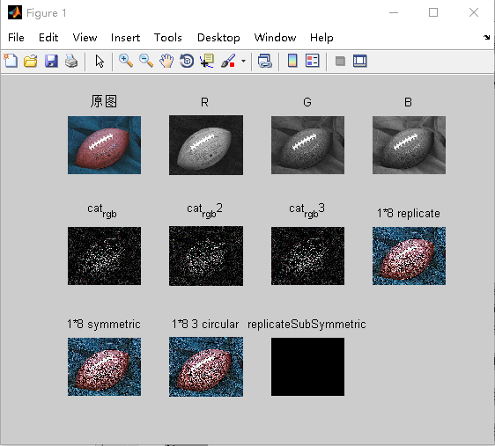

**7 HIS锐化**

function rgb = hsi2rgb(hsi)

H = hsi(:, :, 1) * 2 * pi;

S = hsi(:, :, 2);

I = hsi(:, :, 3);

R = zeros(size(hsi, 1), size(hsi, 2));

G = zeros(size(hsi, 1), size(hsi, 2));

B = zeros(size(hsi, 1), size(hsi, 2));

idx = find( (0 <= H) & (H < 2*pi/3));

B(idx) = I(idx) .* (1 - S(idx));

R(idx) = I(idx) .* (1 + S(idx) .* cos(H(idx)) ./ cos(pi/3 - H(idx)));

G(idx) = 3*I(idx) - (R(idx) + B(idx));

idx = find( (2*pi/3 <= H) & (H < 4*pi/3) );

R(idx) = I(idx) .* (1 - S(idx));

G(idx) = I(idx) .* (1 + S(idx) .* cos(H(idx) - 2*pi/3) ./ cos(pi - H(idx)));

B(idx) = 3*I(idx) - (R(idx) + G(idx));

idx = find( (4*pi/3 <= H) & (H <= 2*pi));

G(idx) = I(idx) .* (1 - S(idx));

B(idx) = I(idx) .* (1 + S(idx) .* cos(H(idx) - 4*pi/3) ./cos(5*pi/3 - H(idx)));

R(idx) = 3*I(idx) - (G(idx) + B(idx));

rgb = cat(3, R, G, B);

rgb = max(min(rgb, 1), 0);

rgb1= imread('football.jpg');

rgb=im2double(rgb1);

rgb_R=rgb(:,:,1);

rgb_G= rgb(:,:,2);

rgb_B= rgb(:,:,3);

lapMatrix=[1 1 1;1 -8 1;1 1 1];

Matrix2=[1 0 1;0 -4 0;1 0 1];

%模板21*4

%模板1*8 3个不同的第三参数的锐化滤波

f_R=imfilter(rgb_R,lapMatrix,'replicate');

f_G=imfilter(rgb_G,lapMatrix,'replicate');

f_B=imfilter(rgb_B,lapMatrix,'replicate');

%symmetric

f_R2=imfilter(rgb_R,lapMatrix,'symmetric');

f_G2=imfilter(rgb_G,lapMatrix,'symmetric');

f_B2=imfilter(rgb_B,lapMatrix,'symmetric');

%circular

f_R3=imfilter(rgb_R,lapMatrix,'circular');

f_G3=imfilter(rgb_G,lapMatrix,'circular');

f_B3=imfilter(rgb_B,lapMatrix,'circular');

%模板 1*4 3个不同的第三参数的锐化滤波

f2_R=imfilter(rgb_R,Matrix2,'replicate');

f2_G=imfilter(rgb_G,Matrix2,'replicate');

f2_B=imfilter(rgb_B,Matrix2,'replicate');

f2_R2=imfilter(rgb_R,Matrix2,'symmetric');

f2_G2=imfilter(rgb_G,Matrix2,'symmetric');

f2_B2=imfilter(rgb_B,Matrix2,'symmetric');

f2_R3=imfilter(rgb_R,Matrix2,'circular');

f2_G3=imfilter(rgb_G,Matrix2,'circular');

f2_B3=imfilter(rgb_B,Matrix2,'circular');

%模板1 锐化后的3分量

rgb_tmp=cat(3,f_R,f_G,f_B);

rgb_tmp2=cat(3,f_R2,f_G2,f_B2);

rgb_tmp3=cat(3,f_R3,f_G3,f_B3);

%模板2 锐化后的3分量

rgb2_tmp=cat(3,f2_R,f2_G,f2_B);

rgb2_tmp2=cat(3,f2_R2,f2_G2,f2_B2);

rgb2_tmp3=cat(3,f2_R3,f2_G3,f2_B3);

%模板1 3种参数的处理结果与原图相减

rgb_sharped =imsubtract(rgb,rgb_tmp);

rgb_sharped2=imsubtract(rgb,rgb_tmp2);

rgb_sharped3=imsubtract(rgb,rgb_tmp3);

%模板2 3种参数的处理结果与原图相减

rgb2_sharped =imsubtract(rgb,rgb2_tmp);

rgb2_sharped2=imsubtract(rgb,rgb2_tmp2);

rgb2_sharped3=imsubtract(rgb,rgb2_tmp3);

figure;

subplot(341);imshow(rgb);title('原图');

subplot(342);imshow(rgb_R);title('R');

subplot(343);imshow(rgb_G);title('G');

subplot(344);imshow(rgb_B);title('B');

subplot(345);imshow(rgb2_tmp);title('cat_r_g_b ');

subplot(346);imshow(rgb2_tmp2);title('cat_r_g_b2');

subplot(347);imshow(rgb2_tmp3);title('cat_r_g_b3');

subplot(348);imshow(rgb2_sharped);title('1*4 replicate');

subplot(349);imshow(rgb2_sharped2);title('1*4 symmetric');

subplot(3,4,10);imshow(rgb2_sharped3);title('1*4 3 circular');

rgb2_diff=imsubtract(rgb2_sharped,rgb2_sharped2);%replicate sub symmetric

subplot(3,4,11);imshow(rgb2_diff);title('replicateSubSymmetric2');

rgb3_diff=imsubtract(rgb2_sharped2,rgb_sharped2);%1*8Sub1*4

figure;

imshow(rgb3_diff);title('1*8Sub1*4');

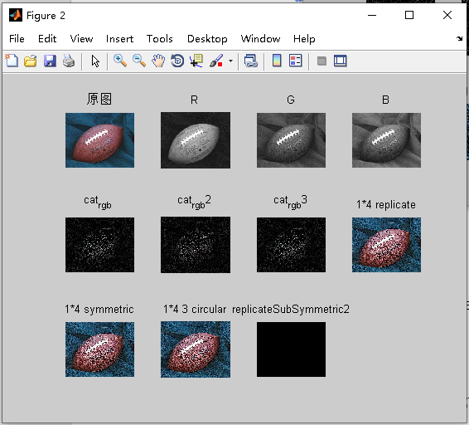

**8 RGB反色**

clc;

a=imread('woman.jpg');

figure(1),subplot(1,2,1);imshow(a);title('原图像');

gary(:,:,1)=255-a(:,:,1);

gary(:,:,2)=255-a(:,:,2);

gary(:,:,3)=255-a(:,:,3);

figure(1),subplot(1,2,2);imshow(gary);title('取反图像');

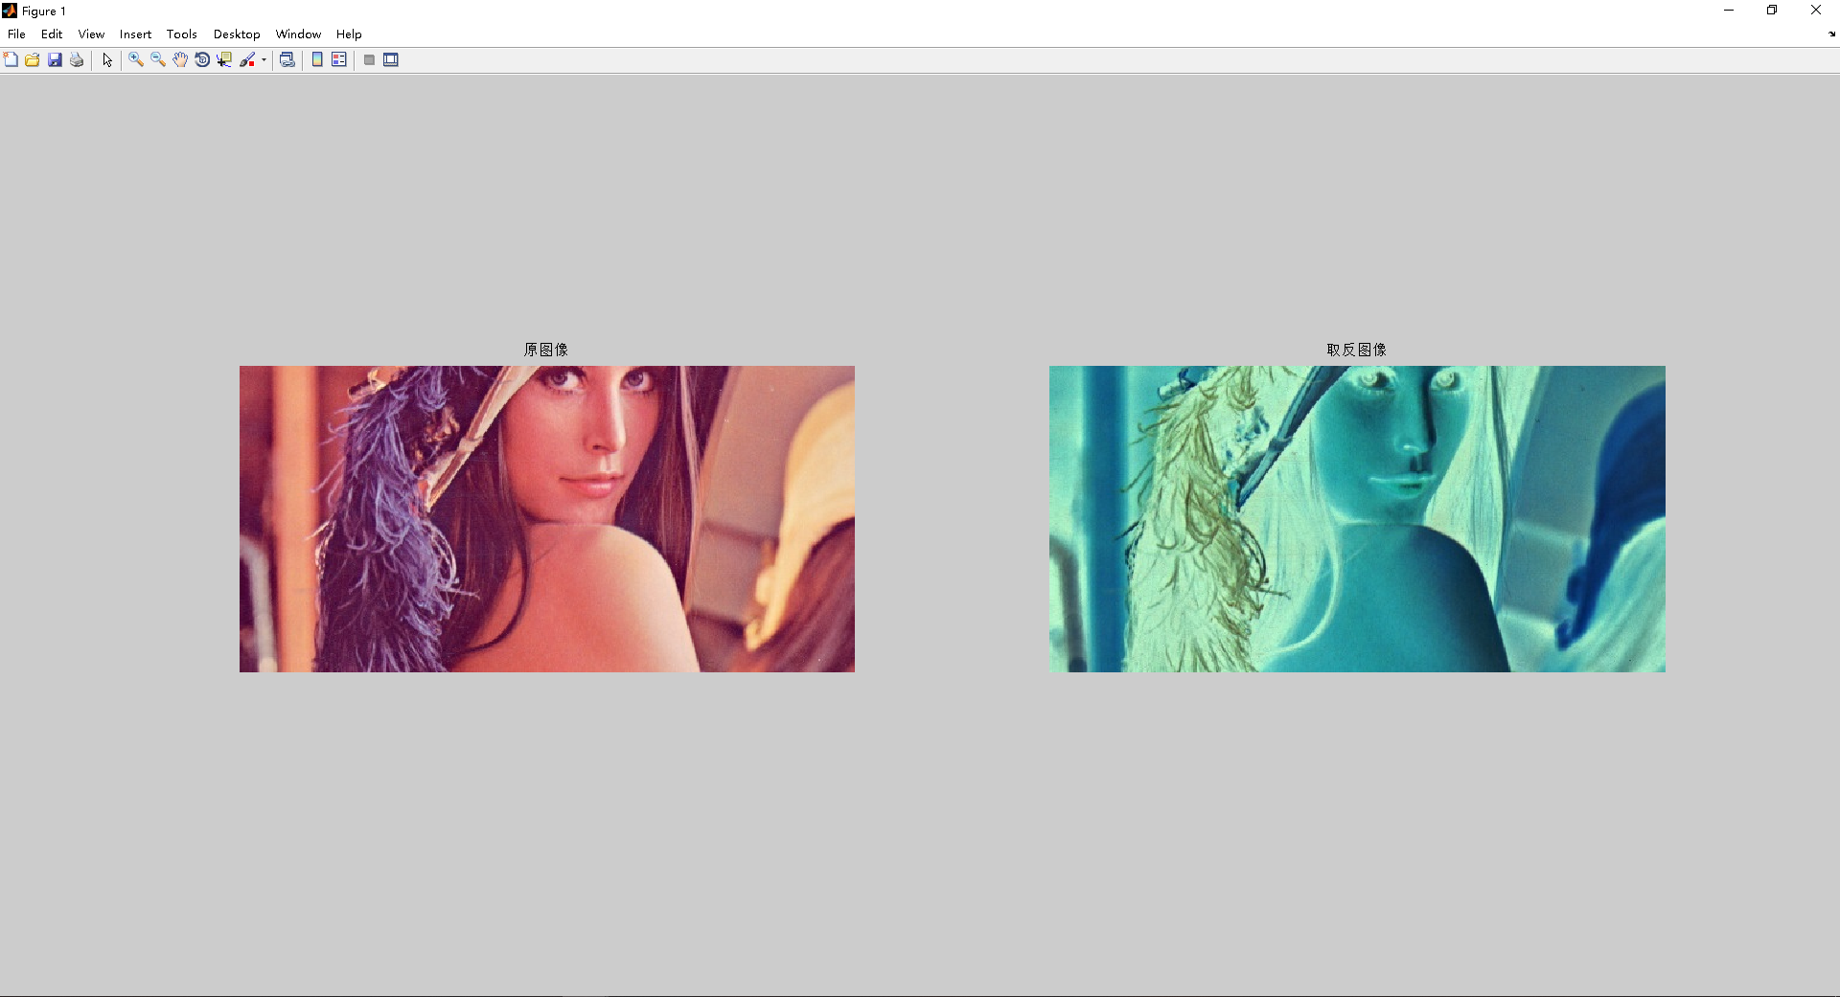

**9 HIS反色**

function rgb = hsi2rgb(hsi)

H = hsi(:, :, 1) * 2 * pi;

S = hsi(:, :, 2);

I = hsi(:, :, 3);

R = zeros(size(hsi, 1), size(hsi, 2));

G = zeros(size(hsi, 1), size(hsi, 2));

B = zeros(size(hsi, 1), size(hsi, 2));

idx = find( (0 <= H) & (H < 2*pi/3));

B(idx) = I(idx) .* (1 - S(idx));

R(idx) = I(idx) .* (1 + S(idx) .* cos(H(idx)) ./ cos(pi/3 - H(idx)));

G(idx) = 3*I(idx) - (R(idx) + B(idx));

idx = find( (2*pi/3 <= H) & (H < 4*pi/3) );

R(idx) = I(idx) .* (1 - S(idx));

G(idx) = I(idx) .* (1 + S(idx) .* cos(H(idx) - 2*pi/3) ./ cos(pi - H(idx)));

B(idx) = 3*I(idx) - (R(idx) + G(idx));

idx = find( (4*pi/3 <= H) & (H <= 2*pi));

G(idx) = I(idx) .* (1 - S(idx));

B(idx) = I(idx) .* (1 + S(idx) .* cos(H(idx) - 4*pi/3) ./cos(5*pi/3 - H(idx)));

R(idx) = 3*I(idx) - (G(idx) + B(idx));

rgb = cat(3, R, G, B);

rgb = max(min(rgb, 1), 0);

a=imread('woman.jpg');

figure(1),subplot(1,2,1);imshow(a);title('原图像');

gary(:,:,1)=255-a(:,:,1);

gary(:,:,2)=255-a(:,:,2);

gary(:,:,3)=255-a(:,:,3);

figure(1),subplot(1,2,2);imshow(gary);title('取反图像');

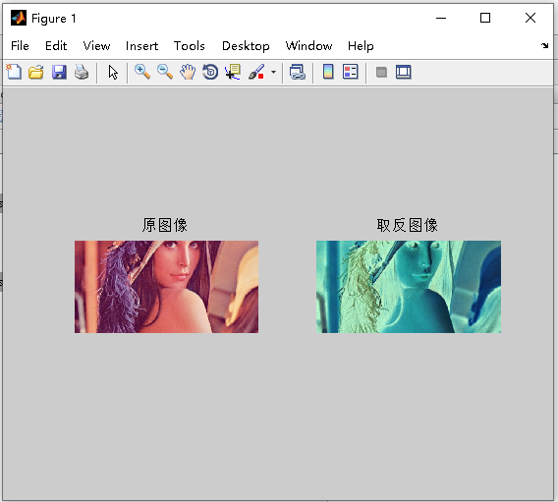

**10形态学开运算的编程实现**

I1=imread('tire.tif'); %读灰度图tire.tif

I2=imnoise(I1,'salt & pepper'); %在图像上加入椒盐噪声

figure,imshow(I2) %显示加椒盐噪声后的灰度图像

I3=im2bw(I2);

figure,imshow(I3) %显示二值化后的图像

I4=bwmorph(I3,'open'); %对二值噪声图像进行二值形态学开运算

figure,imshow(I4) %显示开运算后的图像

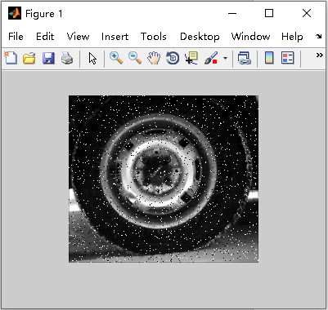

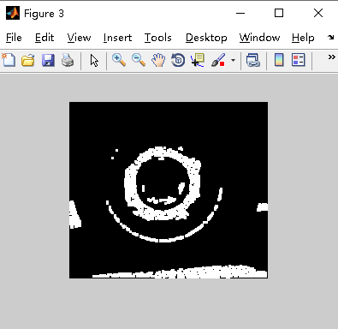

**11用Hough变换 检测直线**

clc;

r = imread('line1.jpg');

t=rgb2gray(r);

figure,imshow(t)

f=edge(t,'canny');

figure,imshow(f)

[H, theta, rho] = hough(f,'RhoResolution',0.5,'Theta',-90:0.5:89.5);

figure

imshow(imadjust(H),'Xdata', theta, 'Ydata', rho, 'InitialMagnification','fit');

axis on, axis normal

p= houghpeaks(H, 5);

%[r,c] = houghpeaks(H, 5);

hold on;

%plot(theta(r), rho(c), 'linestyle', 'none', 'marker', 's', 'color', 'w')

plot(p, 'linestyle', 'none', 'marker', 's', 'color', 'r')

lines = houghlines(f, theta, rho,p);

%lines = houghlines(f, theta, rho, r, c);

figure,

imshow(t)

hold on

for k = 1: length(lines)

xy = [lines(k).point1; lines(k).point2];

plot(xy(:, 2), xy(:, 1), 'LineWidth', 4, 'Color', [.6, .2, .1]);

end

hold off

