**Reading Report Ⅱ**

**1.Big Data and Cloud Computing: Current State and Future Opportunities**

1.1 Motivation of the research.

Introduce the state-of-the-art systems for scalable data management and analysis to us. Cloud computing brings its own set of novel challenges that must be addressed to ensure the success of data management solutions in the cloud environment to ensure the smooth transition of applications from traditional enterprise infrastructure to the next generation cloud infrastructure.

1.2 Significance of the research.

This tutorial presents an organized picture of the challenges faced by application developers and DBMS designers in developing and deploying internet scale applications. We crystallize the design choices made by some successful systems large scale database management systems, analyze the application demands and access patterns, and enumerate the desiderata for a cloud-bound DBMS.

1.3 Body of knowledge incorporated in the research.

Scalable database management systems (DBMS)—both for update intensive application workloads as well as decision support systems for descriptive and deep analytics—are a critical part of the cloud infrastructure and play an important role in ensuring the smooth transition of applications from the traditional enterprise infrastructures to next generation cloud infrastructures.

1.4 Intellectual contribution in the research.

State-of-the-art in scalable data management for traditional and cloud computing infrastructures for both update heavy as well as analytical workloads. Summary of current research projects and future research directions.

1.5 Future direction of this research.

Providing support for ad-hoc querying on top of a Key-Value store or providing consistency guarantees at different access granularities are some research efforts targeted towards enriching the functionality supported by Key-Value stores. Further research however is needed to generalize these proposals to different classes of applications and different Key-Value stores.

**2. Big data using cloud computing**

2.1 Motivation of the research.

Big data entails a huge commitment of hardware and processing resources, making adoption costs of big data technology prohibitive to small and medium sized businesses. The computing needs of MapReduce programming are often beyond what small and medium sized business are able to commit.

2.2 Significance of the research.

Cloud computing offers the promise of big data implementation to small and medium sized businesses. The benefits are hardware cost reduction, processing cost reduction, and ability to test the value of big data.

2.3 Body of knowledge incorporated in the research.

The three types of cloud computing are the public cloud, the private cloud, and the hybrid cloud. A public cloud is the pay-as-you-go services. A private cloud is internal data center of a business not available to the general public but based on cloud structure. The hybrid cloud is a combination of the public cloud and private cloud.

2.4 Intellectual contribution in the research.

The processing capabilities of the big data model could provide new insights to the business. Several models of cloud computing services are available to the businesses to consider, with each model having trade-offs between the benefit of cost savings and the concerns data security and loss of control.

2.5 Future direction of this research.

The parallel processing needs of MapReduce entails a huge commitment of processing power. Use cloud computing for big data implementation lowers the in-house processing power commitment by shifting the data processing to the cloud.

**3. Toward Detection of Child Exploitation Material: A Forensic Approach**

3.1 Motivation of the research.

With the development of the Internet, child pornography spreads on the Internet, but it is difficult to detect children's faces in pornographic images so we need to find a way to detect children's faces accurately.

3.2 Significance of the research.

This paper used the specific context and visual cues of child's face to propose a new framework for child's face detection tools

3.3 Body of knowledge incorporated in the research.

The proposed technique can estimate age categorically - adult or child based on a new hybrid feature descriptor, called Luminance Invariant & Geometrical Relation based Descriptor. It is composed of some low and high-level features, which are found to be effective in characterizing the local appearance in terms of chromaticity, texture, and geometric relational information of few facial visual cues simultaneously.

3.4 Intellectual contribution in the research.

Comparison of experimental results with that of another recently published work reveals our proposed approach yields the highest precision and recall, and overall accuracy in recognition.

This is the first of its kind which is able to recognize a child and adult face image effectively with highest accuracy.

3.5 Future direction of this research.

Future direction is that identify real contents using contextual constraints in the detected skin regions and categorical age detection with highest accuracy.

**4. Benefits of AWS in Modern Cloud**

4.1 Motivation of the research.

The motivation of this paper is to give us an overview of the benefits of AWS in the modern cloud and let us understand the importance of the AWS cloud.

4.2 Body of knowledge incorporated in the research.

It introduces the benefits of AWS cloud to us as follows:

Data Protection, Access Management, Regulatory Compliance, Flexibility, Cost Effectiveness, Secure backend services and platform, Increase Productivity, Increase Scalability, No to Piracy, Advanced technology and career opportunities, make life easier, Storage options in AWS cloud, speed up the workflows, Minimize IT workload, Different databases in AWS Stack, Auto-scaling and Automatic maintenance, Decrease Disaster Recovery Downtime, Getting edge over the competition

4.3 Significance of the research.

The flexibility and scalability are the key reasons why AWS cloud is different from any other cloud platform.

4.4 Intellectual contribution in the research.

In AWS cloud you pay which service you choose. In another cloud platform, whether the services are used or not, payment must be done for all. That is the advance of the AWS cloud and make this different from any other providers.

**5. Forensic Detection of Child Exploitation Material using Deep Learning**

5.1 Motivation of the research.

Categorical age estimation by machine offers substantial extent of challenges and difficulty to the computer vision community due to unavailability of complete knowledge on human visual system.

5.2 Significance of the research.

This paper presented a deep learning methodology, where machine learns the features straight away from the training images without having any information provided by humans to identify children faces.

5.3 Body of knowledge incorporated in the research.

This is a machine learning-based architecture that accomplish a categorization task with the aim of identifying a child face, given a set of child and adult faces using classification technique based on extracted features from the training images.

5.4 Intellectual contribution in the research.

Compared to the results published in a couple of recent work, their proposed approach yields the highest precision and recall, and overall accuracy in recognition.

5.5 Future direction of this research.

The future direction is how to extract features that have discriminative ability for age estimation using skin tone or other facial cues visible in naked eyes and quantify children’s face in ways that agree with human intuition.

**6. Real-time detection of children’s skin on social networking sites using Markov random field modelling**

6.1 Motivation of the research.

In this paper, we propose a framework for detecting images containing children’s pictures in different poses, with the ultimate view of identifying and classifying images as corresponding to the COPINE scale.

* 1. Significance of the research.

In this paper, they develop an approach for automatic detecting children exploitation material being shared over social networks.

6.3 Body of knowledge incorporated in the research.

To achieve the goal of automatic detection, we present a novel stochastic vision model based on a Markov Random Fields prior, which will employ a skin model and human affine-invariant geometric descriptor to detect and identify skin regions containing pornographic contexts.

6.4 Intellectual contribution in the research.

This research paves the way for research in this area to not only help age detection, but also to identify real contents using contextual constrains in the detected skin regions.

6.5 Future direction of this research.

The future direction is how they can use their new methodology to detect the distribution of material in real-time on social networking sites.

**7. Evaluating High-Performance Computing on Google App Engine**

7.1 Motivation of the research.

This article includes an introduction to GAE and a study of its high performance and a comparison with other similar products.

7.2 Body of knowledge incorporated in the research.

GAE has three main components: scalable service, a runtime environment, and a data store. Each application instance executes in a sandbox.

They began their evaluation of GAE with a set of benchmarks to provide important information for scheduling parallel applications onto its resources.

The author has implemented four algorithms with different computation and communication complexity: $π$ approximation, Matrix multiplication, Mandelbrot set, Rank sort.

7.3 Intellectual contribution in the research.

They ran the experiments 100 times in sequence for each problem size and analyzed the cost of CPU time, incoming data, and outgoing data. As a result, $π$ approximation was the most computationally intensive and had almost no data-to-transfer cost.

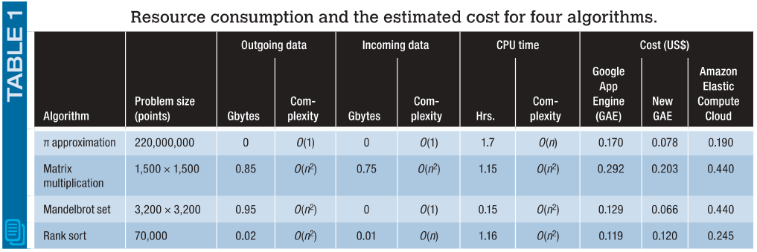And they estimated the cost to run the same experiments on the Amazon EC2 infrastructure using EC2’s ml.small instances. The computation costs were lower for GAE, owing mostly to the cycle-based payments as opposed to EC’s hourly billing intervals.

Experiments proved GAE has high performance.