**任务1：**

[0.41095957 0.7558389 ]

After mapping the features, the shape of newX is: (100, 28)

**任务2：**

The initialized theta's shape is: (28, 1)

**任务3：**

The cost is: 0.6931471805599452

The 5th element of the gradient is: [-0.0003]

**任务4：**

After update theta, now, the 5th element of theta will be: [0.00015]

**任务5：**

At the end, the value of theta is: [[ 10.92684225]

[-20.64469113]

[ 11.70285305]

[ 5.19373709]

[ -2.72691864]

[ 3.41591945]

[ 24.33746965]

[ -8.12640635]

[ 19.63826443]

[ -1.59114548]

[-15.47811361]

[-23.36745523]

[-19.62744014]

[ 7.03009213]

[-23.61286047]

[ -1.0856438 ]

[ -5.43424656]

[ 1.69097694]

[ 26.9445191 ]

[ 9.99106393]

[-29.08982137]

[-31.69505963]

[ -6.17126184]

[-11.34331387]

[ 16.48071022]

[-30.85203617]

[-26.35879506]

[-15.4340745 ]]

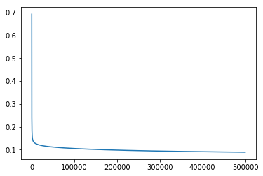

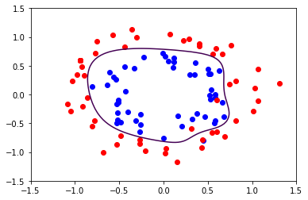

**任务6：**

At the end, the value of theta is: [[ 2.37567971]

[-0.31652489]

[ 0.33218067]

[-1.85291326]

[-0.23318039]

[-1.91728406]

[ 0.12472457]

[-0.10630029]

[-0.07032321]

[-0.02447155]

[-1.61288943]

[-0.0453994 ]

[-0.78465724]

[-0.17213027]

[-1.6978012 ]

[ 0.26380458]

[-0.06920797]

[ 0.02886525]

[-0.10267502]

[-0.03739116]

[-0.15788666]

[-1.31987838]

[ 0.02268086]

[-0.38598843]

[ 0.00754947]

[-0.44850482]

[-0.15893777]

[-1.34973308]]

