**Topic: Navigating the Environment**

**Overview:** Learning how to use Unity well includes learning what tools are at your disposal and where you can find them.

**What we do (and don’t do) in Unity:**

1. *Scenes* are the centerpiece for game design in Unity. Much like a movie scene, a Unity scene is where you compile all the different components that go into the game and program their relationships and interactions. Behind the scene, scenes are files that can only be edited through Unity.
2. Basically any game component you can think of is called an *asset* in Unity. This includes scenes, images, animations, sounds, and scripts.
3. In Unity, we create *game objects* that go into scenes. Game objects are a way of combining assets. For example, the animation and behavior for a character in a game can be stored in one game object. Each game object is tied to a scene.
4. Unity serves as a mixing pot for game elements. Most assets are created outside of Unity: we edit code, design graphics, compose music, and write dialogue in various editors other than Unity.

**The Four Main Panels:** We’ll be discussing Unity’s standard layout, which should be the default when you start a new project. Here, we give a brief overview of the purpose of each panel. If you’re interested in learning more about the panels, check out the documentation.

1. **The scene/game/asset store/animator panel**: In the center of the screen, there is a panel that has four tabs on the top (scene, game, asset store, animator). The scene tab allows us to move objects around. The game tab allows us to view the scene as it will look when the game starts. The animator tab is used to create animations.
2. **The hierarchy panel**: To the left of the scene panel, the hierarchy panel gives us a list of the game objects in the scene. Game objects can be organized into a hierarchy, like files on a computer, with some objects being stored under others.
3. **The inspector panel**: To the right of the scene panel, the inspector panel lists all the properties of a selected game object. Editing, adding, or removing these properties lets us change the behavior and appearance of a game object.
4. **The project/console panel**: Below the scene panel is the project/console panel. The project panel provides a typical file manager layout of all your assets. The console panel is a place where errors and messages from the code appear while the game is running.

**Your turn**:

1. Open a new project in Unity. Find each panel and make sure you can switch between the sub panels.
2. Try creating a new scene and placing a new game object in that scene. Hint: you will use the ‘Create’ button in the ‘Hierarchy.’ Don’t get carried away, you will have more opportunities to create elaborate scenes in other tutorial.
3. Make sure you know what you view in the ‘Hierarchy’, ‘Project’, ‘Assets’ and ‘Inspector’.
4. Run, pause, and reset a game.
5. Switch between Scene and Game view.
6. Find the ‘console.’

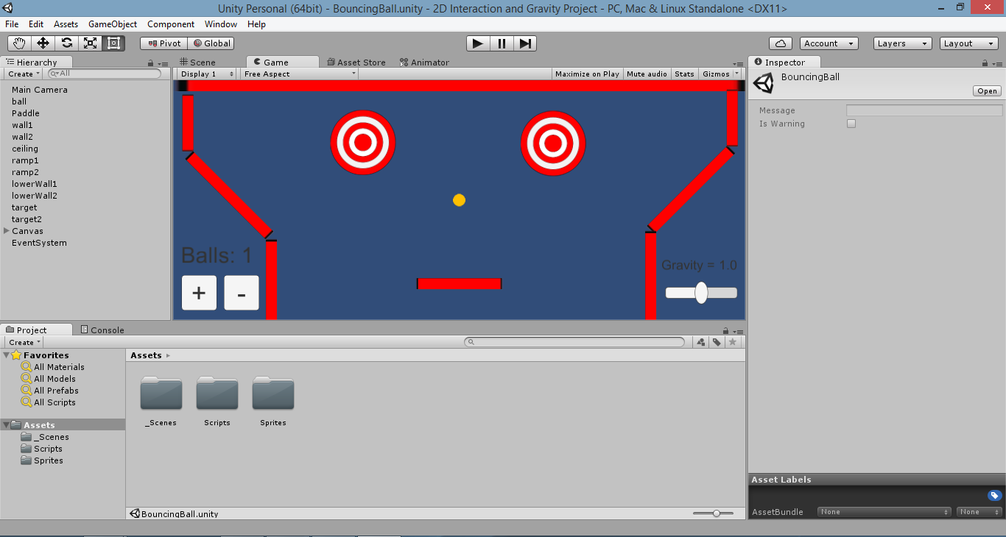

Sample screenshot of the Unity interface

**Unity3D Resource Links:** Select ‘Getting started’ when you open the Unity3D environment.