**Topic: User Interface**

**Overview:** The *User Interface (UI)* of a program is one of the main ways the user interacts with the program. With a UI, the user can change values in the program during runtime (before we could only edit the program outside of runtime). Unity comes with a variety of objects that make it easy to build a user interface. We often need scripts to take values from the UI objects and apply them to other parts of the code. The Scripting Components techniques apply to UI objects as well.

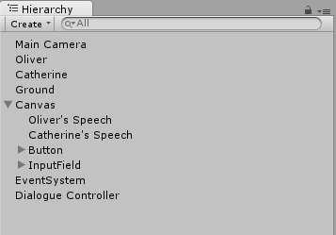

**Types of UI Objects:** All UI objects in Unity are placed in the *canvas* (they will be under canvas in the Hierarchy panel). It’s usually a good idea to set the *canvas scalar* (a component of the canvas) to scale with screen size; otherwise the UI objects may not correctly be placed on different computers.

1. Non-interactive: Text[1] and Image.
2. Interactive: Buttons, Toggle, Sliders, Scrollbar, Dropdown, Input Field (a textbox where you can enter text).



**Scripting with UI Objects:** In order to work with UI objects (and any game object) within a script, you first need to create a public field for the object in the script

Next, you have attach the game object to the script in the Unity editor (after putting the script as a component in a game object).

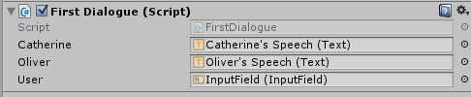

Then you can reference the game objects from within the script and change them in the script. Check out the methods in the First Dialogue script.

Finally, to have an interactive UI object affect the scene, you have to attach methods to the object in the inspector. For example, the Input Field runs the GetName method whenever the user finishes putting in input. You can add and remove methods with the plus and minus buttons.

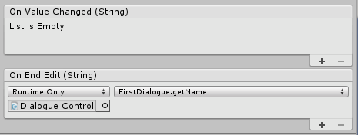

**Your Turn:**

1. Extend the dialogue. Figure out how you can keep track of what the user has said, and see if you can use some string parsing tools to have Cathrine and Oliver respond to what the user says.
2. Add a slider that changes the color of the background.
3. Pick a different interactive UI element and make it change something else about the scene.

1. If text doesn’t show up, it’s probably because the textbox isn’t big enough.