**Topic: Moving Between Scenes**

**Overview:** Most operation for scenes are done through the Scene Manager - an object that lets you create, edit, delete and move between scenes. Documentation for the scene manager can be found in the [Unity manual](https://docs.unity3d.com/ScriptReference/SceneManagement.SceneManager.html).

Follow these instructions:

1. Open the project Scene Switcher
2. Scenes can either be loaded by name or by number, which can be found under File => Build Settings. Open up the build settings and take a look at the different scenes.

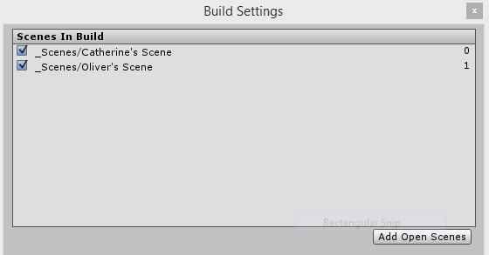

1. Open Scene Switcher script and make sure you understand all the functions that are being used to move between scenes. Notice that this function is called whenever the “Switch” button is pressed.

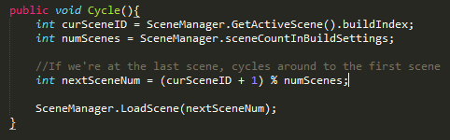

**Your turn**:

1. Add a new scene to the rotation and test to make sure the rotation works.
2. Add a different button that switches to a specific scene by name
3. Read about the variables and functions of the Scene and SceneManager classes. Which look the most useful to you?