**Topic: File Handling**

**Overview:** File handling in Unity is taken care of entirely in the scripts. In a script, you can read and write data from files using the standard C# and JavaScript functions. To read from a file, you open a file reader stream; to write, you open a writer stream. More information on reading files in C# can be found in the [C# File documentation](https://msdn.microsoft.com/en-us/library/system.io.file(v=vs.110).aspx).

Follow these instructions:

1. Open the project Button. Try running and stopping it a few times. Make sure to beat the starting high score at least once, and make sure that it updates appropriately. In order to remember the high score between games, the program must write the high score to a file whenever the high score is surpassed and read the high score from a file whenever a new game starts.
2. Study the ScoreKeeper script and pay attention to where and when the script reads from and writes to a file. Try removing or changing some of the lines and seeing what errors you get in Unity.

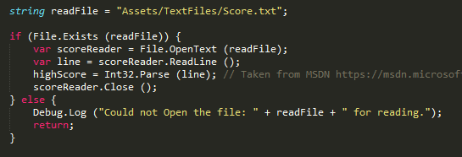

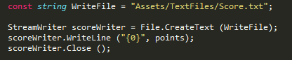

1. Back in the Unity editor, notice how the button calls the update score script each time it is pressed. What happens if you remove this component?

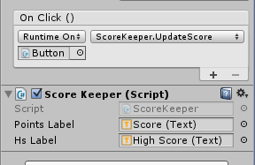

**Your Turn:** Add an input field that takes the player’s name and keep the high scores by name. You’ll need to read multiple lines from the file for this.