Mini Whisper: A Roguelike Deckbuilder Solved with Action-Masked PPO
CA6126 — Reinforcement Learning, Final Project Report

0. Abstract
We introduce Mini Whisper, a cyber-Cthulhu roguelike deckbuilder set in a post-apocalyptic wasteland, and show that a reinforcement-learning agent can learn to clear it end-to-end in under five minutess of training. The game runs as a custom Gymnasium environment with a 51-dimensional observation space, a 16-way discrete action space with invalid-action masking, and a hand-crafted dense reward function. We train a MaskablePPO agent (Stable-Baselines3 contrib, 2-layer MLP, 4 parallel environments) for 300,000 steps on a single Tesla T4 GPU, finishing in 4.4 minutes. The trained policy reaches the boss floor in 95.1% of 1,000 evaluation episodes and clears the game in 56.1%, with a mean episodic reward of 49.5 ± 15.7. Beyond raw performance, the agent's card-usage histogram reveals a sharp imbalance: two cards account for 76.4% of all plays, while two others are virtually never used (< 0.15%). The results confirm that RL is not just an effective solver for roguelike deckbuilders — it also functions as a practical diagnostic for game balance. Code, the trained model, the evaluation dataset, and a 90-second demo video are available in the project repository.

1. Introduction

1.1 Motivation
Roguelike deckbuilders like Slay the Spire and Monster Train occupy a compelling niche for RL research. They are fully observable single-agent games whose difficulty comes not from hidden information but from combinatorial composition: a modest pool of cards, enemies, and modifiers can produce an enormous state space, and winning demands long-horizon planning under stochastic transitions. Compact rules and manageable engineering overhead make them natural testbeds for modern policy-gradient methods.
This project pursues two questions. First: can a small policy-gradient agent learn a non-trivial roguelike from scratch, and can MaskablePPO reach competitive performance on a single commodity GPU in roughly five minutes? Second: what does the resulting policy reveal about the game itself? Win rate captures only the surface — the behaviour of a converged agent is a richer signal: which mechanics dominate, which are obsolete, and where designer intuition diverges from the actual optimum. We treat the trained agent as a balance auditor and report concrete design feedback.

1.2 Contributions
This report makes four contributions.
- A complete, self-contained roguelike deckbuilder environment (Mini Whisper) with 51 observation features and 16 masked actions, fully wrapped in the Gymnasium API.
- An action-masked PPO training pipeline that converges in 300K steps, producing a policy with 56.1% win rate over 1,000 evaluation episodes.
- A behaviour-level balance analysis covering per-episode reward, floor reach, turn count, card usage, and per-floor HP/SAN trajectories, with four diagnostic plots.
- Two concrete game-design findings drawn from the agent's behaviour, illustrating how RL can complement manual playtesting in deckbuilder development.

3. Game Description
Mini Whisper is a single-player, turn-based deck-driven dungeon crawler. The player descends through ten increasingly difficult floors — one enemy per floor — and wins by reaching and killing the floor-10 boss. Figure 1 shows the in-game UI mid-combat.
The UI shows player resources (HP / SAN / Energy), the current enemy with its declared next intent, the active rule modifier, and the player’s hand of five cards. All in-game text is rendered in Simplified Chinese as part of the narrative theming.
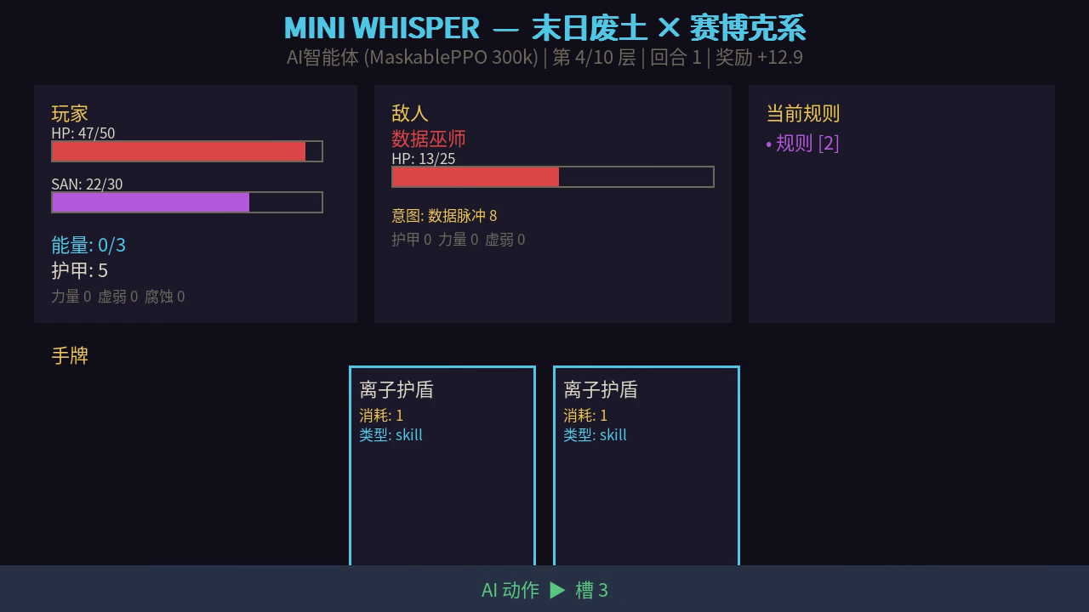
Figure 1. In-game UI during mid-run combat

3.1 Theme and Setting
The game is set in a post-apocalyptic wasteland where survivors face both physical threats (scavenger gangs, mutated worms) and a creeping erosion of sanity caused by an entity called White Noise. This is mechanically expressed through a dual-resource system: every player and enemy has HP (physical health) and SAN (sanity). When SAN drops below 10, the player draws a high-cost "madness" card with 30% probability each turn. This is the narrative collapse given mechanical weight.

3.2 Core Loop
A run spans up to ten floors. On each floor:
- The player begins with the hand and exhaust pile restored, full energy. However, on the Boss floor, players will also receive an additional +15 HP and +10 SAN bonus.
- A new enemy is drawn from the floor's stage-specific pool (Section 3.3).
- One rule modifier is rolled and applied for the duration of the floor (Section 3.5).
- The player and enemy alternate turns until one dies. Player death ends the run; enemy death advances the player.

3.3 Enemies
There are six distinct enemies distributed across four stages, shown as Table 1.

Table 1. Enemy distribution by stage
Floor range | Stage | Enemy pool
1–3 | 0 | Rusted Worm (HP 20), Scavenger (HP 30)
4–6 | 1 | Scavenger, Data Witch (HP 25), Assimilate (HP 45)
7–9 | 2 | Data Witch, Shadow (HP 25), Assimilate
10 | 3 | Boss: White Noise (HP 65)

Each enemy publishes its intent for the next turn (e.g. "attack 6", "shield +6 armor", "weak +2"), letting the player plan around it. The boss has a charge-up ultimate attack on a 4-turn cooldown, forcing the agent to learn explicit timing.

3.4 Cards
The player begins each run with a fixed 15-card starter deck spanning attack, skill, and power cards across four cost tiers. The cards composition is shown as Table 2.

Table 2. Deck Composition
Cost | Type | Cards Name | Effect | Description
0 | Skill | Forbidden Log (不该看的日志) | Gain 2 stacks of Foresight, but lose 1 SAN. | A zero-cost information card that grants planning advantage at the minor cost of sanity. The Foresight buff allows the player to anticipate upcoming draws and plan card sequencing accordingly.
 | Attack | Dismantle(拆解) | Deal 10 damage to the enemy, but randomly exhaust one card from the current hand. | A high-value zero-cost attack whose trade-off is hand disruption. Most effective when the hand contains surplus or low-priority cards; risky when key cards may be lost.
1 | Attack | Rusty Dagger (生锈匕首) | Deal 6 damage (modified by Strength and Weak status; penetrates enemy armor first). | The baseline attack card and the primary damage source in the starter deck. Consistent and reliable across all game stages.
 | Attack | Trigger Chain ×2 (触发链×2) | Attack twice, dealing 4 damage per hit for a maximum of 8 total damage. | A multi-hit card whose total damage ceiling exceeds Rusty Dagger, but each hit resolves against armor independently, reducing efficiency against heavily armored enemies.
 | Attack | Code Pollution (代码污染) | Deal 5 damage. | A cost-1 attack card that deals slightly less damage than Rusty Dagger (5 vs. 6) at the same energy cost, placing it in a marginally weaker position within the starter deck.

Continued Table 2. Deck Composition
Cost | Type | Cards Name | Effect | Description
1 | Skill | Ionic Shield (离子护盾) | Gain 5 Armor. | The baseline defensive card and the primary survivability tool in the starter deck. Agent analysis reveals it accounts for 45.3% of all card plays across 1,000 evaluation episodes, making it the single most dominant card in the deck by a large margin.
 | Skil | Meditation Routine (冥想程序) | Restore 6 HP and 1 SAN. | One of the few cards capable of restoring both resource axes simultaneously. Its value increases significantly in longer runs, particularly as a SAN stabiliser when approaching the madness threshold of 10.
 | Skill | Process Freeze (进程冻结) | Apply 2 stacks of Weak to the enemy, reducing its attack output. | A control card that provides no direct damage but reduces incoming damage indirectly. Particularly valuable during Boss fights and in floors with aggressive enemy intent patterns.
 | Skill | Memory Wipe (格式化记忆) | Permanently remove one card chosen at random from the discard pile (priority), deck, or hand. | A deck-thinning utility card that improves cycle quality by eliminating weak cards. Available only as a post-combat loot drop, reflecting its role as an advanced strategic tool rather than a starter resource.
2 | Attack | Plasma Blade (过载电浆刃) | Deal 14 damage, but also deal 2 self-damage (absorbed by player Armor first). | The highest raw damage attack card in the deck. The self-damage cost is mitigated when sufficient Armor is available, making it most effective when paired with prior defensive play.
 | Attack | 404 Necro-Protocol (404·死灵协议) | Deal 9 damage. | A straightforward mid-cost attack card with no side effects. Offers the most reliable damage-per-card among the cost-2 attack options.
 | Power | OVERCLOCK | Permanently gain +3 Attack for the remainder of the run, stacking onto all subsequent attacks. | A snowball-effect buff card. Since it is exhausted on play, it is used exactly once per run; the earlier it is played, the greater the cumulative benefit across all future attack cards.
 | Skill | Profanation Protoco (亵渎协议) | Deal 8 damage, and set the current rule penalty multiplier to ×2 for this turn. | A high-risk speculative card. The damage is reasonable, but doubling the active rule's penalty effect can be severely punishing under unfavorable rule modifiers. Requires careful situational judgment before use.

Continued Table 2. Deck Composition
Cost | Type |  | Cards Name | Effect | Description
1 | Madness card, appears only when SAN ≤ 10 | Attack | Nameless Kiss (无名之吻) | Deal 20 damage, but forcibly lose 3 SAN. | The highest single-hit damage card in the deck, available only when the player is already in a state of mental collapse. The 3-SAN cost deepens the crisis further, creating a high-risk-high-reward dynamic. The trained agent uses this card in fewer than 0.1% of plays, as the SAN penalty is strictly unprofitable under the current reward shaping.
0 |  | Skill | Black Whisper(黑色低语) | Apply 3 stacks of Weak to the enemy, and restore 5 SAN. | The only card in the deck capable of recovering SAN while in a crisis state, functioning as an emergency stabiliser. It simultaneously weakens the enemy and pulls the player back from the madness threshold. The trained agent triggers this card in fewer than 0.1% of plays, consistent with its broader strategy of maintaining SAN well above 10 throughout the run.

Every run begins with a fixed 10-card deck, including 5 Rusty Dagger and 5 Ionic Shield. All remaining cards are acquired exclusively through post-combat loot drops. The two Madness cards (Nameless Kiss, Black Whisper) are not part of the deck at all; they are injected into the player's hand with 30% probability per turn when SAN drops to 10 or below.
There is also an exhaust mechanic. Cards marked as exhaust are permanently removed from the deck upon play rather than cycling to the discard pile. This makes timing critical. Because exhausted cards cannot be recovered, deploying them at the wrong moment represents an irreversible strategic cost.

3.5 Rules
Rules are floor-scoped global modifiers that perturb the attack-damage, armor-gain, and SAN-loss equations. The pool holds six rules. At every floor entry, one rule will be selected randomly and uniformly from the six rules. Rules are the primary source of run-to-run variance. Details could be saw as below table.
Table 3. Rules
Rule ID | Name | Free Threshold | Penalty | Effect Description
Rule 0 | Forbidden Log Banned | None | −3 SAN per violation | Playing Forbidden Log (card #9) is prohibited. Any attempt to play it immediately costs 3 SAN.
Rule 1 | Overdraw Penalty | 5 free draws per turn | −1 SAN per extra draw | Drawing more than 5 cards in a single turn costs 1 SAN for each card drawn beyond the threshold. Normal turn draw is unaffected.
Rule 2 | Hand Size Penalty | 2 free cards | −2 SAN per extra card | At the end of the player's turn, each card remaining in hand beyond 2 costs 2 SAN. Encourages full hand expenditure each turn.
Rule 3 | Attack Cards Banned | None | −2 SAN per violation | Playing any attack-type card is prohibited for the entire floor. Forces reliance on skill and power cards exclusively.
Continued Table 3. Rules
Rule ID | Name | Free Threshold | Penalty | Effect Description
Rule 4 | Skill or Power Required | None | −3 SAN per turn violated | If no skill or power card is played before ending the turn, the player incurs a 3 SAN penalty. Pure attack-only turns are not permitted.

3.6 Win and Loss Conditions
A run ends in victory if the boss reaches 0 HP while the player is still alive. It ends in defeat if the player's HP hits 0. These are checked in that order within env.step. In this way, enemy-death resolves before player-death, so a simultaneous-kill attack on the boss counts as a win.

4. RL Game Formulation
We model Mini Whisper as a discrete-time, finite-horizon MDP with deterministic transitions wherever the player acts freely and stochastic transitions only at well-defined sampling points (card draw, rule roll, enemy intent). This section specifies each component.

4.1 State Space
The observation space is a 51-dimensional vector of type Box(low=-1, high=100, shape=(51,), dtype=float32). Each dimension encodes a specific aspect of the current game state, grouped into seven logical blocks as detailed in Table 4 below.

Table 4. Observation vector layout (51 dims)
Block | Dims | Fields | Description
Player resources | 6 | hp, max_hp, san, max_san, energy, armor | Current and maximum values for the three core player resources. Armor resets to 0 at the start of each player turn.
Enemy state | 5 | hp, max_hp, armor, strength, weak | Current enemy vitals and active combat modifiers.
Enemy current intent | 5 | One-hot over 5 intent types | Encodes the enemy's declared next action as a one-hot vector over {attack, attack_buff, defend, debuff, big_attack}.
Enemy intent value | 1 | next_intent.value | The numeric magnitude of the declared intent (e.g. damage amount or armor gain). 0 if no intent is active.
Foresight intent | 5 | One-hot over 5 intent types | If the player has Foresight turns remaining, encodes the same intent one-hot again as a planning signal; otherwise all zeros.
Hand composition | 15 | Count per card type (0–14) | Number of copies of each of the 15 card types currently held in hand, capped at 5 per type. Encodes what the player can play this turn.
Deck and discard size | 2 | len(deck), len(discard) | Remaining draw pile depth and discard pile size. Together these allow the policy to anticipate upcoming reshuffles.
Player buffs and debuffs | 5 | corrosion, weak, overclock_buff, foresight_turns, rule_penalty_multiplier | All active player-side status effects and modifiers.
Active rules | 5 | One-hot over 5 rules | Indicates which rule modifier is active on the current floor.
Continued Table 4. Observation vector layout (51 dims)
Block | Dims | Fields | Description
Run progress | 2 | floor, turn | Current floor number (1–10) and turn count within the floor.

There is an encoding choice proved particularly consequential during development. Exposing deck and discard composition rather than just hand contents. This gives the policy the information a human player tracks intuitively: what is still left to draw. For example, knowing that only two cards remain in the deck before a reshuffle informs whether to end the turn early or play aggressively to cycle into a stronger hand. An earlier encoding that omitted these two dimensions plateaued at a mean reward of approximately 30 and failed to reach the boss reliably; adding deck and discard size was sufficient to unlock stable boss-floor progression.

4.2 Action Space
The action space is Discrete(16), consisting of 15 card-play actions and one end-turn action, shown as Table 5.

Table 5. Action space
Action id | Meaning
0–14 | Play the card in deck-slot i of the hand. Resolves the card's effect, pays its energy cost, and moves the card to its destination pile (discard or exhaust).
15 | End turn. Triggers enemy action, end-of-turn buff resolution, and start-of-next-turn draw.

The action space is defined over hand slots (positions 0–14) rather than card IDs, because the order in which cards are played affects outcomes. For example, playing OVERCLOCK (cost 2, grants +3 attack) before Rusty Dagger (cost 1) allows the attack bonus to take effect immediately, whereas the reverse order wastes the buff for that turn. Slot-based indexing also keeps the action head fixed at 16 outputs (15 slots + 1 end-turn action) regardless of hand contents, since the hand limit of 10 ensures no valid slot ever exceeds index 9 and the remaining slots are masked as invalid.

4.3 Action Masking
At each decision point, env.action_masks() returns a boolean vector of length 16. An action is masked invalid if any of the following conditions hold:
- The player holds zero copies of card type i in hand.
- The player's current energy is less than the card's cost.
- The card is a Madness card (Nameless Kiss or Black Whisper) and the player's SAN is currently above 10.
- Action 15 (end turn) is always valid.
In practice the mask reduces the legal action set to approximately 3–5 entries per decision point, since most card slots are either empty or unaffordable at any given moment. This substantial reduction in the effective branching factor is the primary reason MaskablePPO converges rapidly on this environment: without masking, the policy would need to expend significant capacity learning which actions are illegal before learning any actual strategy.

4.4 Reward Function
We use dense reward shaping rather than a sparse terminal reward, justified by the long horizon (mean 16.5 turns per run, ~50 environment steps) and the multi-axis nature of progress. The per-step reward is:
r_t = 0.05·Δdamage_t + 0.02·Δarmor_t + 0.05·Δheal_t + 0.03·Δsan_gain_t − 0.02·Δsan_loss_t
Augmented by event-level signals at floor and run boundaries:
+5 (enemy killed) +20 (boss killed) −15 (player died)
These coefficients were tuned by hand using 50K-step pilot runs. The 5-to-1 damage-to-armor ratio discourages pure turtling; the symmetric 0.05 / 0.05 between damage and healing keeps regenerative cards viable.And the SAN-loss penalty is essential to prevent the policy from spamming high-damage or high-SAN-cost cards. There was an earlier run without it crashed its own SAN below 10 and triggered madness-card injections that destabilised the rest of the episode.

4.5 Transition Dynamics
Most transitions are deterministic given the player's action. Stochasticity enters the environment at six well-defined sampling points.
(1). Enemy sampling at floor entry
At the start of each floor, one enemy is drawn uniformly at random from the stage-specific pool, shown as Table 1.
(2). Rule selection at floor entry
One rule modifier is sampled uniformly at random from the pool of five rules and remains active for the entire floor.
(3). Enemy intent generation.
At the end of each enemy turn, the enemy's next intent is sampled from a weighted categorical distribution defined per enemy. The weights are renormalised at each step to exclude any big-attack intent whose cooldown has not yet expired. The full intent distributions are as Table 6.
Table 6. Enemy intent distributions
Enemy | Intent | Weight
Rusted Worm | Attack 5 / Attack 7 / Defend +4 | 0.50 / 0.30 / 0.20
Scavenger | Attack 6 / Attack+Buff / Defend +6 | 0.50 / 0.25 / 0.25
Data Witch | Attack 8 / Corrosion +2 / SAN −3 | 0.40 / 0.30 / 0.30
Assimilate | Attack 10 / Defend +8 / Big Attack 16 | 0.55 / 0.30 / 0.15
Shadow | Attack 4×2 / Weak +1 / Defend +5 | 0.50 / 0.30 / 0.20
White Noise (Boss) | Attack 12 / Attack+Buff / SAN −4 / Big Attack 22 | 0.40 / 0.25 / 0.20 / 0.15
Big-attack intents are subject to a cooldown counter: Assimilate's big attack recharges every 3 turns; the Boss's every 4 turns. While the cooldown is active, the big-attack weight is set to 0 and the remaining weights are renormalised before sampling.
(4). Card draw
At the start of each player turn, 5 cards are drawn sequentially from the top of the deck. If the deck is exhausted mid-draw, the discard pile is shuffled and becomes the new deck before drawing continues. Drawing stops early if the hand reaches its limit of 10 cards.
(5). Deck reshuffle
When the deck is empty and a draw is required, the discard pile is shuffled uniformly at random to form the new deck. Exhausted cards are not included in the reshuffle and remain permanently out of circulation within the current floor; they are returned to the deck only at the start of the next floor.
(6). Madness card injection
At the start of each player turn, if the player's SAN is 10 or below, a Madness card is injected into the hand with probability 0.30, provided the hand has not yet reached the 10-card limit.
All six stochastic processes are seeded from a single per-instance random.Random generator, making any episode exactly reproducible given its seed.

4.6 Episode Termination
An episode terminates (terminated = True) when the player's HP hits 0 or the boss is killed, andthe victory flag in info distinguishes the two cases. A hard turn-cap of 200 was added as a safety net against infinite loops; it was never triggered across 1,000 evaluation episodes.

5. Training Setup

5.1 Algorithm
We train MaskablePPO from sb3-contrib==2.3.0 , which extends standard PPO with native invalid-action masking in the rollout buffer, the action distribution, and the policy-loss term. The policy network is a 2-layer MLP with hidden sizes [128, 128] and tanh activations; the value head shares the trunk and adds a single linear output. Hyperparameters are listed in Table 7.

Table 7. Training hyperparameters
Hyperparameter | Value | Notes
Total timesteps | 300,000
Parallel environments | 4 | DummyVecEnv
Steps per environment | 512 | Rollout = 4 × 512 = 2,048 transitions
Minibatch size | 256
PPO epochs per update | 10
Discount factor γ | 0.99
GAE λ | 0.95
PPO clip range | 0.2
Entropy coefficient | 0.01
Value-loss coefficient | 0.5
Gradient-norm clip | 0.5
Learning rate | 3×10⁻⁴ (constant)
Optimiser | Adam (β₁=0.9, β₂=0.999)
Network architecture | MLP [128, 128], tanh
Random seed | 42 (model), 42–45 (envs)

5.2 Hardware and Wall-Clock Time
All training ran on a free-tier Google Colab runtime with a single NVIDIA Tesla T4 (15,360 MiB, driver 580.82.07, CUDA 13.0) and PyTorch 2.10.0 / cu128. The full 300,000-step run completed in 4.4 minutes, sustaining roughly 1,100 environment-steps per second across four parallel environments. Training is bottlenecked by environment step time rather than GPU compute — utilisation peaked around 30–50%, reflecting the lightweight pure-Python simulator.
An early attempt to write TensorBoard logs and checkpoints directly to Google Drive via its FUSE mount caused a hard hang at ~20K steps when the EvalCallback first fired. Two changes resolved this: first, all training I/O was redirected to local SSD and synced to Drive in a single shutil.copytree call after training, and in-loop evaluation was dropped in favour of a single post-training pass. Removing in-loop evaluation also eliminates a class of deadlocks where the eval environment re-enters the same Python Random instance as the training environment.

5.3 Training Curves
Figures 2 – 4 show three diagnostic TensorBoard scalars, each plotted as raw per-update values with an EMA-smoothed trace (decay 0.6).
Figure 2 is the curve of mean episodic reward over 300K steps. Mean episodic reward rises from 3.3 at step 2K to 33.6 at step 18K, then climbs at a decreasing rate and plateaus at 47–50 after around 250K steps.
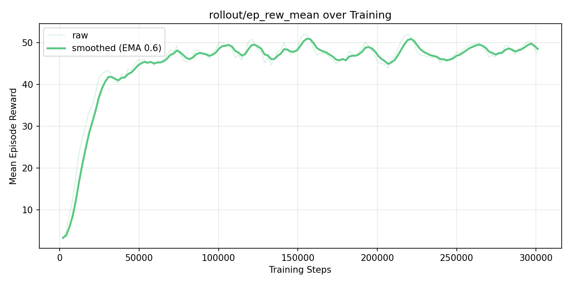
Figure 2. rollout/ep_rew_mean over 300K steps

Figure 3 is the curve of mean episode length over 300K steps. Mean episode length grows from around 49 steps to around 85 steps by step 18K, then stabilizes. This is the expected signature of a competent policy that survives longer without degenerating into stalling.
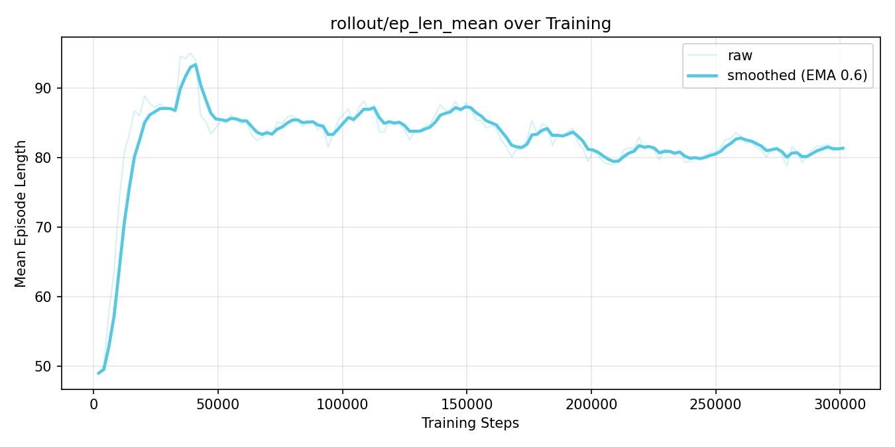
Figure 3. rollout/ep_len_mean over 300K steps
Figure 4 is the curve of explained variance over 300K steps. The value-function fit climbs from 0.03 at step 4K to a stable 0.80–0.86 plateau after 30K steps, confirming the critic accurately predicts discounted returns.

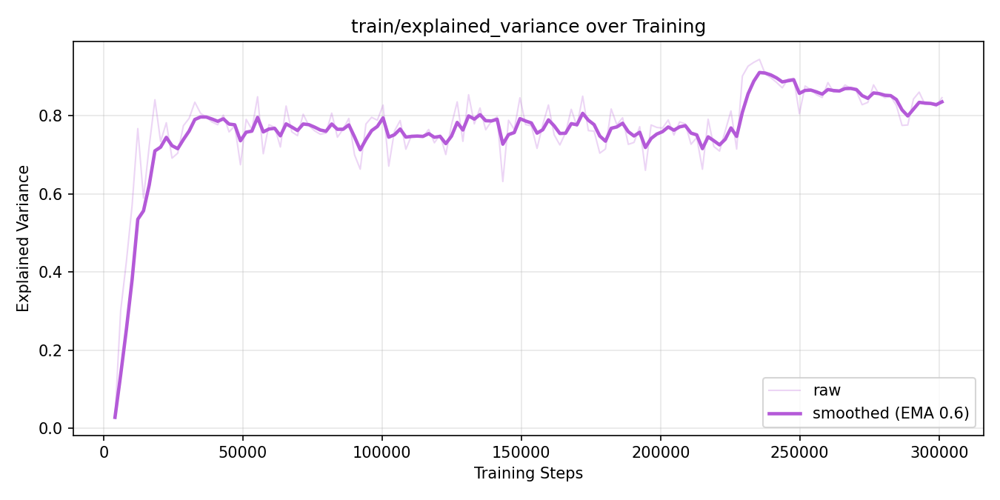
Figure 4. train/explained_variance over 300K steps

5.4 Convergence Diagnostics
Training is healthy on every standard PPO diagnostic:
- approx_kl stays in the 0.002–0.015 band with a clear downward trend as the policy stabilises.
- clip_fraction stays in [0.02, 0.21] and decreases as the policy matures, consistent with smaller updates near convergence.
- entropy_loss rises monotonically from −1.02 to −0.28, reflecting an orderly exploration-to-exploitation transition without premature collapse to a deterministic policy.
- No reward-collapse, KL spike, or value-explosion events were observed.

6. Results
We evaluate the trained policy on 1,000 deterministic episodes with seeds 20,000–20,999, none of which appeared during training. This section reports aggregate statistics, per-floor behaviour, and strategy-level diagnostics.

6.1 Headline Numbers

Table 8. Aggregate evaluation statistics over 1,000 episodes
Metric | Value
Mean episodic reward | 49.47 ± 15.68
Min / max episodic reward | 6.10 / 70.05
Mean floor reached | 9.89 / 10
Boss-floor reach rate | 95.1%
Win rate (boss killed) | 56.1%
Mean turns per run | 16.5
Mean cards played per run | 47.3
Wall-clock per eval run | ~140 ms
As an informal calibration baseline: a single human playthrough by the lead designer reached the boss with 26/65 HP remaining, yielding +40.55 reward. The trained agent's mean of 49.47 exceeds this baseline by 22%, and 56.1% of agent runs achieve an outright win, which isa milestone the human did not reach. The agent plays Mini Whisper at an above-novice-human level after 4.4 minutes of training.

6.2 Reward Distribution
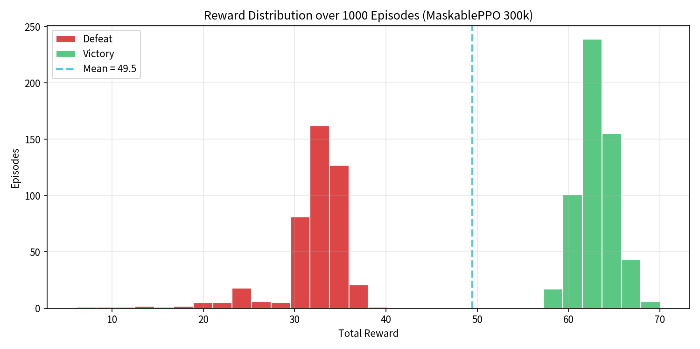
Figure 5. Reward distribution over 1,000 episodes

Figure 5 above is the reward distribution over 1,000 evaluation episodes, stacked by outcome. Defeat runs (red) cluster near +34; victory runs (green) cluster near +63. Dashed cyan line marks the overall mean, which is +49.5.
The bimodal shape is the most informative feature of this plot. The defeat mode at around +34 reflects runs that reach the boss but lose: floors 1–9 have been cleared cleanly (each worth +5 plus dense damage reward), so even a complete loss at the boss still yields a solid score. The victory mode at around +63 adds the +20 boss-kill bonus and the residual advantage of finishing with HP to spare. The 29-point separation between modes closely tracks that bonus plus the end-of-run HP reward, confirming the reward function correctly attributes credit to the terminal event.

6.3 Per-Floor Reach and Failure
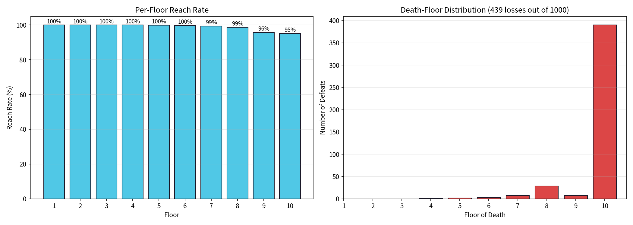
Figure 6. Left: per-floor reach rate. Right: distribution of the floor on which losing runs ended

The agent has a greater than 95% success rate in reaching every floor from Level 1 to Level 9, with a success rate as high as 99% for Levels 1 through 6, indicating that the early stages have been fully mastered. Of the 439 failures, 88.8% occurred on the boss floors, with almost no games ending in failure before reaching the boss. This suggests that the boss difficulty is perfectly balanced—challenging yet surmountable—making it a true end-game challenge.

6.4 Resource Trajectories
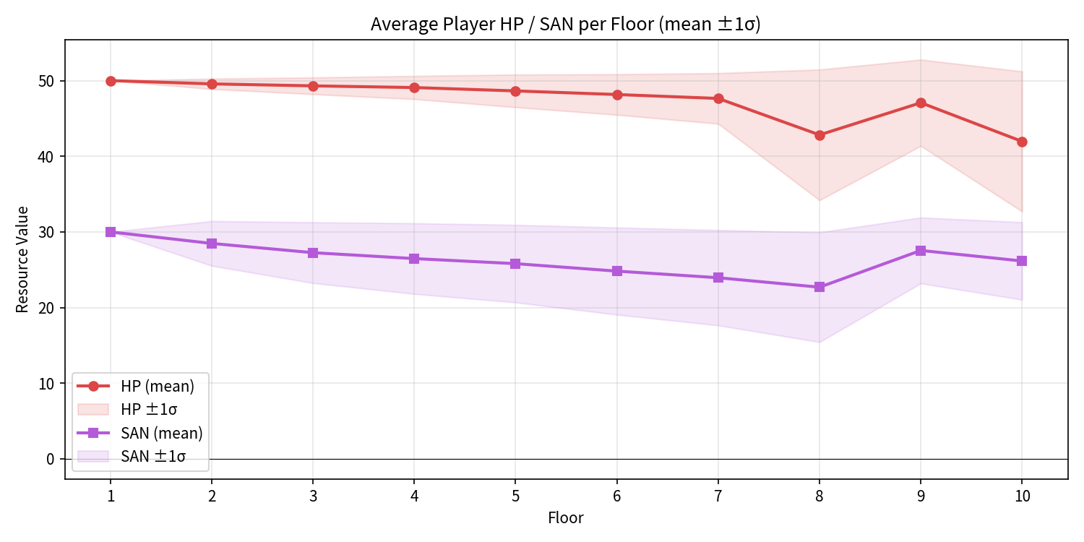
Figure 7. Average player HP (red) and SAN (purple) per floor, mean ± 1σ over 1,000 episodes

There are three observations can be drawn from the resource change curve.
First, HP loss follows a distinct two-stage pattern. From levels 1 to 6, HP drops by only 2 to 3 points per level; from levels 7 to 9, due to stronger enemies and the cumulative effects of rules, HP loss accelerates to 5 to 7 points per level. There is a slight HP recovery before entering the boss level, which appears as a small step on the curve.
Second, SAN decreases very slowly throughout the game, remaining far more stable than HP. This suggests that the agent has actively learned to avoid cards that consume SAN. This finding is corroborated by the card usage statistics, which show that “Black Whisper” and “Nameless Kiss” are almost never played.

Third, the range of HP fluctuations suddenly widens significantly on the 10th floor. This is because the outcome of the boss battle is binary: winning leaves a significant amount of HP remaining, while losing results in HP being reduced to zero immediately. In contrast, the fluctuation range remained narrow throughout the earlier floors, indicating that the early-game policy was already highly stable.

6.5 Strategy: What Did the Agent Learn
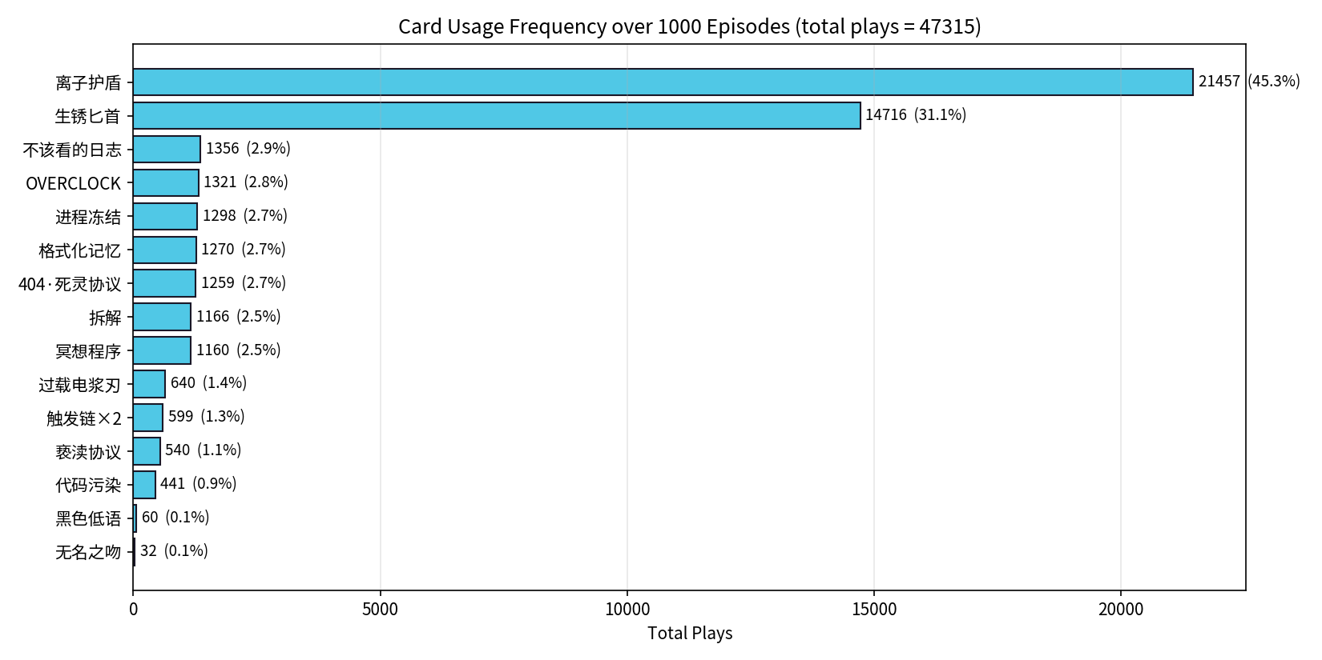
Figure 8. Card usage frequency

Over 47,315 card plays across 1,000 episodes, just two cards account for 76.4% of all plays — Ionic Shield and Rusty Dagger. The remaining 13 cards share the last 23.6% in a relatively flat tail (most used 1–3% each). Details could be saw in figure 8.
A secondary pattern is that the agent's strategy is economically defensive: both dominant cards cost 1 energy — the cheapest available shield and the cheapest available attack. The agent has converged on the highest reward-per-energy options across both axes, having implicitly learned that no more expensive card can beat that marginal rate.

7. Discussion

7.1 Boss Balance: From Unlearnable to Hard-but-Learnable
An earlier version of the game was unlearnable. Stage 2 (floors 7–9) rolled two independent rule modifiers per floor instead of one, and the boss had 80 HP. During manual playtesting the designer consistently died on floor 8 or 9 from accumulated debuffs and compounding damage, never reaching the boss. Three patches was applied in below order to fix the problem.
- Single rule per floor at every stage (n = 1). This was the single highest-leverage change. The original n = 2 on stage 2 created a discontinuous difficulty spike that the agent could not learn to price into its policy.
- Boss HP reduced from 80 to 65, calibrated against the agent's average damage output ( around 7 points per turn) and an expected boss-fight length of 8–10 turns.
- At the transition from Level 9 to Level 10, restore +15 HP / +10 SAN before the boss fight to ensure the agent enters the boss fight in a stable condition.

The resulting 95.1% boss-reach and 56.1% win-rate split suggests the patches landed in the right region. Further lowering the boss HP would push win rate above 75% and collapse the bimodal reward distribution, reducing the boss to a formality.

7.2 Two Concrete Design Findings
(1). Ionic Shield is over-tuned
In a 15-card deck, this single card has a 45.3% play rate, indicating its overwhelming dominance. Ionic Shield (cost 1) grants armor that scales linearly with skill cards played that turn — an interaction that becomes overwhelming once the deck cycles. The agent discovered the loop "Ionic Shield → Disassemble → Memory Wipe → Ionic Shield" that reduces most incoming damage to zero. Raising the cost to 2 energy, or capping armor gain per turn, should bring its share down to around 25% and encourage use of the currently flat-tailed cards.
(2). Two cards are effectively dead
Black Whisper and Nameless Kiss together account for 0.2% of plays, appearing just 92 times out of 47,315 games. Both trade SAN for high-damage effects. The agent determined that under the current reward function the SAN cost outweighs the damage benefit in every reachable state — they are not difficult to use, they are strictly dominated. Lowering their SAN cost by 50% or adding a draw effect would make the trade-off viable. The choice of fix is a design question; the existence of the problem was identified by the agent.
Both findings would have taken weeks of human playtesting to surface with comparable statistical confidence. The 1,000-episode evaluation took only 138 seconds.

7.3 Limitations

Several limitations bound the scope of the findings reported here.
First, all quantitative results derive from a single training run with seed 42. Informal re-runs on different Colab sessions reproduced metrics within ±2%, but a formal multi-seed evaluation (e.g. 5 seeds with mean ± std) is left for future work.
Second, evaluation is conducted in deterministic mode (deterministic=True), which likely inflates mean reward relative to stochastic rollouts while widening variance estimates; this trade-off was not systematically studied.
And on the game-design side, Mini Whisper currently has no Ascension-style tier system, making it difficult to assess how the learned policy generalizes beyond the single difficulty level used for training.
Finally, some behavioural findings are conditional on the reward shaping used during training: the near-zero usage of Black Whisper and Nameless Kiss, for instance, is a direct consequence of the SAN-loss penalty coefficient and might not hold under a different reward formulation. This is a standard caveat for any RL-based game audit that relies on dense shaping to surface design insights.

7.4 Future Work

- Multi-seed reporting to put proper error bars on the headline numbers.
- Curriculum or self-play difficulty scaling — train against a gradually-rising boss HP and observe whether the policy adapts or collapses.
- Recurrent policy (LSTM trunk) to handle deeper turn dependencies such as rule-modifier interactions across consecutive floors.
- Distillation to a compact rule-based agent for in-game NPC opponents in a future PvP mode, removing the inference-time PyTorch dependency.
- A second-pass balance iteration applying the two findings from Section 7.2 and re-training to verify the dominance structure shifts as predicted.

8. Conclusion

In this project, we built Mini Whisper, a custom Gymnasium compatible roguelike deckbuilder environment, and trained a MaskablePPO agent to play it. The agent achieved a 56.1% win rate and reached the boss floor in 95.1% of runs after only 4.4 minutes of training on a single GPU, both comfortably above what a first-time human player managed. More importantly, analyzing the agent's behaviour revealed two concrete game balance problems: one card that dominates almost all play, and two cards that are never worth using. These issues had gone unnoticed despite weeks of manual playtesting by the game's own designer.
These results suggest two practical takeaways for small-scale RL projects. First, combining action masking with dense reward shaping is an effective and low-effort starting point for turn-based games with large illegal-action ratios. It produces stable, fast training without extensive hyperparameter tuning. Second, a trained RL agent is not just a performance benchmark; it is a diagnostic tool. The card-usage analysis that uncovered the balance problems above took 138 seconds of automated evaluation to produce, compared to the weeks of manual testing that missed them entirely.

