中南大学

Web应用开发技术
实验报告

姓 名： | 林子浩
学 号： | 8209190204
班 级： | 软件工程1902
指导老师： | 宋 铁
完成时间： | 2020年2月2日
分 数：
批阅日期：
实验一 基于MVC用JSP/Servlet实现JPetStore

- 实验内容——基本任务。
- 商品展示业务模块，包括大类Category、小类Product和具体商品Item的展示和搜索功能。

1) 运行界面截图

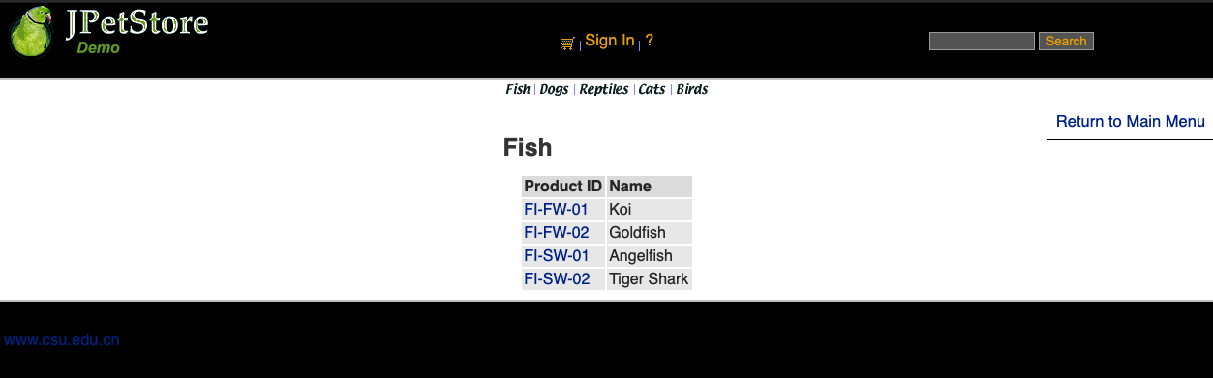
(1) 大类Category(以Fish类为例)

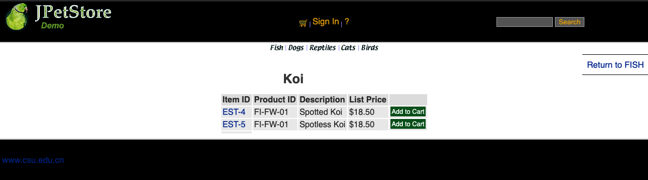
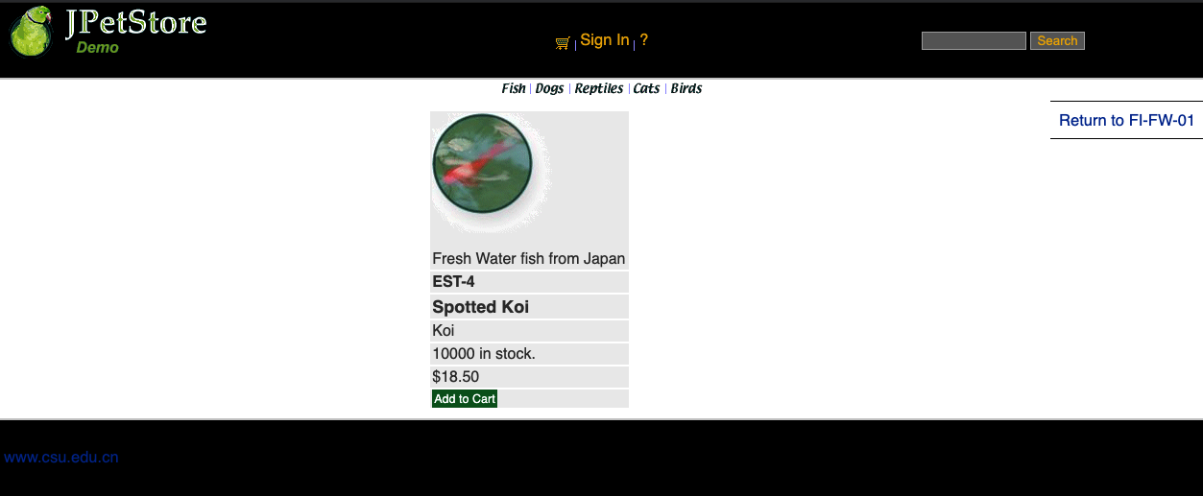
(2) 小类Product(以FI-FW-01 Koi为例)

(3) 具体商品Item

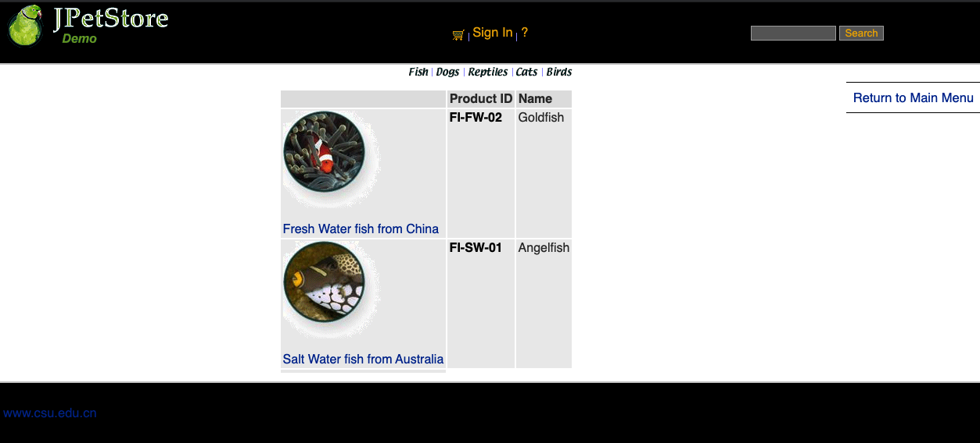
(4) 搜索功能

2) 核心代码

(1) jsp

ⅰ. Catalog.jsp
<%@ include file="../common/IncludeTop.jsp"%>
<div id="BackLink">
<a href="main">Return to Main Menu</a>
</div>
<div id="Catalog">
<h2>${sessionScope.category.name}</h2>
<table>
<tr>
<th>Product ID</th>
<th>Name</th>
</tr>
<c:forEach var="product" items="${sessionScope.productList}">
<tr>
<td>
<a href="viewProduct?productId=${product.productId}">${product.productId}</a>
</td>
<td>${product.name}</td>
</tr>
</c:forEach>
</table>
</div>
<%@ include file="../common/IncludeBottom.jsp"%>

ⅱ. Product.jsp
<%@ include file="../common/IncludeTop.jsp"%>
<div id="BackLink">
<a href="viewCategory?categoryId=${sessionScope.product.categoryId}">Return to ${sessionScope.product.categoryId}</a>
</div>
<div id="Catalog">
<h2>${sessionScope.product.name}</h2>
<table>
<tr>
<th>Item ID</th>
<th>Product ID</th>
<th>Description</th>
<th>List Price</th>
<th>&nbsp;</th>
</tr>
<c:forEach var="item" items="${sessionScope.itemList}">
<tr>
<td>
<a href="viewItem?itemId=${item.itemId}">${item.itemId}</a>
</td>
<td>
${item.product.productId}
</td>
<td>
${item.attribute1} ${item.attribute2} ${item.attribute3}
${item.attribute4} ${item.attribute5} ${sessionScope.product.name}
</td>
<td>
<fmt:formatNumber value="${item.listPrice}" pattern="$#,##0.00" /></td>
<td>
<a class="Button" href="addItemToCart?workingItemId=${item.itemId}">Add to Cart</a>
</td>
</tr>
</c:forEach>
<tr>
<td>
</td>
</tr>
</table>
</div>
<%@ include file="../common/IncludeBottom.jsp"%>

ⅲ. Item.jsp
<%@ include file="../common/IncludeTop.jsp"%>
<div id="BackLink">
<a href="viewProduct?productId=${sessionScope.product.productId}">Return to ${sessionScope.product.productId}</a>
</div>
<div id="Catalog">
<table>
<tr>
<td>${sessionScope.product.description}</td>
</tr>
<tr>
<td><b> ${sessionScope.item.itemId} </b></td>
</tr>
<tr>
<td><b><font size="4"> ${sessionScope.item.attribute1}
${sessionScope.item.attribute2} ${sessionScope.item.attribute3}
${sessionScope.item.attribute4} ${sessionScope.item.attribute5}
${sessionScope.product.name} </font></b></td>
</tr>
<tr>
<td>${sessionScope.product.name}</td>
</tr>
<tr>
<td><c:if test="${sessionScope.item.quantity <= 0}">
Back ordered.
</c:if> <c:if test="${sessionScope.item.quantity > 0}">
${sessionScope.item.quantity} in stock.
</c:if></td>
</tr>
<tr>
<td><fmt:formatNumber value="${sessionScope.item.listPrice}"
pattern="$#,##0.00" /></td>
</tr>
<tr>
<td>
<a class="Button" href="addItemToCart?workingItemId=${item.itemId}">Add to Cart</a>
</td>
</tr>
</table>
</div>
<%@ include file="../common/IncludeBottom.jsp"%>

ⅳ. SearchProducts.jsp
<%@ include file="../common/IncludeTop.jsp"%>
<div id="BackLink">
<a href="main">Return to Main Menu</a>
</div>
<div id="Catalog">
<table>
<tr>
<th>&nbsp;</th>
<th>Product ID</th>
<th>Name</th>
</tr>
<c:forEach var="product" items="${sessionScope.productList}">
<tr>
<td>
<a href="viewProduct?productId=${product.productId}">${product.description}</a>
</td>
<td><b>
<a href="viewProduct?productId=${product.productId}"><font color="BLACK"> ${product.productId} </font></a>
</b></td>
<td>${product.name}</td>
</tr>
</c:forEach>
<tr>
<td></td>
</tr>
</table>
</div>
<%@ include file="../common/IncludeBottom.jsp"%>

(2) Servlet

ⅰ. ViewCategotyServlet
public class ViewCategoryServlet extends HttpServlet {
private static final String VIEW_CATEGORY = "/WEB-INF/jsp/catalog/Category.jsp";
private String categoryId;
protected void doPost(HttpServletRequest request, HttpServletResponse response) throws ServletException, IOException {
doGet(request, response);
}
protected void doGet(HttpServletRequest request, HttpServletResponse response) throws ServletException, IOException {
categoryId = request.getParameter("categoryId");
CatalogService service = new CatalogService();
Category category = service.getCategory(categoryId);
List<Product> productList = service.getProductListByCategory(categoryId);
HttpSession session = request.getSession();
session.setAttribute("category", category);
session.setAttribute("productList", productList );
Account account = (Account)session.getAttribute("account");
if(account!=null && account.isAuthenticated()){
LogService logService = new LogService();
String logDescription = "View Category, Category ID: " + categoryId;
Log log = new Log(account.getUsername(), Log.VIEW, logDescription);
logService.insertLogInfo(log);
}
request.getRequestDispatcher(VIEW_CATEGORY).forward(request,response);
}
}

ⅱ. ViewProduct
public class ViewProductServlet extends HttpServlet {
private static final String VIEW_PRODUCT = "/WEB-INF/jsp/catalog/Product.jsp";
private String productId;
protected void doPost(HttpServletRequest request, HttpServletResponse response) throws ServletException, IOException {
doGet(request, response);
}
protected void doGet(HttpServletRequest request, HttpServletResponse response) throws ServletException, IOException {
productId = request.getParameter("productId");
CatalogService service = new CatalogService();
Product product = service.getProduct(productId);
List<Item> itemList = service.getItemListByProduct(productId);
HttpSession session = request.getSession();
session.setAttribute("product", product);
session.setAttribute("itemList", itemList);
Account account = (Account)session.getAttribute("account");
if(account!=null && account.isAuthenticated()){
LogService logService = new LogService();
String logDescription = "View Product, Product ID: " + productId;
Log log = new Log(account.getUsername(), Log.VIEW, logDescription);
logService.insertLogInfo(log);
}
request.getRequestDispatcher(VIEW_PRODUCT).forward(request,response);
}
}

ⅲ. ViewItemServlet
public class ViewItemServlet extends HttpServlet {
private static final String VIEW_ITEM = "/WEB-INF/jsp/catalog/Item.jsp";
private String itemId;
protected void doPost(HttpServletRequest request, HttpServletResponse response) throws ServletException, IOException {
doGet(request,response);
}
protected void doGet(HttpServletRequest request, HttpServletResponse response) throws ServletException, IOException {
itemId = request.getParameter("itemId");
CatalogService service = new CatalogService();
Item item = service.getItem(itemId);
HttpSession session = request.getSession();
session.setAttribute("item",item);
Account account = (Account)session.getAttribute("account");
if(account!=null && account.isAuthenticated()){
LogService logService = new LogService();
String logDescription = "View Item, Item ID: " + itemId;
Log log = new Log(account.getUsername(), Log.VIEW, logDescription);
logService.insertLogInfo(log);
}
request.getRequestDispatcher(VIEW_ITEM).forward(request,response);
}
}

ⅳ. SearchProductServlet
public class SearchProductServlet extends HttpServlet {
private static final String SEARCH_PRODUCT = "/WEB-INF/jsp/catalog/SearchProducts.jsp";
private String keyword;
protected void doPost(HttpServletRequest request, HttpServletResponse response) throws ServletException, IOException {
doGet(request, response);
}
protected void doGet(HttpServletRequest request, HttpServletResponse response) throws ServletException, IOException {
keyword = request.getParameter("keyword");
CatalogService service = new CatalogService();
List<Product> productList = service.searchProductList(keyword);
HttpSession session = request.getSession();
session.setAttribute("productList", productList);
request.getRequestDispatcher(SEARCH_PRODUCT).forward(request, response);
}
}

- 用户管理业务模块，包括用户注册、登录、修改用户信息、查询用户相关订单等业务功能。

1) 运行界面截图

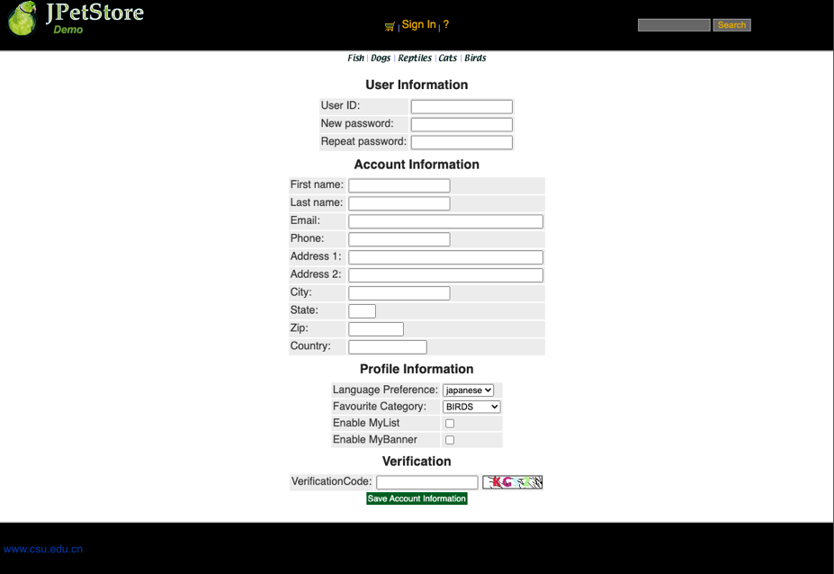
(1) 用户注册

(2) 用户登录

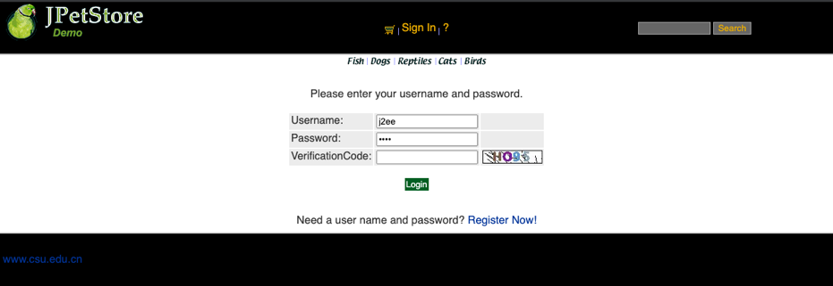

(3) 修改用户信息

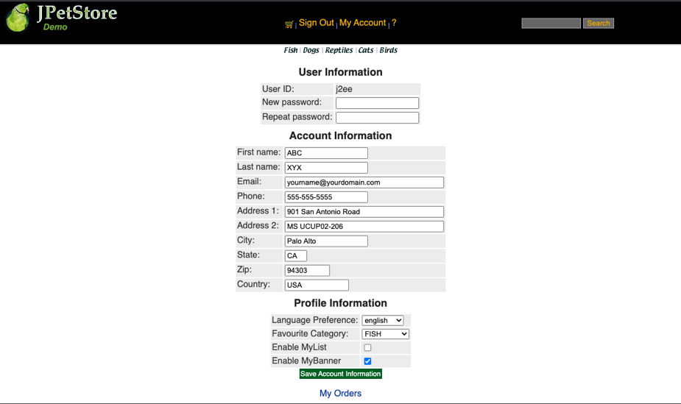

(4) 查询用户相关订单

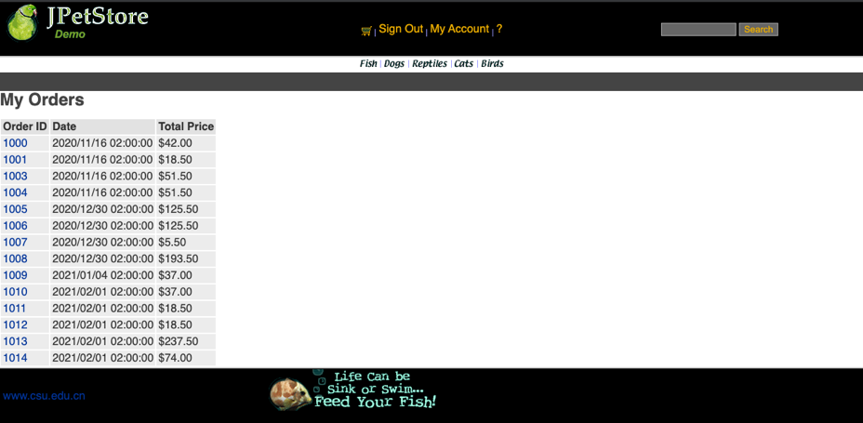

(5) 查看指定订单

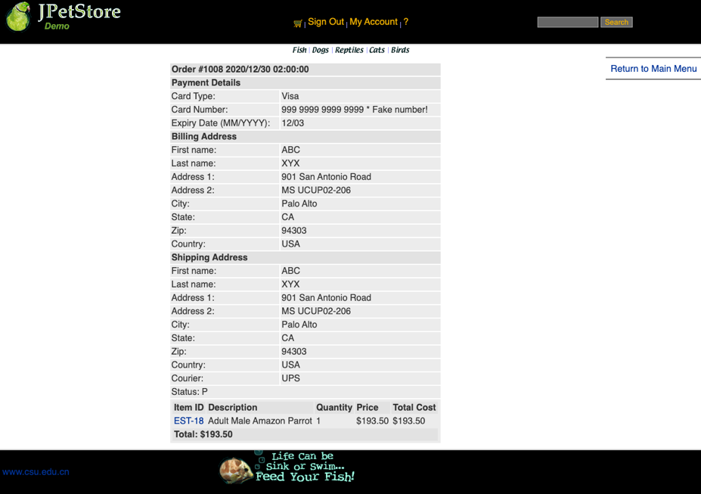

2) 核心代码

(1) jsp

ⅰ. NewAccountForm.jsp
<%@ include file="../common/IncludeTop.jsp"%>
<div id="Catalog">
<c:if test="${requestScope.registerMsg != null}">
<p>${requestScope.registerMsg}</p>
</c:if>
<form action="register" method="post">
<h3>User Information</h3>
<table>
<tr>
<td>User ID:</td>
<td>
<input type="text" name="username" id="username" onblur="isUsernameExist();" />
<div id="isExistInfo"></div>
</td>
</tr>
<tr>
<td>New password:</td>
<td><input type="text" name="password" /></td>
</tr>
<tr>
<td>Repeat password:</td>
<td><input type="text" name="repeatedPassword" /></td>
</tr>
</table>
<%@ include file="IncludeAccountFields.jsp"%>
<%@ include file="VerificationForm.jsp"%>
<input type="submit" name="newAccount" value="Save Account Information" class="button" />
</form>
</div>
<%@ include file="../common/IncludeBottom.jsp"%>

ⅱ. SignonForm.jsp
<%@ include file="../common/IncludeTop.jsp"%>
<c:if test="${requestScope.message != null}">
<ul>
<li>${requestScope.message}</li>
</ul>
</c:if>
<div id="Catalog">
<p>Please enter your username and password.</p>
<form action="login" method="post">
<table>
<tr>
<td> Username:</td>
<td><input type="text" name="username" value="j2ee"></td>
<td>&nbsp;</td>
</tr>
<tr>
<td> Password:</td>
<td><input type="password" name="password" value="j2ee" /></td>
<td>&nbsp;</td>
</tr>
<tr>
<td>VerificationCode:</td>
<td><input type="text" name="vrfCode"></td>
<td><img src="verifyCode" alt="refresh" onclick="change(this)"></td>
</tr>
</table>
<p>
<input type="submit" name="signon" value="Login" class="button"></>
</p>
</form>
Need a user name and password?
<a href="newAccountForm" >Register Now!</a>
</div>
<%@ include file="../common/IncludeBottom.jsp"%>

ⅲ. IncludeAccountFields.jsp
<h3>Account Information</h3>
<table>
<tr>
<td>First name:</td>
<td><input type="text" name="firstName" value="${sessionScope.account.firstName}" /></td>
</tr>
<tr>
<td>Last name:</td>
<td><input type="text" name="lastName" value="${sessionScope.account.lastName}" /></td>
</tr>
<tr>
<td>Email:</td>
<td><input type="text" size="40" name="email" value="${sessionScope.account.email}" /></td>
</tr>
<tr>
<td>Phone:</td>
<td><input type="text" name="phone" value="${sessionScope.account.phone}" /></td>
</tr>
<tr>
<td>Address 1:</td>
<td><input type="text" name="address1" size="40" value="${sessionScope.account.address1}" /></td>
</tr>
<tr>
<td>Address 2:</td>
<td><input type="text" name="address2" size="40" value="${sessionScope.account.address2}" /></td>
</tr>
<tr>
<td>City:</td>
<td><input type="text" name="city" value="${sessionScope.account.city}" /></td>
</tr>
<tr>
<td>State:</td>
<td><input type="text" name="state" size="4" value="${sessionScope.account.state}" /></td>
</tr>
<tr>
<td>Zip:</td>
<td><input type="text" name="zip" size="10" value="${sessionScope.account.zip}" /></td>
</tr>
<tr>
<td>Country:</td>
<td><input type="text" name="country" size="15" value="${sessionScope.account.country}" /></td>
</tr>
</table>
<h3>Profile Information</h3>
<table>
<tr>
<td>Language Preference:</td>
<td>
<select name="languagePreference">
<option value="japanese"
<c:if test="${sessionScope.account.languagePreference eq 'japanese'}">
selected="selected"
</c:if>
>japanese
</option>
<option value="english"
<c:if test="${sessionScope.account.languagePreference eq 'english'}">
selected="selected"
</c:if>
>english
</option>
</select>
</td>
</tr>
<tr>
<td>Favourite Category:</td>
<td>
<select name="favouriteCategoryId">
<option value="BIRDS"
<c:if test="${sessionScope.account.favouriteCategoryId eq 'BIRDS'}">
selected="selected"
</c:if>
>BIRDS
</option>
<option value="DOGS"
<c:if test="${sessionScope.account.favouriteCategoryId eq 'DOGS'}">
selected="selected"
</c:if>
>DOGS
</option>
<option value="CATS"
<c:if test="${sessionScope.account.favouriteCategoryId eq 'CATS'}">
selected="selected"
</c:if>
>CATS
</option>
<option value="FISH"
<c:if test="${sessionScope.account.favouriteCategoryId eq 'FISH'}">
selected="selected"
</c:if>
>FISH
</option>
<option value="REPTILES"
<c:if test="${sessionScope.account.favouriteCategoryId eq 'REPTILES'}">
selected="selected"
</c:if>
>REPTILES
</option>
</select>
</td>
</tr>
<tr>
<td>Enable MyList</td>
<td>
<input type="checkbox" name="listOption" value="checked"
<c:if test="${sessionScope.account.listOption == true}">
checked="checked"
</c:if>
>
</td>
</tr>
<tr>
<td>Enable MyBanner</td>
<td>
<input type="checkbox" name="bannerOption" value="checked"
<c:if test="${sessionScope.account.bannerOption == true}">
checked="checked"
</c:if>
>
</td>
</tr>
</table>

ⅳ. EditAccountForm.jsp
<%@ include file="../common/IncludeTop.jsp"%>
<div id="Catalog">
<c:if test="${requestScope.saveInfoMsg != null}">
<p>${requestScope.saveInfoMsg}</p>
</c:if>
<form action="saveAccountInfo" method="post">
<h3>User Information</h3>
<table>
<tr>
<td>User ID:</td>
<td>${sessionScope.account.username}</td>
</tr>
<tr>
<td>New password:</td>
<td><input type="text" name="password" /></td>
</tr>
<tr>
<td>Repeat password:</td>
<td><input type="text" name="repeatedPassword" /></td>
</tr>
</table>
<%@ include file="IncludeAccountFields.jsp"%>
<input type="submit" name="editAccount" value="Save Account Information" />
</form>
<a href="viewOrderList">My Orders</a>
</div>

(2) Servlet

ⅰ. RegisterServlet
public class RegisterServlet extends HttpServlet {
private static final String NEW_ACCOUNT_FORM = "/WEB-INF/jsp/account/NewAccountForm.jsp";
private static final String SIGN_ON_FORM = "/WEB-INF/jsp/account/SignonForm.jsp";
protected void doPost(HttpServletRequest request, HttpServletResponse response) throws ServletException, IOException {
AccountDAO accountDAO = new AccountDAOImpl();
HttpSession session = request.getSession();
String username = request.getParameter("username");
String inputedPassword = request.getParameter("password");
String repeatedPassword = request.getParameter("repeatedPassword");
String firstName = request.getParameter("firstName");
String lastName = request.getParameter("lastName");
String email = request.getParameter("email");
String phone = request.getParameter("phone");
String address1 = request.getParameter("address1");
String address2 = request.getParameter("address2");
String city = request.getParameter("city");
String state = request.getParameter("state");
String zip = request.getParameter("zip");
String country = request.getParameter("country");
String languagePreference = request.getParameter("languagePreference");
String favouriteCategoryId = request.getParameter("favouriteCategoryId");
String[] listOption = request.getParameterValues("listOption");
String[] bannerOption = request.getParameterValues("bannerOption");
List<String> emptyItemList = new ArrayList<>();
Account newAccount = new Account();
newAccount.setAuthenticated(false);
newAccount.setPassword(inputedPassword);
String vrfCodeInput = request.getParameter("vrfCode");
String theCode = (String)session.getAttribute("theCode");
if( !username.isEmpty() ){
newAccount.setUsername(username);
}else{
emptyItemList.add("Username");
}
if( !firstName.isEmpty() ){
newAccount.setFirstName(firstName);
}else{
emptyItemList.add("FirstName");
}
if( !lastName.isEmpty() ){
newAccount.setLastName(lastName);
}else{
emptyItemList.add("LastName");
}
if( !email.isEmpty() ){
newAccount.setEmail(email);
}else{
emptyItemList.add("Email");
}
if( !phone.isEmpty() ){
newAccount.setPhone(phone);
}else{
emptyItemList.add("Phone");
}
if( !address1.isEmpty() ){
newAccount.setAddress1(address1);
}else{
emptyItemList.add("Address1");
}
if( !address2.isEmpty() ){
newAccount.setAddress2(address2);
}else{
emptyItemList.add("Address2");
}
if( !city.isEmpty() ){
newAccount.setCity(city);
}else{
emptyItemList.add("City");
}
if( !state.isEmpty() ){
newAccount.setState(state);
}else{
emptyItemList.add("State");
}
if( !zip.isEmpty() ){
newAccount.setZip(zip);
}else{
emptyItemList.add("Zip");
}
if( !country.isEmpty() ){
newAccount.setCountry(country);
}else{
emptyItemList.add("Country");
}
if( !languagePreference.isEmpty() ){
newAccount.setLanguagePreference(languagePreference);
}
if( !favouriteCategoryId.isEmpty() ){
newAccount.setFavouriteCategoryId(favouriteCategoryId);
}
if( null == listOption ){
newAccount.setListOption(false);
}else{
newAccount.setListOption(true);
}
if( null == bannerOption ){
newAccount.setBannerOption(false);
}else{
newAccount.setBannerOption(true);
}
session.setAttribute("account", newAccount);
//验证码是否正确
if( null == vrfCodeInput || !vrfCodeInput.equalsIgnoreCase(theCode) ){
request.setAttribute("registerMsg", "Invalid verification code. Register failed.");
request.getRequestDispatcher(NEW_ACCOUNT_FORM).forward(request,response);
return;
}
//判断是否有同用户名的用户存在
Account account = accountDAO.getAccountByUsername(username);
if( null != account ){
request.setAttribute("registerMsg", "username "+username+" has been occupied, please try again with another username");
request.getRequestDispatcher(NEW_ACCOUNT_FORM).forward(request, response);
}
boolean eq = inputedPassword.equals(repeatedPassword);
if( !eq ){
request.setAttribute("registerMsg", "The repeated password doesn't conform with the first one. Pleae try again." );
request.getRequestDispatcher(NEW_ACCOUNT_FORM).forward(request,response);
}else if( inputedPassword.isEmpty() ){
request.setAttribute("registerMsg", "Please enter your password." );
request.getRequestDispatcher(NEW_ACCOUNT_FORM).forward(request,response);
}
//查看是否有空项
if(emptyItemList.size() == 0){
accountDAO.insertSignon(newAccount);
accountDAO.insertAccount(newAccount);
accountDAO.insertProfile(newAccount);
request.setAttribute("message", "You've registered successfully. Congratulations! \n You may sign in now.");
request.getRequestDispatcher(SIGN_ON_FORM).forward(request,response);
}else{
StringBuilder message = new StringBuilder("Item(");
StringBuilder itemListString = new StringBuilder();
for (String s : emptyItemList) {
itemListString.append(s).append(",");
}
//删除多余的","
int len = itemListString.length();
len -= 1;
itemListString.deleteCharAt(len);
message.append(itemListString);
message.append(") is empty. Please fill them all and try again.");
request.setAttribute("registerMsg", message.toString());
request.getRequestDispatcher(NEW_ACCOUNT_FORM).forward(request,response);
}
}
protected void doGet(HttpServletRequest request, HttpServletResponse response) throws ServletException, IOException {
}
}

ⅱ. LoginSetvlet
public class LoginServlet extends HttpServlet {
private static final String MAIN = "/WEB-INF/jsp/catalog/Main.jsp";
private static final String SIGN_ON_FORM = "/WEB-INF/jsp/account/SignonForm.jsp";
protected void doPost(HttpServletRequest request, HttpServletResponse response) throws ServletException, IOException {
AccountDAO accountDAO = new AccountDAOImpl();
String username = request.getParameter("username");
String password = request.getParameter("password");
Account account = new Account();
account.setUsername(username);
account.setPassword(password);
account = accountDAO.getAccountByUsernameAndPassword(account);
HttpSession session = request.getSession();
String vrfCodeInput = request.getParameter("vrfCode");
String theCode = (String)session.getAttribute("theCode");
//验证码是否正确
if( null == vrfCodeInput || !vrfCodeInput.equalsIgnoreCase(theCode) ){
request.setAttribute("message", "Invalid verification code. Signon failed.");
request.getRequestDispatcher(SIGN_ON_FORM).forward(request,response);
return;
}
if(account != null){
account.setAuthenticated(true);
session.setAttribute("account", account );
LogService logService = new LogService();
Log log = new Log(username, Log.LOG_IN, "Successfully");
logService.insertLogInfo(log);
request.getRequestDispatcher(MAIN).forward(request,response);
}else{
request.setAttribute("message", "Invalid username or password. Signon failed.");
request.getRequestDispatcher(SIGN_ON_FORM).forward(request,response);
LogService logService = new LogService();
Log log = new Log(username, Log.LOG_IN, "failed");
logService.insertLogInfo(log);
}
}
protected void doGet(HttpServletRequest request, HttpServletResponse response) throws ServletException, IOException {
doPost(request,response);
}
}

ⅲ. SaveAccontInfoServlet
public class SaveAccontInfoServlet extends HttpServlet {
private static final String EDIT_ACCOUNT_FORM = "/WEB-INF/jsp/account/EditAccountForm.jsp";
protected void doPost(HttpServletRequest request, HttpServletResponse response) throws ServletException, IOException {
boolean eq = true;
AccountDAO accountDAO = new AccountDAOImpl();
HttpSession session = request.getSession();
Account loginAccount = (Account) session.getAttribute("account");
String inputedPassword = request.getParameter("password");
String repeatedPassword = request.getParameter("repeatedPassword");
eq = inputedPassword.equals(repeatedPassword);
if(eq){//两次输入一致，可能是修改密码，也可能是不修改密码
String firstName = request.getParameter("firstName");
String lastName = request.getParameter("lastName");
String email = request.getParameter("email");
String phone = request.getParameter("phone");
String address1 = new String(request.getParameter("address1").getBytes("iso-8859-1"), "utf-8");
// String address1 = request.getParameter("address1");
String address2 = request.getParameter("address2");
String city = request.getParameter("city");
String state = request.getParameter("state");
String zip = request.getParameter("zip");
String country = request.getParameter("country");
String languagePreference = request.getParameter("languagePreference");
String favouriteCategoryId = request.getParameter("favouriteCategoryId");
String[] listOption = request.getParameterValues("listOption");
String[] bannerOption = request.getParameterValues("bannerOption");
if( !inputedPassword.isEmpty() ){
loginAccount.setPassword(inputedPassword);
}
if( !firstName.isEmpty() ){
loginAccount.setFirstName(firstName);
}
if( !lastName.isEmpty() ){
loginAccount.setLastName(lastName);
}
if( !email.isEmpty() ){
loginAccount.setEmail(email);
}
if( !phone.isEmpty() ){
loginAccount.setPhone(phone);
}
if( !address1.isEmpty() ){
loginAccount.setAddress1(address1);
}
if( !address2.isEmpty() ){
loginAccount.setAddress2(address2);
}
if( !city.isEmpty() ){
loginAccount.setCity(city);
}
if( !state.isEmpty() ){
loginAccount.setState(state);
}
if( !zip.isEmpty() ){
loginAccount.setZip(zip);
}
if( !country.isEmpty() ){
loginAccount.setCountry(country);
}
if( !languagePreference.isEmpty() ){
loginAccount.setLanguagePreference(languagePreference);
}
if( !favouriteCategoryId.isEmpty() ){
loginAccount.setFavouriteCategoryId(favouriteCategoryId);
}
if( null == listOption ){
loginAccount.setListOption(false);
}else{
loginAccount.setListOption(true);
}
if( null == bannerOption ){
loginAccount.setBannerOption(false);
}else{
loginAccount.setBannerOption(true);
}
accountDAO.updateAccount(loginAccount);
if(!inputedPassword.isEmpty()){
accountDAO.updateSignon(loginAccount);
}
accountDAO.updateProfile(loginAccount);
request.setAttribute("saveInfoMsg", "Infomation saved successfully");
request.getRequestDispatcher(EDIT_ACCOUNT_FORM).forward(request,response);
}else{
request.setAttribute("saveInfoMsg", "The repeated password doesn't conform with the first one. Pleae try again.");
request.getRequestDispatcher(EDIT_ACCOUNT_FORM).forward(request,response);
}
}
protected void doGet(HttpServletRequest request, HttpServletResponse response) throws ServletException, IOException {
}
}

ⅳ. ViewOrderListServlet
public class ViewOrderListServlet extends HttpServlet {
private static final String VIEW_ORDER_LIST = "/WEB-INF/jsp/order/MyOrderList.jsp";
protected void doPost(HttpServletRequest request, HttpServletResponse response) throws ServletException, IOException {
doGet(request, response);
}
protected void doGet(HttpServletRequest request, HttpServletResponse response) throws ServletException, IOException {
HttpSession session = request.getSession();
Account account = (Account)session.getAttribute("account");
OrderService orderService = new OrderService();
List<Order> orderList = orderService.getOrdersByUsername(account.getUsername());
session.setAttribute("orderList",orderList);
request.getRequestDispatcher(VIEW_ORDER_LIST).forward(request,response);
}
}

- 订单管理模块，包括购物车管理、新增订单、地址信息等业务功能。

1) 运行界面截图

(1) 购物车界面

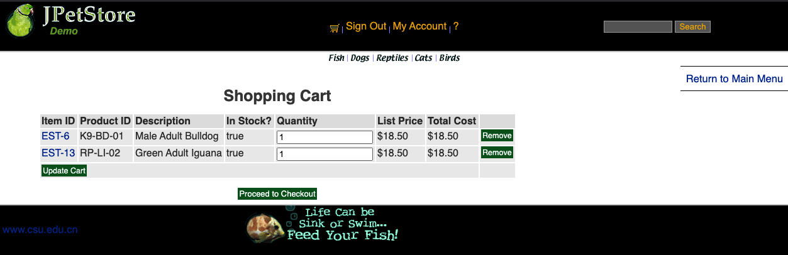

(2) 订单账单信息页面

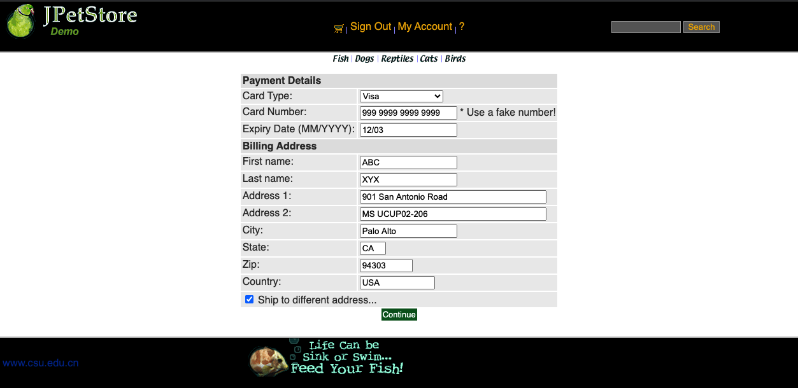

(3) 订单邮寄信息页面

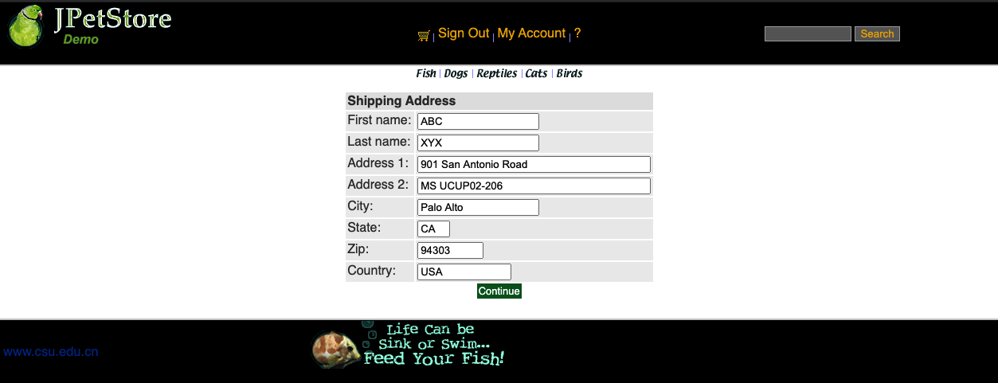

(4) 确认订单界面

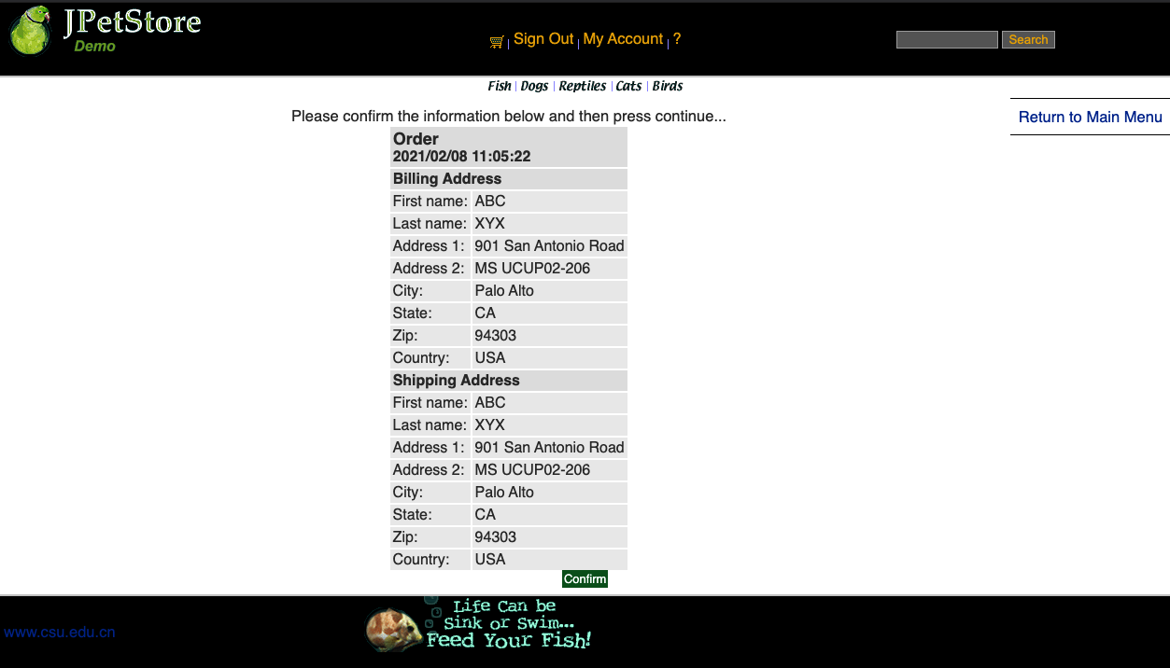

2) 核心代码

(1) jsp

ⅰ. Cart.jsp
<%@ include file="../common/IncludeTop.jsp"%>
<div id="BackLink">
<a href="main">Return to Main Menu</a>
</div>
<div id="Catalog">
<div id="Cart">
<h2>Shopping Cart</h2>
<form action="updateCartQuantities" method="post">
<table>
<tr>
<th><b>Item ID</b></th>
<th><b>Product ID</b></th>
<th><b>Description</b></th>
<th><b>In Stock?</b></th>
<th><b>Quantity</b></th>
<th><b>List Price</b></th>
<th><b>Total Cost</b></th>
<th>&nbsp;</th>
</tr>
<c:if test="${sessionScope.cart.numberOfItems == 0}">
<tr>
<td colspan="8"><b>Your cart is empty.</b></td>
</tr>
</c:if>
<c:forEach var="cartItem" items="${sessionScope.cart.cartItems}">
<tr>
<td>
<a href="viewItem?itemId=${cartItem.item.itemId}">${cartItem.item.itemId}</a>
</td>
<td>
${cartItem.item.product.productId}
</td>
<td>
${cartItem.item.attribute1} ${cartItem.item.attribute2}
${cartItem.item.attribute3} ${cartItem.item.attribute4}
${cartItem.item.attribute5} ${cartItem.item.product.name}
</td>
<td>
${cartItem.inStock}
</td>
<td>
<input type="text" name="${cartItem.item.itemId}" value="${cartItem.quantity}" />
</td>
<td>
<fmt:formatNumber value="${cartItem.item.listPrice}" pattern="$#,##0.00" />
</td>
<td>
<fmt:formatNumber value="${cartItem.total}" pattern="$#,##0.00" />
</td>
<td>
<a href="removeItemFromCart?workingItemId=${cartItem.item.itemId}" class="Button">Remove</a>
</td>
</tr>
</c:forEach>
<tr>
<td colspan="7">
<input type="submit" value="Update Cart"/>
</td>
<td>&nbsp;</td>
</tr>
</table>
</form>
<c:if test="${sessionScope.cart.numberOfItems > 0}">
<a href="proceedToCheckOut" class="Button">Proceed to Checkout</a>
</c:if>
</div>
<div id="Separator">&nbsp;</div>
</div>
<%@ include file="../common/IncludeBottom.jsp"%>

ⅱ. ConfirmOrder,jsp
<%@ include file="../common/IncludeTop.jsp"%>
<div id="BackLink">
<a href="main">
Return to Main Menu
</a>
</div>
<div id="Catalog">
Please confirm the information below and then press continue...
<table>
<tr>
<th align="center" colspan="2"><font size="4"><b>Order</b></font>
<br />
<font size="3"><b> <fmt:formatDate
value="${sessionScope.order.orderDate}" pattern="yyyy/MM/dd hh:mm:ss" /></b></font>
</th>
</tr>
<tr>
<th colspan="2">Billing Address</th>
</tr>
<tr>
<td>First name:</td>
<td><c:out value="${sessionScope.order.billToFirstName}" /></td>
</tr>
<tr>
<td>Last name:</td>
<td><c:out value="${sessionScope.order.billToLastName}" /></td>
</tr>
<tr>
<td>Address 1:</td>
<td><c:out value="${sessionScope.order.billAddress1}" /></td>
</tr>
<tr>
<td>Address 2:</td>
<td><c:out value="${sessionScope.order.billAddress2}" /></td>
</tr>
<tr>
<td>City:</td>
<td><c:out value="${sessionScope.order.billCity}" /></td>
</tr>
<tr>
<td>State:</td>
<td><c:out value="${sessionScope.order.billState}" /></td>
</tr>
<tr>
<td>Zip:</td>
<td><c:out value="${sessionScope.order.billZip}" /></td>
</tr>
<tr>
<td>Country:</td>
<td><c:out value="${sessionScope.order.billCountry}" /></td>
</tr>
<tr>
<th colspan="2">Shipping Address</th>
</tr>
<tr>
<td>First name:</td>
<td><c:out value="${sessionScope.order.shipToFirstName}" /></td>
</tr>
<tr>
<td>Last name:</td>
<td><c:out value="${sessionScope.order.shipToLastName}" /></td>
</tr>
<tr>
<td>Address 1:</td>
<td><c:out value="${sessionScope.order.shipAddress1}" /></td>
</tr>
<tr>
<td>Address 2:</td>
<td><c:out value="${sessionScope.order.shipAddress2}" /></td>
</tr>
<tr>
<td>City:</td>
<td><c:out value="${sessionScope.order.shipCity}" /></td>
</tr>
<tr>
<td>State:</td>
<td><c:out value="${sessionScope.order.shipState}" /></td>
</tr>
<tr>
<td>Zip:</td>
<td><c:out value="${sessionScope.order.shipZip}" /></td>
</tr>
<tr>
<td>Country:</td>
<td><c:out value="${sessionScope.order.shipCountry}" /></td>
</tr>
</table>
<a href="submitOrder" class="Button">
<%-- <stripes:param name="confirmed" value="true" />--%>
Confirm
</a>
</div>
<%@ include file="../common/IncludeBottom.jsp"%>

(2) Servlet

ⅰ. ViewCartServlet
public class ViewCartServlet extends HttpServlet {
private static final String VIEW_CART = "/WEB-INF/jsp/cart/Cart.jsp";
private CartService cartService;
protected void doPost(HttpServletRequest request, HttpServletResponse response) throws ServletException, IOException {
doGet(request, response);
}
protected void doGet(HttpServletRequest request, HttpServletResponse response) throws ServletException, IOException {
HttpSession session = request.getSession();
Cart cart = (Cart)session.getAttribute("cart");
Account account = (Account)session.getAttribute("account");
cartService = new CartService();
if (cart == null) {
cart = new Cart();
cart = cartService.getCartByUsername(account.getUsername());
session.setAttribute("cart", cart);
}
if(account!=null && account.isAuthenticated()){
LogService logService = new LogService();
String logDescription = "View Cart";
Log log = new Log(account.getUsername(), Log.VIEW, logDescription);
logService.insertLogInfo(log);
}
request.getRequestDispatcher(VIEW_CART).forward(request, response);
}
}

ⅱ. UpdateCartQuantitiesServlet
public class UpdateCartQuantitiesServlet extends HttpServlet {
private static final String VIEW_CART = "/WEB-INF/jsp/cart/Cart.jsp";
private static final String ERROR = "/WEB-INF/jsp/common/Error.jsp";
private Cart cart;
private Account account;
protected void doPost(HttpServletRequest request, HttpServletResponse response) throws ServletException, IOException {
doGet(request, response);
}
protected void doGet(HttpServletRequest request, HttpServletResponse response) throws ServletException, IOException {
HttpSession session = request.getSession();
cart = (Cart) session.getAttribute("cart");
account = (Account)session.getAttribute("account");
CartService cartService = new CartService();
Iterator<CartItem> cartItems = cart.getAllCartItems();
while (cartItems.hasNext()) {
CartItem cartItem = cartItems.next();
String itemId = cartItem.getItem().getItemId();
try {
int quantity = Integer.parseInt(request.getParameter(itemId));
int originalQuantity = cart.getQuantityByItemId(itemId);
cart.setQuantityByItemId(itemId, quantity);
if (quantity < 1) {
cartItems.remove();
if(account!=null && account.isAuthenticated()){
cartService.removeItemFromCart(account.getUsername(), itemId);
LogService logService = new LogService();
String logDescription = "Remove Item, Item ID: " + itemId;
Log log = new Log(account.getUsername(), Log.UPDATE_CART, logDescription);
logService.insertLogInfo(log);
}
}else if(originalQuantity != quantity){
if(account!=null && account.isAuthenticated()){
cartService.updateItemQuantity(account.getUsername(), itemId, quantity);
LogService logService = new LogService();
String logDescription = "Change Quantity, Item ID: " + itemId + ", From " + originalQuantity + " to " + quantity;
Log log = new Log(account.getUsername(), Log.UPDATE_CART, logDescription);
logService.insertLogInfo(log);
}
}
} catch (Exception e) {
session.setAttribute("message", "The Quantities of Item must be Integer!");
request.getRequestDispatcher(ERROR).forward(request, response);
return;
}
}
request.getRequestDispatcher(VIEW_CART).forward(request, response);
}
}

ⅲ. ProceedToCheckOutServlet
public class ProceedToCheckOutServlet extends HttpServlet {
private static final String SIGN_ON_FORM = "/WEB-INF/jsp/account/SignonForm.jsp";
private static final String NEW_ORDER_FORM = "/WEB-INF/jsp/order/NewOrderForm.jsp";
protected void doPost(HttpServletRequest request, HttpServletResponse response) throws ServletException, IOException {
HttpSession session = request.getSession();
Account account = (Account)session.getAttribute("account");
Cart cart = (Cart)session.getAttribute("cart");
if( null == account || !account.isAuthenticated() ){
request.setAttribute("message", "You must sign on before attempting to check out. Please sign on and try checking out again.");
request.getRequestDispatcher(SIGN_ON_FORM).forward(request, response);
}else{
Order order = new Order();
order.initOrder(account, cart);
session.setAttribute("order", order);
request.getRequestDispatcher(NEW_ORDER_FORM).forward(request,response);
}
}
protected void doGet(HttpServletRequest request, HttpServletResponse response) throws ServletException, IOException {
doPost(request, response);
}
}

- 实验内容——扩展任务。
- 添加验证码功能：在用户注册和用户登录模块中添加验证码功能。

1) 运行界面截图

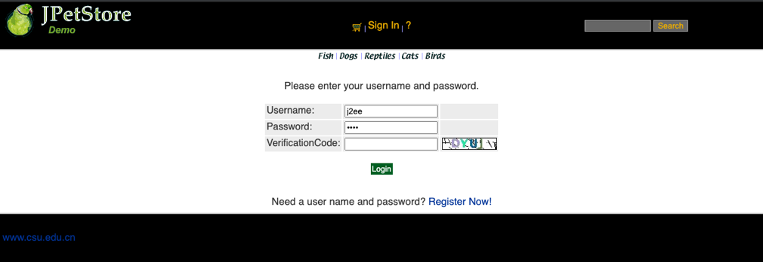
(1) 登录界面验证码

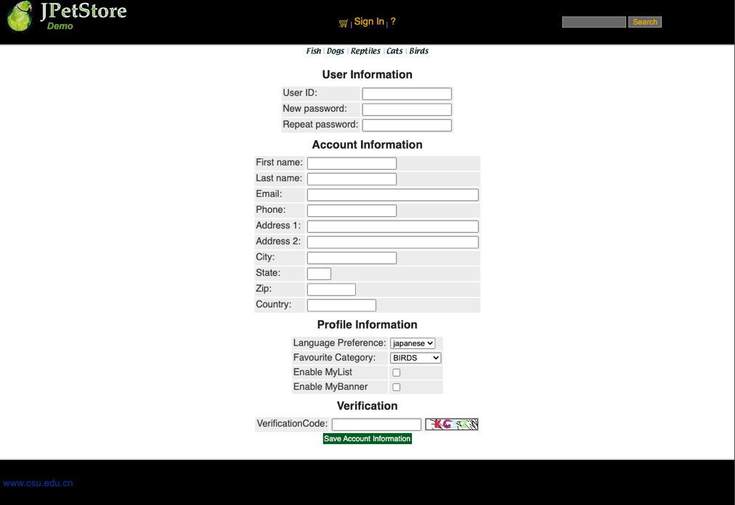
(2) 注册界面验证码

2) 验证码的基本原理

通过向包含有验证码的图像中加入构成干扰的几何图形，从而避免OCR等电脑程序识别图像中的文字，以区别人和机器，防止恶意操作。

3) 验证码的实现方案

(1) 生成随机的定长字符串作为验证码；

(2) 用Java中的Graphics类将验证码进行绘图，并向其中添加若干干扰点和干扰线；

(3) 将图像文件输出到Servlet输出流，将验证码存储到Session对象中；

(4) JSP通过请求服务器获得验证码图片，Servlet通过校对输入的字符串与Session中存储的字符串是否相同来判断验证码是否输入正确。

4) 核心代码

(1) VerifyCodeServlet
public class VerifyCodeServlet extends HttpServlet {
private static int width = 90;// 定义图片的width
private static int height = 20;// 定义图片的height
private static int codeCount = 4;// 定义图片上显示验证码的个数
private static int xx = 15;
private static int fontHeight = 18;
private static int codeY = 16;
private static char[] codeSequence =
{ 'A', 'B', 'C', 'D', 'E', 'F', 'G', 'H', 'I', 'J', 'K', 'L', 'M', 'N', 'O', 'P', 'Q', 'R',
'S', 'T', 'U', 'V', 'W', 'X', 'Y', 'Z', '0', '1', '2', '3', '4', '5', '6', '7', '8', '9' };
protected void doPost(HttpServletRequest request, HttpServletResponse response) throws ServletException, IOException {
doGet(request, response);
}
protected void doGet(HttpServletRequest request, HttpServletResponse response) throws ServletException, IOException {
// 定义图像buffer
BufferedImage buffImg = new BufferedImage(width, height, BufferedImage.TYPE_INT_RGB);
Graphics gd = buffImg.getGraphics();
// 创建一个随机数生成器类
Random random = new Random();
// 将图像填充为白色
gd.setColor(Color.WHITE);
gd.fillRect(0, 0, width, height);
// 创建字体，字体的大小应该根据图片的高度来定。
Font font = new Font("Fixedsys", Font.BOLD, fontHeight);
// 设置字体。
gd.setFont(font);
// 画边框。
gd.setColor(Color.BLACK);
gd.drawRect(0, 0, width - 1, height - 1);
// 随机产生40条干扰线，使图象中的认证码不易被其它程序探测到。
gd.setColor(Color.BLACK);
for (int i = 0; i < 30; i++) {
int x = random.nextInt(width);
int y = random.nextInt(height);
int xl = random.nextInt(12);
int yl = random.nextInt(12);
gd.drawLine(x, y, x + xl, y + yl);
}
// randomCode用于保存随机产生的验证码，以便用户登录后进行验证。
StringBuffer randomCode = new StringBuffer();
int red = 0, green = 0, blue = 0;
// 随机产生codeCount数字的验证码。
for (int i = 0; i < codeCount; i++) {
// 得到随机产生的验证码数字。
String code = String.valueOf(codeSequence[random.nextInt(36)]);
// 产生随机的颜色分量来构造颜色值，这样输出的每位数字的颜色值都将不同。
red = random.nextInt(255);
green = random.nextInt(255);
blue = random.nextInt(255);
// 用随机产生的颜色将验证码绘制到图像中。
gd.setColor(new Color(red, green, blue));
gd.drawString(code, (i + 1) * xx, codeY);
// 将产生的四个随机数组合在一起。
randomCode.append(code);
}
Map<String,Object> map =new HashMap<String,Object>();
//存放验证码
map.put("code", randomCode);
//存放生成的验证码BufferedImage对象
map.put("codePic", buffImg);
// 将图像输出到Servlet输出流中。
ServletOutputStream servletOutputStream;
try {
servletOutputStream = response.getOutputStream();
ImageIO.write((RenderedImage)map.get("codePic"), "jpeg", servletOutputStream);
servletOutputStream.close();
} catch (IOException e) {
e.printStackTrace();
}
HttpSession session = request.getSession();
session.setAttribute("theCode", randomCode.toString());
}
}

(2) jsp
<table>
<tr>
<td>VerificationCode:</td>
<td><input type="text" name="vrfCode"></td>
<td><img src="verifyCode" alt="refresh" onclick="change(this)"></td>
</tr>
</table>

- 购物车功能：原项目中购物车为内存购物车，即将用户相关的购物车存储在session中；在数据库中添加购物车表，将购物车数据持久化，以便用户下次登录时可查看或修改自己的购物车数据。

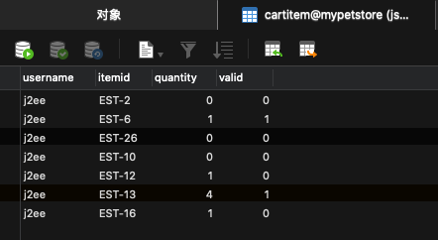
1) 效果截图

2) 实现

(1) 新增cartItem表，表单的每一项记录由用户名、商品ID、数量、有效位4个字段组成；

(2) 实现CartDAO接口、新增CartService类以提供对数据库的修改接口。

3) 核心代码

(1) CartDAOImpl
public class CartDAOImpl implements CartDAO {
private static final String GET_CART_ITEMS_BY_USERNAME = "SELECT ITEMID, QUANTITY, VALID FROM CARTITEM WHERE USERNAME = ?";
private static final String INSERT_CARD_ITEM = "INSERT INTO CARTITEM (USERNAME,ITEMID, QUANTITY) VALUES (?, ?, ?)";
private static final String UPDATE_CART_ITEM_QUANTITY = "UPDATE CARTITEM SET QUANTITY = ? WHERE USERNAME = ? AND ITEMID = ?";
private static final String SET_CART_ITEM_ISVALID = "UPDATE CARTITEM SET VALID = ? WHERE USERNAME = ? AND ITEMID = ?";
CatalogService catalogService;
@Override
public Cart getCartByUsername(String username) {
List<CartItemDB> cartItemDBList = new ArrayList<>();
catalogService = new CatalogService();
Cart cart = new Cart();
boolean isInStock;
try{
Connection connection = DBUtil.getConnection();
PreparedStatement pStatement = connection.prepareStatement(GET_CART_ITEMS_BY_USERNAME);
pStatement.setString(1, username);
ResultSet resultSet = pStatement.executeQuery();
while( resultSet.next() ){
CartItemDB cartItemDB = new CartItemDB();
cartItemDB.setItemId(resultSet.getString(1));
cartItemDB.setQuantity(resultSet.getInt(2));
cartItemDB.setValid(resultSet.getBoolean(3));
if(cartItemDB.isValid()){
isInStock = catalogService.isItemInStock(cartItemDB.getItemId());
Item item = catalogService.getItem(cartItemDB.getItemId());
cart.addItem(item,isInStock);
cartItemDBList.add(cartItemDB);
}
}
DBUtil.closeResultSet(resultSet);
DBUtil.closePreparedStatement(pStatement);
DBUtil.closeConnection(connection);
}catch (Exception e){
e.printStackTrace();
}
return cart;
}
@Override
public void addItemToCart(String itemId, String username) {
try{
Connection connection = DBUtil.getConnection();
Cart cart = getCartByUsername(username);
if(cart == null){
cart = new Cart();
}
if(cart.containsItemId(itemId)){
PreparedStatement updateStatement = connection.prepareStatement(UPDATE_CART_ITEM_QUANTITY);
cart.incrementQuantityByItemId(itemId);
int quantity = cart.getQuantityByItemId(itemId);
updateStatement.setInt(1, quantity );
updateStatement.setString(2, username);
updateStatement.setString(3, itemId);
updateStatement.executeUpdate();
DBUtil.closePreparedStatement(updateStatement);
DBUtil.closeConnection(connection);
}else{
PreparedStatement insertStatement = connection.prepareStatement(INSERT_CARD_ITEM);
insertStatement.setString(1, username);
insertStatement.setString(2, itemId);
insertStatement.setInt(3, 1);
insertStatement.executeUpdate();
DBUtil.closePreparedStatement(insertStatement);
DBUtil.closeConnection(connection);
}
}catch (Exception e){
e.printStackTrace();
}
}
public void updateItemValid(String username, String itemId, boolean valid){
try{
Connection connection = DBUtil.getConnection();
PreparedStatement updateStatement = connection.prepareStatement(SET_CART_ITEM_ISVALID);
updateStatement.setBoolean(1, valid );
updateStatement.setString(2, username);
updateStatement.setString(3, itemId);
updateStatement.executeUpdate();
DBUtil.closePreparedStatement(updateStatement);
DBUtil.closeConnection(connection);
}catch (Exception e){
e.printStackTrace();
}
}
@Override
public void clearCart(String username) {
Cart cart = getCartByUsername(username);
List<CartItem> cartItemList = new ArrayList<>();
cartItemList = cart.getCartItemList();
CartItem cartItem;
for(int i = 0; i < cartItemList.size(); i ++){
cartItem = cartItemList.get(i);
updateItemValid(username, cartItem.getItem().getItemId(), false);
}
}
@Override
public void updateItemQuantity(String username, String itemId, int quantity) {
try{
Connection connection = DBUtil.getConnection();
Cart cart = getCartByUsername(username);
if(cart == null){
cart = new Cart();
}
PreparedStatement updateStatement = connection.prepareStatement(UPDATE_CART_ITEM_QUANTITY);
cart.setQuantityByItemId(itemId, quantity);
updateStatement.setInt(1, quantity );
updateStatement.setString(2, username);
updateStatement.setString(3, itemId);
updateStatement.executeUpdate();
DBUtil.closePreparedStatement(updateStatement);
DBUtil.closeConnection(connection);
}catch (Exception e){
e.printStackTrace();
}
}
}

(2) CartService
public class CartService {
private CartDAO cartDAO;
public CartService() {
cartDAO = new CartDAOImpl();
}
public Cart getCartByUsername(String username){
return cartDAO.getCartByUsername(username);
}
public void addItemToCart(String itemId, String username){
cartDAO.addItemToCart(itemId, username);
}
public void removeItemFromCart(String username, String itemId){
cartDAO.updateItemValid(username, itemId, false);
cartDAO.updateItemQuantity(username, itemId, 0);
}
public void updateItemQuantity(String username, String itemId, int quantity){
cartDAO.updateItemQuantity(username, itemId, quantity);
}
public void clearCart(String username){
cartDAO.clearCart(username);
}
}

- 日志功能：数据库中添加日志信息表，给项目添加日志功能，用户登录后记录用户行为，比如浏览了哪些商品、将商品添加进购物车、生成订单等。

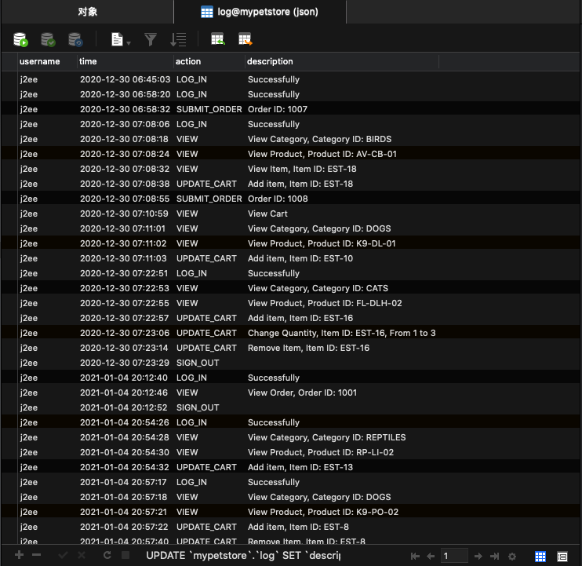
1) 效果截图

2) 记录信息

(1) 用户名；

(2) 动作时间；

(3) 动作类型；

(4) 动作描述：如查看的商品ID、订单号、操作是否成功等。

3) 实现

(1) 数据库中新建log表，每一条记录由用户名、时间戳、用户动作和动作描述组成；

(2) 新增Log类；

(3) 实现LogDAO接口和新增LogService类，在不同类型的Servlet中插入不同类型的日志记录。
- 小组成员分工及实验总结
- 小组分工：

小组只由一人组成，实验工作占比100%.
- 实验总结

1) 问题1：对于数据库中类型为tinyint类型的数据与java数据类型的对应关系未知

(1) 问题描述：对于结果集中tinyint数据类型的数据不知道该如何处理

(2) 解决：通过上网搜索，得知tinyint类型的字段会被当作boolean类型进行返回，可以直接用getBoolean()或setBoolean()对相应字段进行设置。

(3) 体会：遇到不懂的问题借助搜索引擎可以更快得到结果。

2) 问题2：将数据库中购物车商品添加到购物车中时数量总为1

(1) 解决：细心查看获取购物车时的每一个函数，在Cart类的addItem()中发现会默认将商品数量设为1。于是将Item类的quantity字段分为cartQuantity和stockQuantity，在新增商品时根据cartQuantity的大小设置购物车商品的数量。

(2) 总结：由于购物车部分的代码直接用了老师给的现成代码，直接调用函数没有注意具体实现，从而出现了问题。经过仔细察看后最终解决。

3) 问题3：实现日志功能时，数据库无法设置时间戳的默认值为当前时间

(1) 问题描述：Navicat For MySQL无法设置时间戳的默认值为当前时间，没有提供CURRENT_TIMESTAMP这一选项，即使用SQL语句进行设置也会报错，无法成功解析“CURRENT_TIMESTAMP”这一语句。

(2) 解决：曲线救国，在插入记录时在Java中获取当前时间作为时间戳字段的值。

(3) 体会：实现一个功能可以通过不同的方法实现，虽然用数据库的时间戳特性可能更加方便高效，但在一直找不到报错原因的情况下，或许可以尝试不同的方法。

4) 实验总结：

本次实验从头开始，跟着老师录制的视频，借助现有的项目资源慢慢敲出整个实验的内容。在刚开始上手的时候，每一个功能都是非常的挑战，但在实现了前几个功能之后，弄清楚了整个流程，照葫芦画瓢，后面功能的实现过程效率高了不少。好在实验的时间要求比较宽松，在平时的学习间隙构想功能如何实现并付诸行动，总算在最后一次实验课之前将功能全部实现了，还是挺有成就感的。
实验二 使用AJAX和jQuery改善用户体验
- 实验内容——基本任务。
- 账号管理模块。在新建账号和修改账号信息页面上用AJAX技术进行表单验证，如“判断用户名是否已存在”等功能。

1) 效果截图

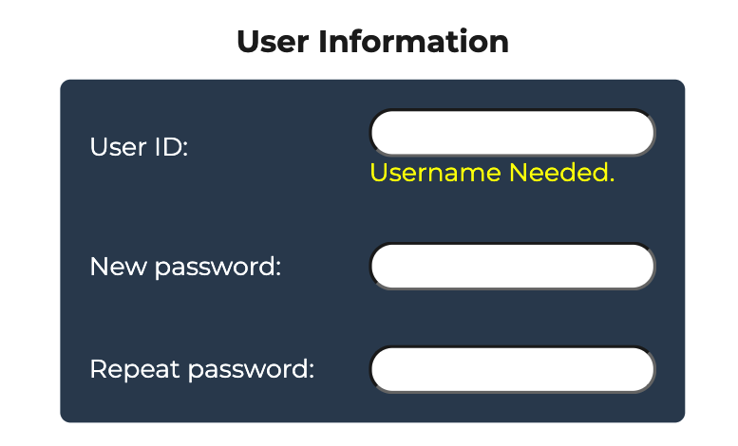
(1) 输入框为空

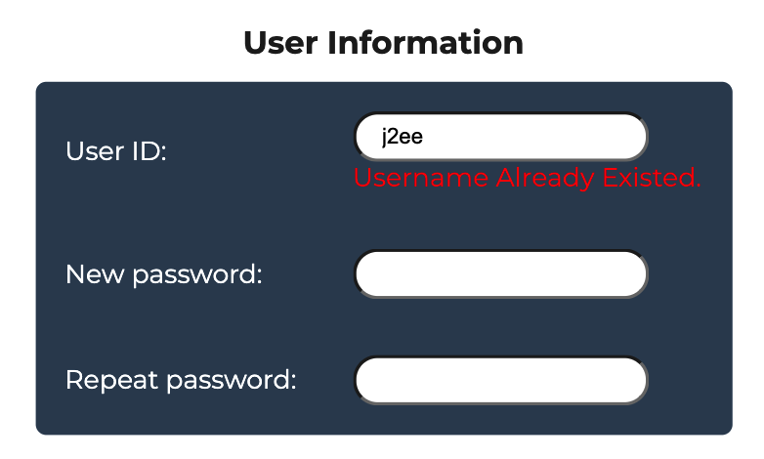
(2) 用户名不可用

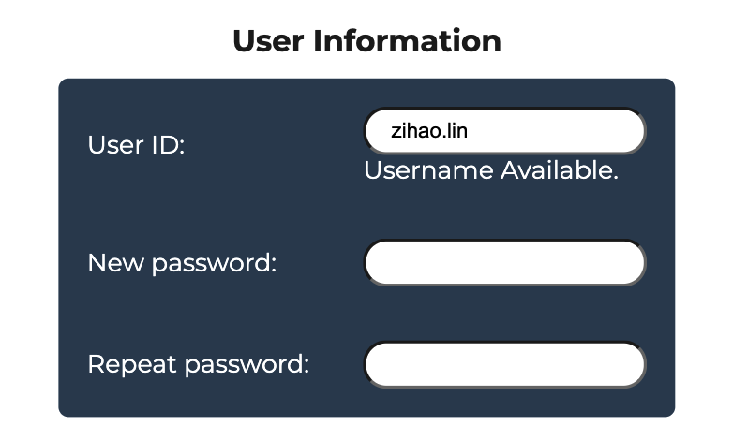
(3) 用户名可用

2) 核心代码

(1) HTML
<input type="text" name="username" id="username" onblur="isUsernameExist();" />

(2) Servlet
public class IsUsernameExistServlet extends HttpServlet {
protected void doPost(HttpServletRequest request, HttpServletResponse response) throws ServletException, IOException {
AccountDAO accountDAO = new AccountDAOImpl();
String username = request.getParameter("username");
Account account = accountDAO.getAccountByUsername(username);
response.setContentType("text/plain");
PrintWriter out = response.getWriter();
if(null == account){ //用户名没有重复
out.println("Not Exist");
}else{
out.println("Exist");
}
out.flush();
out.close();
}
protected void doGet(HttpServletRequest request, HttpServletResponse response) throws ServletException, IOException {
doPost(request, response);
}
}

(3) JavaScript
function isUsernameExist() {
// debugger
let input = document.getElementById( 'username' );
username = '';
if ( input ) {
username = input.value;
}
if(username.trim() != ''){
//声明XHR对象
createXMLHttpRequest();
//初始化url
var url = "isUsernameExistServlet?username=" + username;
//建立对服务器的调用
xhr.open( "GET", url, true ); //默认为true,即异步通信
xhr.onreadystatechange = processResponse;
xhr.send( null );
}else{
var msgDiv = document.getElementById( 'isExistInfo' );
msgDiv.innerHTML = "<font color='yellow'>Username Needed.</font>";
}
}
function processResponse() {
if ( xhr.readyState == 4 ) {
if ( xhr.status == 200 ) {
// debugger
var responseInfo = xhr.responseText;
//删除返回信息后边的回车符
var trimedInfo = responseInfo.trim();
//获取DOM树中显示用户名是否存在的节点
var msgDiv = document.getElementById( 'isExistInfo' );
if ( trimedInfo === 'Exist' ) {
msgDiv.innerHTML = "<font color='red'>Username Already Existed.</font>";
} else if ( trimedInfo === 'Not Exist' ) {
msgDiv.innerHTML = "<font color='white'>Username Available.</font>";
}
}
}
}

- 查询商品模块。在主页面右上角的查询商品功能中添加自动补全功能。

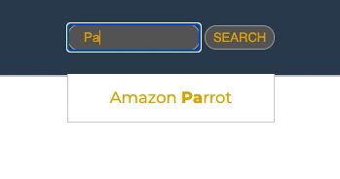
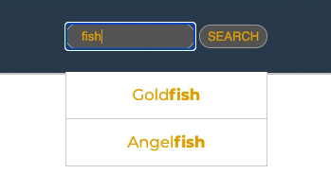
1) 效果截图

2) 核心代码

(1) HTML
<input type="text" id="keyword" name="keyword" size="14" onclick="initAutoComplete();"/>

(2) Servlet
public class GetAllProductListServlet extends HttpServlet {
private CatalogService catalogService;
protected void doPost( HttpServletRequest request, HttpServletResponse response ) throws ServletException, IOException {
doGet( request, response );
}
protected void doGet( HttpServletRequest request, HttpServletResponse response ) throws ServletException, IOException {
catalogService = new CatalogService();
List<Product> productList = catalogService.getAllProductList();
StringBuilder productListString = null;
if ( !productList.isEmpty() ) {
productListString = new StringBuilder( productList.get( 0 ) + "" );
if ( productList.size() > 1 ) {
for ( int i = 1; i < productList.size(); i++ ) {
productListString.append( "," ).append( productList.get( i ) ) ; //Product类的toString()默认返回对象的name字
}
}
}
response.setContentType( "text/plain" );
PrintWriter out = response.getWriter();
out.print( productListString );
out.flush();
out.close();
}
}

(3) JavaScript
var xhr;
var productArray = [];
var initAutoComplete = ( function () {
createXMLHttpRequest();
let url = "getAllProductList";
xhr.open( "GET", url, true );
xhr.onreadystatechange = function () {
if ( xhr.readyState == 4 ) {
if ( xhr.status == 200 ) {
productArray = xhr.responseText.split( ',' );
autocomplete( document.getElementById( "keyword" ), productArray );
}
}
};
xhr.send( null );
} );
function autocomplete( inp, arr ) {
/*the autocomplete function takes two arguments,
the text field element and an array of possible autocompleted values:*/
var currentFocus;
/*execute a function when someone writes in the text field:*/
inp.addEventListener( "input", function ( e ) {
var wrapperDiv, itemDiv, i, index, val = this.value;
/*close any already open lists of autocompleted values*/
closeAllLists();
if ( !val ) {
return false;
}
currentFocus = -1;
/*create wrapperDiv DIV element that will contain the items (values):*/
wrapperDiv = document.createElement( "DIV" );
wrapperDiv.setAttribute( "id", this.id + "autocomplete-list" );
wrapperDiv.setAttribute( "class", "autocomplete-items" );
/*append the DIV element as wrapperDiv child of the autocomplete container:*/
this.parentNode.appendChild( wrapperDiv );
/*for each item in the array...*/
for ( i = 0; i < arr.length; i++ ) {
/*check if the item contains the same letters as the text field value:*/
index = arr[i].toUpperCase().indexOf( val.toUpperCase() );
if ( index != -1 ) {
/*create wrapperDiv DIV element for each matching element:*/
itemDiv = document.createElement( "DIV" );
/*make the matching letters bold:*/
itemDiv.innerHTML = arr[i].substring( 0, index ); //substring() returns a sub-string where index's inside [from, to - 1]
itemDiv.innerHTML += "<strong>" + arr[i].substr( index, val.length ) + "</strong>";
itemDiv.innerHTML += arr[i].substring( index + val.length );
/*insert wrapperDiv input field that will hold the current array item's value:*/
itemDiv.innerHTML += "<input type='hidden' value='" + arr[i] + "'>";
/*execute wrapperDiv function when someone clicks on the item value (DIV element):*/
itemDiv.addEventListener( "click", function ( e ) {
/*insert the value for the autocomplete text field:*/
inp.value = this.getElementsByTagName( "input" )[0].value;
/*close the list of autocompleted values,
(or any other open lists of autocompleted values:*/
closeAllLists();
} );
wrapperDiv.appendChild( itemDiv );
}
}
} );
/*execute a function presses a key on the keyboard:*/
inp.addEventListener( "keydown", function ( e ) {
var x = document.getElementById( this.id + "autocomplete-list" );
if ( x ) x = x.getElementsByTagName( "div" );
if ( e.keyCode == 40 ) {
/*If the arrow DOWN key is pressed,
increase the currentFocus variable:*/
currentFocus++;
/*and and make the current item more visible:*/
addActive( x );
} else if ( e.keyCode == 38 ) { //up
/*If the arrow UP key is pressed,
decrease the currentFocus variable:*/
currentFocus--;
/*and and make the current item more visible:*/
addActive( x );
} else if ( e.keyCode == 13 ) {
/*If the ENTER key is pressed, prevent the form from being submitted,*/
e.preventDefault();
if ( currentFocus > -1 ) {
/*and simulate a click on the "active" item:*/
if ( x ) x[currentFocus].click();
}
}
} );
function addActive( x ) {
/*a function to classify an item as "active":*/
if ( !x ) return false;
/*start by removing the "active" class on all items:*/
removeActive( x );
if ( currentFocus >= x.length ) currentFocus = 0;
if ( currentFocus < 0 ) currentFocus = ( x.length - 1 );
/*add class "autocomplete-active":*/
x[currentFocus].classList.add( "autocomplete-active" );
}
function removeActive( x ) {
/*a function to remove the "active" class from all autocomplete items:*/
for ( var i = 0; i < x.length; i++ ) {
x[i].classList.remove( "autocomplete-active" );
}
}
function closeAllLists( elmnt ) {
/*close all autocomplete lists in the document,
except the one passed as an argument:*/
var x = document.getElementsByClassName( "autocomplete-items" );
for ( var i = 0; i < x.length; i++ ) {
if ( elmnt != x[i] && elmnt != inp ) {
x[i].parentNode.removeChild( x[i] );
}
}
}
/*execute a function when someone clicks in the document:*/
document.addEventListener( "click", function ( e ) {
closeAllLists( e.target );
} );
}

- 购物车模块。在购物车模块中修改购买数量时，通过AJAX修改购物车信息。

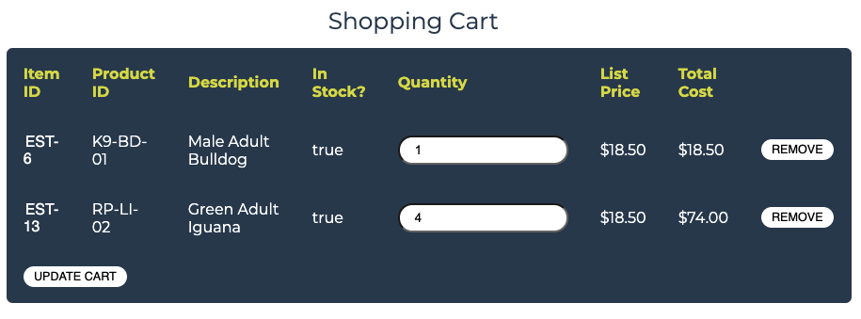
1) 效果截图

2) 核心代码
(1) HTML
<c:forEach var="cartItem" items="${sessionScope.cart.cartItems}">
<tr itemid="${cartItem.item.itemId}">
<td>
<a href="viewItem?itemId=${cartItem.item.itemId}">
${cartItem.item.itemId}
</a>
</td>
<td>
${cartItem.item.product.productId}
</td>
<td>
${cartItem.item.attribute1} ${cartItem.item.attribute2}
${cartItem.item.attribute3} ${cartItem.item.attribute4}
${cartItem.item.attribute5} ${cartItem.item.product.name}
</td>
<td>
${cartItem.inStock}
</td>
<td>
<input type="text" name="${cartItem.item.itemId}" value="${cartItem.quantity}" onchange="updateCartRequest()" />
</td>
<td>
<fmt:formatNumber value="${cartItem.item.listPrice}" pattern="$#,##0.00" />
</td>
<td>
<fmt:formatNumber value="${cartItem.total}" pattern="$#,##0.00" />
</td>
<td>
<a onclick="removeCartItemRequest('${cartItem.item.itemId}')" href="#" class="btn">Remove</a>
</td>
</tr>
</c:forEach>

(2) Servlet
public class UpdateCartQuantitiesServlet extends HttpServlet {
private static final String VIEW_CART = "/WEB-INF/jsp/cart/Cart.jsp";
private static final String ERROR = "/WEB-INF/jsp/common/Error.jsp";
private Cart cart;
private Account account;
protected void doPost(HttpServletRequest request, HttpServletResponse response) throws ServletException, IOException {
doGet(request, response);
}
protected void doGet(HttpServletRequest request, HttpServletResponse response) throws ServletException, IOException {
HttpSession session = request.getSession();
cart = (Cart) session.getAttribute("cart");
account = (Account)session.getAttribute("account");
CartService cartService = new CartService();
int quantity, originalQuantity;
Iterator<CartItem> cartItems = cart.getAllCartItems();
boolean isSthRemoved = false;
StringBuilder removedItemsString = new StringBuilder("");
while (cartItems.hasNext()) {
CartItem cartItem = cartItems.next();
String itemId = cartItem.getItem().getItemId();
try {
quantity = Integer.parseInt(request.getParameter(itemId));
originalQuantity = cart.getQuantityByItemId(itemId);
cart.setQuantityByItemId(itemId, quantity);
if (quantity < 1) {
cartItems.remove();
removedItemsString.append( "," ).append( cartItem.getItem().getItemId() );
isSthRemoved = true;
if(account!=null && account.isAuthenticated()){
cartService.removeItemFromCart(account.getUsername(), itemId);
LogService logService = new LogService();
String logDescription = "Remove Item, Item ID: " + itemId;
Log log = new Log(account.getUsername(), Log.UPDATE_CART, logDescription);
logService.insertLogInfo(log);
}
}else if(originalQuantity != quantity){
if(account!=null && account.isAuthenticated()){
cartService.updateItemQuantity(account.getUsername(), itemId, quantity);
LogService logService = new LogService();
String logDescription = "Change Quantity, Item ID: " + itemId + ", From " + originalQuantity + " to " + quantity;
Log log = new Log(account.getUsername(), Log.UPDATE_CART, logDescription);
logService.insertLogInfo(log);
}
}
} catch (Exception e) {
session.setAttribute("message", "The Quantities of Item must be Integer!");
return;
}
}
session.setAttribute( "cart", cart );
StringBuilder message = new StringBuilder("");
if( !isSthRemoved ){
message.append( "No Remove Action" );
}else{
message.append( "Remove Action/" ); /*Append a '/' in the end for js to call split('/')*/
if(cart.getNumberOfItems() == 0){
message.append( "Empty" );
}
message.append( removedItemsString );
}
response.setContentType( "text/plain" );
PrintWriter out = response.getWriter();
out.write(message.toString());
out.flush();
out.close();
}
}

(3) JavaScript
var xhr;
var respMsgArray;
var updateCartRequest = function () {
createXMLHttpRequest();
let parameters = $( '#cartForm' ).serialize();
console.log(parameters);
let url = "updateCartQuantities?" + parameters;
xhr.open( "GET", url, true );
xhr.onreadystatechange = function () {
if ( xhr.readyState == 4 ) {
if ( xhr.status == 200 ) {
console.log(xhr.responseText);
respMsgArray = xhr.responseText.split( ',' );
// debugger
if ( respMsgArray.length > 1 ) {
if ( respMsgArray[0].split( '/' )[0] == 'Remove Action' ) {
var removedItemsList = respMsgArray.slice( 1 );
for ( let i = 0; i < removedItemsList.length; i++ ) {
//remove cart item whose quantity eq 0
$( 'tr[itemid = ' + removedItemsList[i] + ']' ).remove();
}
}
}
if ( respMsgArray[0].split( '/' )[1] == 'Empty' ) { /* The cart falls empty */
/* insert a row of message of empty cart */
let $emptyMsgRow = $( '<tr>\n' +
' <td colspan="8"><b>Your cart is empty.</b></td>\n' +
' </tr>' );
$( 'tr.trHead' ).after( $emptyMsgRow );
}
}
}
}
xhr.send( null );
}
var removeCartItemRequest = function (itemid) {
let removalUrl = 'removeItemFromCart?workingItemId=' + itemid;
createXMLHttpRequest();
xhr.open( "GET", removalUrl, true );
xhr.onreadystatechange = function () {
if ( xhr.readyState == 4 ) {
if ( xhr.status == 200 ) {
$( 'tr[itemid = ' + itemid + ']' ).remove();
if(xhr.responseText == 'Cart Empty' ){
let $emptyMsgRow = $(
' <tr>\n' +
' <td colspan="8"><b>Your cart is empty.</b></td>\n' +
' </tr>'
);
$( 'tr.trHead' ).after( $emptyMsgRow );
}
}
}
}
xhr.send( null );
}

- 实验内容——选做任务。
- 商品展示模块。在首页展示商品的图片上添加AJAX效果，即当鼠标移到某个商品图片上时，用悬浮窗展示该类型商品的信息。

1) 效果截图

(1) 鼠标悬停在FISH类上时
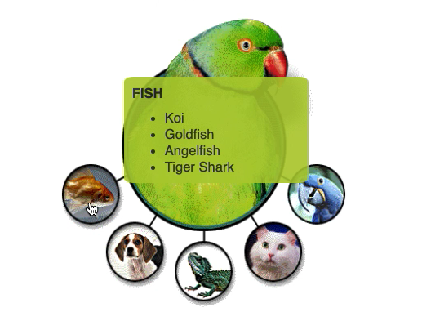

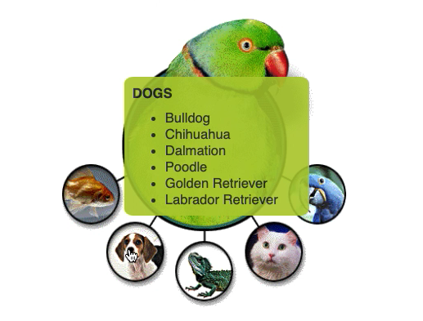
(2) 鼠标悬停在DOGS类上时

2) 具体实现方法

- 没有使用框架，使用了jQuery库

(1) 在主页中加入空的隐藏DIV元素作为悬浮窗的内容容器；

(2) 对商品图片元素的mouseover和mouseout事件添加JS函数，向服务器发出异步请求获取对应商品种类相关信息，以及操纵DOM元素使得页面变化。

3) 核心源代码

(1) HTML
<div id="MainImage">
<div id="MainImageContent">
<div id="HoverSideBar" > <!-- 悬浮窗 -->
<img>
<div id="HoverSidebarContent"></div>
</div>
<map name="estoremap">
<area alt="Birds" coords="72,2,280,250" href="viewCategory?categoryId=BIRDS" shape="rect" onmouseover="showHoverLayer(alt)" onmouseout="concealHoverSideBar()"/>
<area alt="Fish" coords="2,180,72,250" href="viewCategory?categoryId=FISH" shape="rect" onmouseover="showHoverLayer(alt)" onmouseout="concealHoverSideBar()"/>
<area alt="Dogs" coords="60,250,130,320" href="viewCategory?categoryId=DOGS" shape="rect" onmouseover="showHoverLayer(alt)" onmouseout="concealHoverSideBar()"/>
<area alt="Reptiles" coords="140,270,210,340" href="viewCategory?categoryId=REPTILES" shape="rect" onmouseover="showHoverLayer(alt)" onmouseout="concealHoverSideBar()"/>
<area alt="Cats" coords="225,240,295,310" href="viewCategory?categoryId=CATS" shape="rect" onmouseover="showHoverLayer(alt)" onmouseout="concealHoverSideBar()"/>
<area alt="Birds" coords="280,180,350,250" href="viewCategory?categoryId=BIRDS" shape="rect" onmouseover="showHoverLayer(alt)" onmouseout="concealHoverSideBar()"/>
</map>
<img height="355" src="images/splash.gif" align="middle" usemap="#estoremap" width="350" />
</div>
</div>

(2) CSS
#HoverSideBar {
position: absolute;
left: 47%;
top: 24%;
width: 15%;
text-align: left;
z-index: 99;
visibility: hidden;
background-color: rgb(180, 204, 56);
border-radius: 5%;
padding: 5px;
opacity: 0.9;
}
#HoverSideBar img{
visibility: hidden;
width: 100%;
height: auto;
}
#HoverSidebarContent ul{
margin: 5px;
}
#HoverSidebarContent p{
padding: 5px;
}

(3) Servlet
public class GetProductLIstByCategoryServlet extends HttpServlet {
private CatalogService catalogService;
protected void doPost( HttpServletRequest request, HttpServletResponse response ) throws ServletException, IOException {
doGet( request, response );
}
protected void doGet( HttpServletRequest request, HttpServletResponse response ) throws ServletException, IOException {
catalogService = new CatalogService();
String categoryId = request.getParameter( "categoryId" );
List<Product> productList = catalogService.getProductListByCategory( categoryId );
StringBuilder respText = new StringBuilder();
if ( productList != null ){
respText.append( "Success;" );
for(int i = 0; i < productList.size(); i ++ ){
if( i == 0 ){
respText.append( productList.get( i ).getName() );
}else{
respText.append( "," ).append( productList.get( i ).getName() );
}
}
}else{
respText.append( "Failure;" );
}
response.setContentType( "text/plain" );
PrintWriter out = response.getWriter();
out.print( respText );
out.flush();
out.close();
}
}

(4) JavaScript
var xhr;
var category;
var showHoverLayer = function ( categoryId ) {
createXMLHttpRequest();
category = categoryId;
let showUrl = 'getProductListByCategory?categoryId=' + categoryId;
xhr.open( "GET", showUrl, true );
$( 'area' ).mouseover( function ( event ) {
event.preventDefault();
} );
xhr.onreadystatechange = processResp;
xhr.send( null );
}
function processResp() {
console.log( '' + xhr.status + ' ' + xhr.readyState );
let respArray, productList;
if ( xhr.readyState == 4 ) {
if ( xhr.status == 200 ) {
/* call empty() to remove all the child element of wrapper div */
$( '#HoverSidebarContent' ).empty();
/* encode the response text */
respArray = xhr.responseText.split( ';' );
if ( respArray[0] == 'Success' ) {
/* initial the title */
let $title = $( '<p><strong>' + category.toUpperCase() + '</strong></p>' )
$( '#HoverSidebarContent' ).append( $title );
productList = respArray[1].split( ',' );
let $list = $( '<ul></ul>' );
$( '#HoverSidebarContent' ).append( $list );
let $listItem;
for ( let i = 0; i < productList.length; i++ ) {
$listItem = $( '<li>' + productList[i] + '</li>' );
$list.append( $listItem );
}
console.log('success');
console.log(xhr.responseText);
}
}else{
console.log('otherwise');
}
$( '#HoverSideBar' ).css( 'visibility', 'visible' );
}
}
function concealHoverSideBar(){
$( '#HoverSideBar' ).css( 'visibility', 'hidden' );
}

- 订单模块。通过选项卡或模版内容实现订单多个信息部分的录入，不需要页面跳转，在一个页面完成订单所有内容的录入。

1) 效果截图

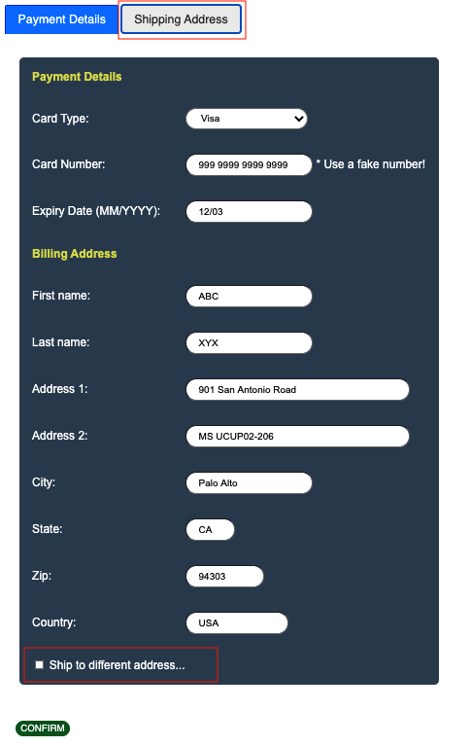
(1) 多选框没有被勾选：邮寄信息标签页链接不可用
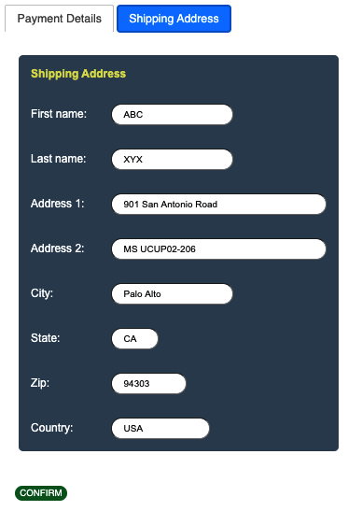
(2) 多选框被勾选：可点击邮寄信息标签页

2) 实现方法

- 没有使用框架，使用了jQuery-ui库和jQuery库

(1) 使用jQuery-ui的tab组件，将支付信息与邮寄信息分为两个标签页；

(2) 对“Ship to different address…”多选框进行事件绑定，若多选框被选中，则邮寄信息标签页链接可被点击，否则不能被点击。

3) 核心代码

(1) HTML
<div id="OrderTabs">
<ul>
<li><a href="#tabs-1">Payment Details</a></li>
<li><a href="#tabs-2" id="shipAddrLink" class="disabled" >Shipping Address</a></li>
</ul>
<div id="tabs-1">
<%-- Codes concerning Payment Details --%>
</div>
<div id="tabs-2">
<%-- Codes concerning Shipping Address --%>
</div>
<p>
<input type="submit" name="newOrder" value="Confirm" class="btn"/>
</p>
</div>
<script>
$( "#OrderTabs" ).tabs();
</script>

(2) JavaScript
var checkboxChange = function ( inp ){
if( inp.checked == true ){
$('#shipAddrLink').removeClass('disabled');
}else{
$('#shipAddrLink').addClass('disabled');
}
}

- 其他效果：可自行选择其他UI模版，或选择其他功能点进行用户体验的优化。

1) 用户登录采用异步请求

(1) 应用理由：使得用户可以在任意界面通过悬浮窗进行登录，而无需跳转到登录界面，从而简化流程，提升用户体验。

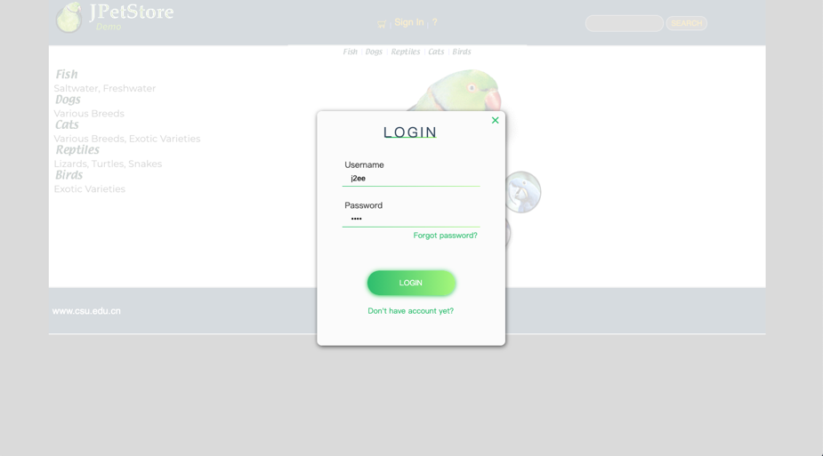
(2) 效果截图

(3) 具体实现方法

- 没有使用框架，使用了jQuery库
ⅰ.在页面中添加登录卡界面的隐藏控件；
ⅱ.当用户需要登录时，显示登录卡界面；登录完成后隐藏登录卡，并对页面中其他元素相应调整。

(4) 核心源代码
ⅰ.HTML
<div id="log-in-card-background">
<img>
</div>
<div id="login-card">
<span class="closebtn" id="login-card-closebtn"></span>
<div id="card-content">
<div id="card-title">
<h2>LOGIN</h2>
<div class="underline-title"></div>
</div>
<form method="post" action="login" class="form" id="loginForm">
<label for="user-name" style="padding-top:13px">
&nbsp;Username
</label>
<input id="user-name" class="form-content" type="text" name="username" autocomplete="on" value="j2ee" required />
<div class="form-border"></div>
<label for="user-password" style="padding-top:22px">&nbsp;Password
</label>
<input id="user-password" class="form-content" type="password" name="password" value="j2ee" required />
<div class="form-border"></div>
<a href="#">
<legend id="forgot-pass">Forgot password?</legend>
</a>
<input id="submit-btn" type="submit" name="submit" value="LOGIN" />
<a href="newAccountForm" id="signup">Don't have account yet?</a>
</form>
</div>
</div>

ⅱ.CSS
label {
font-family: "Raleway", sans-serif;
font-size: 11pt;
}
#forgot-pass {
color: #2dbd6e;
font-family: "Raleway", sans-serif;
font-size: 10pt;
margin-top: 3px;
text-align: right;
}
#login-card {
visibility: hidden;
background: #fbfbfb;
border-radius: 8px;
box-shadow: 1px 2px 8px rgba(0, 0, 0, 0.65);
height: 410px;
margin: 6rem auto 8.1rem auto;
width: 329px;
position: absolute;
top: 0px;
left: 0px;
right: 0px;
bottom: 0px;
z-index: 99;
margin: auto;
}
#card-content {
padding: 12px 44px;
}
#card-title {
font-family: "Raleway Thin", sans-serif;
letter-spacing: 4px;
padding-bottom: 23px;
padding-top: 13px;
text-align: center;
}
#signup {
color: #2dbd6e;
font-family: "Raleway", sans-serif;
font-size: 10pt;
margin-top: 16px;
text-align: center;
}
#submit-btn {
background: -webkit-linear-gradient(right, #a6f77b, #2dbd6e);
border: none;
border-radius: 21px;
box-shadow: 0px 1px 8px #24c64f;
cursor: pointer;
color: white;
font-family: "Raleway SemiBold", sans-serif;
height: 42.3px;
margin: 0 auto;
margin-top: 50px;
transition: 0.25s;
width: 153px;
}
#submit-btn:hover {
box-shadow: 0px 1px 18px #24c64f;
}
.form {
align-items: left;
display: flex;
flex-direction: column;
}
.form-border {
background: -webkit-linear-gradient(right, #a6f77b, #2ec06f);
height: 1px;
width: 100%;
}
.form-content {
background: #fbfbfb;
border: none;
outline: none;
padding-top: 14px;
}
.underline-title {
background: -webkit-linear-gradient(right, #a6f77b, #2ec06f);
height: 2px;
margin: -1.1rem auto 0 auto;
width: 89px;
}
#log-in-card-background{
display: block;
visibility: hidden;
position: absolute;;
left:0;
top:0;
width: 100%;
height: 100%;
z-index:10;
background: white;
-moz-opacity: 0.8;
opacity:.80;
filter: alpha(opacity=80);
}
#log-in-card-background img{
visibility: hidden;
width: 100%;
height: auto;
}
.closebtn::before, .closebtn::after {
content: '';
position: absolute;
height: 2px;
width: 15px;
top: 4%;
right: 3%;
margin-top: -1px;
background: #2ec06f;
}
.closebtn::before {
-webkit-transform: rotate(45deg);
-moz-transform: rotate(45deg);
-ms-transform: rotate(45deg);
-o-transform: rotate(45deg);
transform: rotate(45deg);
}
.closebtn::after {
-webkit-transform: rotate(-45deg);
-moz-transform: rotate(-45deg);
-ms-transform: rotate(-45deg);
-o-transform: rotate(-45deg);
transform: rotate(-45deg);
}

ⅲ. Servlet
public class LoginServlet extends HttpServlet {
private static final String MAIN = "/WEB-INF/jsp/catalog/Main.jsp";
private static final String SIGN_ON_FORM = "/WEB-INF/jsp/account/SignonForm.jsp";
private CartService cartService;
private AccountService accountService;
protected void doPost(HttpServletRequest request, HttpServletResponse response) throws ServletException, IOException {
AccountDAO accountDAO = new AccountDAOImpl();
accountService = new AccountService();
cartService = new CartService();
String username = request.getParameter("username");
String password = request.getParameter("password");
Account account;
account = accountService.getAccount(username, password);
HttpSession session = request.getSession();
PrintWriter out = response.getWriter();
String message;
//异步方式完成登录
if(account != null){
account.setAuthenticated(true);
session.setAttribute("account", account );
LogService logService = new LogService();
Log log = new Log(username, Log.LOG_IN, "Successfully");
logService.insertLogInfo(log);
message = "Log-in Succeed";
}else{
request.setAttribute("message", "Invalid username or password. Signon failed.");
session.setAttribute("account", null );
LogService logService = new LogService();
Log log = new Log(username, Log.LOG_IN, "failed");
logService.insertLogInfo(log);
message = "Log-in Failed";
}
out.print( message );
out.flush();
out.close();
}
protected void doGet(HttpServletRequest request, HttpServletResponse response) throws ServletException, IOException {
doPost(request,response);
}
}

ⅳ.JavaScript
$(document).ready(function(){
$('#login-link').click(function ( event ){
event.preventDefault();
showLoginCard();
});
$('#login-link-proceed').click(function ( event ){
event.preventDefault();
showLoginCard();
});
hideLoginCard();
$('#login-card-closebtn').bind('click', function ( event ){
hideLoginCard();
event.stopPropagation();
})
$('#loginForm').on('submit', function (e) {
e.preventDefault();
$.ajax({
type: 'post',
url: 'login',
data: $('form').serialize(),
success: function ( result ) {
if(result == 'Log-in Succeed'){
hideLoginCard();
var $loginLink = $('#login-link');
let $accountLinks = $('<a href="signout">Sign Out</a>\n' +
' <img align="middle" src="images/separator.gif" />\n' +
' <a href="editAccountForm">My Account</a>');
$loginLink.after($accountLinks);
$loginLink.remove();
if($('#to-check-out').length != 0 ){
let $checkoutLink = $('<a href="proceedToCheckOut" class="btn">Proceed to Checkout</a>');
$('#to-check-out').append($checkoutLink);
}
if($('#note').length != 0 ){
$('#note').remove();
}
}else{
alert('Invalid username or password. Please try later.');
}
},
error: function (){
console.log('log-in ajax error');
}
});
});
})
var hideLoginCard = function (){
$('#login-card').css( 'visibility', 'hidden' );
$('#log-in-card-background').css( 'visibility', 'hidden' );
}
var showLoginCard = function (){
$('#login-card').css( 'visibility', 'visible' );
$('#log-in-card-background').css( 'visibility', 'visible' );
return false;
}

2) 用户界面改进

(1) 效果截图
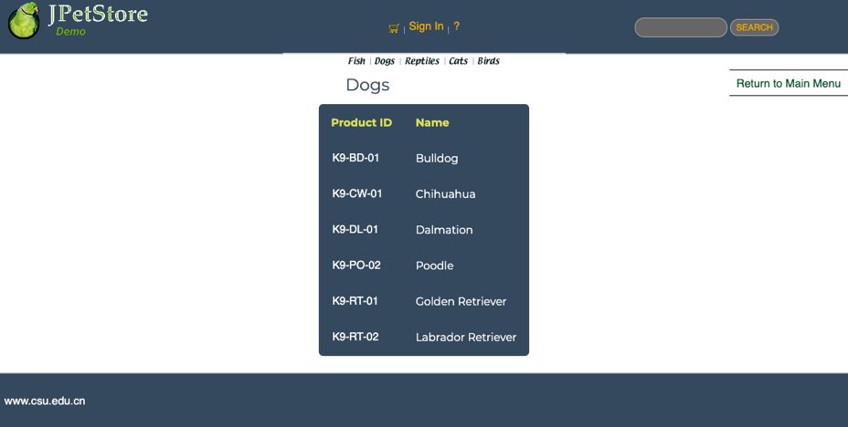
ⅰ. 产品页
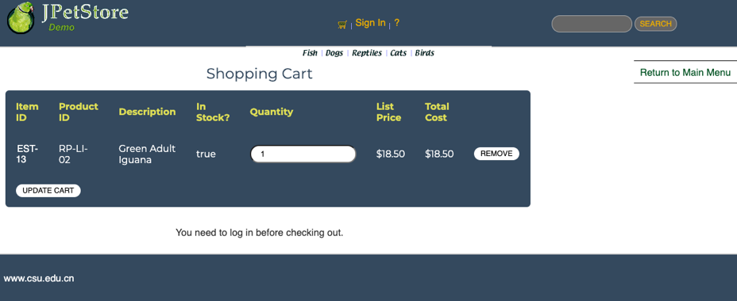
ⅱ. 购物车
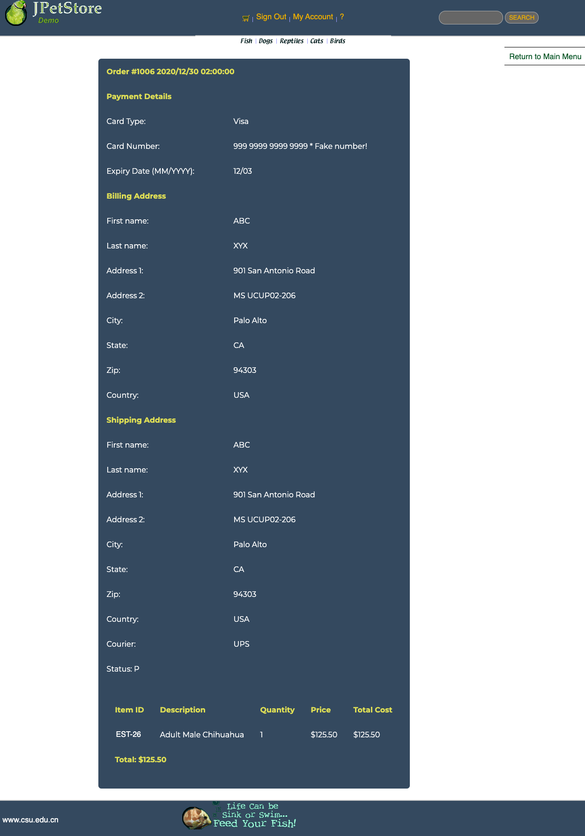
ⅲ. 订单页

(2) 具体实现

- 没有使用框架
ⅰ. 选取与整体相符的表格样式、按钮样式及字体
ⅱ. 对原网页的页头和页尾部分进行相应的调整，使得整体协调

(3) 核心代码
.rwd-table {
margin: 1em 0;
min-width: 300px;
}
.rwd-table tr {
border-top: 1px solid #ddd;
border-bottom: 1px solid #ddd;
}
.rwd-table th {
display: none;
}
.rwd-table td {
display: block;
}
.rwd-table td:first-child {
padding-top: .5em;
}
.rwd-table td:last-child {
padding-bottom: .5em;
}
.rwd-table td:before {
content: attr(data-th) ": ";
font-weight: bold;
width: 6.5em;
display: inline-block;
}
@media (min-width: 480px) {
.rwd-table td:before {
display: none;
}
}
.rwd-table th, .rwd-table td {
text-align: left;
}
@media (min-width: 480px) {
.rwd-table th, .rwd-table td {
display: table-cell;
padding: .25em .5em;
}
.rwd-table th:first-child, .rwd-table td:first-child {
padding-left: 0;
}
.rwd-table th:last-child, .rwd-table td:last-child {
padding-right: 0;
}
}
.rwd-table {
background: #34495E;
color: #fff;
border-radius: .4em;
overflow: hidden;
}
.rwd-table tr {
border-color: #46637f;
}
.rwd-table th, .rwd-table td {
margin: .5em 1em;
}
@media (min-width: 480px) {
.rwd-table th, .rwd-table td {
padding: 1em !important;
}
}
.rwd-table th, .rwd-table td:before {
color: #dd5;
}
a, a:visited, a:link {
color: #FFFFFF;
padding: 2px;
text-decoration: none;
font-family: helvetica, tahoma, arial, verdana, sans-serif;
}
.btn, .btn:visited, .btn:link {
border-radius: 15px;
border: 1px black;
background-color: #FFFFFF;
color: black;
cursor: pointer;
padding: .5ex 1.7ex;
text-transform: uppercase;
transition: all 0.1s ease-in-out;
font-size: 1.5ex;
text-decoration: none;
}
.btn:hover {
box-shadow: 0px 2px 15px 0px rgba(0,0,0,0.5);
transform: translateY(-3px);
}

- 小组成员分工及实验总结
- 小组分工：

小组只由一人组成，实验工作占比100%.
- 实验总结

1) 问题1：改变CSS文件之后重启服务器仍不生效，在Chrome的DevTools中查看元素，发现仍为修改之前的CSS样式表。

- 解决方法：清空浏览器缓存

2) 问题2：在AJAX获取服务器回传的信息之后，进行字符串的比对时，发现由于返回字符串后带着一个换行符而导致‘==’比较失败

(1) 原因：Servlet输出文本用的是println()方法，因此输出的单行信息中会带一个回车键。

(2) 解决方法：在比对之前，对返回字符串调用trim()方法，将造成干扰的换行符去除。

3) 问题3：将表单提交异步化之后，在JS中不知道如何获取网页中的数据

- 解决方法：对form表单的jQuery元素调用serialize()或serializeArray()方法，将表单内容转换为键值对，作为请求的一部分发送给服务器。

4) 总结

在本次实验中，我发现找到问题最快的方法是Chrome的开发工具。一开始在遇到问题2时，还不知道怎么使用Chrome的DevTools，找了很久也没有找到问题出在哪里，后来随着Chrome在我的认知中从一个单纯无邪的浏览器变成一个武艺精进的开发工具，找出问题的效率也就高了很多；并且发现在搜索问题时，搜索引擎之间的确是有高下之分，不同论坛的信息量也差距甚大，适当运用外网资源，能够更加高效地得到问题的答案。在本次实验中，我收获的不仅是Web应用开发方面的技术与技巧，也学到了许多解决问题的方法，同时增长了自我的开发经验，为接下来的学习生活打下更坚实的基础。经过本次实验后，当看到网页或者小程序中有什么新奇的、引人注目的功能时，时常会不由自主地思考这个功能是如何实现的，大致的业务流程是什么样子的，也就是对网页应用的感知更加敏锐了。虽然debug的时候有无穷焦躁与困扰，但总的来说，甜比苦多，也算是一桩实在的美事。

