Vibe Coding 图像颜色空间、图像插值

Prompt
- 实现RGB，HSV等颜色空间相关的实现，要求输入图像，可以输出不同颜色空间中每个通道的图像
- 在上述功能基础上，要求实现图像插值算法：最近邻、双线性插值（输入图像，选择图像操作：放大、缩小、旋转拉伸等，输出插值后的图像）
- 在test_image这张图像上实现上述两个要求
- 最后将上述功能做成一个网页，集成所有功能，并且提供可选择选项

核心代码
def rgb_to_hsv(rgb_image):
rgb = rgb_image.astype(np.float32) / 255.0
r, g, b = rgb[:, :, 0], rgb[:, :, 1], rgb[:, :, 2]

max_val = np.maximum(np.maximum(r, g), b)
min_val = np.minimum(np.minimum(r, g), b)
diff = max_val - min_val

h = np.zeros_like(max_val)
s = np.zeros_like(max_val)
v = max_val.copy()

s = np.where(max_val != 0, diff / max_val, 0)

mask_r = (max_val == r)
mask_g = (max_val == g) & ~mask_r
mask_b = (max_val == b) & ~mask_r & ~mask_g

safe_diff = np.where(diff == 0, 1, diff)
h[mask_r] = ((g[mask_r] - b[mask_r]) / safe_diff[mask_r]) % 6
h[mask_g] = (b[mask_g] - r[mask_g]) / safe_diff[mask_g] + 2
h[mask_b] = (r[mask_b] - g[mask_b]) / safe_diff[mask_b] + 4

h = h / 6.0
h = np.clip(h, 0, 1)

hsv = np.stack([h, s, v], axis=2)
return (hsv * 255).astype(np.uint8)
def nearest_neighbor_interpolate(image, new_width, new_height):
src_height, src_width = image.shape[:2]
result = np.zeros((new_height, new_width, 3), dtype=image.dtype)

scale_y = src_height / new_height
scale_x = src_width / new_width

for y in range(new_height):
for x in range(new_width):
src_y = int((y + 0.5) * scale_y - 0.5)
src_x = int((x + 0.5) * scale_x - 0.5)
src_y = np.clip(src_y, 0, src_height - 1)
src_x = np.clip(src_x, 0, src_width - 1)
result[y, x] = image[src_y, src_x]

return result

def bilinear_interpolate(image, new_width, new_height):
src_height, src_width = image.shape[:2]
result = np.zeros((new_height, new_width, 3), dtype=np.float32)

scale_y = (src_height - 1) / (new_height - 1) if new_height > 1 else 0
scale_x = (src_width - 1) / (new_width - 1) if new_width > 1 else 0

for y in range(new_height):
for x in range(new_width):
src_y = y * scale_y
src_x = x * scale_x

y0 = int(src_y)
x0 = int(src_x)
y1 = min(y0 + 1, src_height - 1)
x1 = min(x0 + 1, src_width - 1)

fy = src_y - y0
fx = src_x - x0

p00 = image[y0, x0].astype(np.float32)
p10 = image[y0, x1].astype(np.float32)
p01 = image[y1, x0].astype(np.float32)
p11 = image[y1, x1].astype(np.float32)

result[y, x] = (1 - fx) * (1 - fy) * p00 + \
fx * (1 - fy) * p10 + \
(1 - fx) * fy * p01 + \
fx * fy * p11

return result.astype(np.uint8)

def scale_image(image, scale_factor, method):
new_height = int(image.shape[0] * scale_factor)
new_width = int(image.shape[1] * scale_factor)

if method == "nearest":
return nearest_neighbor_interpolate(image, new_width, new_height)
else:
return bilinear_interpolate(image, new_width, new_height)

def resize_image(image, new_width, new_height, method):
if method == "nearest":
return nearest_neighbor_interpolate(image, new_width, new_height)
else:
return bilinear_interpolate(image, new_width, new_height)

def rotate_image(image, angle, method):
h, w = image.shape[:2]
center_y, center_x = h / 2, w / 2

angle_rad = np.radians(angle)
cos_a = np.cos(angle_rad)
sin_a = np.sin(angle_rad)

new_h = int(abs(-sin_a * w) + abs(cos_a * h)) + 2
new_w = int(abs(cos_a * w) + abs(-sin_a * h)) + 2

result = np.zeros((new_h, new_w, 3), dtype=np.uint8)
new_center_y, new_center_x = new_h / 2, new_w / 2

for y in range(new_h):
for x in range(new_w):
dx = x - new_center_x
dy = y - new_center_y

src_x = dx * cos_a + dy * sin_a + center_x
src_y = -dx * sin_a + dy * cos_a + center_y

src_x = np.clip(src_x, 0, w - 1)
src_y = np.clip(src_y, 0, h - 1)

if method == "nearest":
result[y, x] = image[int(src_y), int(src_x)]
else:
x0, y0 = int(src_x), int(src_y)
x1 = min(x0 + 1, w - 1)
y1 = min(y0 + 1, h - 1)

fx = src_x - x0
fy = src_y - y0

p00 = image[y0, x0].astype(np.float32)
p10 = image[y0, x1].astype(np.float32)
p01 = image[y1, x0].astype(np.float32)
p11 = image[y1, x1].astype(np.float32)

result[y, x] = ((1 - fx) * (1 - fy) * p00 +
fx * (1 - fy) * p10 +
(1 - fx) * fy * p01 +
fx * fy * p11).astype(np.uint8)

return result

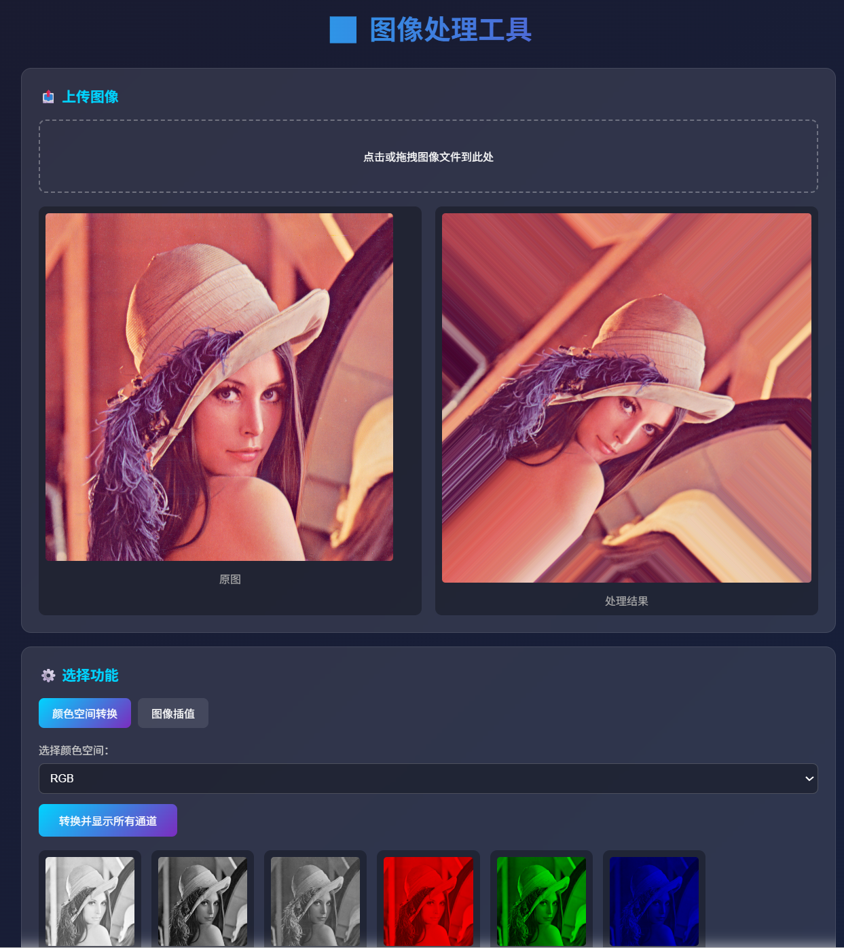
测试截图

作业小结
理解了颜色空间的本质：RGB 是面向硬件的加色模型，适用于显示设备；HSV 是面向人眼视觉的模型，更便于色彩的语义化分析（如通过 H 通道区分不同颜色、S 通道判断色彩鲜艳程度），掌握了不同颜色空间的适用场景。
掌握了插值算法的核心逻辑：插值的本质是通过已知像素值估算未知像素值，算法的精度与计算量呈正相关，需根据实际需求选择合适的插值方式。

