All the programs have a quite similar structure, and ‘cos_fa.mlx’ has a detailed annotation.

The OA experiment data is stored in ’cos_oa.mat’ and ‘plc_oa.mat’, the FA experiment data is stored in ‘cos_fa.mat’ and ‘plc_fa.mat’.

All these data file have a same form:

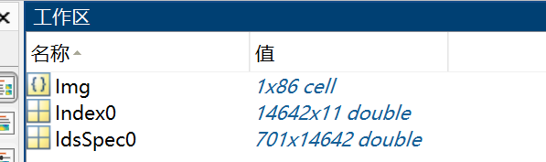

Img: the images of cells;

Index0: the position, size and other information of every LDs;

ldsSpec0: the spectrums of every LDs.

For Index0:

1: the No of LDs 2-3: the position of every LDs 4: the radius of LDs (not accurate)

5: the area of LDs 6: the mean intensity of LDs 7: the max in tensity of LDs

8: sometimes there are 2 or 3 cells in the view, so we need to choose one cell from them. the 0 means the LD is in the selected cell, 1 mean not and these LDs should be abandoned.

9: the treatment:

100: 0uM OA 101: 50uM OA 102: 100uM OA 103: 200uM OA 104: 300uM OA

200: control(0uM) 201: mix FA 202: 200uM AA 203: 200uM OA 204: 200uM PA

11: the No of cells;

