1. 下载nginx.tar.gz包

<https://nginx.org/en/download.html>

下载稳定版

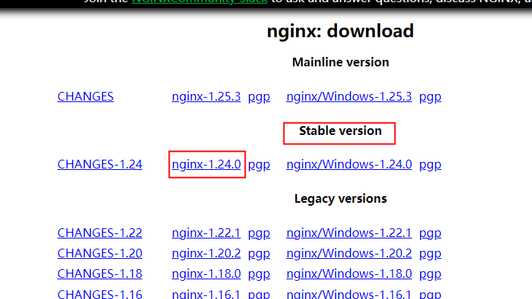

二、解压缩

tar -zxf nginx-1.24.0.tar.gz

三、指到解压缩后的目录

cd nginx-1.24.0

四、编译配置

执行以下命令：

./configure \

--prefix=/usr/local/nginx \

--pid-path=/var/run/nginx.pid \

--lock-path=/var/run/nginx.lock \

--http-client-body-temp-path=/usr/local/nginx/client_temp \

--http-proxy-temp-path=/usr/local/nginx/proxy_temp \

--http-fastcgi-temp-path=/usr/local/nginx/fastcgi_temp \

--http-uwsgi-temp-path=/usr/local/nginx/uwsgi_temp \

--http-scgi-temp-path=/usr/local/nginx/scgi_temp \

--user=nginx \

--group=nginx \

--with-mail \

--with-stream \

--with-threads \

--with-file-aio \

--with-poll_module \

--with-select_module \

--with-http_v2_module \

--with-http_flv_module \

--with-http_mp4_module \

--with-http_sub_module \

--with-http_dav_module \

--with-http_flv_module \

--with-http_ssl_module \

--with-http_geoip_module \

--with-http_slice_module \

--with-http_gunzip_module \

--with-http_realip_module \

--with-http_addition_module \

--with-http_gzip_static_module \

--with-http_random_index_module \

--with-http_secure_link_module \

--with-http_degradation_module \

--with-http_stub_status_module \

--with-mail_ssl_module \

--with-stream_ssl_module \

--with-stream_realip_module \

--with-stream_ssl_preread_module

五、编译安装

sudo make

sudo make install

1. 启动nginx

cd /usr/local/nginx/sbin

./nginx

若遇到缺少包的情况则需要安装对应安装包

七、常用命令

关闭nginx

./nginx -s quit 或者 ./nginx -s stop

重启nginx

./nginx -s reload

查看nginx进程

ps aux|grep nginx

若遇到libpng安装后不起作用

cd libpng-1.6.40

echo '/usr/local/libpng/lib' > /etc/ld.so.conf.d/libpng.conf

ldconfig

ldconfig -p| grep libpng