CLAIMCOURT
A Private Local AI Evidence Court
AMD AI DevMaster Hackathon 2026
Track 2 - Development & Local Deployment of Private AI Agents
Team Zi Fei Yu
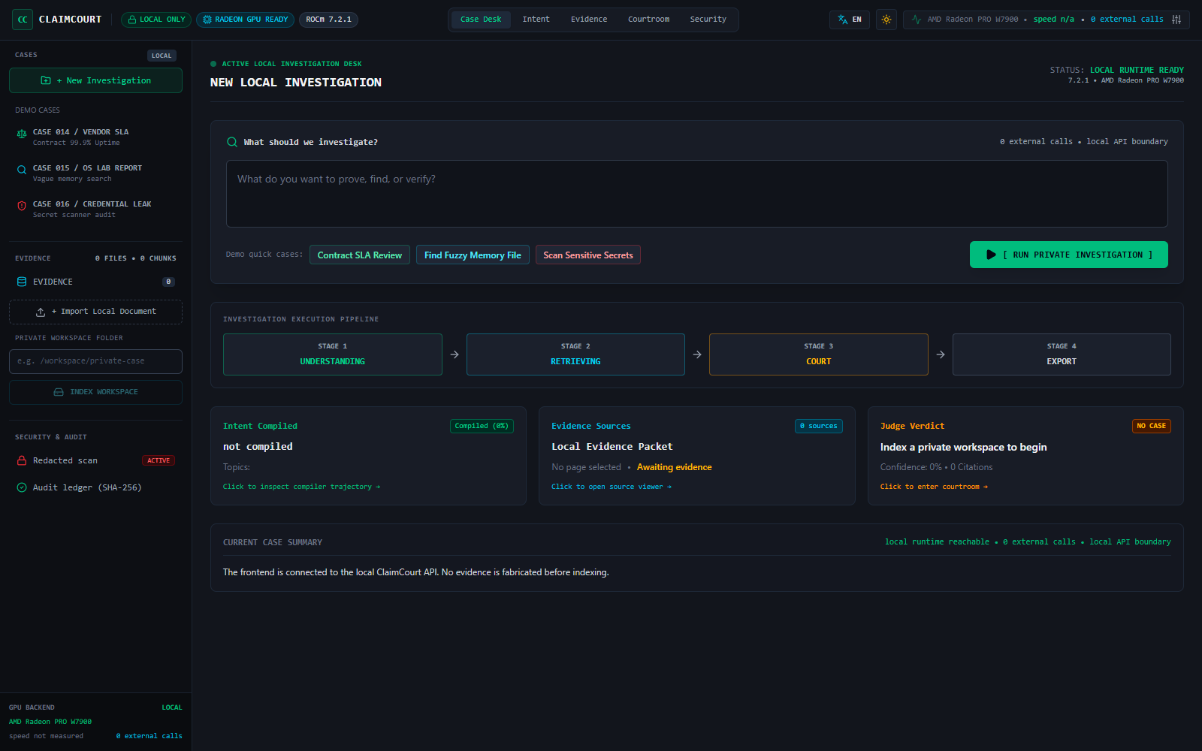
Private documents stay inside the selected deployment boundary. Evidence is retrieved, cited, challenged, and exported only after approval.

1. Executive Summary
ClaimCourt is a private, evidence-grounded local AI agent for people who remember the meaning of a record but not its filename, and for teams that must resolve disputed commitments across contracts, email, meeting notes, presentations, and internal reports.
Its Fuzzy Intent Compiler converts incomplete human recollections into a transparent structured search plan. Its Evidence Court then runs controlled prosecution, defense, and judge stages using one local instruction model. Every verdict is constrained to citations from the retrieved packet and includes contradictions, a timeline, missing evidence, and a recommended next action.
The verified competition stack runs on an AMD Radeon PRO W7900-class GPU with ROCm, Qwen3-14B BF16 through vLLM, a ClaimCourt intent LoRA, BAAI/bge-small-zh-v1.5, and a local BGE cross-encoder. No closed remote model API is required.

2. Application Scenarios

2.1 Disputed commitment review
A customer says sales promised 99.9% uptime. Procurement sees no SLA in the signed agreement. Engineering remembers a conditional Q4 target. ClaimCourt distinguishes marketing, drafts, signed obligations, exceptions, and missing records before producing a cited brief.

2.2 Fuzzy private file recovery
A user asks, "Find the presentation I wrote about the customer's delayed launch and Q4 risk." ClaimCourt compiles the recollection, groups draft and final versions, selects the authoritative file, and creates a cited summary from the complete artifact.

2.3 Redacted sensitive-record location
A deterministic local scanner locates credential-like records but returns only file location, category, fingerprint, and redacted preview. Raw secret values never enter the model, UI history, or exported report.

2.4 Approval reconstruction
ClaimCourt reconstructs who approved a change and under what conditions from dated meeting notes, approval logs, email, and change requests.

3. Agent Architecture
The three roles are controlled serial stages using one local model. This is auditable orchestration, not a claim of autonomous multi-model collaboration.
Stage | Local component | Output
1. Ingest | PDF, DOC, DOCX, PPTX, TXT, MD, EML and local OCR parsers | Parent-child chunks with page or slide locators
2. Remember | SHA-256 evidence ledger, durable SQLite FTS5 and version archive | Auditable local workspace memory
3. Understand | Qwen3-14B + ClaimCourt intent LoRA | Structured intent, constraints and clarification policy
4. Retrieve | BM25, FTS5, TF-IDF, BGE, metadata and file-family authority rules | Ranked evidence and authoritative files
5. Challenge | Prosecutor and defense calls | Supporting evidence, counter-evidence and exceptions
6. Decide | Judge call with citation allow-list | Verdict, confidence, contradictions, timeline and missing evidence
7. Act | Explicit permission gate | Local Markdown decision brief

3.1 Core Track 2 capabilities
- Local RAG with structure-aware chunks, durable indexes, embeddings and reranking.
- Tool routing for evidence court, file location, artifact summary and redacted secret scanning.
- Multi-step planning across understand, retrieve, prosecute, defend, judge and export.
- Persistent local memory for hashes, versions, query plans, feedback and diagnostics.
- Permission controls, loopback endpoints, citation validation and fail-closed privacy behavior.

4. Retrieval and Fuzzy Intent Innovation
ClaimCourt does not treat a vague sentence as an embedding query. The Fuzzy Intent Compiler extracts artifact types, topics, entities, dates, remembered relations, required roles, excluded roles, request mode, and clarification requirements. This plan is visible to the user and drives every retrieval layer.

4.1 Hybrid retrieval
- BM25 and SQLite FTS5 preserve exact terms, identifiers and Chinese short phrases.
- Word TF-IDF and character n-grams handle partial filenames and spelling variation.
- BGE embeddings recover semantic similarity and cross-language concepts.
- Metadata and filename evidence enforce artifact, time and path constraints.
- A local cross-encoder reranks only a bounded shortlist.
- File-family authority rules keep Final or Signed above Draft unless Draft is explicitly requested.

4.2 Safety against confident retrieval mistakes
Ranking is not treated as a verdict. ClaimCourt calibrates score and margin, asks for clarification on ambiguous requests, returns no-match for unsupported year or role constraints, and records local owner feedback without exporting private query text into public training data.

5. Privacy, Permissions and Audit
Threat | Control
Document text sent to a public model | Only loopback endpoints are accepted unless the owner explicitly allow-lists a private host.
Secret exposed in an answer | Deterministic redaction runs before model, UI, history and export paths.
Model invents a citation | Only citation IDs from the retrieved packet are allowed; unknown IDs are removed and logged.
Report written without consent | Export is disabled until the user approves the local write.
Model failure hidden by a demo answer | Real workspaces fail closed; deterministic fallback is limited to the labeled synthetic demo.
Stale or changed evidence | SHA-256 source and evidence hashes plus version history expose changes.

5.1 Honest scope
ClaimCourt is a private alpha and not legal advice. The public benchmark is synthetic. Encryption at rest, authenticated multi-user isolation, and long-term owner dogfood remain post-hackathon production gates.

6. Model and Radeon Deployment
Layer | Verified component
GPU | AMD Radeon PRO W7900 class, gfx1100, 51.52 GB VRAM
Runtime | ROCm + vLLM, OpenAI-compatible loopback endpoints
Judge | Qwen3-14B BF16
Intent specialization | ClaimCourt LoRA trained on synthetic query-to-intent plans
Embedding | BAAI/bge-small-zh-v1.5, 512 dimensions, vLLM pooling runner
Reranker | Local bge-reranker-base cross-encoder
Interface | React/Vite frontend with a local Python API

6.1 Startup
cd /workspace/claimcourt
python -m pip install -r requirements-radeon.txt
bash scripts/start_radeon_stack.sh

6.2 Radeon optimization
- One shared Qwen3-14B service is reused by prosecution, defense and judge.
- BF16 fits the verified W7900 stack while preserving model quality.
- Judge VRAM allocation is 0.82 and embedding allocation is 0.10; observed peak stack usage was approximately 45.3 GB of 51.52 GB.
- Thinking is disabled for schema calls to reduce output overhead and protect JSON contracts.
- The judge receives a bounded 8,192-token evidence packet instead of the complete workspace.
- The cross-encoder reranks only a shortlist; router concurrency 8 saturated the GPU during live evaluation.

7. Measured Results

7.1 Live Radeon court gate
Metric | Measured result
First-token latency | 0.27 s
Generation throughput | 14.3 tokens/s
Completion tokens | 1,778
Complete three-role latency | 126.44 s
Court mode | local vLLM
Expected verdict | insufficient_evidence

7.2 Frozen live fuzzy-intent holdout
Metric | Result
Queries | 320
Overall pass rate | 100%
Intent contract accuracy | 100%
Single-target Top-1 | 100%
Multi-target full coverage | 100%
No-match and clarification accuracy | 100%
Unsafe wrong auto-selections | 0
Live Router, embedding and reranker | all passed
The frozen holdout is an engineering regression gate built from synthetic data. It does not claim universal retrieval quality. Private directory evaluation remains outside the public repository and only sanitized aggregate metrics are published.

8. Demo and Repository Verification

8.1 Four-minute demo
- Show rocminfo, rocm-smi, local vLLM endpoints and zero-external-call runtime evidence.
- Load the synthetic multi-file SLA workspace and ask whether 99.9% uptime was contractually committed.
- Inspect the intent plan, evidence packet, prosecution, defense, cited verdict and timeline.
- Approve the local export and show that no report is written before consent.
- Close with measured latency, throughput, VRAM and 320/320 live holdout evidence.

8.2 Verification commands
python -m unittest discover -s tests -t .
python scripts/championship_check.py --output championship_results.local.json
python scripts/adversarial_holdout_check.py
CLAIMCOURT_RERANKER_MODEL=/workspace/models/bge-reranker-base bash scripts/run_radeon_holdout.sh
Current release status: 78 Python tests passed, frontend TypeScript lint passed, frontend production build passed, and both Radeon live acceptance gates passed.

