Poznan University of Technology

Faculty of Computing and Telecommunications

Simulation Techniques

Project

Task 1

Mohammed ZITANI | 154705

1. Simulation Model Scheme

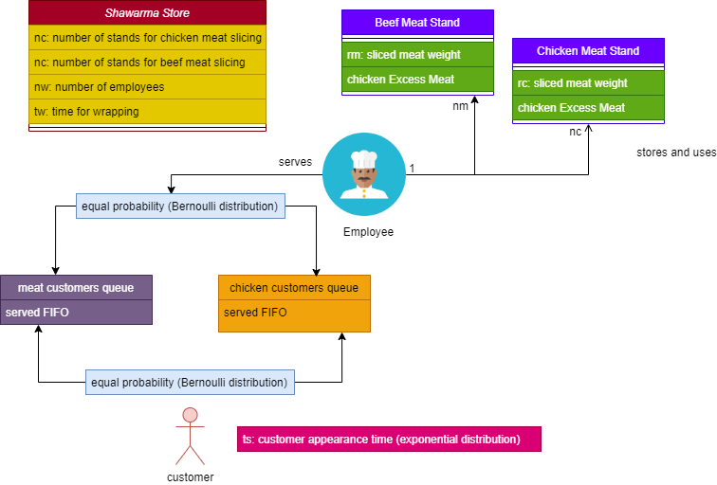

1. Objects Description

|  |  |  |  |
| --- | --- | --- | --- |
| Object | Class name | Attributes | types | Description |
| Shawarma Store | ShawarmaStore | numberOfChickenStands int  numberOfBeefStands int  numberOfEmployees int  wrappingTime int  averageWaitingTime int  averageStorageTime int  averageFreeTime int | Instance to introduce input parameters and create the initial state of the simulation and store output parameters |
| Customer | Customer | customerId int  arrival_time int  serviced_time int | Instance to manage the customers attributes |
| Employee | Employee | employeeId int  isFree bool  freeTime int | Instance to manage the employees attributes |
| MeatStand | MeatStand | meatStandId int  slicedMeatQuantity int  isChicken bool  currentQuantity int  storageTime int | Instance to manage the meat stands attributes |

3. Event Description

* Time Events

- Meat Slicing (each T)

- Customer appearance (each ts: exponential distribution)

- Free Employee (start service+tw: wrapping time)

* Conditional Events
* Begin of Service (if customer queue is not empty)

- Employee Serving choice (to serve either chicken or meat queue)

- Enough meat on the queue to make a wrap

* Begin of Meat Slicing

- Checking the Meat queue (Excess Meat) before slicing.

4. Processes Description

* Customer Process

- Start: Customer arrives

- waits until: Customer starts service

- End: Customer completion

* Meat Slicing Process

- Start: Each period T.

- waits if storedMeatQuantity==max (N)

- End: End of Simulation

* Block Diagram

