
9/1/2025

TemperatureConverterFX
Java-fx

Aptech
Computer Education

Project Reported By
A-1 Uniform Teem

A-1 Uniform | Project Title
Student1554201 AKRAM AMEEN SAIF ANAM  Student1554427 ZEYAD RAGEH AHMED AL-SHAWESH  student 1554359 ANAS AHMED MOHAMMED QASEM  Student1556125 EBRAHIM AHMED ALI HEZAM  AL-MOQBELI | Members Name
SEM-2 | Semester
ACE – SANA'A | Center Name

Acknowledgements

In successfully completing this project, many friends have worked together to accomplish this project. Primarily, we would like to thank Allah for helping us completing this project with success.We must also show great and special thanks to Al-Nasser University’s staff members for their immense support and help during this project. Without their help, completing this project would have been very difficult.

Executive Summary
TemperatureConverterFX is a JavaFX desktop application that converts temperatures between Celsius and Fahrenheit. The project demonstrates a clean separation of concerns: a responsive FXML-based UI, a controller for interaction logic, and a pure computation utility module. The build uses Maven with JavaFX 21 on JDK 17. A jlink profile is provided to produce a runnable runtime image.

Project Analysis

Objective: provide a minimal, reliable, bilingual-ready converter with input validation and clear error messages.
Scope: a single-screen UI with modern styling, result formatting, and unit tests for conversion routines.
Constraints: no external database or network; portability across Windows, macOS, and Linux via Maven profiles.
Risks: local JavaFX dependency resolution; mitigated by using org.openjfx Maven artifacts and providing jlink profiles.

Design

Architecture
Pattern: MVC-lite. The view is defined in FXML; the controller handles UI events and validation; the utility class provides pure functions.

Modules

- MainApp: JavaFX entry point and stage setup.
- ConverterController: UI logic, event handling, validation, result rendering.
- TemperatureConverter: pure static methods for C↔F.
- resources: FXML layout, stylesheet, and images.

UI/UX

The interface centers a card that scales within a wide window. The theme uses a dark gradient background, rounded controls, and hover focus states. The form is vertical for readability on small widths, while the overall window is landscape and resizable.

Data Flow Diagrams (DFDs)

Level-0 DFD: User enters temperature → Controller validates input → Converter computes result → UI displays formatted result.
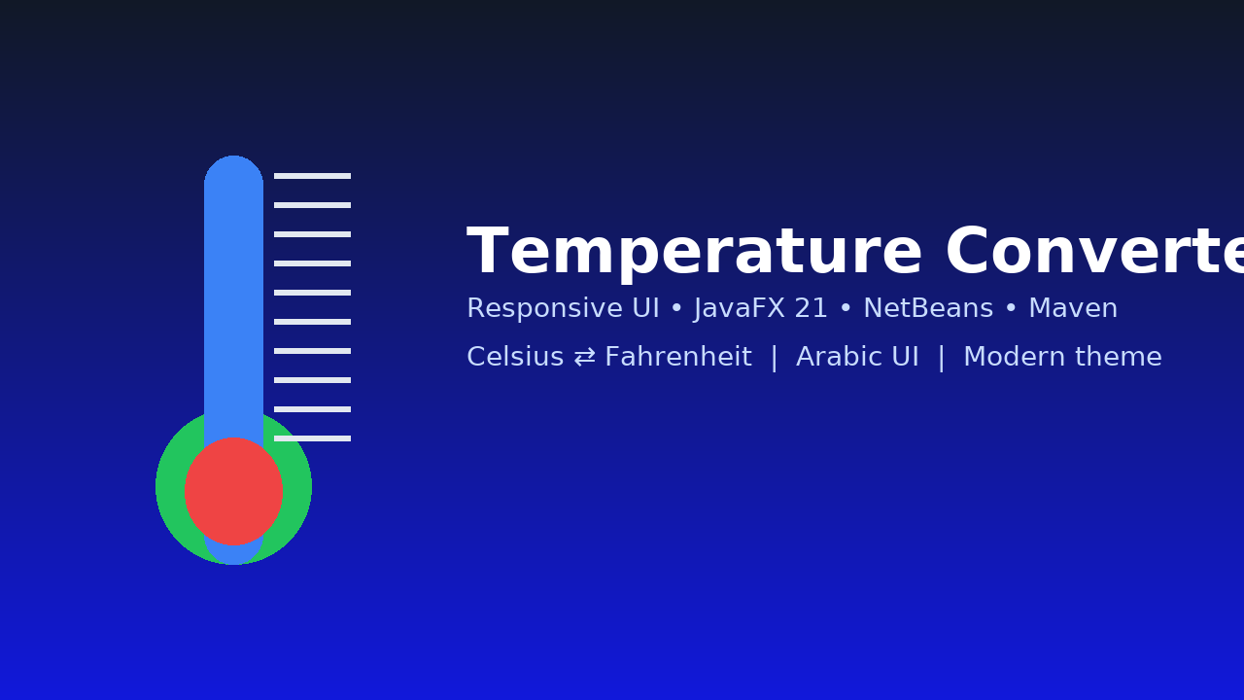

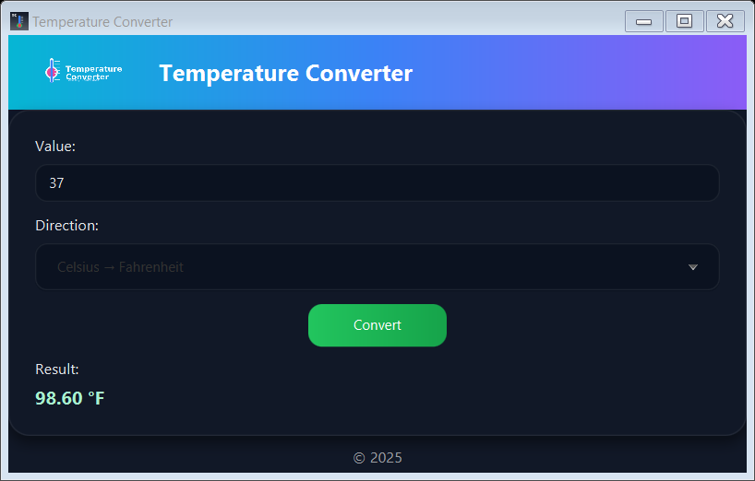

Flowcharts

Conversion flow: Start → Read input → Is numeric? → If no, show error → If yes, read direction → Compute → Format → Display → End.

Process Diagrams

Process map: Input Handling → Conversion Core → Output Rendering. Each step is isolated for testability and maintainability.

Database Design / Structure

No database is required for the current scope. If extended with history, a simple schema suffices:
- table: conversions(id PK, input_value DOUBLE, direction ENUM('CtoF','FtoC'), output_value DOUBLE, created_at TIMESTAMP).

Screenshots

Representative UI asset:


Source Code with Comment

Complete source is included in the attached project folder. Example excerpt from MainApp.java:
public class MainApp extends Application {
@Override
public void start(Stage stage) throws Exception {
FXMLLoader loader = new FXMLLoader(getClass().getResource("converter-view.fxml"));
Parent root = loader.load();
Scene scene = new Scene(root, 640, 380);
scene.getStylesheets().add(getClass().getResource("styles.css").toExternalForm());
stage.setTitle("Temperature Converter — JavaFX");
stage.getIcons().add(new Image(getClass().getResourceAsStream("app-icon.png")));
stage.setMinWidth(560);
stage.setMinHeight(380);
stage.setResizable(true);
stage.setScene(scene);
stage.show();
}
}

User Guide
Prerequisites: JDK 17 and Maven installed. On Windows with NetBeans 23, open the project and press Run.

Run via Maven
In a terminal from the project root:
1) mvn clean javafx:run
2) Enter a number, choose direction, click Convert.
3) The result appears with two decimals.

Build a Runtime Image (no separate JRE required)
Windows: run build-win.bat, then launch the executable from target/jlink/TemperatureConverterFX/bin/TemperatureConverterFX.

Controls
- Value: numeric input
- Direction: Celsius → Fahrenheit or Fahrenheit → Celsius
- Convert: performs the conversion
- Result: read-only formatted output

Developer Guide

Project Structure
src/main/java/com/example/tempconverter: MainApp and packages controllers/, util/
src/main/resources/com/example/tempconverter: FXML, CSS, images
src/test/java: JUnit tests

Build
Use JDK 17. JavaFX version 21.0.2 is defined in pom.xml. Profiles set javafx.platform by OS for jlink.

Tests
Run: mvn -q -Dtest=TemperatureConverterTest test

Extensibility
Add Kelvin conversions by extending TemperatureConverter and updating the ComboBox items and controller logic.

Module Descriptions
- com.example.tempconverter.MainApp: bootstraps JavaFX stage and loads FXML and CSS.
- com.example.tempconverter.controllers.ConverterController: handles events, validation, and formatting.
- com.example.tempconverter.util.TemperatureConverter: deterministic static conversion methods.
- resources: converter-view.fxml, styles.css, thermo-banner.png, app-icon.png.

