TemperatureConverterFX — Project e-Report
Version 1.0.0
Date: 26 September 2025

Acknowledgements
I acknowledge the guidance of the course instructor and the feedback from peers during implementation and testing.

Executive Summary
TemperatureConverterFX is a JavaFX desktop application that converts temperatures between Celsius and Fahrenheit. The project demonstrates a clean separation of concerns: a responsive FXML-based UI, a controller for interaction logic, and a pure computation utility module. The build uses Maven with JavaFX 21 on JDK 17. A jlink profile is provided to produce a runnable runtime image.

Project Analysis
Objective: provide a minimal, reliable, bilingual-ready converter with input validation and clear error messages.
Scope: a single-screen UI with modern styling, result formatting, and unit tests for conversion routines.
Constraints: no external database or network; portability across Windows, macOS, and Linux via Maven profiles.
Risks: local JavaFX dependency resolution; mitigated by using org.openjfx Maven artifacts and providing jlink profiles.

Design

Architecture
Pattern: MVC-lite. The view is defined in FXML; the controller handles UI events and validation; the utility class provides pure functions.

Modules
- MainApp: JavaFX entry point and stage setup.
- ConverterController: UI logic, event handling, validation, result rendering.
- TemperatureConverter: pure static methods for C↔F.
- resources: FXML layout, stylesheet, and images.

UI/UX
The interface centers a card that scales within a wide window. The theme uses a dark gradient background, rounded controls, and hover focus states. The form is vertical for readability on small widths, while the overall window is landscape and resizable.

Data Flow Diagrams (DFDs)
Level-0 DFD: User enters temperature → Controller validates input → Converter computes result → UI displays formatted result.
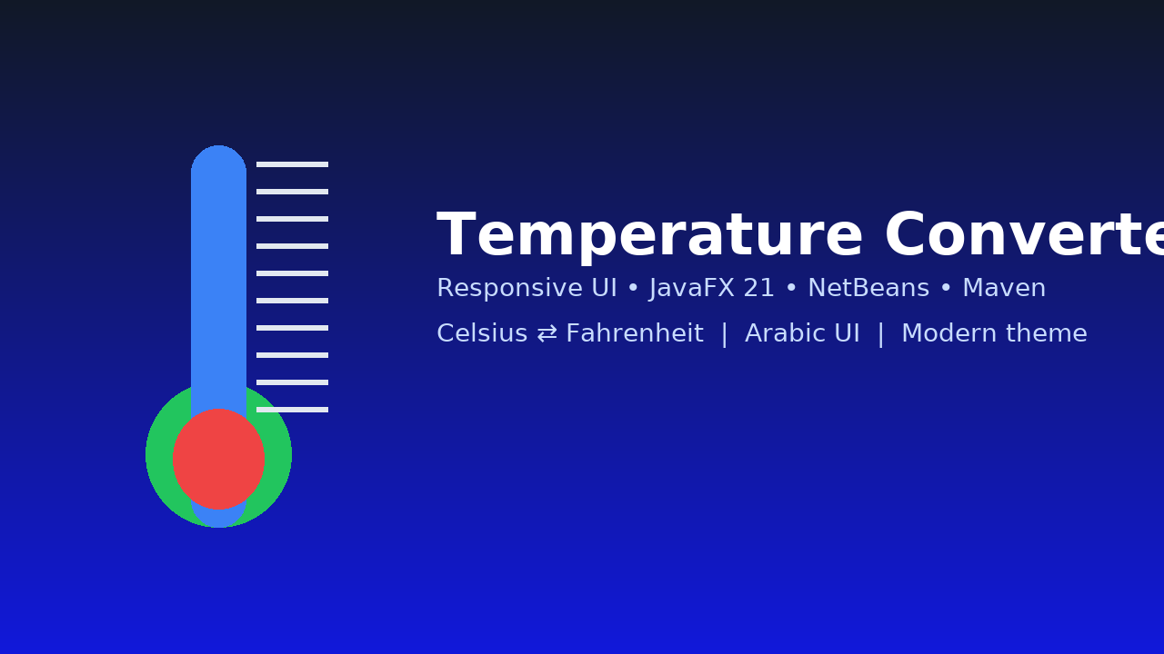

Flowcharts
Conversion flow: Start → Read input → Is numeric? → If no, show error → If yes, read direction → Compute → Format → Display → End.

Process Diagrams
Process map: Input Handling → Conversion Core → Output Rendering. Each step is isolated for testability and maintainability.

Database Design / Structure
No database is required for the current scope. If extended with history, a simple schema suffices:
- table: conversions(id PK, input_value DOUBLE, direction ENUM('CtoF','FtoC'), output_value DOUBLE, created_at TIMESTAMP).

Screenshots
Representative UI asset:


Source Code with Comments
Complete source is included in the attached project folder. Example excerpt from MainApp.java:
public class MainApp extends Application {
@Override
public void start(Stage stage) throws Exception {
FXMLLoader loader = new FXMLLoader(getClass().getResource("converter-view.fxml"));
Parent root = loader.load();
Scene scene = new Scene(root, 640, 380);
scene.getStylesheets().add(getClass().getResource("styles.css").toExternalForm());
stage.setTitle("Temperature Converter — JavaFX");
stage.getIcons().add(new Image(getClass().getResourceAsStream("app-icon.png")));
stage.setMinWidth(560);
stage.setMinHeight(380);
stage.setResizable(true);
stage.setScene(scene);
stage.show();
}
}

User Guide
Prerequisites: JDK 17 and Maven installed. On Windows with NetBeans 23, open the project and press Run.

Run via Maven
In a terminal from the project root:
1) mvn clean javafx:run
2) Enter a number, choose direction, click Convert.
3) The result appears with two decimals.

Build a Runtime Image (no separate JRE required)
Windows: run build-win.bat, then launch the executable from target/jlink/TemperatureConverterFX/bin/TemperatureConverterFX.

Controls
- Value: numeric input
- Direction: Celsius → Fahrenheit or Fahrenheit → Celsius
- Convert: performs the conversion
- Result: read-only formatted output

Developer Guide

Project Structure
src/main/java/com/example/tempconverter: MainApp and packages controllers/, util/
src/main/resources/com/example/tempconverter: FXML, CSS, images
src/test/java: JUnit tests

Build
Use JDK 17. JavaFX version 21.0.2 is defined in pom.xml. Profiles set javafx.platform by OS for jlink.

Tests
Run: mvn -q -Dtest=TemperatureConverterTest test

Extensibility
Add Kelvin conversions by extending TemperatureConverter and updating the ComboBox items and controller logic.

Module Descriptions
- com.example.tempconverter.MainApp: bootstraps JavaFX stage and loads FXML and CSS.
- com.example.tempconverter.controllers.ConverterController: handles events, validation, and formatting.
- com.example.tempconverter.util.TemperatureConverter: deterministic static conversion methods.
- resources: converter-view.fxml, styles.css, thermo-banner.png, app-icon.png.

Demo Video (How-To)
Record a short screen-capture showing: launching the app, entering 37, converting to Fahrenheit, switching direction and converting 98.6. On Windows press Win+Alt+R (Xbox Game Bar) or use OBS Studio. Save as MP4 and include it with the submission.

