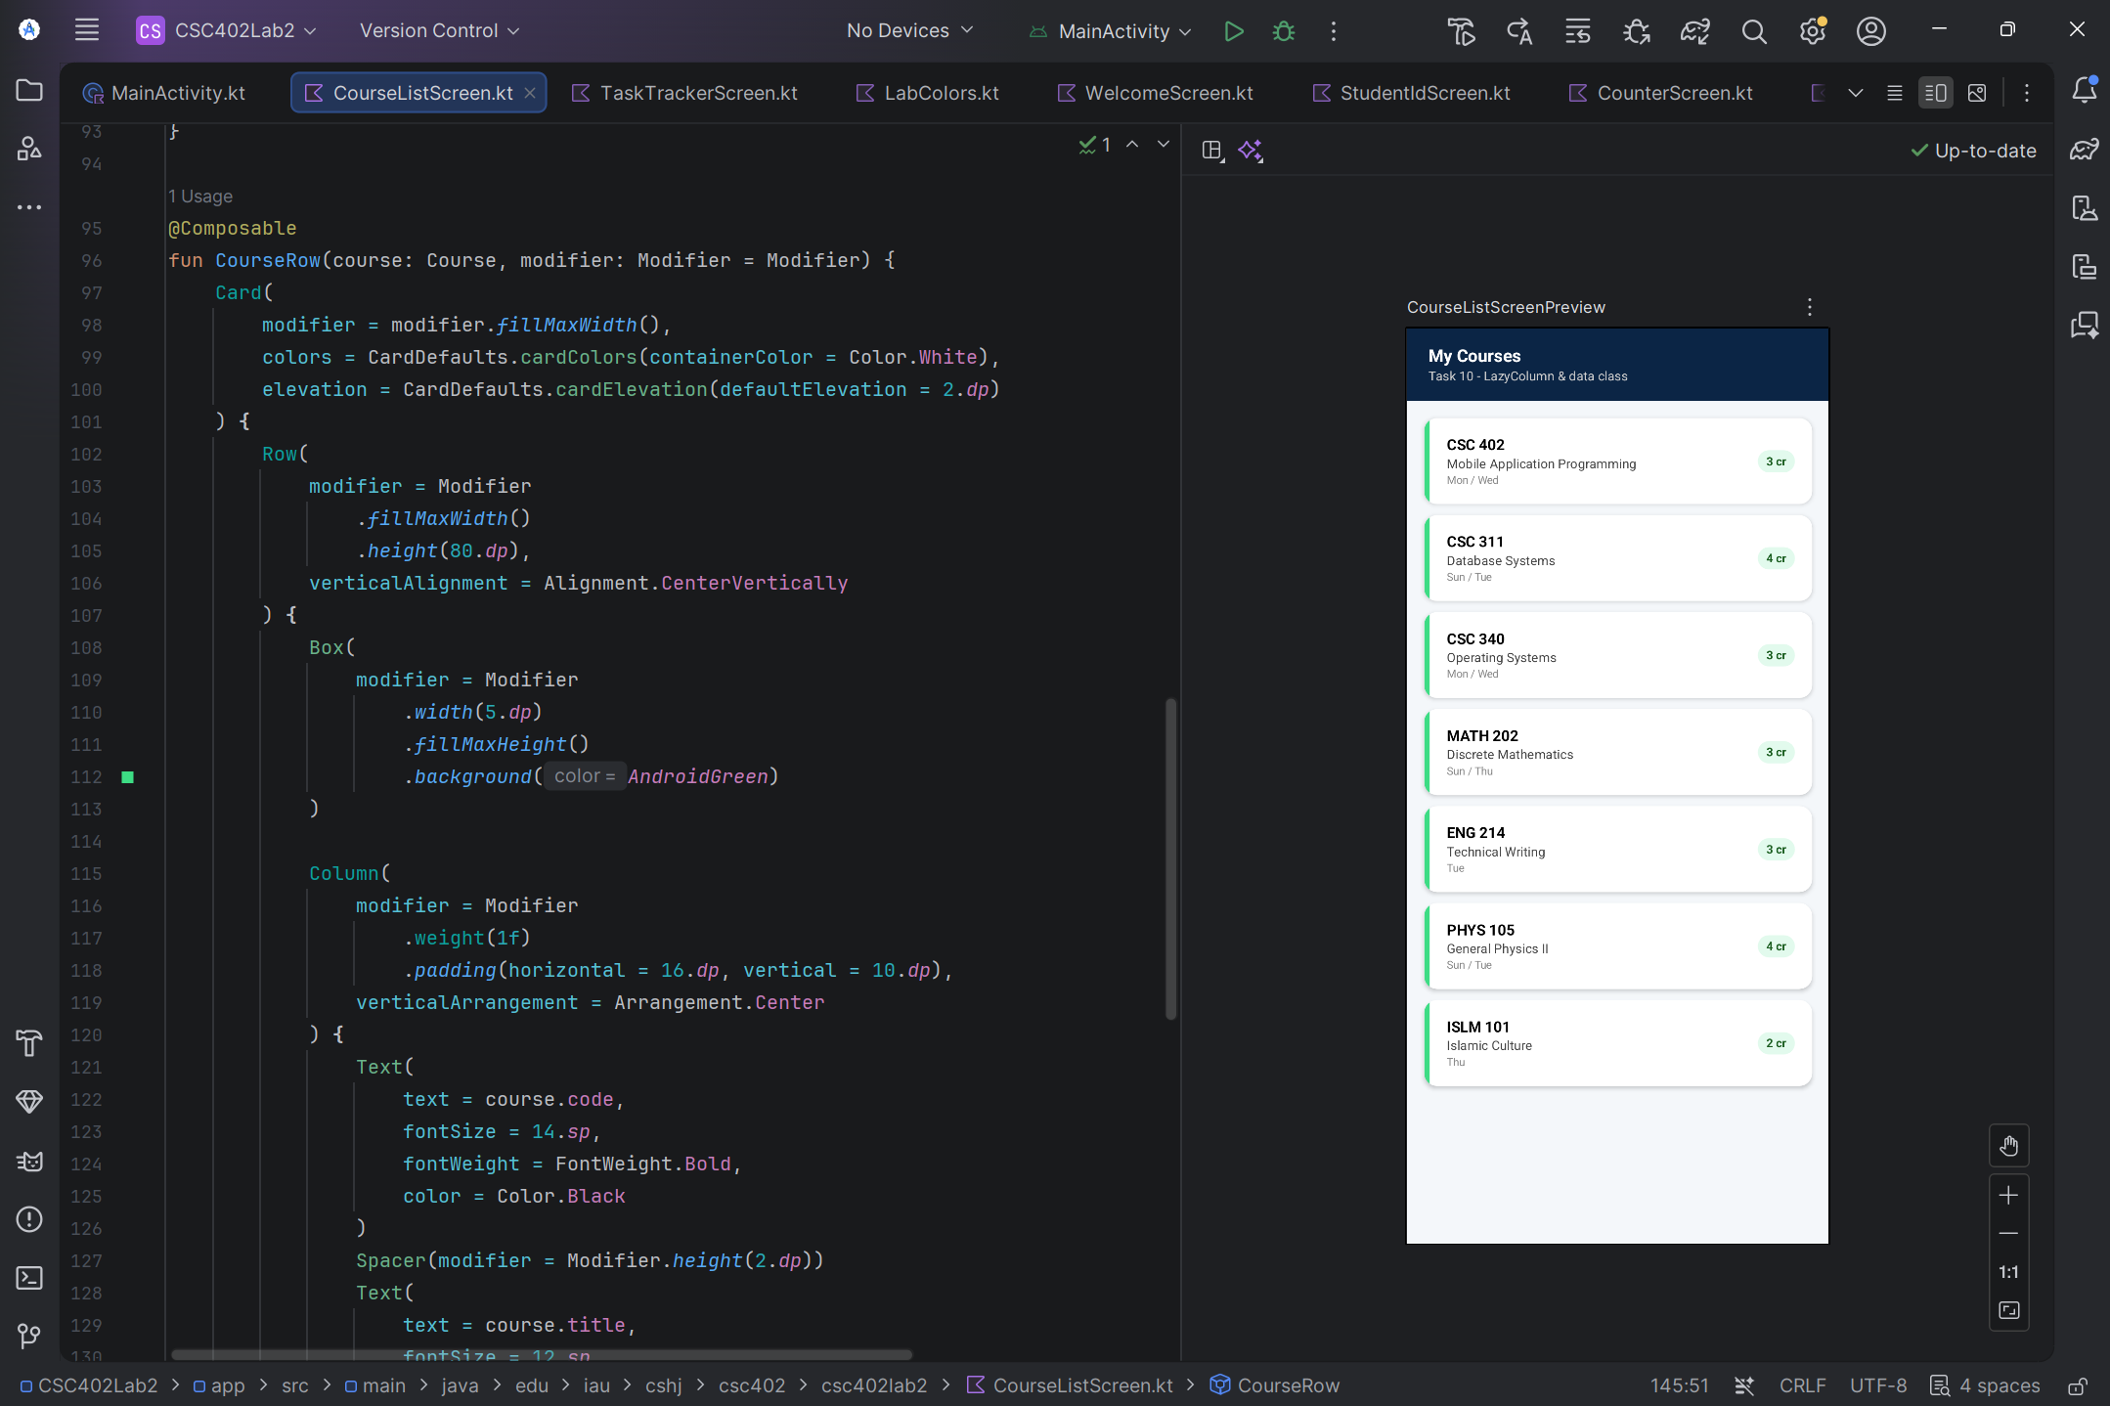
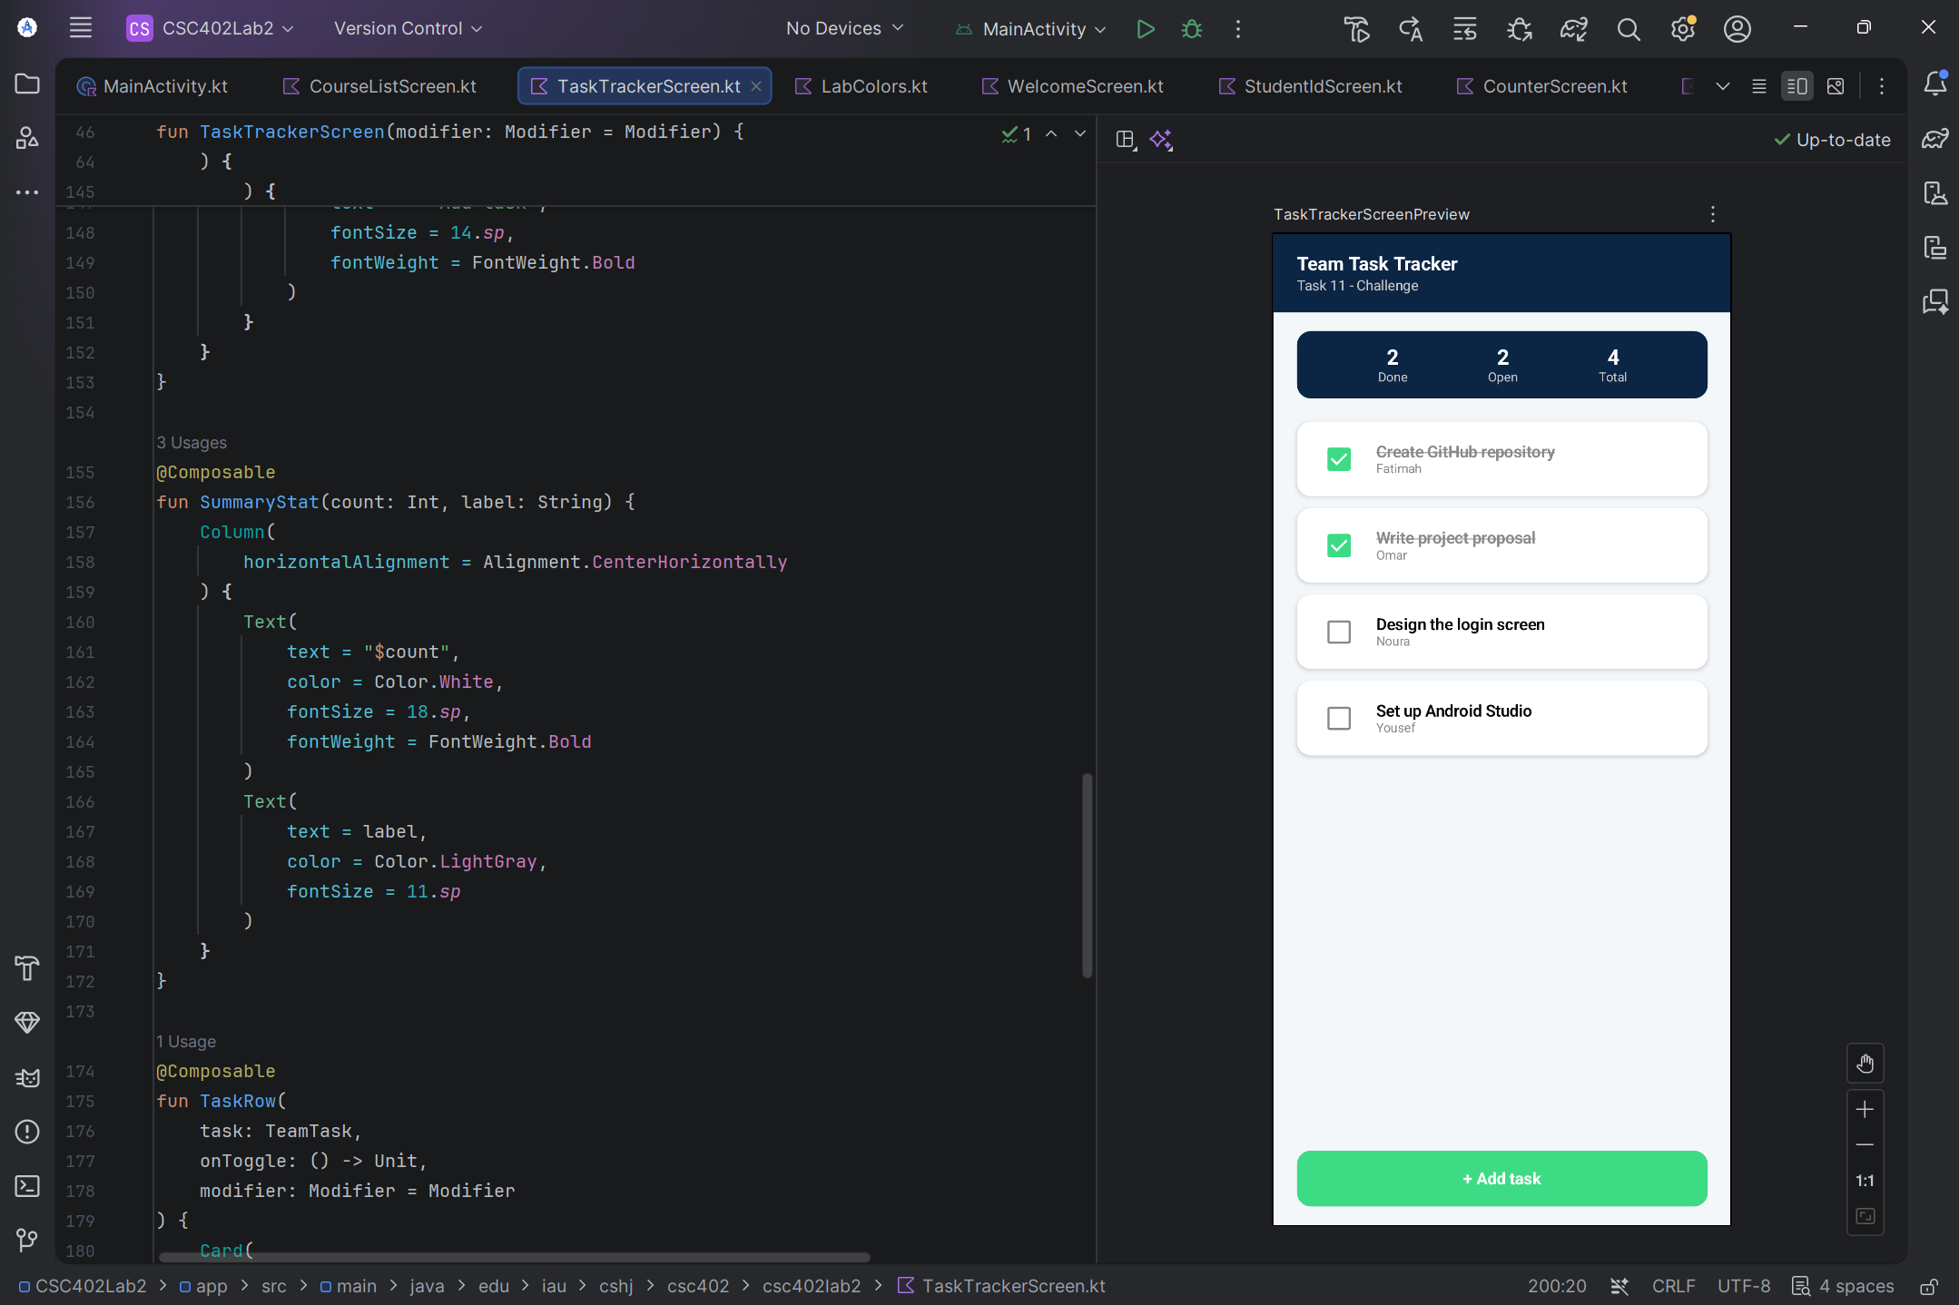
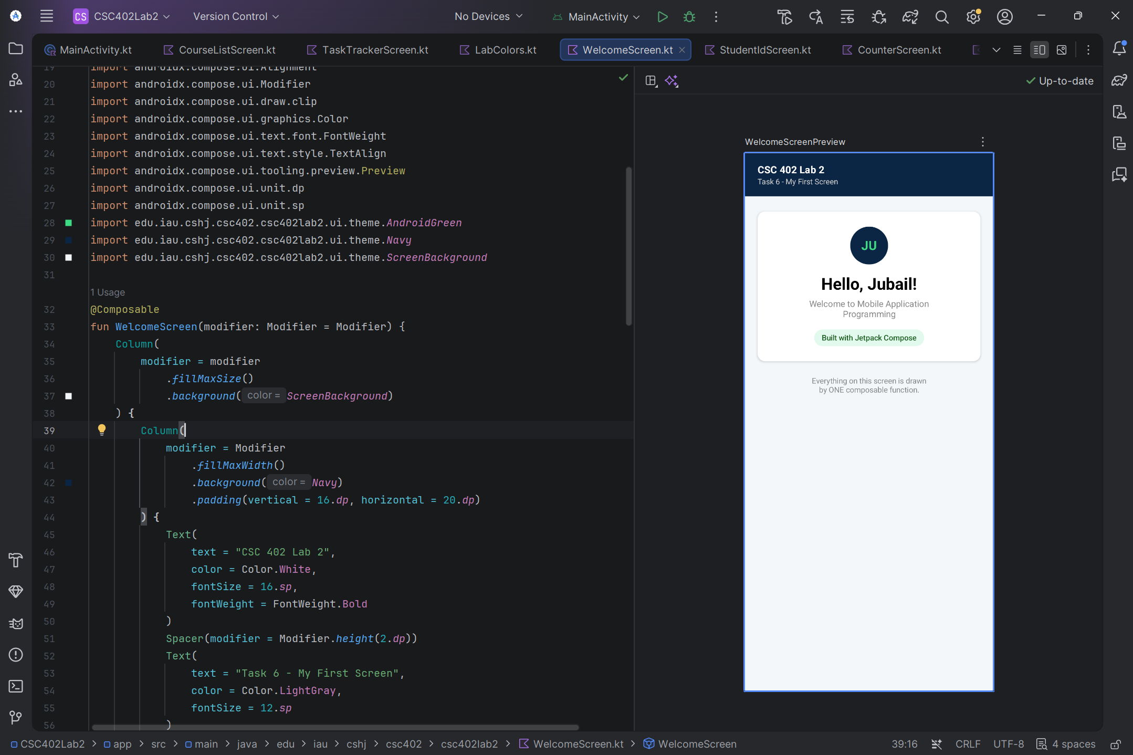
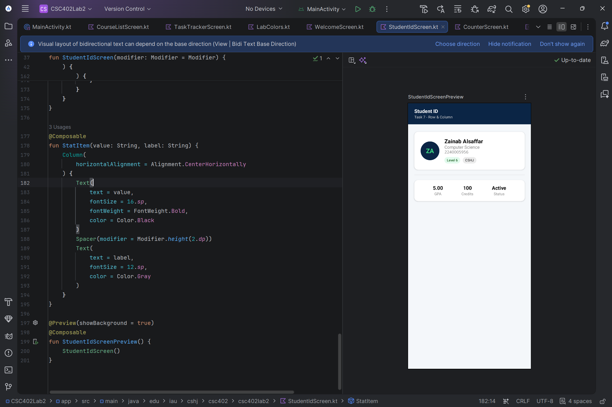
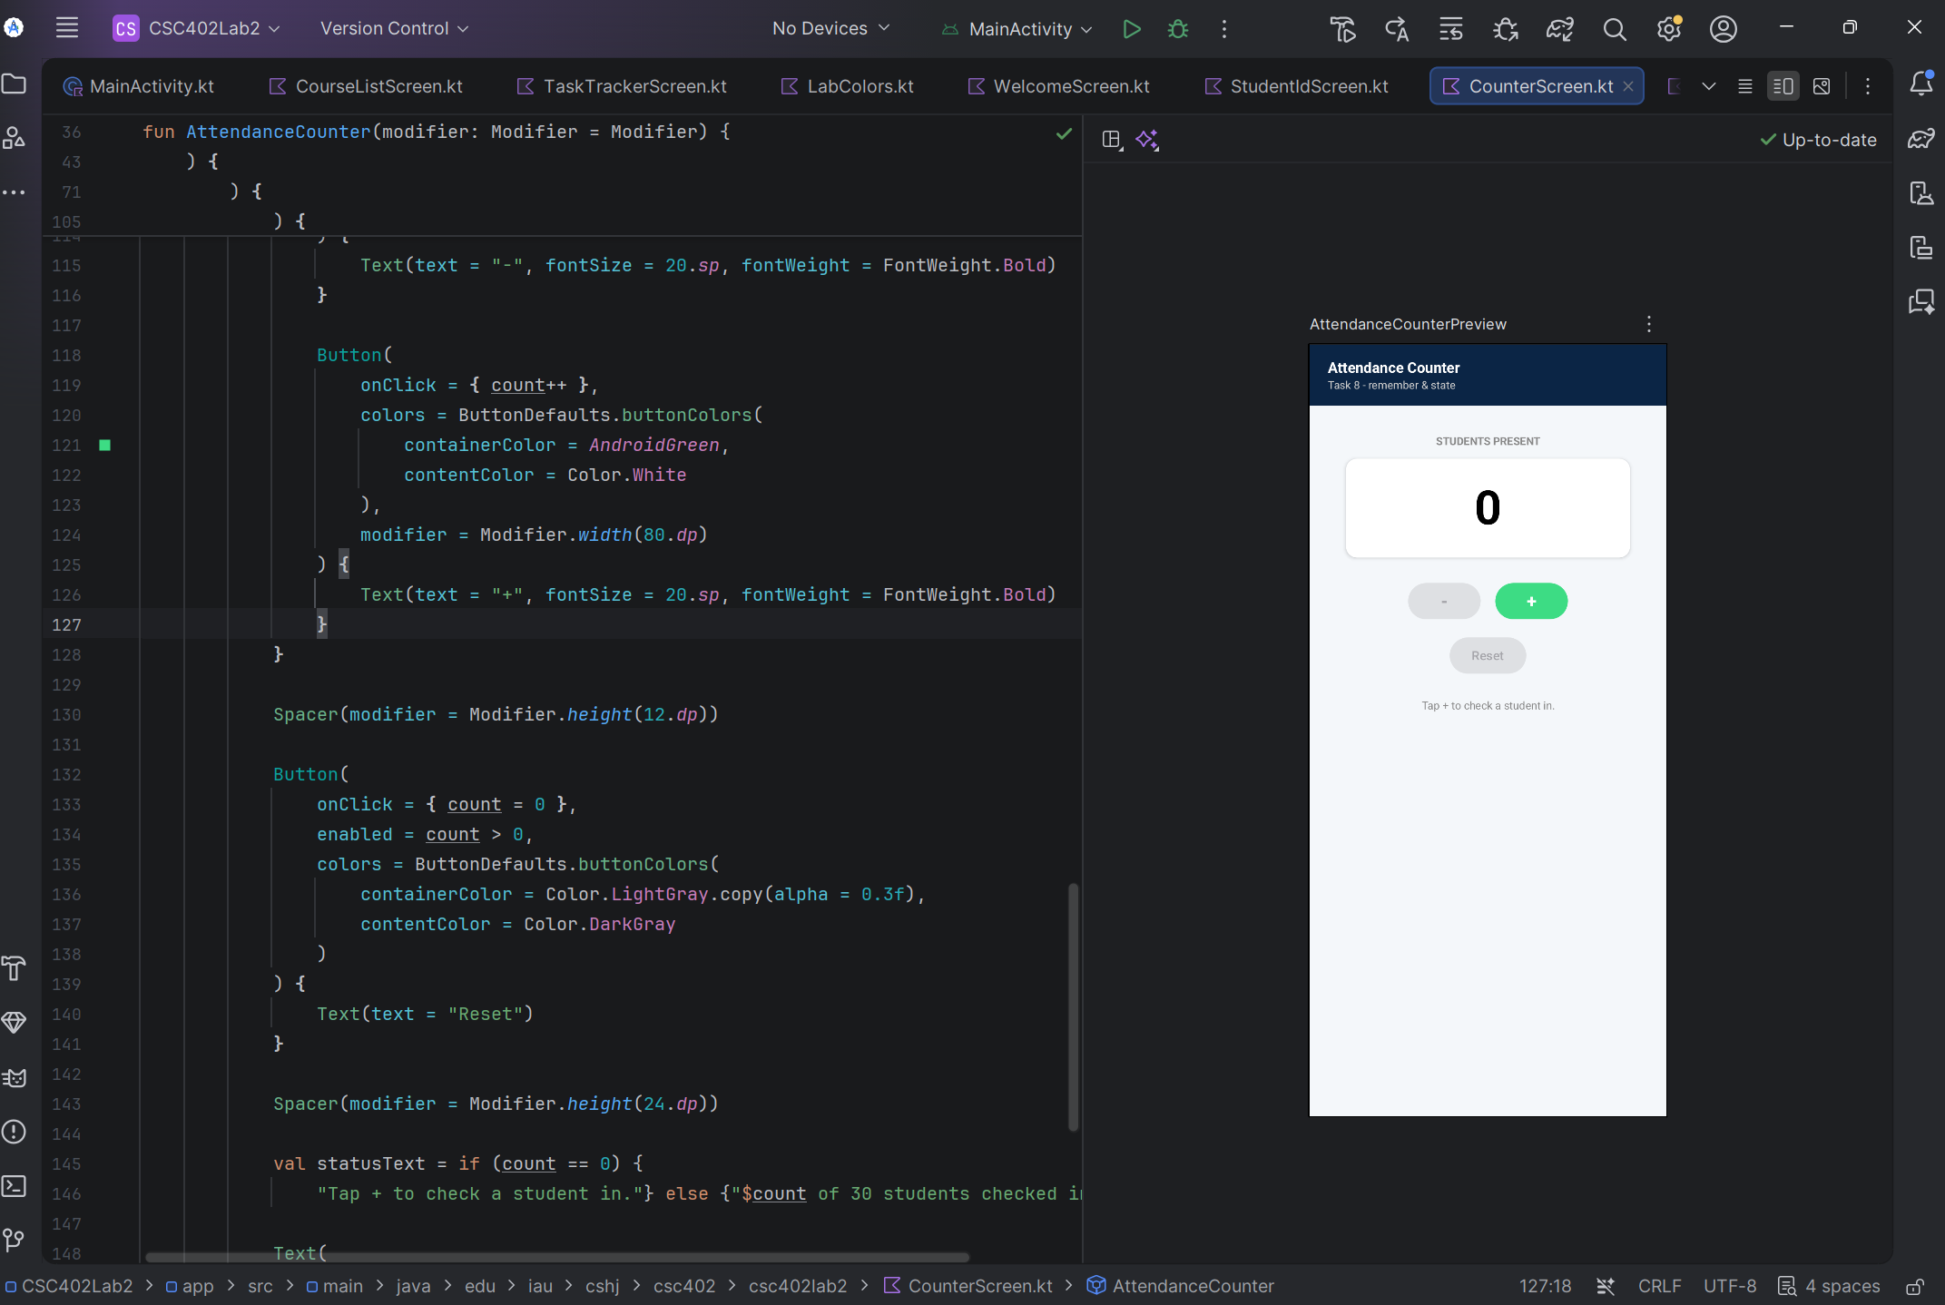
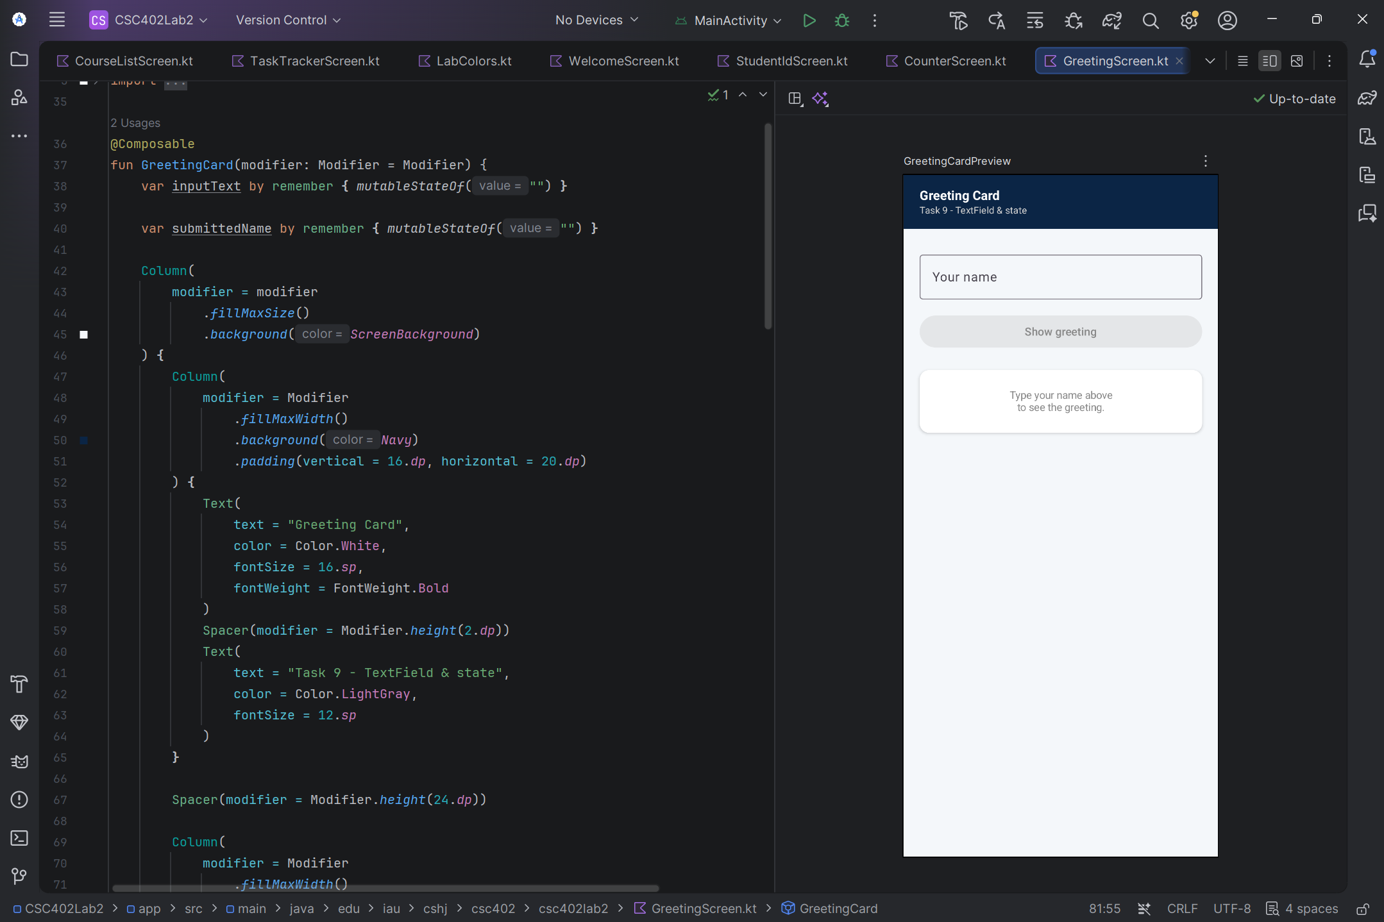
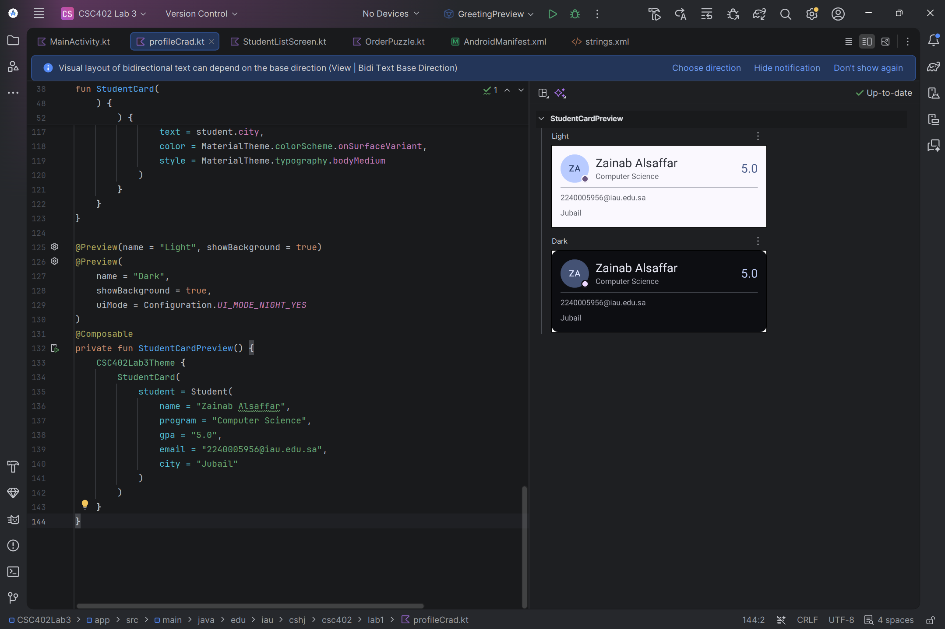
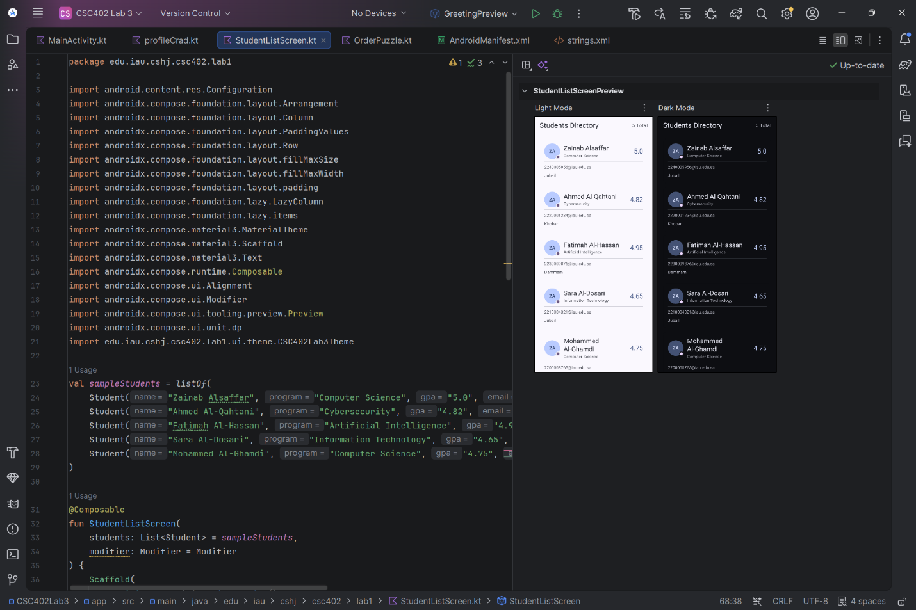

Q1: Why is passing a modifier parameter to custom composables important?
Passing a modifier parameter makes custom composables flexible and reusable across different screens. It allows parent layouts to adjust styling attributes such as padding, size, or alignment without modifying the internal code of the composable.
Q2: Why did we use a Box inside the GPA section?
Because it allows overlapping elements on top of each other(its function). This made it easy to apply a rounded background shape and center the GPA value text directly on top of it.
Q3: What happened when the order of modifiers was swapped in Task 4?
Modifiers in jetpack are applied sequentially in the exact order they are chained(displayed). Swapping their order changed how padding was applied relative to the background and border, which change the visual appearance and spacing of the card.
Q4: What is the benefit of using Material 3 Color Roles instead of hardcoded Hex colors?
Using Material 3 color roles (such as colorScheme.onSurface or colorScheme.primary) enables the UI to automatically adapt to theme changes, such as switching between Light and Dark modes, without needing manual color adjustments in the code.
Q5: Why shouldn't we use hardcoded font sizes (sp) for all text elements?
Hardcoded font sizes prevent the app from scaling correctly(adapting) with system accessibility settings. Using MaterialTheme.typography ensures consistent typography across the app while supporting dynamic text resizing for better user accessibility.

AI Use Table
Task | AI tool Used | Question asked | Summary of assist
Fix a few errors | Gemini | “Provided my code” Where is the error and how can I fix it? | Highlighted the errors and brushed them off
Task 5 & 6 (Material 3 Theme) | Gemini | What does this task require?  How can I convert colors and sp sizes ? | Gave me Examples of two codes before and after change, I followed the steps and applied it on my code
Task 7 & 10 (Dark Mode & LazyColumn) | Gemini | How to add dark mode?  What is the structure of LazyColumn and where to put it? | Provided a code showing the structure of the @Preview and example of a code with LazyColumn
Structure of each code | Gemini | Give me an ideal structure to mimic in each task | Provided an example code with a lot of comments

