William Thing

CSE 414

Homework 6

1. E/R Diagram below

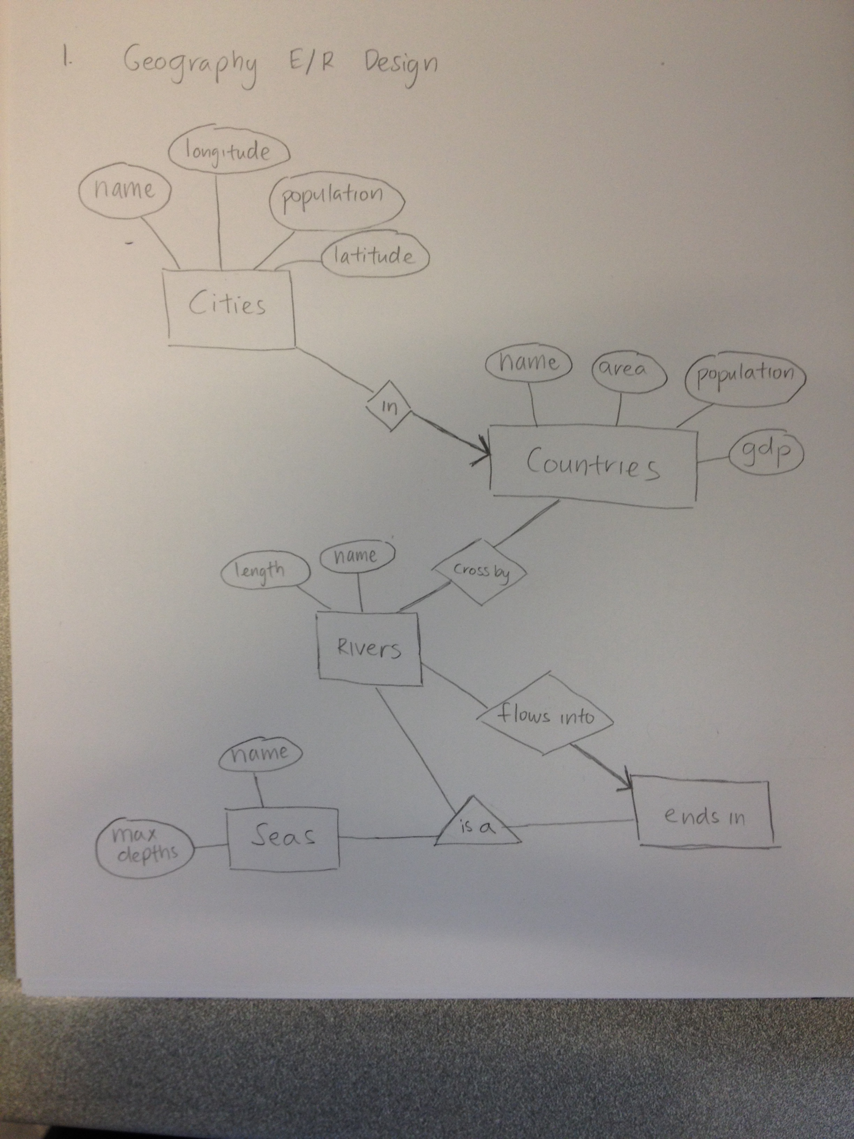

2.

a) CREATE TABLE **InsuranceCo**(name VARCHAR(30) PRIMARY KEY, phone VARCHAR(10));

CREATE TABLE **Person**(name VARCHAR(30), ssn VARCHAR(9) PRIMARY KEY);

CREATE TABLE **Driver**(licenceNo VARCHAR(12) PRIMARY KEY, ssn VARCHAR(9) REFERENCES Person);

CREATE TABLE **NonProfessionalDriver**(licenceNo VARCHAR(12) PRIMARY KEY, FOREIGN KEY (licenceNo) REFERENCES Driver);

CREATE TABLE **ProfessionalDriver**(licenceNo VARCHAR(12) PRIMARY KEY, medicalHistory VARCHAR(200), FOREIGN KEY (licenceNo) REFERENCES Driver);

CREATE TABLE **Vehicle**(licencePlate VARCHAR(10) PRIMARY KEY, year INT, maxLiability INT, maxLossDamage INT, name VARCHAR(20) REFERENCES InsuranceCo, ssn VARCHAR(9) REFERENCES Person);

CREATE TABLE **Car**(licencePlate VARCHAR(10) PRIMARY KEY, make VARCHAR(20), FOREIGN KEY (licencePlate) REFERENCES Vehicle);

CREATE TABLE **Truck**(licencePlate VARCHAR(10) PRIMARY KEY, capacity INT, licenceNo VARCHAR(12) REFERENCES ProfessionalDriver, FOREIGN KEY (licencePlate) REFERENCES Vehicle);

CREATE TABLE **drives**(licenceNo VARCHAR(12) REFERENCES NonProfessionalDriver, licencePlate VARCHAR(10) REFERENCES Vehicle, PRIMARY KEY (licenceNo, licencePlate));

b) In my relational schema, Vehicles represents “insures” because it is a many-to-one relationship and we do not need to make a separate relation for “insures” in the E/R diagram. Which is why I included it in my Vehicles relation.

c) The operates represents a ‘many-to-one relationship’ when drives represents a ‘many-to-many relationship’. The operates relation is because a truck or many trucks can only be driven by one professional driver (which is why we can include it in one table: Truck), when the drives relation represents a many-to-many which driver drives which cars (reason why there is a separate table is to represent that relationship).

3. i.

R(A,B,C,D,E): D 🡪 B, CE 🡪 A

First iteration we get:

R1: D+ = {D,B}

Dependency violations: D+ ≠ {D} or {A,B,C,D,E}

Since closure is not {A,B,C,D,E}

Decompose to: R1(D,B), R2(D,A,C,E)

Second iteration we get:

R2: (CE)+ = {C,E,A}

Dependency violations: (CE)+ ≠ {C,E} or {D,A,C,E}

Since closure is not {A,B,C,D,E}

Decompose to: R21(C,E,A), R22(C,E,D)

BCNF: R1(D,B), R21(C,E,A), R22(C,E,D)

ii.

S(A,B,C,D,E): A 🡪 E, BC 🡪 A, DE 🡪 B

First iteration we get:

S1: A+ = {A,E}

Dependency violations: A+ ≠ {A} or {A,B,C,D,E}

Decompose to: S1(A,E), S2(A,B,C,D)

Second iteration we get:

S2: (BC)+ = {B,C,A}

Dependency violations: (BC)+ ≠ {B,C} or {B,C,A,D}

Decompose to: S21(B,C,A), S22(B,C,D)

Third iteration we get:

No dependency violations!!

BCNF: S1(A,E), S21(B,C,A), S22(B,C,D)

4.

a. Functional dependencies:

(empty set)

A 🡪 A

B 🡪 B

C 🡪 C

D 🡪 D

b. Functional dependencies:

A 🡪 B

B 🡪 C

C🡪 D

D 🡪 A

c. Functional dependencies:

A 🡪 B

B 🡪 A

C 🡪 A B D

D 🡪 A B C

5. i.

sqlite> create table Sales(name varchar(15), discount varchar(10), month varchar(5), price int);

sqlite> .mode tabs

sqlite> .import mrFrumbleData.txt Sale

ii. Functional dependencies

**Name 🡪 discount**

SELECT COUNT(DISTINCT s1.name)

FROM Sales s1, Sales s2

WHERE s1.name = s2.name

AND s1.discount != s2.discount;

This query result is 0

**Month 🡪 discount**

SELECT COUNT(*)

FROM Sales s1, Sales s2

WHERE s1.month = s2.month

AND s1.discount != s2.discount;

This query result is 0

**Name 🡪 price**

SELECT COUNT(*)

FROM Sales s1, Sales s2

WHERE s1.name = s2.name

AND s1.price != s2.price;

This query result is 0

**Name 🡪 discount, price**

SELECT COUNT(*)

FROM Sales s1, Sales s2

WHERE s1.name = s2.name

AND s1.discount != s2.discount

AND s1.price != s2.price;

This query result is 0

**Name 🡪 month, price**

SELECT COUNT(*)

FROM Sales s1, Sales s2

WHERE s1.name = s2.name

AND s1.month != s2.month

AND s1.price != s2.price;

This query result is 0

**Name 🡪 discount, price, month**

SELECT COUNT(*)

FROM Sales s1, Sales s2

WHERE s1.name = s2.name

AND s1.discount != s2.discount

AND s1.price != s2.price

AND s1.month != s2.month;

This query result is 0

5. iii.

Sales(name, discount, month, price): name 🡪 price, month 🡪 discount

1.

Sales: name+ = {name, price}

Dependency violations: name+ ≠ {name} or {name, discount, month, price}

Decompose into: Sales1(name, price), Sales2(name, discount, month)

2.

Sales2: month+ = {month, discount}

Dependency violations: month+ ≠ {month} or {name, discount, month}

Decompose into: Sales21(month, discount), S22(month, name)

BCNF 🡪 Sales1(name, price), Sales21(month, discount), Sales22(month, name)

***SQL commands for my tables:***

CREATE TABLE Sales1(name VARCHAR(15) PRIMARY KEY, price INT);

CREATE TABLE Sales21(month VARCHAR(5) PRIMARY KEY, discount FLOAT);

CREATE TABLE Sales22(month VARCHAR(5) REFERENCES Sales21, name VARCHAR(15) REFERENCES Sales1);

iv.

INSERT INTO Sales1 SELECT DISTINCT name, price FROM Sales;

Results:

name price

bar1 19

bar8 19

gizmo3 19

gizmo7 19

mouse1 19

gizmo6 29

gizmo4 29

mouse3 29

mouse7 29

bar4 29

bar7 29

click7 29

bar9 39

click1 39

click2 39

click3 39

click8 39

click4 49

click9 49

gizmo1 49

mouse2 49

mouse8 59

bar2 59

bar3 59

mouse9 69

mouse4 69

gizmo9 79

gizmo5 79

gizmo8 89

mouse5 89

click6 89

bar5 89

bar6 99

mouse6 99

click5 99

gizmo2 99

INSERT INTO Sales21 SELECT DISTINCT month, discount FROM Sales;

Results:

month discount

apr 15%

aug 15%

dec 33%

feb 10%

jan 33%

jul 33%

jun 10%

mar 15%

may 10%

nov 15%

oct 10%

sep 15%

INSERT INTO Sales22 SELECT DISTINCT month, name FROM Sales;

Results:

month name

apr bar1

apr bar8

apr gizmo3

apr gizmo7

apr mouse1

aug bar1

aug bar8

aug gizmo3

aug gizmo7

aug mouse1

dec bar1

dec bar8

dec gizmo3

dec gizmo7

dec mouse1

feb bar1

feb bar8

feb gizmo3

feb gizmo7

feb mouse1

jan bar1

jan bar8

jan gizmo3

jan gizmo7

jul bar1

jul bar8

jul gizmo3

jul gizmo7

jul mouse1

jun bar1

jun bar8

jun gizmo3

jun gizmo7

jun mouse1

mar bar1

mar bar8

mar gizmo3

mar gizmo7

mar mouse1

may bar1

may bar8

may gizmo3

may gizmo7

may mouse1

nov bar1

nov bar8

nov gizmo3

nov gizmo7

nov mouse1

oct bar1

oct bar8

oct gizmo3

oct gizmo7

oct mouse1

sep bar1

sep bar8

sep gizmo3

sep gizmo7

sep mouse1

sep gizmo6

sep gizmo4

sep mouse3

sep mouse7

oct mouse7

sep bar4

sep bar7

sep click7

oct gizmo6

oct mouse3

oct gizmo4

oct click7

oct bar4

oct bar7

nov mouse7

nov mouse3

nov gizmo6

nov gizmo4

nov bar4

nov bar7

nov click7

may mouse7

may gizmo6

may mouse3

may gizmo4

may click7

may bar4

may bar7

mar mouse7

mar mouse3

mar gizmo6

mar gizmo4

jun mouse7

mar bar4

mar bar7

mar click7

jun gizmo6

jun mouse3

jun gizmo4

jun click7

jun bar4

jun bar7

jul mouse7

jul mouse3

jul gizmo6

jul gizmo4

jul bar4

jul bar7

jul click7

jan mouse7

jan mouse3

jan gizmo4

jan gizmo6

jan click7

jan bar4

jan bar7

feb mouse7

feb mouse3

feb gizmo4

feb gizmo6

feb click7

dec mouse7

feb bar7

dec mouse3

dec gizmo4

dec gizmo6

dec bar7

dec click7

dec bar4

aug mouse7

aug mouse3

aug gizmo6

aug gizmo4

aug bar7

aug click7

aug bar4

apr mouse7

apr gizmo6

apr mouse3

apr gizmo4

apr bar7

apr click7

apr bar4

apr bar9

apr click1

apr click2

apr click3

apr click8

aug click8

aug bar9

aug click2

aug click3

dec bar9

dec click1

dec click2

dec click3

dec click8

feb click8

feb bar9

feb click1

feb click2

feb click3

jan bar9

jan click1

jan click2

jan click3

jan click8

jul bar9

jul click1

jul click2

jul click8

jun bar9

jun click1

jun click2

jun click3

jun click8

mar click8

mar bar9

mar click1

mar click2

mar click3

may bar9

may click1

may click2

may click3

may click8

nov bar9

nov click1

nov click2

nov click3

nov click8

oct bar9

oct click1

oct click2

oct click3

oct click8

sep click8

sep bar9

sep click1

sep click2

sep click3

sep click4

sep click9

sep gizmo1

oct click9

oct gizmo1

oct mouse2

oct click4

nov click9

nov gizmo1

nov mouse2

sep mouse2

nov click4

may mouse2

may click9

may gizmo1

may click4

mar click4

mar click9

mar gizmo1

mar mouse2

jun click9

jun gizmo1

jun mouse2

jun click4

jul click9

jul gizmo1

jul mouse2

jul click4

jan mouse2

jan click9

jan gizmo1

jan click4

feb mouse2

feb click4

feb click9

feb gizmo1

dec click9

dec gizmo1

dec mouse2

dec click4

aug mouse2

aug click4

aug click9

aug gizmo1

apr gizmo1

apr click4

apr mouse2

apr mouse8

aug bar2

aug bar3

apr bar2

apr bar3

aug mouse8

dec bar2

dec bar3

dec mouse8

feb bar2

feb bar3

feb mouse8

jan bar2

jan bar3

jan mouse8

jul bar2

jul bar3

jul mouse8

jun bar2

jun bar3

mar mouse8

may bar2

may bar3

jun mouse8

mar bar2

mar bar3

may mouse8

nov bar2

nov bar3

sep mouse8

nov mouse8

oct bar2

oct bar3

oct mouse8

sep bar2

sep bar3

oct mouse9

oct mouse4

nov mouse9

nov mouse4

sep mouse9

sep mouse4

may mouse9

may mouse4

jun mouse9

mar mouse9

mar mouse4

jul mouse9

jul mouse4

jun mouse4

jan mouse9

jan mouse4

feb mouse9

feb mouse4

dec mouse9

dec mouse4

aug mouse9

aug mouse4

apr mouse9

apr mouse4

apr gizmo9

apr gizmo5

aug gizmo5

aug gizmo9

dec gizmo9

feb gizmo5

feb gizmo9

jan gizmo5

jan gizmo9

jul gizmo9

jul gizmo5

jun gizmo9

jun gizmo5

mar gizmo9

mar gizmo5

may gizmo9

may gizmo5

sep gizmo9

sep gizmo5

nov gizmo9

nov gizmo5

oct gizmo9

oct gizmo5

oct gizmo8

oct mouse5

sep click6

sep bar5

nov gizmo8

nov click6

nov bar5

nov mouse5

oct click6

oct bar5

sep gizmo8

sep mouse5

may gizmo8

may click6

may bar5

may mouse5

mar gizmo8

mar mouse5

mar click6

mar bar5

jun gizmo8

jun mouse5

jul mouse5

jun click6

jun bar5

jul gizmo8

jul click6

jul bar5

jan gizmo8

jan mouse5

jan click6

jan bar5

feb click6

feb gizmo8

feb mouse5

feb bar5

dec mouse5

dec gizmo8

dec click6

aug gizmo8

aug click6

aug mouse5

dec bar5

apr click6

apr bar5

apr gizmo8

apr mouse5

aug bar5

aug bar6

apr mouse6

apr bar6

apr click5

apr gizmo2

dec bar6

dec click5

aug mouse6

aug gizmo2

aug click5

dec gizmo2

dec mouse6

feb bar6

feb gizmo2

feb click5

feb mouse6

jan bar6

jan click5

jan gizmo2

jan mouse6

jul click5

jul bar6

jul gizmo2

jun bar6

jun click5

jul mouse6

jun mouse6

jun gizmo2

mar bar6

mar gizmo2

mar click5

mar mouse6

may mouse6

nov click5

may bar6

may click5

may gizmo2

sep mouse6

oct bar6

oct click5

nov mouse6

nov bar6

nov gizmo2

sep bar6

sep gizmo2

sep click5

oct mouse6

oct gizmo2