**1.DFAs**

**(a)**

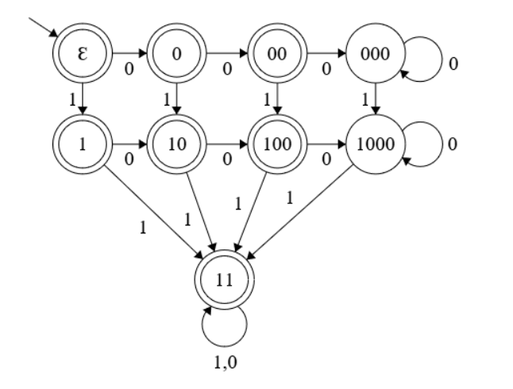

**Ɛ**: start state, representing empty string

**0**: “0” **00**: ”00” **1**: ”1”

**000**: “0000*”

**10**: “10” or “01”

**100**: “001” or “010” or “100”

**1000**: “0000*10*” or “00100*” or “01000*” or “10000*”

**11**: any binary strings that has at least two 1’s

**(b)**

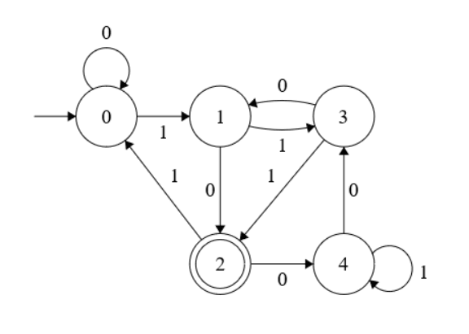

**0**: start state, binary strings that is congruent to 0 modulo 5

Such as “00”, “11001”(25), “100011”(35) etc.

**1**: binary strings that is congruent to 1 modulo 5

Such as “01”, “10000”(16), “1011011011”(731) etc.

**2**: binary strings that is congruent to 2 modulo 5

Such as “10”, “111”, “10001110001”(1137) etc.

**3**: binary strings that is congruent to 3 modulo 5

Such as “11”, “1101”, “10000101010101010101”(546133) etc.

**4**: binary strings that is congruent to 4 modulo 5

Such as “100”, “1110”, “100010010010010”(17554) etc.

**(c)**

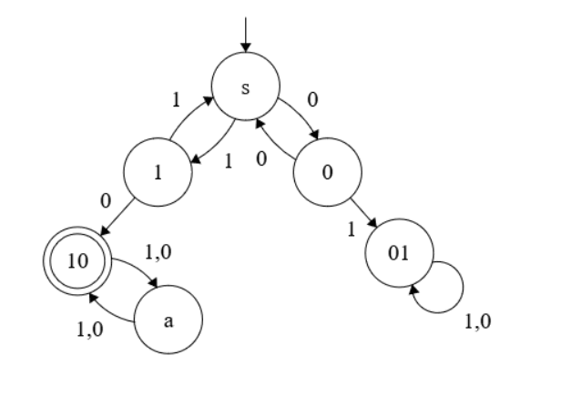

**S**: start state, (11U00)*

**1**: (11U00)*1

**0**: (11U00)*0

**01**: (11U00)*01(0U1)*

**10**: (11U00)*10((1U0)(1U0))*

**a**: (11U00)*10((1U0)(1U0))*(1U0)