# Report

### 1.Basic Concepts

There are several basic concepts.Firstly,Charge is fundamental of quantity of electricity ,and a property of matter,and charge can be positive or negative. The amount of electric charge is the amount of electricity carried by matter, atom or electron. The sign of charge is Q, and the unit is Coulomb (Mark C).The elementary charge is proton/electron,and their charge are +1.602 x 10-19 C / -1.602 x 10-19 C. So, 1 C = 6.24 x 1018 elementary charges, Charge can neither be created nor destroyed. It can only be transferred from one object to another via electric field, or from one part of the object to another. In the process of transfer, the total charge of the system remains unchanged.

Secondly, Also known as potential difference, it is a physical quantity to measure the energy difference of unit charge in electrostatic field due to different potential. Voltage is the cause of the electric current. The reason why the current can flow in the wire is that there is a difference between high potential and low potential in the current. Charge q moves from point a to point B in the electric field. The ratio of the work WAB done by the electric field force to the charge q is called the potential difference between two points AB. and expressed by UAB. 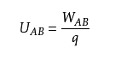 The formula of instantaneous voltage is

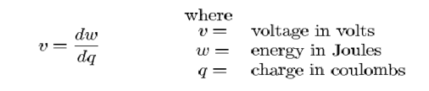

Thridly,current. The strength of the current is described by the current intensity, which is the electric quantity passing through a certain cross section of the conductor in unit time, referred to as the current, expressed in I. The current intensity is scalar, and the moving direction of the positive charge is usually defined as the current direction. In the conductor, the direction of current always points from high potential to low potential along the direction of electric field. In the SI system, the unit of current intensity is ampere (A), which is one of the seven basic units in the SI system. Define the formula:

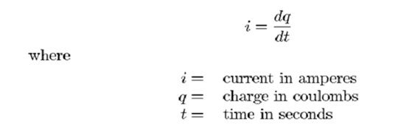

The current is divided into alternating current and direct current.

AC(Alternating current): periodic changes in size and direction. The plug-in electrical appliances in our life use the civil AC power supply.

DC: direction does not change with time. The portable external power supply used in our life provides direct current.

And next is power. Physical definition: the work done in unit time is called power.

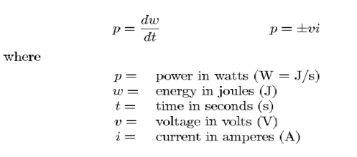

Last one is energy. If an object is affected by a force and there is a displacement in the direction of the force, we say that the force does work on the object.0



### 2. Passive Sign Convention

Electricity flows into the positive pole and energy is gained。 When the current flows out of the positive pole, it loses energy

🤮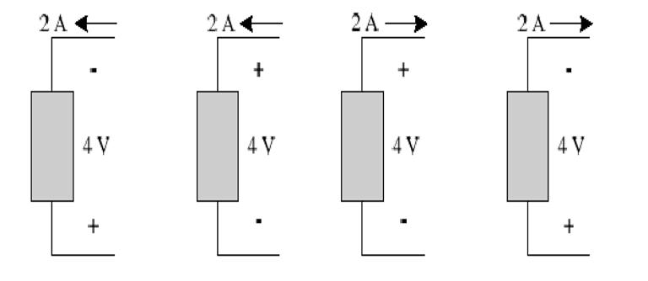

①current flows out of positive pole,so p=-vi=-8w

②current flows into positive pole,so p=+vi=8w

③ current flows out of positive pole,so p=-vi=-8w

④ current flows into positive pole,so p=+vi=8w

### 3. Electric Circuits

The simplest circuit is composed of power supply, electrical appliances (load), wires, switches and other components. There are series circuit, parallel circuit and other circuits in the circuit.

Series connection is one of the basic ways to connect circuit components. Circuit components (such as resistance, capacitance, inductance, electrical appliances, etc.) are connected in sequence one by one, and the circuit formed by connecting all electrical appliances in series is called series circuit.

Advantages: in a circuit, if you want to control all electrical appliances through a switch, you can use a series circuit;

Disadvantage: as long as there is a certain disconnection, the whole circuit will become an open circuit. That is to say, the electronic components in series cannot work normally.

Parallel circuit is to make more than one independent path of current between circuit elements that make up parallel circuit.

Features: no influence between electric appliances. The consumer on one branch is damaged, and other branches are not affected.

### 4. Ohm’s Law

Only materials with a linear relationship satisfy ohm’s law.

Ohm's law is a very accurate law for the conductor (such as metal) of electronic conduction under the condition of normal or not too low temperature. When the temperature is low to a certain temperature, the metal conductor may enter the superconducting state from the normal state. The conductor resistance in the superconducting state disappears, and there can be current without voltage. In this case, of course, Ohm's law is no longer applicable.

Ohm's law also applies to ionic conducting conductors such as electrolytes (aqueous solutions of acids, alkalis, and salts) when the temperature or the range of temperature change is usually not very large. However, Ohm's law does not hold true for the state of conductivity and some conductive devices, such as electronic tubes and transistors, under the condition of gas ionization.