ECS 189G HW2
916678034 Zhengfeng Lai
lzhengfeng@ucdavis.edu
Task 1
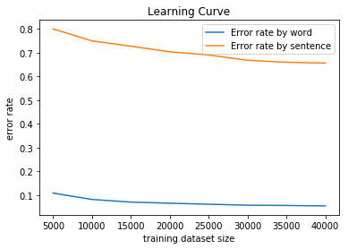
Answer: With the larger dataset size, the error rate gose down gradually, which indicates that our model has better performance.

Task 2
My function is written in Viterbi.py based on Viterbi.pl
And this is my results:
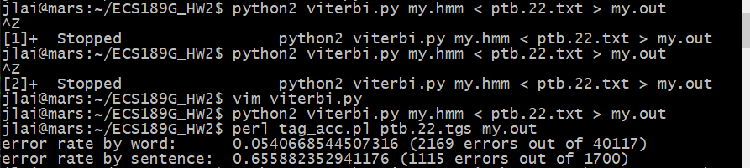
As is shown above, the results are the same as the output of .pl

Task 3
In this task, I implemented two scripts, which are trigram_train.py and trigram_viterbi.py.
I just implemented a trigram model because it could have better accuracy since this model can consider more words at every time comparing to a bigram model. Due to my limited time, I only tried add-one smoothing, the easiest smoothing methods. Also I tried to iterate my model through all possible transitions even those are not appearing in the training data. So my model has a little better performance than the baseline model.
mysmoothed.hmm
mysmoothed22.out
mysmoothed23.out
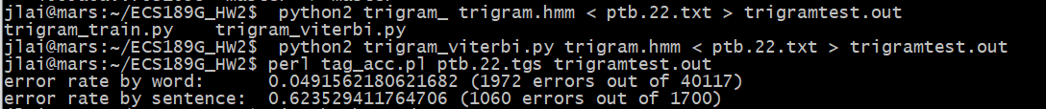
We can see that the error rate by word has decreased to 0.04 from 0.05 and the error rate by sentence has decreased to 0.62 while the original model is 0.65. It’s much better.

And the output of ptb.23 is in mysmoothed23.out.

Task 4
Base Model on Japanese:
basejv.hmm
basejv.out
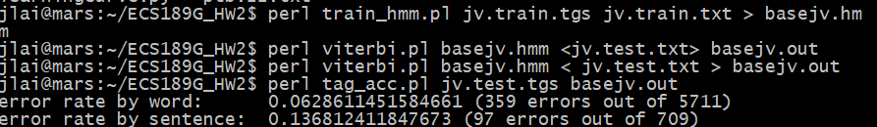
My Model on Japanese:
trijv.hmm
trijv.out
We can see that my model is greatly better than the base model on Japanese.
Base Model on Bulgarian:
basebtb.hmm
basebtb.out
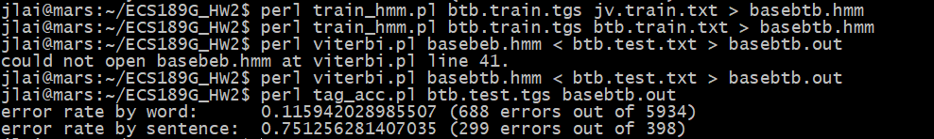
My Model on Bulgarian:
tribtb.hmm
tribtb.out
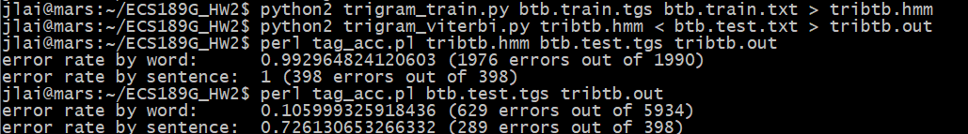
Analysis:
From above, we can see that whatever the base model or my model, the performance of Bulgarian is the worst. The first reason may lie in the smaller training data on Bulgarian comparing to English. And the training time is considerably shorter than the time of Japanese training. Another reason may be the long sentences in the test data of Bulgarian because longer sentences are more likely to be predicted wrongly.
And my model performs best in Japanese because my smoothing methods is to make rare transitions to be considered.

Task 5

