# PS1

I. Short Answer Problems

1. Assume there is a filter .

And there is an image .

We do the multiplication .(9 multiplications).

According to Associative property we can reduce it by dividing the filter as part1 and part2:

. We can get . It uses 9 times of multiplication.

. We can get. It uses 3 times of multiplication.

So the associative property makes it more efficient.

2. The result is [1 1 1 1 1 0 1 1].

3.

4.

II. Programming Problem

|  |
| --- |
| **1.** Reduces the width of the image by 100 pixels |
| outputReduceWidthPrague.png |
| outputReduceWidthMall.png |

2.

outputReduceHeightPrague.png

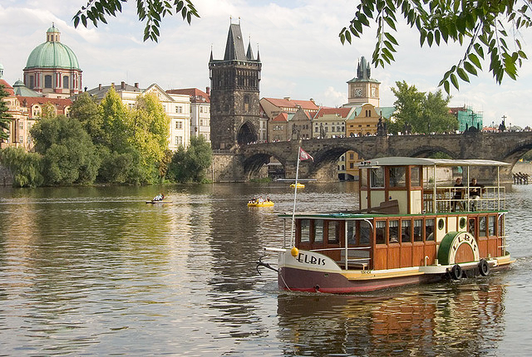

outputReduceHeightMall.png

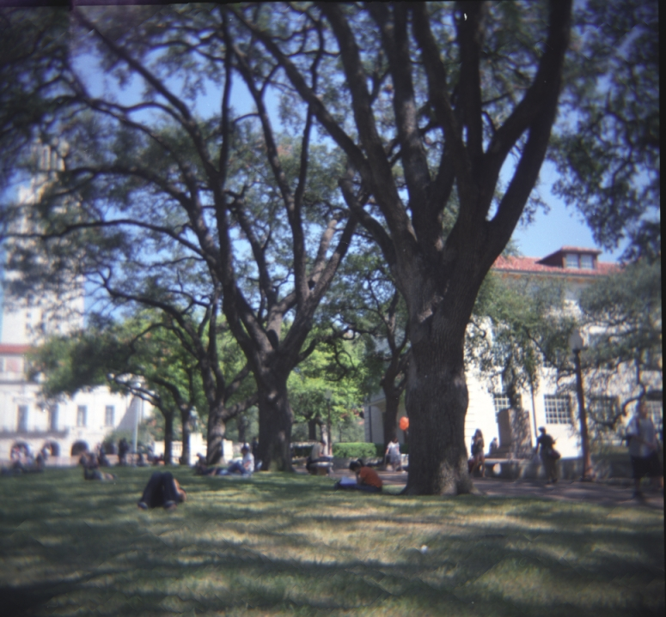

Submit the script for image inputSeamCarvingPrague.jpg

It is Problem2_sumbit.m

3.

(a) the energy function output for the provided image inputSeamCarvingPrague.jpg

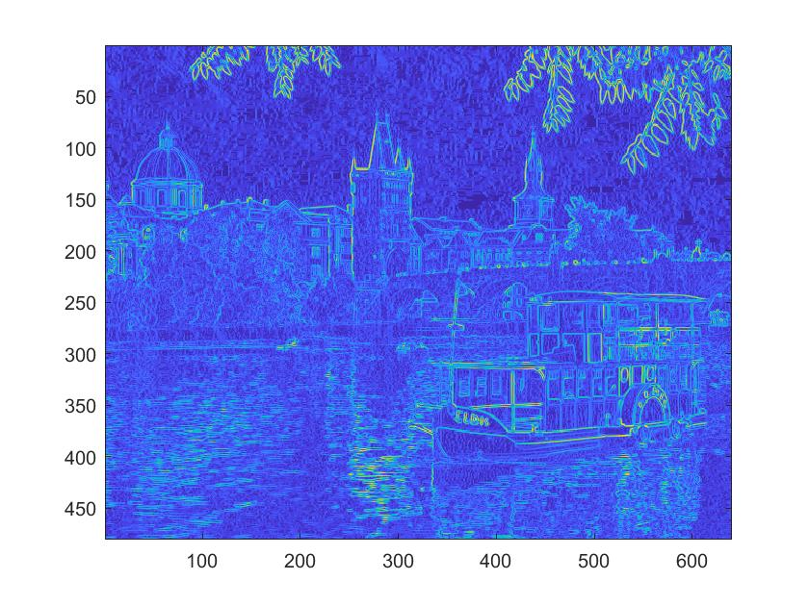

(b) the two corresponding cumulative minimum energy maps for the seams in each direction

|  |  |
| --- | --- |
| Vertical | Horizontal |
|  |  |

Explain why these outputs look the way they do given the original image’s content.

The energy function output includes the outlines of the edges in the original image, successfully delineating key components when we calculate the minimum cost path. The cumulative minimum energy draws the key components with more clear details. The light areas corresponding to high energy cost at the bottom of the vertical energy map and on the right of the horizontal energy map. This is because the cumulative energy map function sweeps from top to bottom for vertical while left to right for horizontal. In the horizontal cumulative energy map, we can see high energy is at the large boat, buildings and bridges because we cannot start compressing the boat when we carve the original image horizontally. The vertical cumulative energy map places high energy cost at the boat and highly reflective areas of the water. The boats are the key component which cannot be carved.

4.Original

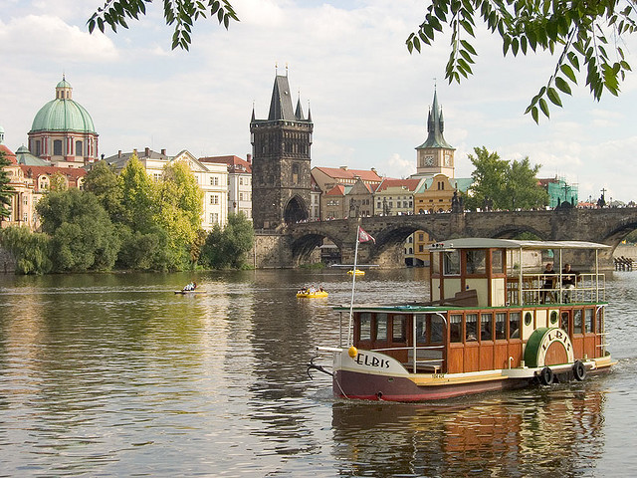

a)Vertical

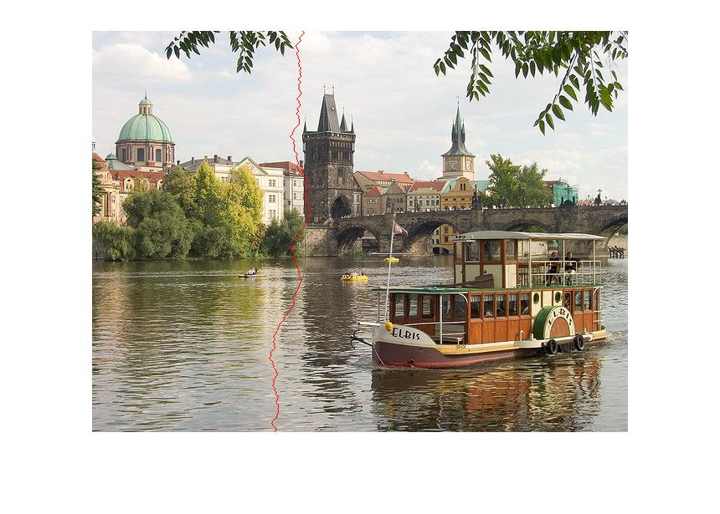

b）Horizontal

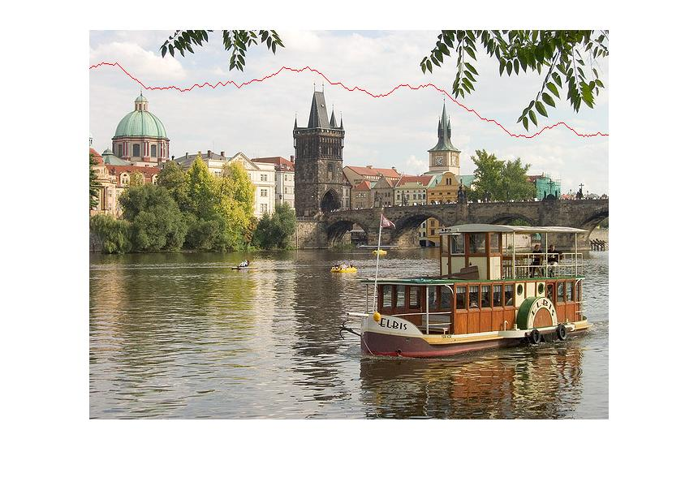

Explain why these are the optimal seams for this image.

The first vertical seam, nearly a vertical line, is around the edge of between the dark tower and the white building. The vertical seam also goes along the reflection of the white building in the water because the colors there are almost the same, which indicates low cost there.

The first horizontal seam is in the sky where color is almost the same and the contrast is low. So there is low cost to seam at that place.

5.

Horizontal:

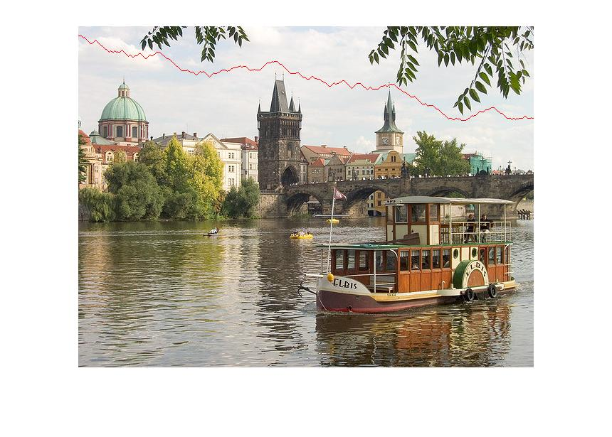

Vertical:

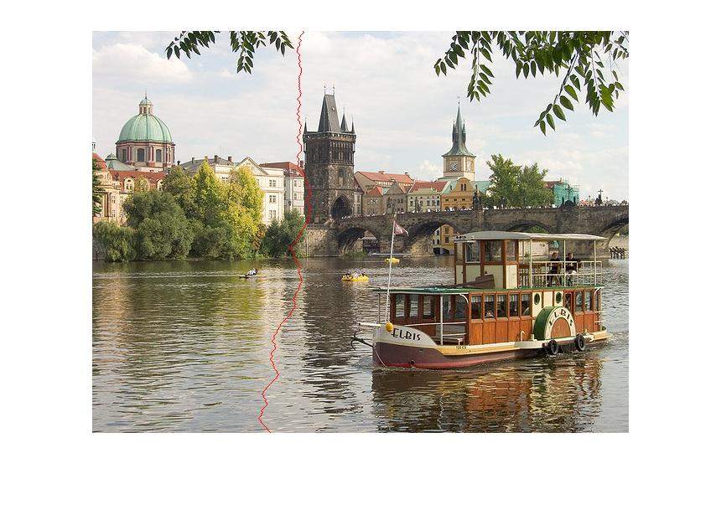

explain the impact:  
It goes through the cost area where there is a big giant around the seam since it is less sensitive to the difference of cost energy now. Comparing it the original function, it is less sensitive to the energy gap areas.