First,run the exe file @

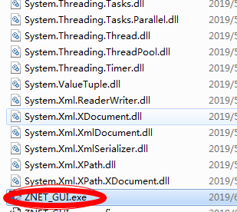

I don’t know why I have so many dll files here,I am new to Csharp.

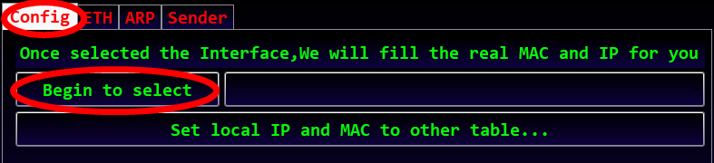

Click that red circle above,Then select the Network Card you used…as following:

Mine is:

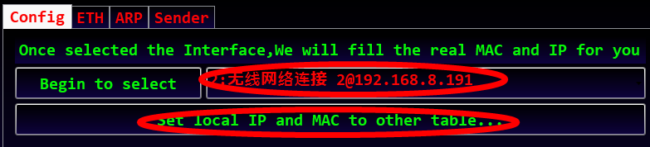

Click that red circle above.

Input the textbox’s cotent as you wanted,then click as follows:

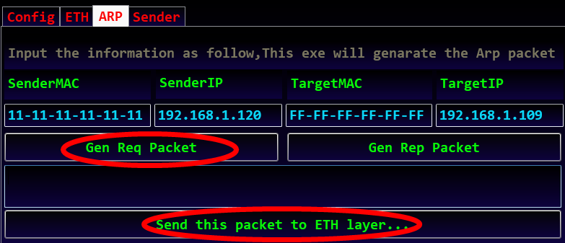

When clicked “Gen Req Packet”,This soft will generate Data including the cotent you had inputed,

When clicked “send this packet to ETH later”,It doesnot means we send this packet out,It will switch to ETH’s page,You still have aome cotent to fill for a full Packet.

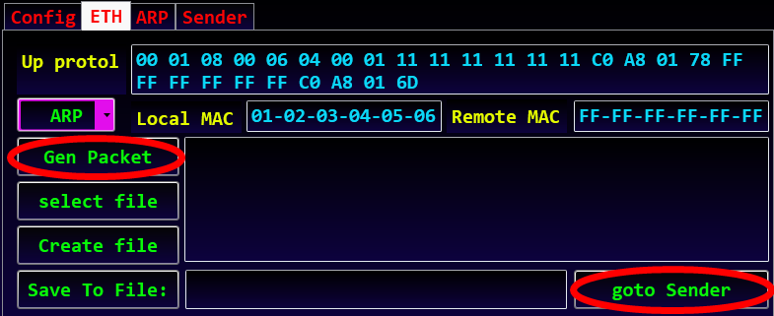

When clicked “Gen Packet”,It will generate a full packet of arp,,Then click “goto Sender”

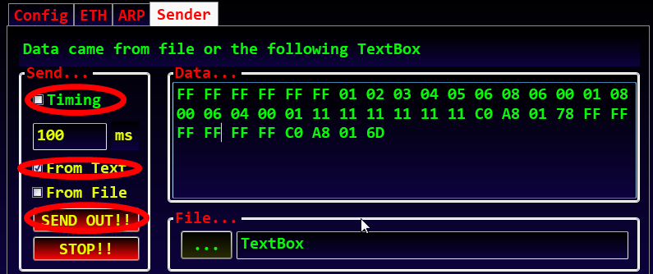

Select “From Text”, Select “Timing” can send the Packet timingly,Then click “SEND OUT!!”，this software will send this Packet out!!!You can test it use wireshark…

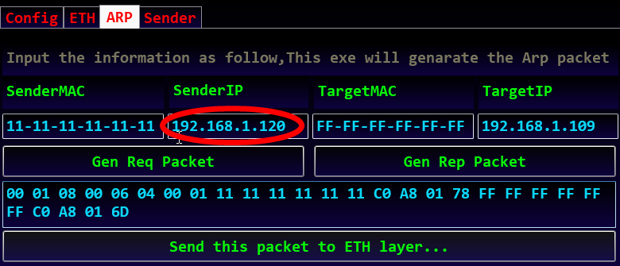

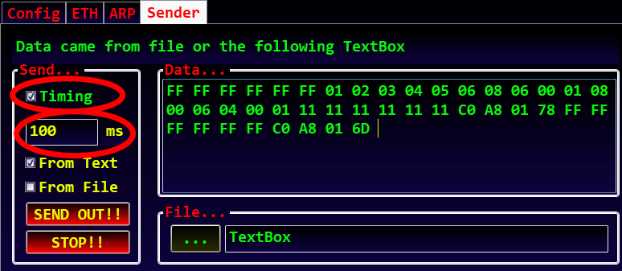

When you Fill the “SenderIP” a same content as your phone,Then Send this packet timingly(<100ms),You can make a conflict in the LAN,Your phone’s network speed will be affected…

I had successed reduced my phone’s network speed!!!